**Topics: Normal distribution, Functions of Random Variables**

1. The time required for servicing transmissions is normally distributed with *μ* = 45 minutes and *σ* = 8 minutes. The service manager plans to have work begin on the transmission of a customer’s car 10 minutes after the car is dropped off and the customer is told that the car will be ready within 1 hour from drop-off. What is the probability that the service manager cannot meet his commitment?
2. 0.3875
3. **0.2676**
4. 0.5
5. 0.6987

**ANS: Given *μ* = 45 ,*σ* = 8**

**The probability that the service manager cannot meet his commitment is *μ<50.***

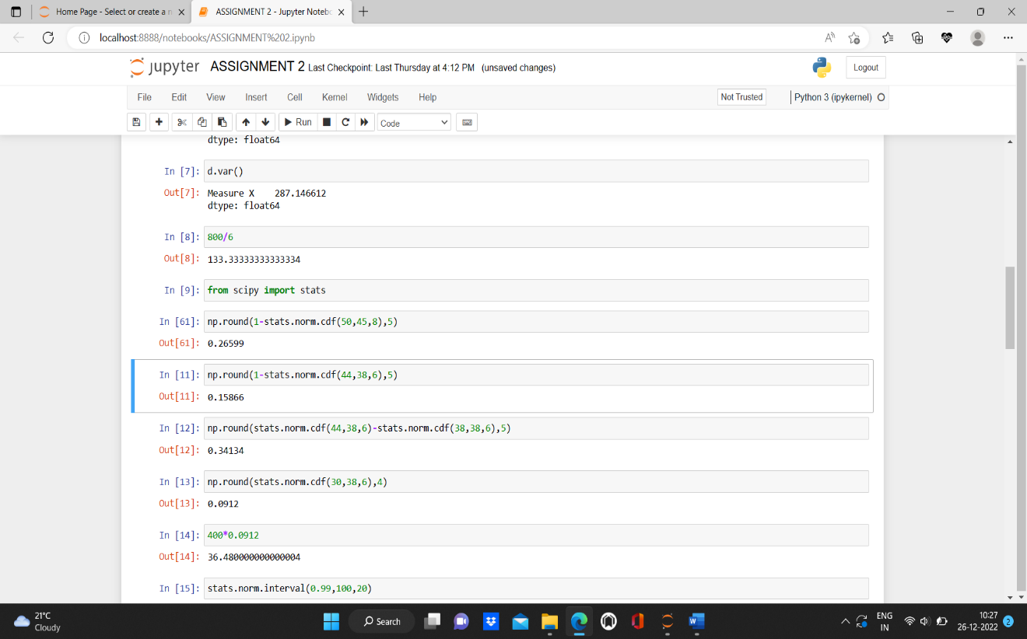

1. The current age (in years) of 400 clerical employees at an insurance claims processing center is normally distributed with mean *μ* = 38 and Standard deviation *σ* =6. For each statement below, please specify True/False. If false, briefly explain why.
2. More employees at the processing center are older than 44 than between 38 and 44.

**FALSE: The probability employees at the processing center are older than 44(*μ>44*) is 15.86% whereas, the probability employees at the processing center are between 38 and 44 (*38<μ<44*) is 34.13%.**

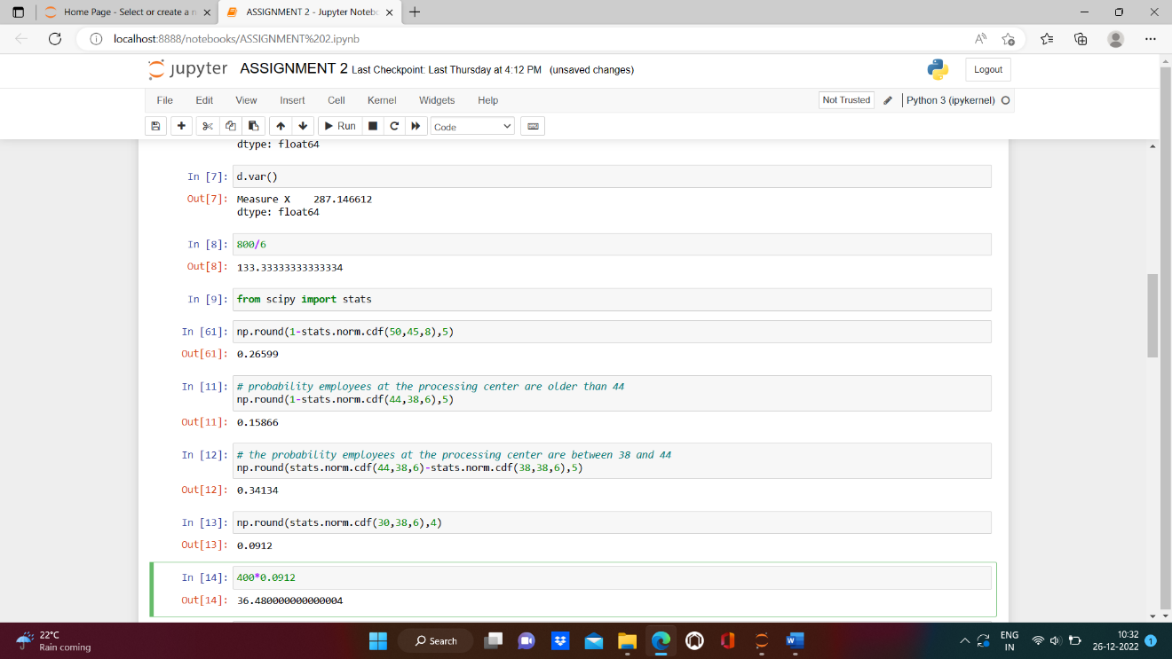

1. A training program for employees under the age of 30 at the center would be expected to attract about 36 employees.

**TRUE: The number of employees under the age 30 is around 36.**

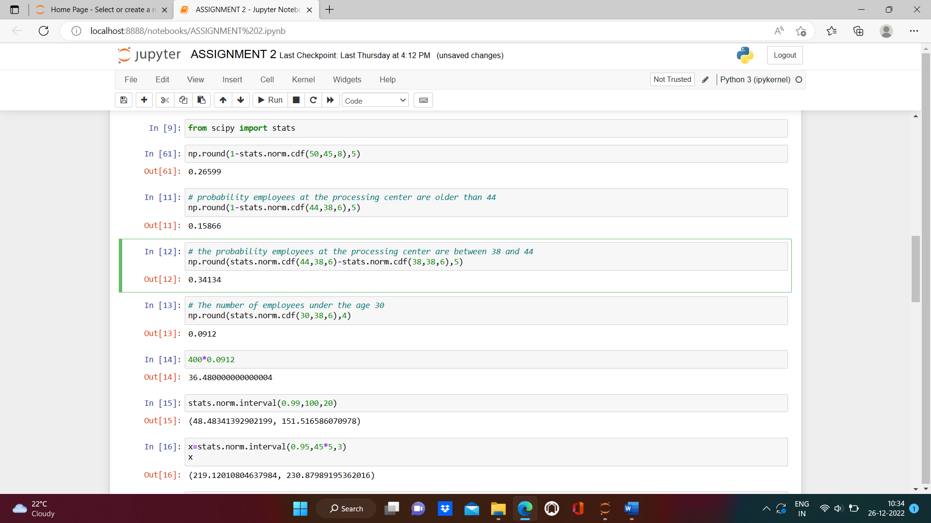

1. If *X1* ~ *N*(μ, σ2) and *X*2 ~ *N*(μ, σ2) are *iid* normal random variables, then what is the difference between 2 *X*1 and *X*1 + *X*2? Discuss both their distributions and parameters.

* **Both are identically and independently distributed. Both will have same mean but the variance will be twice for 2 than compared to.That is**

**2 *X*1 ~ N(2μ , ) and ~ *N*(2μ, 2σ2).**

* **Their difference is 2 *X*1 – ~ (2μ-2μ, 2σ2) .**
* **2 *X*1 scales the distribution by 2 times.**

1. Let X ~ N(100, 202). Find two values, *a* and *b*, symmetric about the mean, such that the probability of the random variable taking a value between them is 0.99.
2. 90.5, 105.9
3. 80.2, 119.8
4. 22, 78
5. **48.5, 151.5**
6. 90.1, 109.9

**ANS: We have μ= 100 , σ=20**

**Then, the random variable taking a value between them is 0.99:**

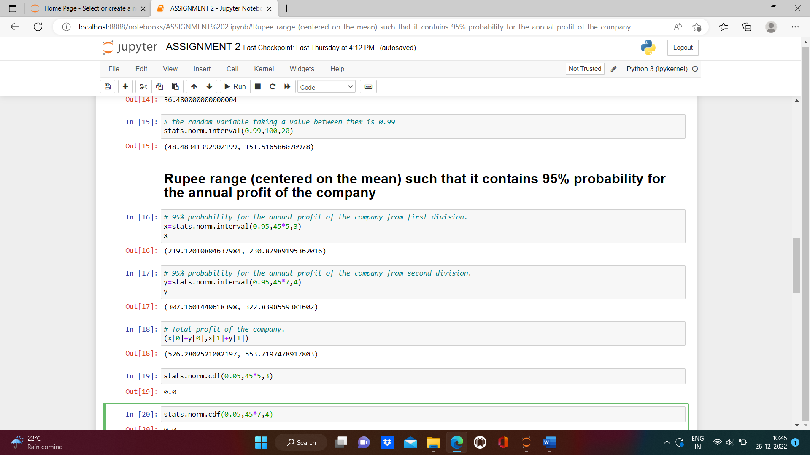

1. Consider a company that has two different divisions. The annual profits from the two divisions are independent and have distributions Profit1 ~ N(5, 32) and Profit2 ~ N(7, 42) respectively. Both the profits are in $ Million. Answer the following questions about the total profit of the company in Rupees. Assume that $1 = Rs. 45
2. Specify a Rupee range (centered on the mean) such that it contains 95% probability for the annual profit of the company.

**ANS: The total profit of company in rupees= 526.28 rs to 553.719 rs.**



1. Specify the 5th percentile of profit (in Rupees) for the company

**ANS: 170 RS**

**X= μ+ Z σ**

**For 5 percentile z=-1.645, μ=540 σ= 225**

**Therefore, X=170**

1. Which of the two divisions has a larger probability of making a loss in a given year?

**ANS:**

**The probability of making a loss in a given year by 1st division (μ<0): 4.77% (0.04779)**

**The probability of making a loss in a given year by 1st division (μ<0): 4.00% (0.04006)**

**Therefore, 1st division of the company has the high probability of making loss.**

