**VISVESVARAYA TECHNOLOGICAL UNIVERSITY, BELGAUM 59014**



Database Application Development Project Report on

**“HOSTEL MANAGEMENT SYSTEM”**

By

**Sowkhya S Adiga (1BM15CS110)**

**Shreeprada Divakar Bhat(1BM15CS100)**

**Madhabi Choudhury (1BM15CS152)**

**Vatsala Jha (1BM15CS123)**

Under the Guidance of

**VIKRANTH B.M.**

Associate Professor, Department of CSE

BMS College of Engineering

Database ApplicationDevelopment carried out at



Department of Computer Science and Engineering

BMS College of Engineering

(Autonomous college under VTU)

P.O. Box No.: 1908, Bull Temple Road, Bangalore-560 019

2015-2016

**BMS College of EngineerinG**

**DEPARTMENT OF COMPUTER SCIENCE AND ENGINEERING**



***CERTIFICATE***

This is to certify that the Database Application development titled “**Hostel Management System**” has been carried out by **Sowkya.S.Adiga (1BM15CS110), Shreeprada.Divakar.Bhat(1BM15CS100), Madhabi.Chiudhri(1BM15CS152) and Vatsala Jha (1BM15CS123)**  during the academic year 2016-2017.

Signature of the guide

**Dr. Vikranth B.M.**

Associate Professor

Department of Computer Science and Engineering

BMS College of Engineering, Bangalore

**BMS College of EngineerinG**

**DEPARTMENT OF COMPUTER SCIENCE AND ENGINEERING**



***DECALARATION***

We,Sowkhya.S.Adiga(1BM15CS110),Shreeprada.Divakar.Bhat(1BM15CS100), Madhabi Choudhuri(1BM15CS152) and Vatsala Jha (1BM15CS123) students of 4th Semester, B.E, Department of Computer Science and Engineering, BMS College of Engineering, Bangalore, hereby declare that, this Database Application development work entitled "Hostel Management System" has been carried out by us under the guidance of Dr. Vikranth B.M, Associate Professor, Department of CSE, BMS College of Engineering, Bangalore during the academic semester Jan-April 2017

We also declare that to the best of our knowledge and belief, the development reported here is not from part of any other report by any other students.

Signature

Sowkhya S Adiga (1BM15CS110)

Shreeprada Divakar Bhat(1BM15CS100)

Madhabi Choudhuri (1BM15CS152)

Vatsala Jha (1BM15CS123)

**Main Features are:**

**1.Hostelers**

**a. Profile Entry**

**b. Extra Services Entry**

**c. Services Entry**

**d. Allocation and De-Allocation**

**e. Extend Agreement**

**f. Change Hostel and Change room within same hostel**

**2.Transaction**

**a. Transaction Entry**

**b. Purchased Inventory**

**c. Payment Voucher**

**3. Caution Money Receipt**

**4. Payment Voucher Receipt**

**5. Quotation Receipt**

**6. Fee Payment slip**

**7. Hosteler 's Report Card**

**8. Users**

**a. Registration**

**b. Change Password**

**c. Password Recovery**

**9. Advance Records Searching**

**10. Advance Reports**

**Login Information:**

**User Name - admin**

**Password - 12345**

**1. Requirements**

Project Requirements are as follows

**Software Requirements - Visual Studio 2010 and Crystal Report for VS 2010 must be installed on your system to run this Project Successfully**

**Windows8.1**

**Hardware Requirements –**

**OS – windows platform**

**Key board – 104 keys**

**Front end – Visual basic 10.0**

**Back end – oracle Mysql**

**2. Short Description of the Project Work**

Development of a database application to automate the process of hostel management.

a. It contains nine tables.

b. Hostel has name, address and contact details which is managed by the manager of hostel.

c. Hostellers are the students who registers for the hostel and live in hostel. Hostellers get basic services like food, room, and also get extra services like internet etc.

d. Hostellers pay for the services and extra services. They also pay registration charges. And those payments will be recorded in the Fee Payment table. They have due dates for their payment of fees.

e. Hostel has Rooms, and Quotation which will tell the summary of the hosteller’s fee status .

**3. List of Entities, Attributes and Keys**

a. Hostel (hostel name (PrimaryKey), hostel address, hostel phone, hostel contact No, managed by)

b. Hostellers (hosteler ID(PrimaryKey), hosteler Name, gender,DOB,room No, hostel name,date of joining,purpose,father name,mobile no1,phone 1,mother name,mobile no 2,city,address,E mail,contact no,Inst ofcdetails,phone 2,agreement,guardian name, guardian address,mobile no 3,phone 3,photo,docspic,competion date)

c. Room (hostel Name(PrinaryKey), room no(key),room type,no of beds, beds available)

d. Fee Payment(fee payment ID (PrimaryKey), hosteler id, service charges,extra charges,fee month,pyment date,total paid, fine, due payment)

e. Services(ID (Primary key), hosteller id, service name, service charges)

f. Extra services(ID (Primary key), hosteller id, service date, item, quantity, unit price, totl price)

g. Reg Charges(Receipt no (primary key), hosteller id, Caution money, rental charges, payment date)

h. Quotation(Quotation id (primary key),hostel name, contact no,charges per month1,no of month1,total charges1, charges per month2, no of month2,total charges2, grand total, quotation date)

i. Due date(ID (primary key),hosteller id, due date)

**4. Entity-Relationship diagram**

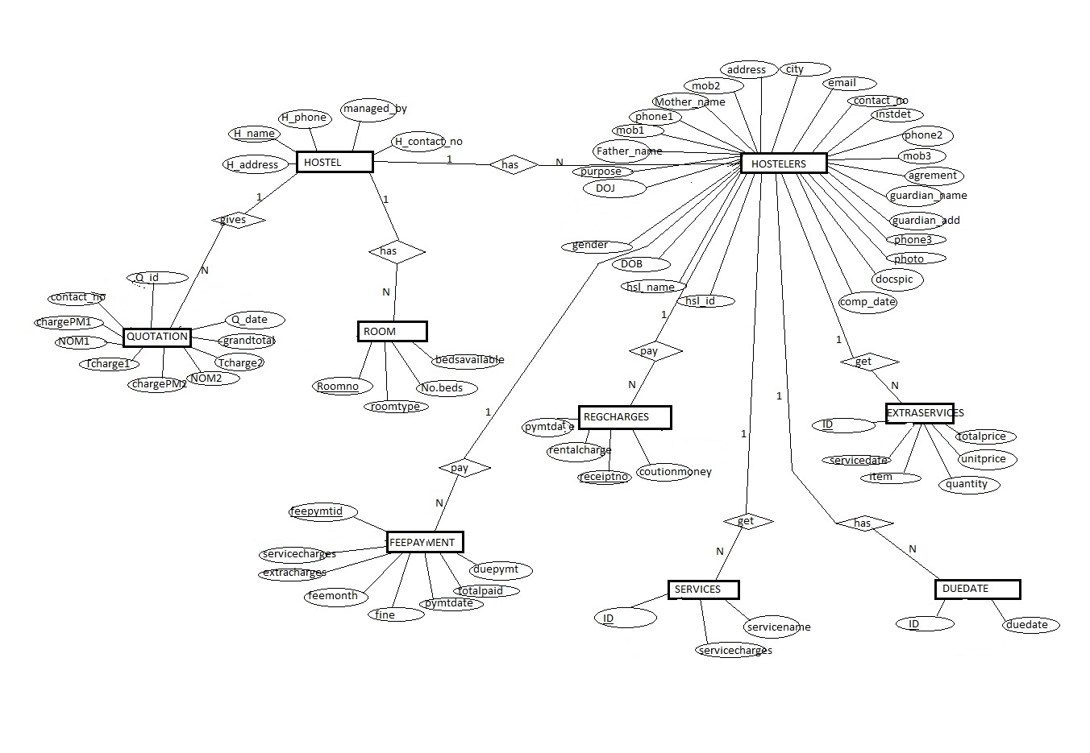

**5. Schema Diagram**

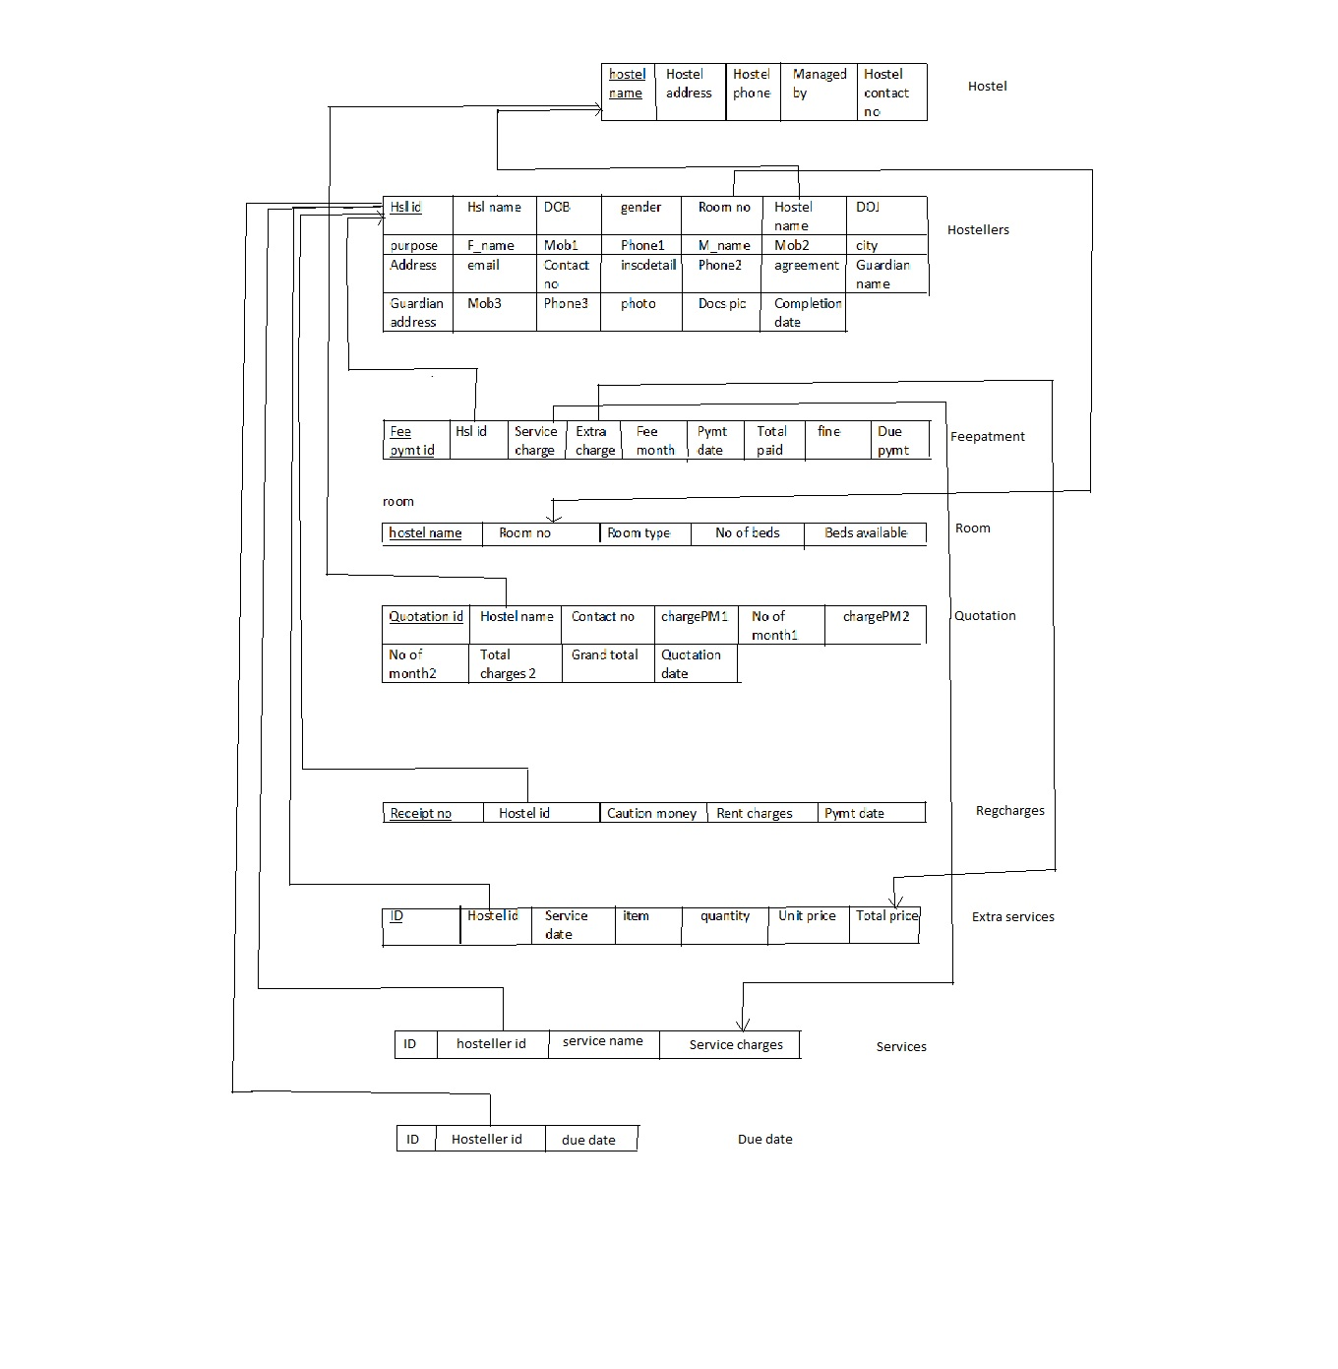

**5.2 Constraints**

**a. Not null constraints**

**b.Foreign key constraints**

**c. key constraints**

**6. Front-End Screen shots**

In this section, front-end screen shots of all the forms are shown.

**6.1 Login Window**

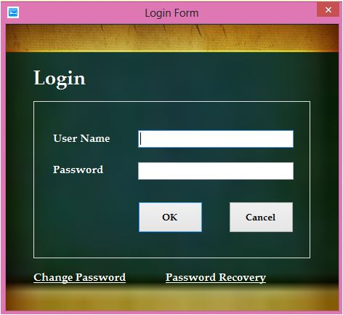

**6.2 Main Window**

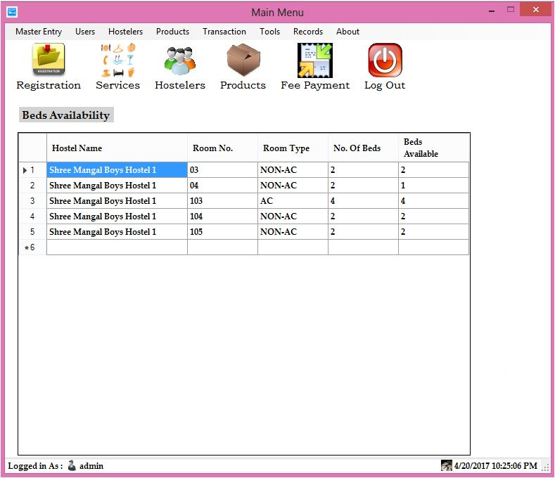

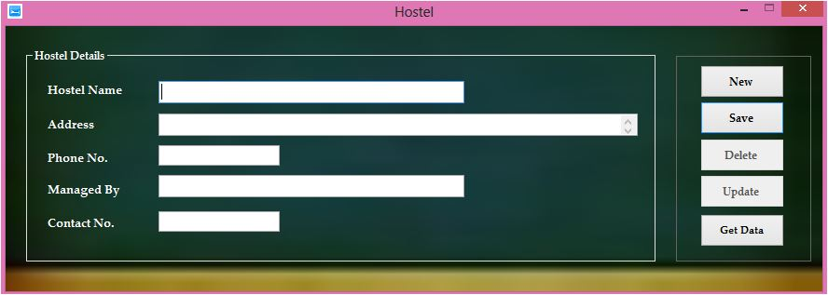

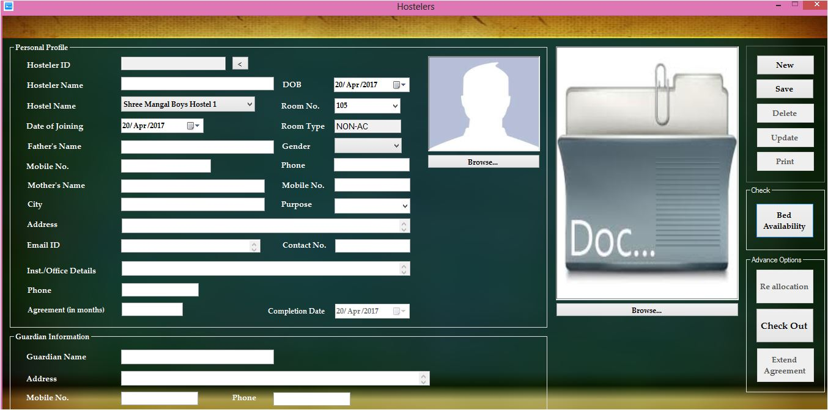

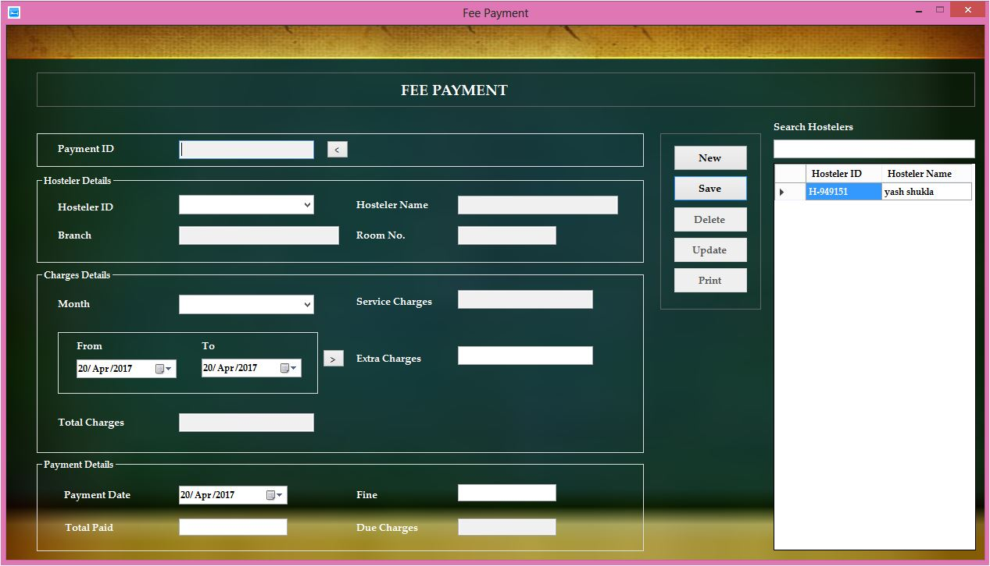

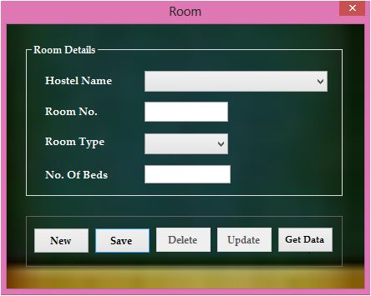

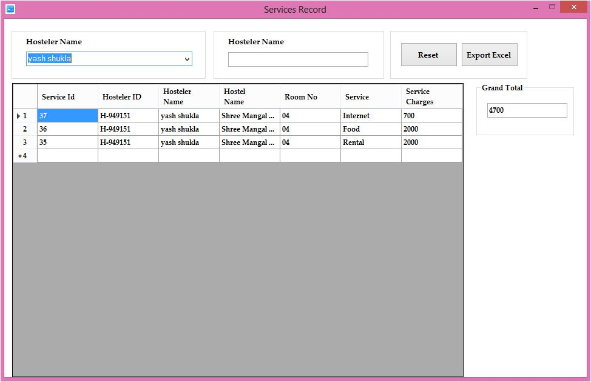

**7. Back-End table descriptions**

In this section for all database tables, the Description, sample table Data and upto what level tables are normalized will be listed out.

**7.1 Hostel**

|  |  |  |
| --- | --- | --- |
| **Hostel name** | **Not null primary key** | **Varchar(20)** |
| **Hostel address** |  | **Varchar(30)** |
| **Hostel phone** |  | **Int** |
| **Managed by** |  | **Varchar(20)** |
| **Hostel contact no** |  | **Int** |

**7.2 hostellers**

|  |  |  |
| --- | --- | --- |
| **Hosteller id** | **Not null primary key** | **Varchar(20)** |
| **Hosteller name** | **Not null** | **Varchar(20)** |
| **DOB** |  | **Date** |
| **Gender** |  | **Varchar(10)** |
| **Room no** |  | **Int** |
| **Hostel name** | **Foreign key** | **Varchar(20)** |
| **DOJ** |  | **Date** |
| **Purpose** |  | **Varchar(20)** |
| **Father name** |  | **Varchar(20)** |
| **Mob1** |  | **Int** |
| **Phone1** |  | **Int** |
| **Mother name** |  | **Varchar(20)** |
| **Mob2int** |  | **Int** |
| **City** |  | **Varchar(30)** |
| **Address** |  | **Varchar(20)** |
| **Email** |  | **Varchar(20)** |
| **Contat no** |  | **Int** |
| **Ins of details** |  | **Varchar(20)** |
| **Phone2** |  | **Int** |
| **Agreement** |  | **Varchar(10)** |
| **Guardian name** |  | **Varchar(20)** |

**Guardian address varchar(30)**

|  |  |  |
| --- | --- | --- |
| **Mob3** |  | **Int** |
| **Phone3** |  | **Int** |
| **Photo** |  | **Iage** |
| **Docspic** |  | **Image** |
| **Completion date** |  | **Date** |

**7.3 Room**

|  |  |  |
| --- | --- | --- |
| **Hostel name** | **Not null foreign key** | **Varchar(20)** |
| **Room no** | **Not null primary key** | **Int** |
| **Room type** |  | **Varchar(20)** |
| **No of beds** |  | **Int** |
| **Beds available** |  | **Int** |

**7.4 Services**

|  |  |  |
| --- | --- | --- |
| **ID** | **Not null primary key** | **Int** |
| **Hosteller id** | **Foreign key** | **Varchar(20)** |
| **Service name** |  | **Varchar(20)** |
| **Service charges** |  | **Real** |

**7.5 Fee Payment**

|  |  |  |
| --- | --- | --- |
| **Feepymt id** | **Not null primary key** | **Int** |
| **Hosteller id** | **Foreign key** | **Varchar(20)** |
| **Service charges** |  | **Real** |
| **Fee month** |  | **Varchar(10)** |
| **Payment date** |  | **Date** |
| **Total paid** |  | **Real** |
| **Fine** |  | **Real** |
| **Due payment** |  | **Date** |
| **Extra charges** |  | **Real** |

**7.6 Due date**

|  |  |  |
| --- | --- | --- |
| **Id** | **Not null primary key** | **Int** |
| **Hosteller id** | **Foreign key** | **Varchar(20)** |
| **Due date** |  | **Date** |

**7.7 Extra services**

|  |  |  |
| --- | --- | --- |
| **Id** | **Not null primary key** | **Int** |
| **Hosteller id** | **Foreign key** | **Varchar(20)** |
| **Service date** |  | **Date** |
| **Item** |  | **Varchar(10)** |
| **Quantity** |  | **Int** |
| **Unit price** |  | **Real** |
| **Total price** |  | **Real** |

**7.8 Quotation**

|  |  |  |
| --- | --- | --- |
| **Quotation id** | **Not null primary key** | **Int** |
| **Hostel name** | **Foreign key** | **Varchar(20)** |
| **Contact no** |  | **Int** |
| **Charges per month1** |  | **Real** |
| **No of month1** |  | **Int** |
| **Total charges1** |  | **Real** |
| **Charges per month2** |  | **Real** |
| **No of month2** |  | **Int** |
| **Total charges2** |  | **Real** |
| **Grand total** |  | **Real** |
| **Quotation date** |  | **Date** |
| **Student name** | **Foreign key** | **Varchar(20)** |

**7.9 Reg charges**

|  |  |  |
| --- | --- | --- |
| **Receipt no** | **Not null primary key** | **Int** |
| **Hosteller id** | **Foreign key** | **Varchar(20)** |
| **Caution money** |  | **Real** |
| **Rental charges** |  | **Real** |
| **Payment date** |  | **Date** |