**Business Requirements Document (BRD)** 

This “Business Requirements Document” contains a series of questions that will help provide clarity around your project requirements and the level of complexity. It will also help for planning and estimating the features you require on your new application.

**This document is divided into the following sections:**

* **Overview**
* **Application User Interface (UI)**
* **Admin Section**
* **Customer Section**
* **Database**
* **Multi-Market Requirements**

**Our Privacy Policy:**

We take your privacy seriously. The purpose of collecting this information is solely with the objective of understanding your project requirements. We will only retain this information as long as necessary for the fulfillment of this purpose. Only authorized personnel from us will have access to this document. We will protect your client’s information by reasonable security safeguards against loss or theft, as well as unauthorized access, disclosure, copying, use or modification.

# Overview

**Project’s Objective –**

* To create an Order portal application from which a customer can place order of Admin’s product.
* Admin could update the list of product, update the client record, and see the order history of client’s order.

**Application’s Objective –**

* Application will suggest products to clients according to their recent purchase.
* Application UI will be User friendly and simple to use.
* After every purchase made by customer application will send email (Receipt of Purchase) to customer as well as Admin.
* When Customer Account is created one time password and user id will be provided to user which will be later changed by user.
* Flutter will be in use for this application’s development.

# Application User Interface (UI)

* Main Colour Scheme for this application will be Blue and White.
* Application UI will be User friendly and simple to use.
* The media of application’s UI will be under Admin’s control.(e.g. Logo, product images)
* UI will have navigation drawer to navigate through different pages.
* UI will consist of following things: Home Page, Profile, Shopping cart, order history, Filter, Featured items.

# Admin Section

* The task under admin will be included in this section.
* Admin will create user account.
* Admin will delete user account.
* Admin will add product in the database.
* Admin will remove product from the database.
* Admin will approve account request of the client.
* Admin will update the database.
* Order history of the client will be visible to admin.
* The product & price will be added by admin.
* Vender registrasion will be done by admin.

# Customer Section

* Customer will login into user account using user user id and password.
* Customer will be able to browse through the products.
* Customer will be able to filter the categories of product using filter option.
* Customer will be able to provide their review on the product.
* Customer will “Add to cart” user required product.
* In the cart, customer can set the quantity of the product or remove the product from the cart.
* After finalizing the cart, customer will place the order.
* After successfully placing order, customer will receive an email on the provided email id.
* Customer will be able to view his purchase history.

# Database

* For this application firebase db will be used.
* The information regarding users and products will be stored in the database.
* Admin will have privileges to update the database.

# Multi-Market Requirements

* A platform is needed to quickly and reliably purchase the products of client.
* This application will allow customers to quickly order the product from anywhere and anytime using their mobile devices.
* Approximately 99% mobile market share is occupied by android and iOS combined.
* This application will be developed using flutter thanks to which we can develop mobile application which can run on both android and iOS using same codebase.
* As the application will run on both android and iOS more customers can use the application.

Architecture Diagrams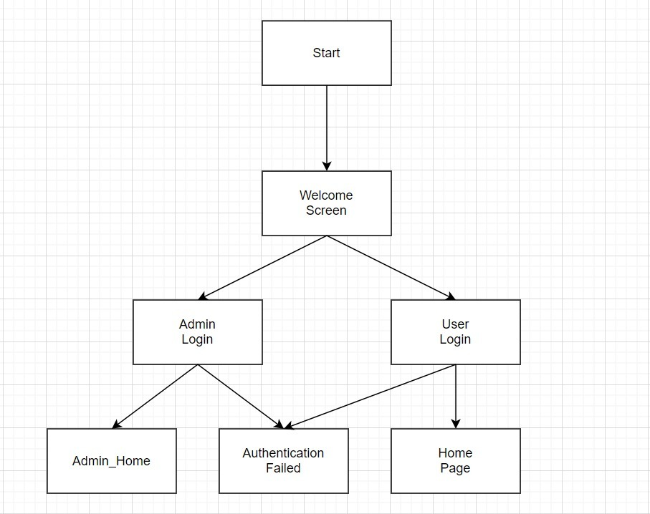

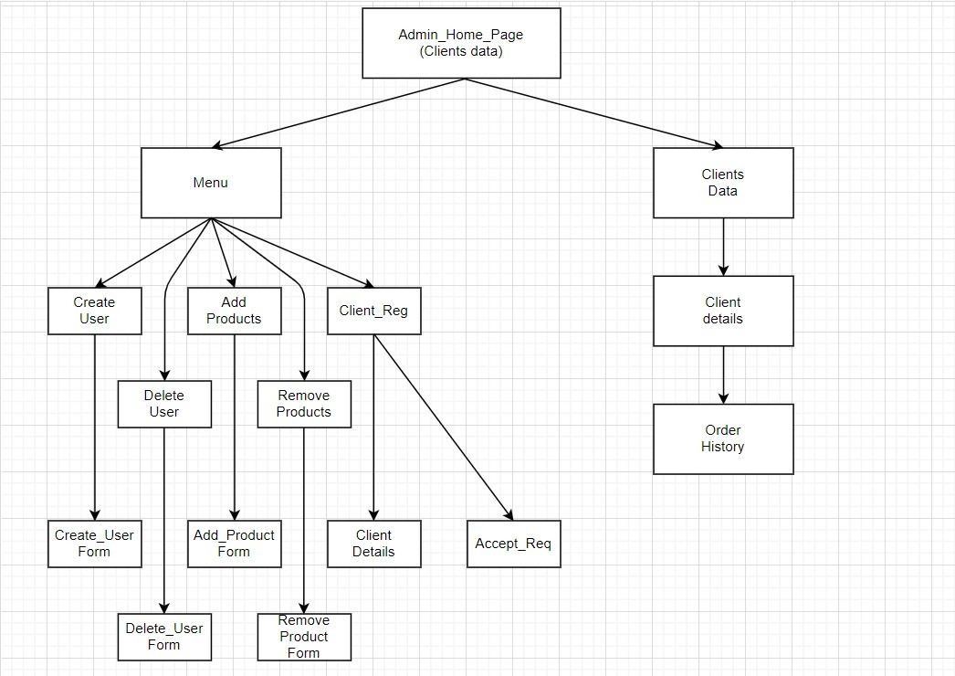

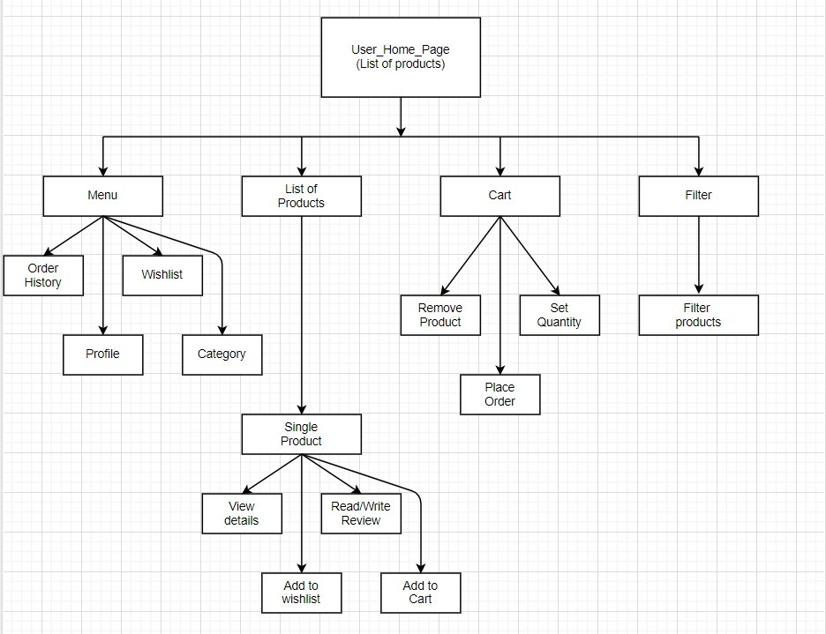

# Document Signature

|  |  |  |  |
| --- | --- | --- | --- |
| Sr. No. | Name | Signature | Date |
| 1 |  |  |  |
| 2 |  |  |  |