

(ISO 9001:2015 Certified), Accredited with ‘A’ Grade by NAAC

: 08258 - 281039 – 281263, Fax: 08258 – 281265

# Department of Computer Science and Engineering

B.E. CSE Program Accredited by NBA, New Delhi from 1-7-2018 to

30-6-2021

Report on Mini Project

Shopper's Stop

**Course Code:**

**19CSE41 Course Name: Web Programming**

Semester: V SEM Section: D

**Submitted To:**

Mr. Shashank Shetty

Assistant Professor

[GDII]

Department of Computer

Science and Engineering

**Submitted By:**

Shreeraj Shetty (4NM19CS182)

Aditya VT (4NM19CS222)

**Date of Submission:**

## 22-12-2021

**Signature of Course Instructor**

# ABSTRACT

Shoppers Stop is a website that compares the prices of different mobiles and accessories across Flipkart and Amazon.

This website solves the need to go to two different websites to find out about the best deal.

We can compare the prices across the two websites and we can get redirected to the two websites based on the user’s choice.

**TABLE OF CONTENTS**

# INTRODUCTION

Shoppers Stop is a price comparison engine. Comparison shopping engines are websites that consumers can use to find multiple retailers offering the product they want to buy.

They can compare the offering from each of these retailers and select the most appealing one. Comparison Shopping Engines (CSE) is also known as price comparison websites.

From a retailers’ perspective, comparison shopping engines are a method of online advertising. They allow retailers to upload their product data feeds, set bids for particular products or product categories.

The products in the data feed then appear on the comparison shopping engine. This is alongside products from other retailers.

When a user clicks on one of your products, they go to your website where they can complete the purchase.

# PROBLEM STATEMENT

Users search for the same products on different eCommerce websites to find the best price. This way of approach to finding data from websites is a time-consuming task.

To ease the process of searching over the websites by giving search keywords requires software. This search engine website ensures the end-user get information by accessing the websites that are specified in the database and even redirects them to the original page where they can make the purchase

# OBJECTIVES

* Helps customers to find lower prices by comparing products from different websites.
* Customers can search for a specific product.
* A simple, central location for comparison.

# HARDWARE / SOFTWARE Requirements

**Hardware Requirements:**

|  |  |
| --- | --- |
| RAM | 2GB or more |
| Processor | Intel Core Processor |
| Hard Disk | 100GB or more |

**Software Requirements:**

|  |  |
| --- | --- |
| Operating System | Windows / Linux / Mac OS |
| Server | XAMPP / Localhost |
| Database | PhpMyAdmin |
| Code Editor | Visual Studio Code |
| Front-end | HTML, CSS, JavaScript |
| Back-end | PHP, MySQL |

# METHODOLOGY

* Initially, create databases and tables in it for storing login details and product details from different websites, as well as their images, prices in different websites, and the URL links to the different websites so that the user can purchase from his/her preferred website.

* **Login/Sign up Page:**
* The user clicks on the Account navigation tab and is redirected to the login/signup page.
* The login page has username and password fields.
* The Signup page has a username, email, and password fields.
* HTML forms are created to implement the authentication form.
* If the user doesn't have an account then he/she can use the Sign-up page which will store the data given by the user in a database and check this database when the user is trying to login.
* The user enters his/her login credentials.
* If the credentials are matching with the data on the database then it will redirect to the product page.
* Otherwise, an “Invalid login” message is displayed.

* **Product page:**
* On this page we have listed the products on which the user can compare prices.
* We have a sliding featured product banner on the top showing the top deals in the market.
* Below the featured product banner we have listed all the products listed on the website at that particular time.
* When we click on one of the products which are listed on the products page we will be redirected to a page which has the images of the product, product title, product price, features and components, an option to compare the price, and two buttons which will redirect to the website which the user intends to purchase from.

* **The footer:**

The footer has information about how to contact the website admins and other relevant information.

# IMPLEMENTATION

* Download and install XAMPP distribution
* <https://www.apachefriends.org/download.html>

* Download and install Visual Studio Code (Code Editor)
* <https://code.visualstudio.com/Download>

* Languages used in the front end:-
* **HTML:** HTML is short for Hypertext Markup Language. HTML is used to create electronic documents (called pages) that are displayed on the World Wide Web. Each page contains a series of connections to other pages called hyperlinks. Every web page you see was written using one version of HTML.
* **CSS:** Cascading Style Sheets, fondly referred to as CSS, is a simple design language intended to simplify the process of making web pages presentable.CSS handles the look and feel part of a web page. Using CSS, you can control the color of the text, the style of fonts, the spacing between paragraphs, how columns are sized and laid out, what background images or colors are used, layout designs, variations in display for different devices, and screen sizes as well as a variety of other effects.
* **JavaScript:** JavaScript is a text-based programming language used both on the client-side and server-side that allows us to make web pages interactive. It is an objectoriented scripting language. It is used to control the behavior of different elements
* Languages used in the back end**:-**
* **PHP:** PHP is a recursive acronym for Hypertext

Preprocessor. PHP is a server-side scripting language that is embedded in HTML. It is used to manage dynamic content, databases, session tracking, even build entire e-commerce sites. It is integrated with several popular databases, including MySQL, PostgreSQL, Oracle, Sybase, Informix, and Microsoft SQL Server.

* **MySQL:** MySQL is a relational database system that runs on a server. The data in a MySQL database is stored in tables which consists of rows and columns. There are 3 ways in which we can connect to MySQL from PHP: using MySQLi object-oriented procedure, using MySQLi procedural procedure, and PDO (PHP Data Objects) procedure. After successful connection, MySQL database can be created in which we can create tables and operations such as insertion, updating, and deletion of data can be performed.

**RESULTS AND DISCUSSIONS**

Home Page:

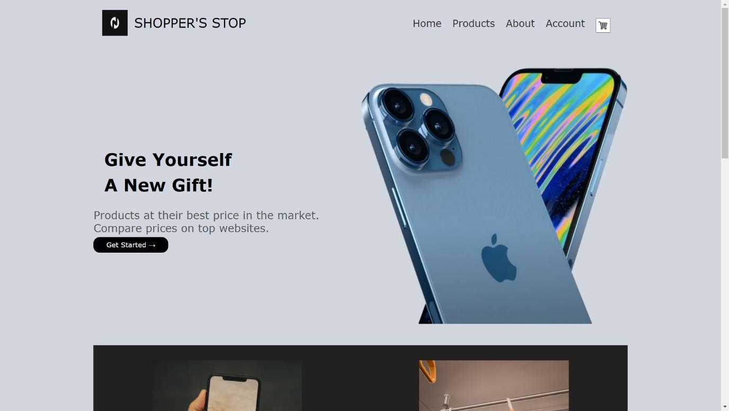

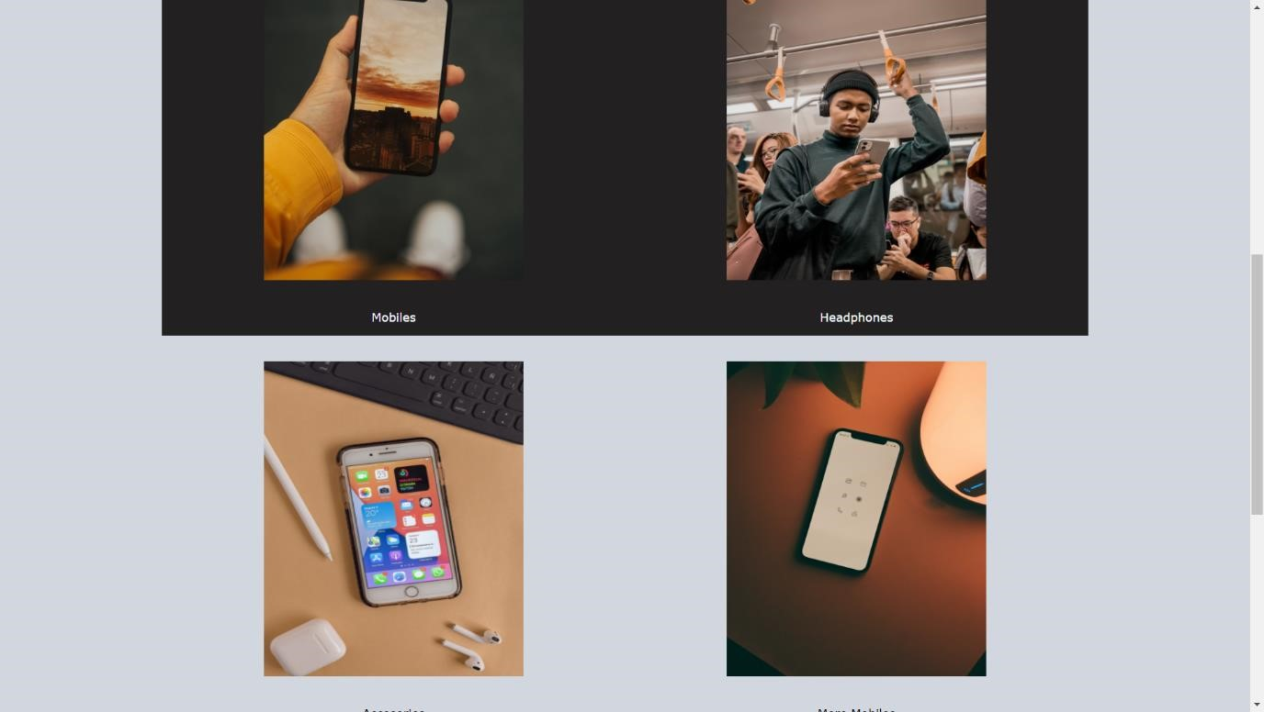

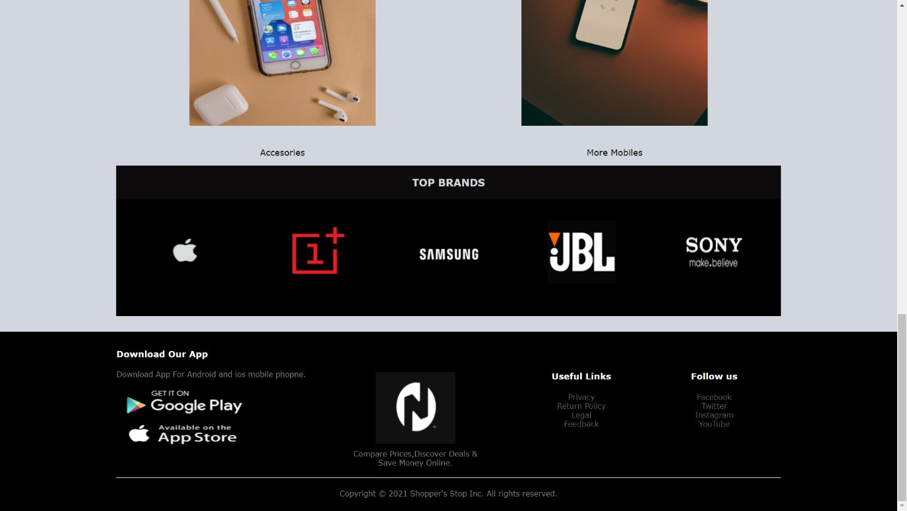

Account Page:

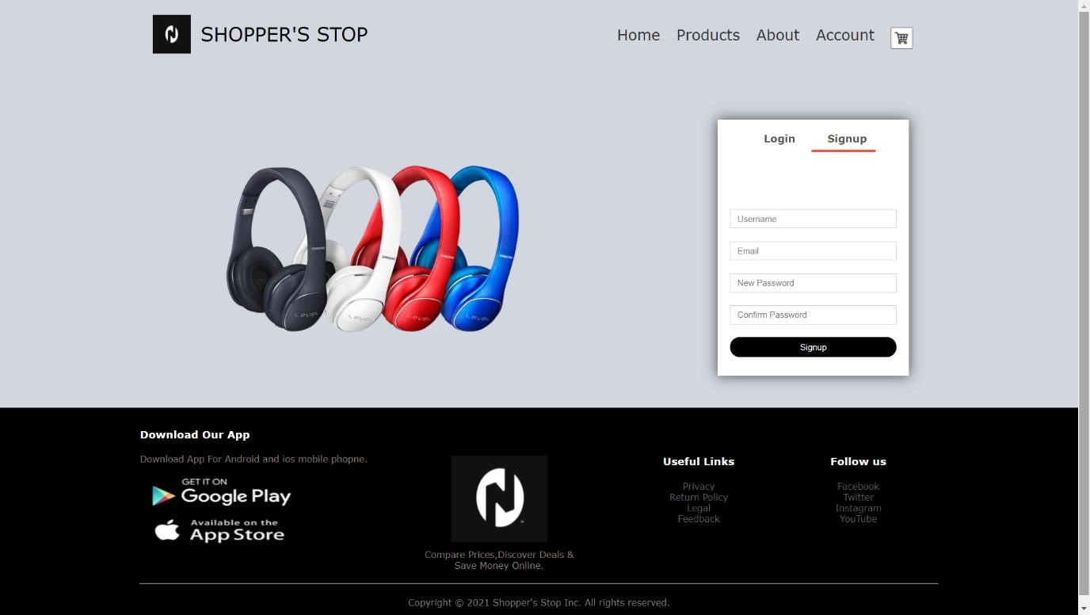

About Page:

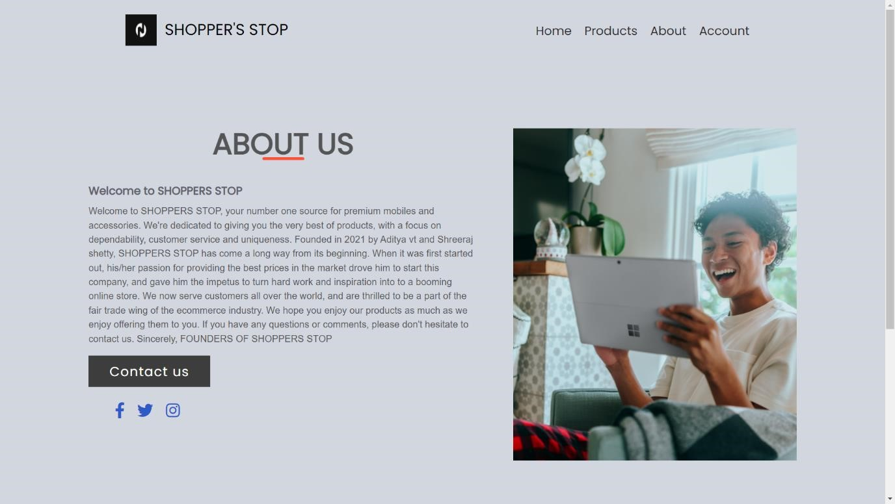

Product Page:

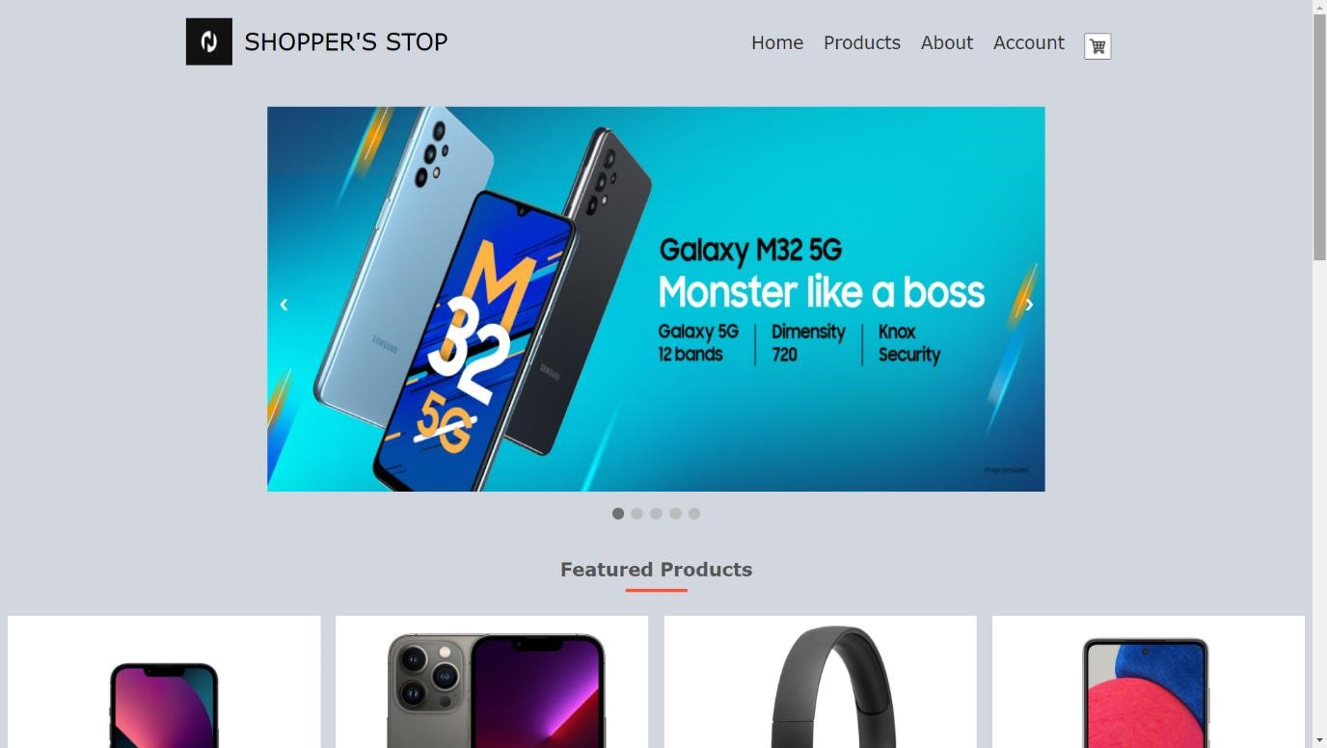

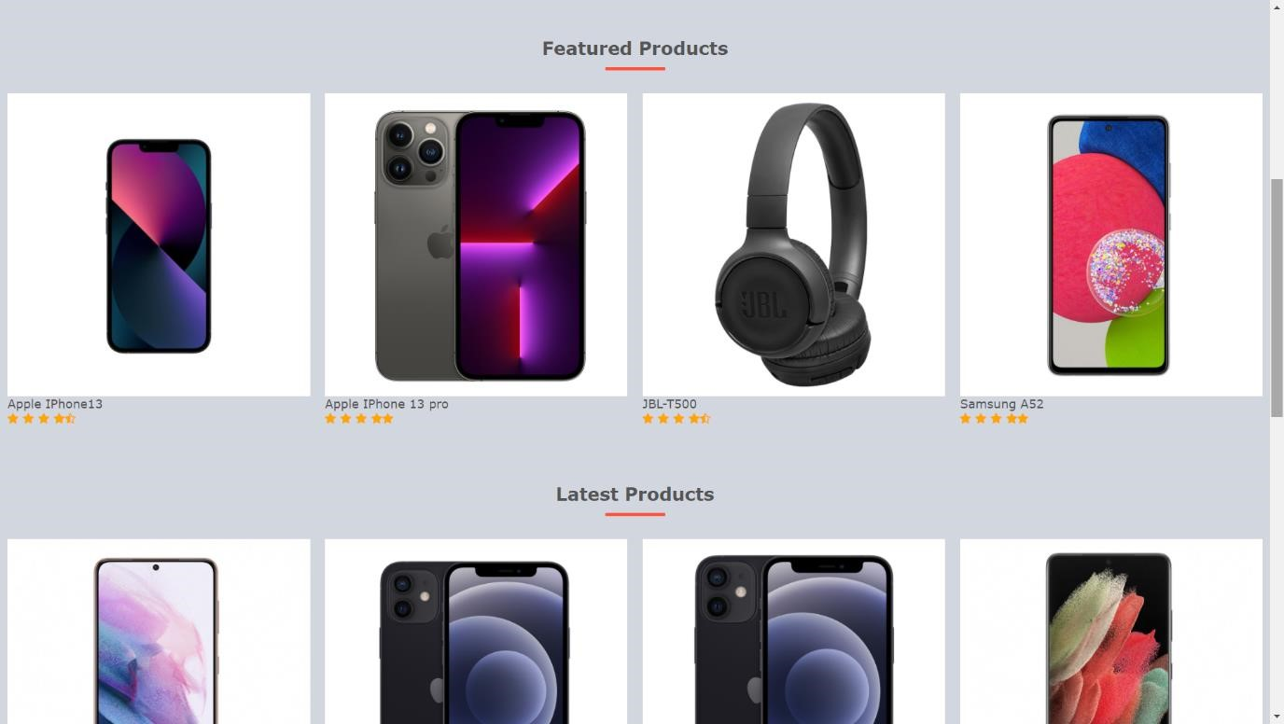

Product-Details Page:

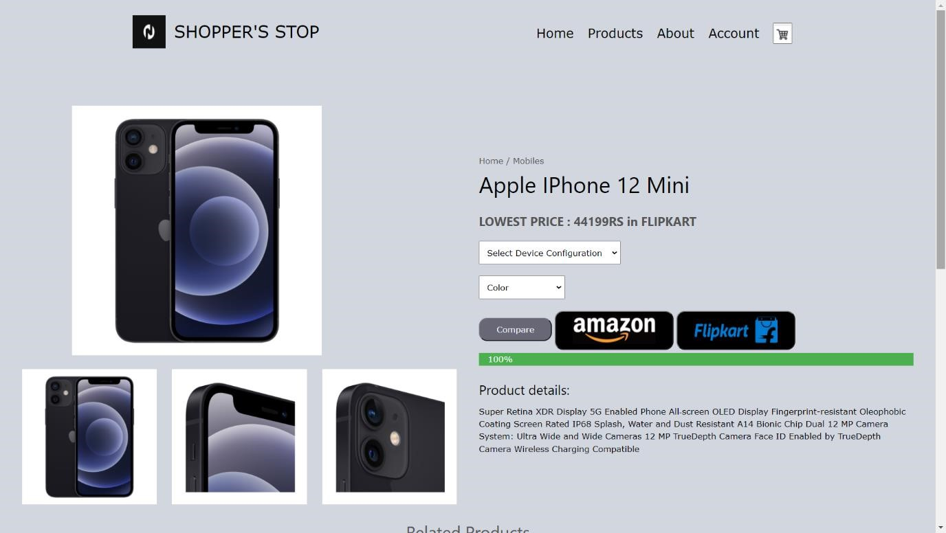

Structure of the Database:

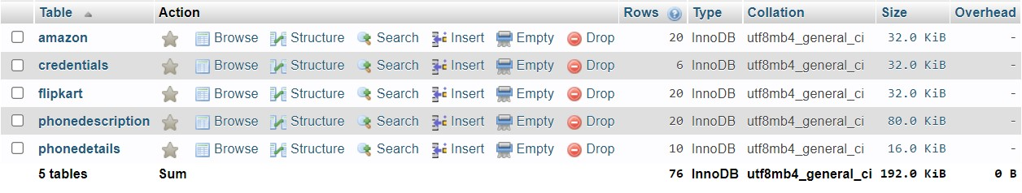

# CONCLUSION AND FUTURE SCOPE

The key to a successful business is the business how to promote the product and services to all readers by using the online. According to the statistical data, more than 80% of people will everyday surf through the technologies such as the internet. So, the internet has become an indispensable part of people’s lives. Thus, it can be considered a wide channel for the business which wants to promote their products and services to all the people.

Websites provide a great platform for companies, businesses, and organizations to showcase their products, projects, research, or facilities provided in a well-designed manner and can be viewed by the entire world.

**What problem has been solved:**

A traditional way to go to different websites and check the prices of the products and compare them has been solved in this website.

Our website compares the prices of the product and gives the best price.

**Loopholes and Scope for Improvement:**

* The website doesn't have all the products.
* We have only concentrated on premium mobiles.
* We want to add a page so that the user can buy products from our website itself instead of getting redirected to the amazon website.
* We want to use Web scraping to get data about the products to make sure that the price change in any other websites will be reflected in our website dynamically.

# REFERENCES

* Front end:
* <https://www.youtube.com/c/CodeWithHarry/videos>
* Bootstrap: <https://getbootstrap.com/>
* PHP: <https://www.tutorialspoint.com/>