**Crossword Crusade**

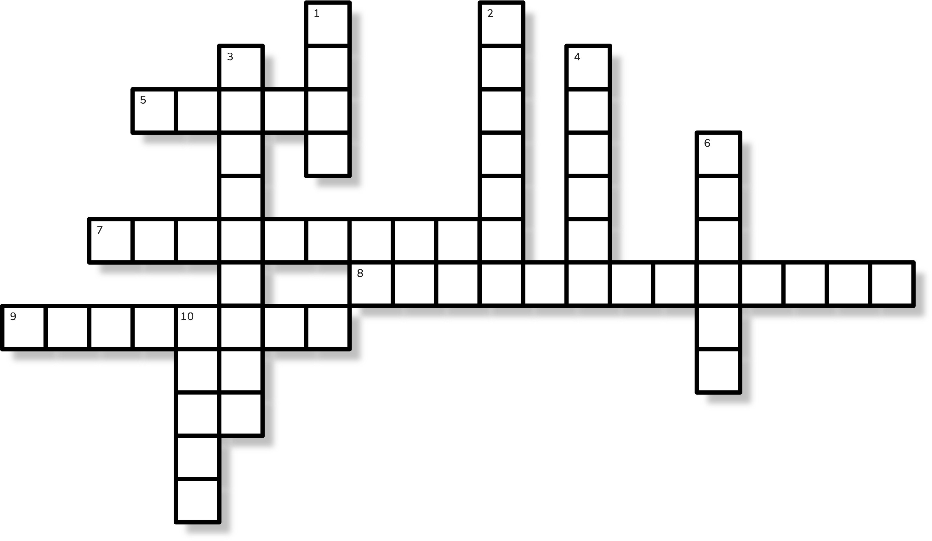 **Across**

5. What has keys, but cannot open locks

1. A tiny bottle of liquid art, often found in shades that match a sunset or the deep sea, but can also make a mess if you're not careful with the brush
2. I in IBM stands for
3. The more you take, the more you leave behind. What am I?

**Down**

* 1. The app that turns your 'out-of-office' into an

'in-your-face' meeting, where everyone’s camera is on, whether they like it or not

* 1. Light as a feather, yet the strongest man cannot hold me for more than 5 mins
  2. IBM’s first product
  3. IBM’s AI platform

6. The device that knows more about you than your best friend, but still can’t seem to find your keys or remember where you left your charger

10. A workspace where messages flow in vibrant hues of purple, green, yellow, and red, but it’s all digit.