Learning Document - Week 5 Learnings + Doables
  - .NET / C# - ASP.NET Core Web API Fundamentals with Design Patterns (unsecured on purpose) - Days 1-5 | Repo: impact-dotnet-shreeram

Day 1 - Project Anatomy & Routing

Learnings
- Task 5.1 - Program.cs is the composition root: everything above builder.Build() registers services, everything after it builds the middleware pipeline, and the ORDER of those app.Use...() calls is the order every request walks through. The template's default pipeline (OpenAPI mapping in Development, UseHttpsRedirection, UseAuthorization, MapControllers) is listed as a comment at the top of Program.cs, recorded after deleting WeatherForecastController and starting the empty app. launchSettings.json only controls how `dotnet run` launches locally (http profile on port 5095, ASPNETCORE_ENVIRONMENT=Development); it isn't deployed with the app.
- Task 5.2 - [ApiController] + [Route("api/[controller]")] on StudentsController : ControllerBase routes api/students to GetAll() and api/students/5 to GetById(int id). The {id:int} constraint matters as soon as a literal segment like /search is added, because it stops "search" from ever being bound as an id.

Day 2 - Reuse Service + Repository Pattern + CRUD Verbs

Learnings
- Task 5.3 - Student, IStudentService and InMemoryRepository<T> moved over from Week 4 almost unchanged. The one behavioural change was a lock around every mutation, because a Singleton repository can now be hit by several HTTP requests at the same time. The repository is registered AddSingleton (one shared list for the app's lifetime) and the service AddScoped (a fresh instance per request). Scoped means something here, unlike Week 4's console app, because every HTTP request is a scope boundary.
- Task 5.4 - All five endpoints (GET all, GET by id, POST, PUT, DELETE) are one line of orchestration each: read input, call one IStudentService method, map the result, pick a status code. StudentsController has no reference to IRepository<T> and contains no business rule. Every verb was exercised against the running app with the StudentApi.http request collection (25 requests, success and failure cases for every verb), which plays the role of a Postman collection.

Day 3 - Status Codes & Validation

Learnings
- Task 5.5 - The Service never returns an HTTP status code. It returns an OperationResult whose OperationOutcome (Success / NotFound / Conflict) the controller maps to a status code. GET {id} returns 200 or 404; POST returns 201 with a Location header from CreatedAtAction (or 409 for a duplicate roll number); PUT and DELETE return 204 or 404.
- Task 5.6 - [Required], [Range(5,100)] and [EmailAddress] on StudentCreateDto produce an automatic 400 ProblemDetails response before the action body runs, and no action checks ModelState. Temporarily removing [ApiController] showed something worse than "bad data gets through". It also switches off [FromBody] inference, so the same request came back as a 201 holding an EMPTY student (every field at its default), with no error at all. Validation_Notes.md records both runs.

Day 4 - DTOs, Documentation & an Applied Pattern

Learnings
- Task 5.7 - StudentCreateDto is what a client may SEND and StudentReadDto is what it gets BACK. StudentMapper does the entity<->DTO copy by hand, outside the controller. Student.InternalNotes is an internal-only field that StudentReadDto doesn't declare at all, so it can't leak into a response however the mapper is written. StudentMapperTests serialises a mapped DTO and asserts the field is absent.
- Task 5.8 - Strategy + Factory applied to a real concern: GET api/students/{id}/grade?scale=percentage|gpa. IGradeStrategy has PercentageGradeStrategy and GpaGradeStrategy implementations, and GradeStrategyFactory picks one per request, case-insensitively, falling back to Percentage for anything it doesn't recognise. The controller only calls factory.Create(scale).Describe(score), so adding a LetterGradeStrategy would mean one more factory case and no controller change. The factory is Singleton because it's stateless. Swagger (UseSwagger/UseSwaggerUI) drives every endpoint. ILogger<StudentsController> logs an Information entry on every create and a Warning on every 404.

Day 5 - Hardening, Search + Tests

Learnings
- Task 5.9 - GET api/students/search?name=... filters case-insensitively with LINQ (Contains with StringComparison.OrdinalIgnoreCase) inside StudentService, not the controller. An empty or missing name is treated as a valid "match everything" search, so it returns 200 with the full list instead of a 400. The route appears in Swagger with its name query parameter.
- Task 5.10 (stretch) - TeachersController mirrors the Student slice with full CRUD, TeacherCreateDto/TeacherReadDto and the same 200/201/204/400/404 status codes, which shows the layering holds for a second entity. Neither controller contains a business rule.

Status-Code Map (Evidence)
Verb | Route | Success | Failure
GET | /api/students | 200 (list, possibly empty) | -
GET | /api/students/{id} | 200 | 404 if missing
GET | /api/students/search?name= | 200 (matches or []) | - (empty query returns everyone)
GET | /api/students/{id}/grade?scale= | 200 { studentId, scale, grade } | 404 if missing
POST | /api/students | 201 + Location header | 400 (DataAnnotations) / 409 duplicate roll number
PUT | /api/students/{id} | 204 | 400 / 404 / 409
DELETE | /api/students/{id} | 204 | 404 if missing
GET/POST/PUT/DELETE | /api/teachers... | 200 / 201 / 204 | 400 / 404

Swagger UI: http://localhost:5095/swagger/index.html (start the API with `dotnet run --project Week_5/StudentApi`). Request collection: Week_5/StudentApi/StudentApi.http.
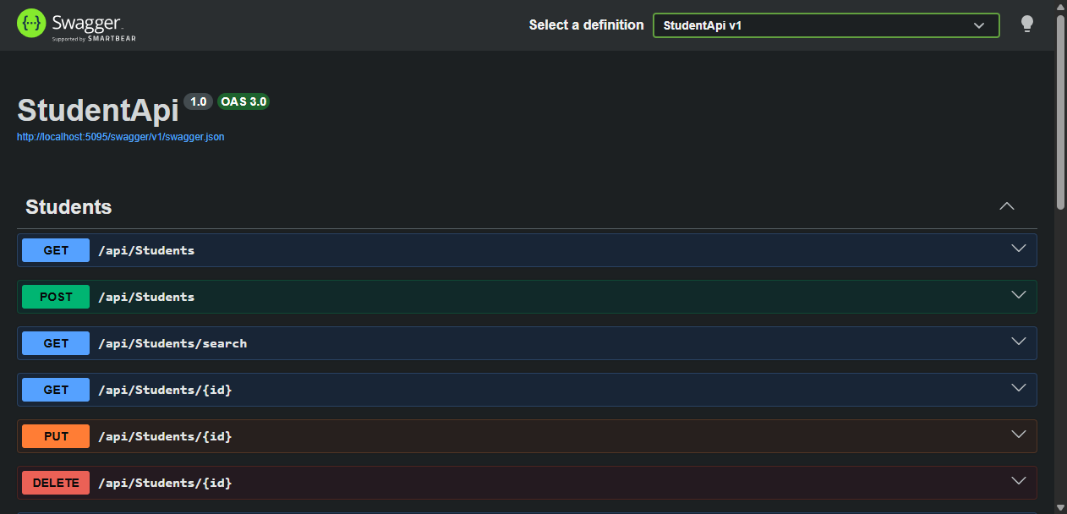
Swagger UI of the Week 5 Student API (http://localhost:5095/swagger) - every endpoint documented and executable.

Reflection - Why keep the controller thin?
A controller is the only class in the API that knows it's being called over HTTP, so its job is translation: JSON into a DTO, a DTO into a Service call, an OperationOutcome into a status code. The rules that decide whether a request is valid (a roll number that is unique across all students, a score that can be graded on a chosen scale) have nothing to do with HTTP. If they lived in the controller, they could only be tested by spinning up the whole web pipeline.
This week showed why that matters. StudentService's 409 rule is covered by plain, fast Moq tests that never start a web server, while the controller tests only check that each outcome turns into the right status code. Week 7 will replace InMemoryRepository with three different databases, and none of that should touch a controller - the same seam that let Week 4's console View be swapped for HTTP endpoints this week.

Testing - Coverage Summary
- One xUnit test project, StudentApi.Tests, with 63 tests, all passing.
- Services/StudentServiceTests.cs and Services/TeacherServiceTests.cs test the Service with IRepository<T> mocked through Moq. Cases: valid create, duplicate roll number -> Conflict without calling Add(), update/delete of a missing id -> NotFound, and a search hit, a miss, and an empty query.
- Services/Grading/GradeStrategyTests.cs and GradeStrategyFactoryTests.cs check each strategy's output and the factory's selection logic ("gpa", "GPA", " Gpa " -> GPA; "percentage", "unknown-scale", null, "" -> Percentage).
- Dtos/StudentMapperTests.cs proves InternalNotes never appears in serialised output. Data/InMemoryRepositoryTests.cs tests the real repository, including concurrent adds to check the lock.
- Controllers/*Tests.cs run the real pipeline through WebApplicationFactory<Program>, with an in-memory fake IStudentService/ITeacherService, and assert 200/201/204/400/404/409 per outcome. That includes the automatic [ApiController] 400, which only a real-pipeline test can exercise.
- Coverage (coverlet.collector, XPlat Code Coverage): 96.5% overall line coverage (274/284 lines). StudentService 94.9%, TeacherService 92.6%, GradeStrategyFactory 100%, both strategies 100%, StudentMapper 100%, InMemoryRepository 100%, StudentsController 98.0%, TeachersController 86.7%. That is above the 80% target.

Submission
- Git: Week_5/ (StudentApi + StudentApi.Tests) on branch feature/week5; Swagger URL and status-code map in Week_5/StudentApi/README.md; test project in the same PR.
- Assignments: the unsecured Student API (full CRUD + search + grade endpoint) with the applied Strategy/Factory pattern and its 63 tests.

