Learning Document - Week 10 Capstone: Learnings + Doables
  - Microservices Capstone - Portal Assembly & Demo (Identity / Academics / Reporting / YARP Gateway / React, docker-compose) - Days 1-5 | Repo: impact-dotnet-shreeram

Day 1 - Split into Services

Learnings
- Task 10.1 - The Week 9 monolith became three services (Identity, Academics, Reporting) and a gateway, each its own project with its own database: StudentPortal_Identity, StudentPortal_Academics and StudentPortal_Reporting. No service reads another's database. Taking that rule seriously had an immediate cost: Academics' Student lost its UserId foreign key, because a database can't reference a table in another service's database. The only thing the services share is a small library (StudentPortal.Shared) holding the JWT validation rules, claim names and the ProblemDetails handler. There are no shared domain types, so each service stays independently deployable. All three build and run on their own (ports 5101-5103) and each answers its own /health.

Day 2 - Identity (ADO.NET) + Academics (EF Code First)

Learnings
- Task 10.2 - Week 6's minimal auth became the Identity service: PBKDF2 hashing, JWT issuing, registration with Teacher self-registration off by default, and ADO.NET calling only two stored procedures (usp_GetUserByUsername, usp_InsertUser) with typed parameters, so the service contains no SQL text. Its scripts are idempotent (create-if-missing, never drop), because docker-compose re-runs them on every start. Identity is the only service that signs tokens. The gateway, Academics and Reporting verify them with identical rules from the shared library, and a test validates Identity's token with exactly those shared parameters.
- Task 10.3 - Academics carries the Week 5-9 Student/Teacher slice forward and adds Course plus a many-to-many Enrollment (composite key, cascade delete from student or course, SetNull when a teacher is deleted), all with the Fluent API. One migration (InitialAcademics) creates the schema and HasData seed. Writes are Teacher-only, and every controller also carries [Authorize], so even reads need a valid token if someone bypasses the gateway. A new Invalid outcome (400) separates "the course in the URL doesn't exist" (404) from "the teacherId in the body doesn't exist" (400). The tests also found a real edge case: updating a detached entity whose Id was already tracked threw, so the repository now copies the values onto the tracked instance.

Day 3 - Reporting (EF DB First) + Gateway (YARP)

Learnings
- Task 10.4 - The reporting database is the "pre-existing" warehouse (Terms, Departments, CourseCatalog, EnrollmentFacts), created in SSMS from the data team's script. `dotnet ef dbcontext scaffold` generated the context and entities, with keys, unique indexes, relationships and EF's own navigation names such as CourseCodeNavigation, which I kept so a re-scaffold doesn't fight hand edits. ReportService turns LINQ GroupBy projections into one SQL GROUP BY per report and returns only aggregates (enrolled, completed, average, pass rate). A test found that .NET rounds 79.25 to 79.2 (banker's rounding), so reports now round half away from zero (79.3), as people and SQL Server's ROUND expect.
- Task 10.5 - The YARP gateway routes /identity/* (anonymous), /academics/* and /reporting/* (JWT required), stripping the prefix. It validates the JWT centrally, so a missing, expired or tampered token gets 401 at the edge and never reaches a service. It removes any client-sent X-User-Name/Role/Id headers and writes the validated claims instead, so nobody becomes a Teacher by adding a header. CORS moved to the gateway, and React talks only to the gateway.

Day 4 - Orchestration & Tests (keep the 80% green)

Learnings
- Task 10.6 - docker-compose.yml brings up sqlserver (with a healthcheck), a one-shot db-init (sqlcmd runs the Identity and Reporting scripts), identity, academics (migrates itself on start), reporting, gateway (the only published API port, 8080) and web (an nginx-served Vite build on 3000), with fixed service URLs. One parameterised multi-stage Dockerfile builds all four .NET services and runs them as the non-root app user. .gitattributes keeps db-init.sh on LF line endings so bash in the container doesn't fail on a Windows checkout. `docker compose config` validates. The Docker daemon wasn't available on my machine, so I published every service in Release and ran it in Production mode with exactly the environment variables compose supplies: all four started, Academics migrated a fresh database, and a missing Jwt__Key failed fast.
- Task 10.7 - Every service keeps its own suite above 80%: Identity 46 tests (100%), Academics 66 (96.2%), Reporting 17 (100%), Gateway 15 (92.8%), plus 115 Jest tests (100% lines). The Selenium suite (7 tests, now including a reporting journey) runs green against the composed stack through the gateway. run-all-tests.ps1 runs the whole thing with one command.

Day 5 - Demo Day

Learnings
- Task 10.8 - The demo journey runs end to end: bring the stack up -> register -> login -> Teacher CRUD -> Student read-only -> Reports page (enrollment summary, switch term) -> logout. Every step is covered by the E2E suite against the composed system.
- Task 10.9 - ARCHITECTURE.md explains each service's database choice in my own words, and states plainly that a real product would usually standardise on one strategy. It also lists what I'd change for production: RS256 instead of a shared HS256 key, a separate SQL login per service, and events or an ETL feeding Reporting instead of a seed script.
- Task 10.10 (stretch) - With Reporting stopped, the gateway answers 502 for /reporting/* only. Academics and Identity keep returning 200, and the React Reports page says "Reporting is temporarily unavailable. Students and courses still work". run-all-tests.ps1 stops Reporting mid-run and asserts this, and a gateway unit test covers the same behaviour.

Architecture Note - Why each service uses its data-access approach
Service | Approach | Why it fits
Identity - register, login, PBKDF2, JWT | ADO.NET + stored procedures | Most security-critical, smallest and most stable schema. Explicit, auditable SQL via two stored procedures; no ORM on the login path; EXECUTE-only permissions possible. Hand-mapping five columns costs almost nothing.
Academics - Students, Teachers, Courses, Enrollments | EF Core Code First | The domain we own and keep changing (EnrolledOn in Week 7, Courses/Enrollments now). The model is the schema; changes are reviewable, reversible migrations; relationships declared once; the same model runs on SQLite for fast tests.
Reporting - read-mostly summaries | EF Core Database First | Another team owns the schema, so no migrations from us. Scaffold reads it, re-scaffold on change; our DTOs isolate their changes. Integration, not greenfield.

A real product would usually standardise on ONE data-access strategy (typically EF Core, with raw ADO.NET or Dapper only for a measured hot path) so every engineer reads, reviews and debugs the same way. This portal mixes three deliberately as a training exercise.

Evidence

Architecture diagram
- React SPA -> YARP gateway (validates JWT, forwards X-User-* claims, CORS) -> Identity (ADO.NET) / Academics (EF Code First) / Reporting (EF DB First) -> StudentPortal_Identity / StudentPortal_Academics / StudentPortal_Reporting. Full diagram: Week_10/ARCHITECTURE.md.

Composed portal running (through the gateway)
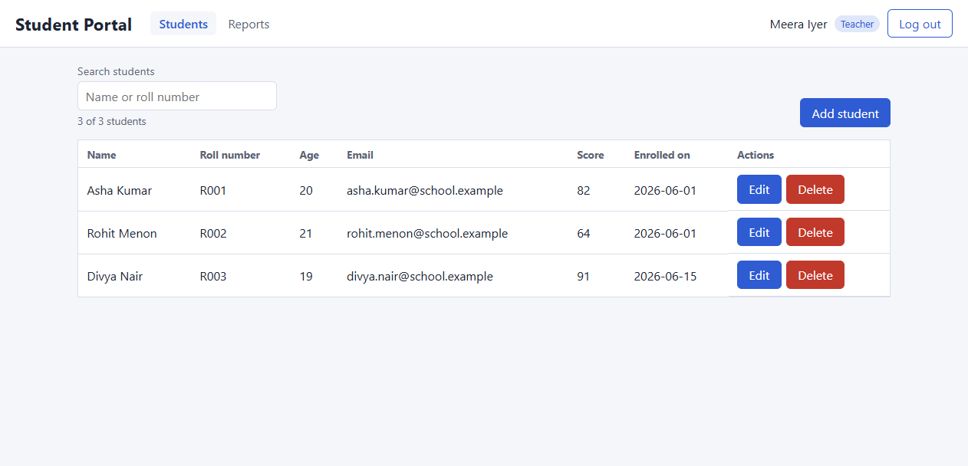
Students page (Academics service, EF Code First) as a Teacher - React calling only the YARP gateway.
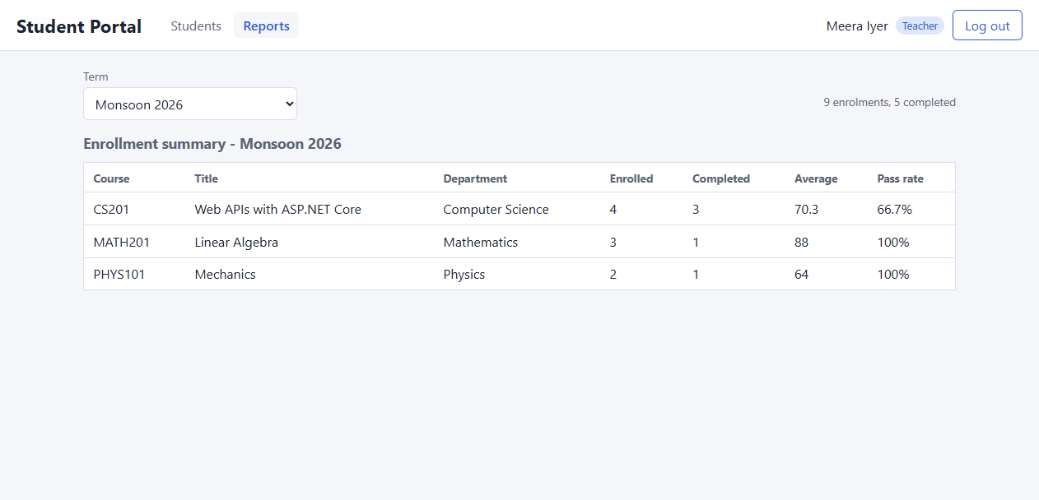
Reports page (Reporting service, EF DB First) - enrollment summary for Monsoon 2026.
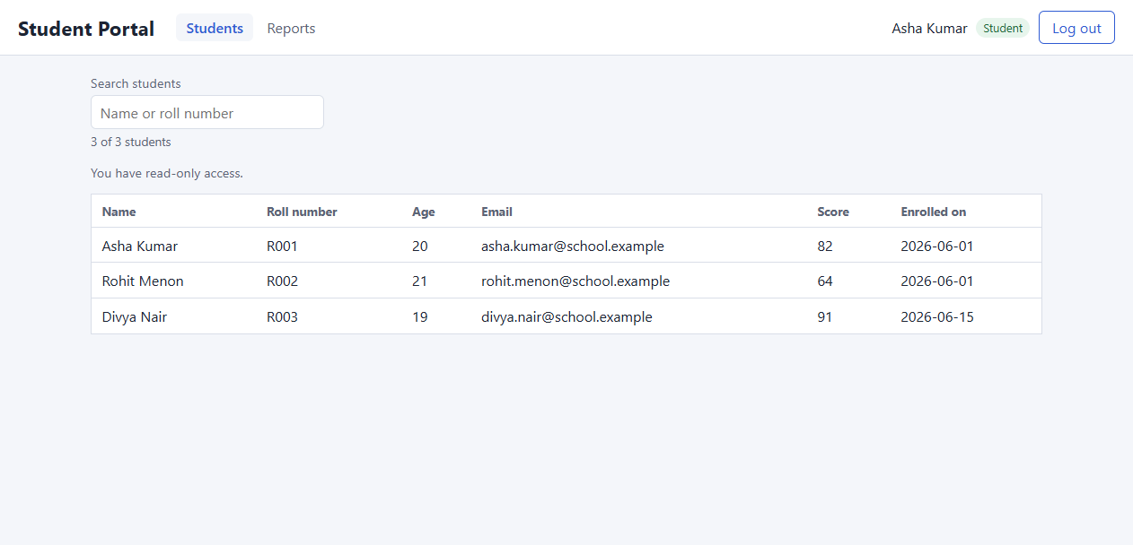
The same portal as a Student - read-only, with the Reports page available.

docker-compose up
- Services: sqlserver, db-init, identity, academics, reporting, gateway, web (`docker compose config --services`). [Insert `docker compose up` screenshot here]

Coverage per service
Suite | Tests | Line coverage
Identity.Tests (ADO.NET) | 46 | 100%
Academics.Tests (EF Code First) | 66 | 96.2%
Reporting.Tests (EF DB First) | 17 | 100%
Gateway.Tests (YARP) | 15 | 92.8%
Jest + RTL (React) | 115 | 100% lines / 95.4% branches
Selenium E2E (through the gateway) | 7 | not counted toward 80%

Reflection - Learnings across the whole program
- Weeks 1-4 (C# foundations, OOP, patterns, layered console app): the habits that made everything later possible. Encapsulation, interfaces over concrete classes, the Repository and Strategy patterns, and Week 4's rule that every layer has one job. The Week 3 IRepository<T> survived, nearly unchanged, to Week 10.
- Week 5 (Web API): the console View became HTTP controllers without the Service layer changing. Status codes are part of the contract, DTOs keep internal fields from leaking, and [ApiController] does more than it looks (it also infers [FromBody]).
- Week 6 (crypto + auth): encoding, hashing and encryption are different tools. A cipher alone gives no integrity (CBC vs GCM). Passwords get a slow, salted hash, never encryption. Authentication and authorization are different questions, and both are answered on the server.
- Week 7 (data access): the repository interface let me swap four storage implementations with zero controller changes. ADO.NET, Code First and DB First each have a natural home, and Week 10 put each one there.
- Week 8 (React): components render from props and state, the JWT goes in memory and travels via an interceptor, and hiding a button is UX, not security.
- Week 9 (testing): unit tests find which piece broke, E2E proves the journey works. Both real E2E failures (a browser password bubble swallowing a click, and Clear() bypassing React) were invisible to unit tests.
- Week 10 (microservices): splitting is mostly about boundaries. One database per service, one issuer of identity, one front door. Each boundary removes a shortcut (no cross-service joins, no foreign key into another service's database) and buys independence and failure isolation in return.

Testing - Coverage Summary
- Per-service xUnit suites, each above the 80% mandate: Identity 46 tests / 100% (including the ADO.NET store against a throwaway SQL Server database built from its own scripts, run twice to prove idempotency); Academics 66 / 96.2% (CourseService with every repository mocked, EF repositories and cascades on SQLite, full HTTP role matrix on SQLite); Reporting 17 / 100% (report maths on the scaffolded model plus a real SQL Server run proving the GROUP BY translation); Gateway 15 / 92.8% (a real stub service behind the real gateway).
- Gateway-level security test: TamperedJwt_IsRejectedAtTheGateway_AndNeverReachesAService gets 401 and the stub records zero requests. Also covered: a forged Teacher payload, wrong issuer, wrong key, expired token, spoofed X-User-Role replaced by the real claim, CORS at the edge, and one service down -> 502 for that route only.
- Frontend: 115 Jest + RTL tests, 100% statements/lines/functions, 95.4% branches (threshold 80%). E2E: 7 Selenium tests green against the composed system. run-all-tests.ps1 finished with ALL SUITES GREEN.

Submission
- Git: Week_10/ - Shared, Identity (Api + Tests), Academics (Api + Tests), Reporting (Api + Tests), Gateway (Api + Tests), web/student-portal-web, e2e/StudentPortal.E2E, docker-compose.yml, docker/, ARCHITECTURE.md, README.md, run-all-tests.ps1, setup-local-databases.ps1, ImpactDotnetShreeram.slnx.
- Assignments: the complete microservices portal (Identity/ADO.NET, Academics/EF Code First, Reporting/EF DB First, YARP gateway, React) with every suite green, every service above 80% coverage, and a live demo journey.

