Learning Document - Week 8 Learnings + Doables
  - React Fundamentals & Full-Stack Integration (Part 1) - Vite, Components, Router, axios + JWT, Role-Based UI, CORS - Days 1-5 | Repo: impact-dotnet-shreeram

Day 1 - Setup & Components

Learnings
- Task 8.1 - Week_8/student-portal-web is a Vite + React app (React 19, Vite 8). `npm run dev` serves it on http://localhost:5173 with the "Student Portal" heading. Vite's dev server only transforms the files the browser asks for, which is why it starts almost instantly. `npm run build` produces a production bundle in dist/, which is ignored by git along with node_modules/ and coverage/ (added to the repo .gitignore).
- Task 8.2 - StudentRow renders one student purely from its `student` prop. StudentList maps the array to rows keyed by the database id, not the array index, so React can keep track of rows when the list is filtered or reordered. Neither component fetches or stores anything: given the same props, they always render the same output, which makes them trivial to test.

Day 2 - State, Effects, Lists

Learnings
- Task 8.3 - The search query lives in useState in StudentsPage. SearchBox is a controlled input that just reports keystrokes, and the filtered list is derived with useMemo (name or roll number, case-insensitive) rather than stored, so the rows and the "1 of 3 students" counter can't disagree.
- Task 8.4 - useEffect with an empty dependency array fetches api/students once on mount. The page shows "Loading students...", then the rows, "No students found", or an error message. An `active` flag in the effect's cleanup ignores a response that arrives after unmount. React StrictMode runs effects twice in development, which would otherwise make that stale response a real bug.

Day 3 - Forms & Routing

Learnings
- Task 8.5 - RegisterPage (Name, Date of birth, Designation, Email, Password) uses controlled inputs. Inline errors appear once a field has been visited, and Register stays disabled until validateRegistration finds nothing wrong. The API re-checks everything with DataAnnotations: client-side validation is for the user's convenience, server-side validation is for safety. A new POST api/auth/register endpoint makes the email the username and the Designation the role. Users gained DisplayName/DateOfBirth through an EF migration (AddUserProfile) and an ALTER script followed by a DB-First re-scaffold.
- Security decision: if anyone could self-register as a Teacher, every server-side role check would be pointless. Teacher self-registration is therefore behind Registration:AllowTeacherSelfRegistration, off by default (403) and on only in appsettings.Development.json for local demos.
- Task 8.6 - LoginPage posts to api/auth/login. React Router defines /login, /register and /students, and ProtectedRoute redirects to /login when there's no session, remembering where the user was going. Visiting /students without a token lands on /login (unit test and E2E test).

Day 4 - JWT Handling & Role UI

Learnings
- Task 8.7 - The JWT is kept in memory only (AuthContext state plus a module variable for axios), never in localStorage, where an injected script could read it. The trade-off is that a refresh logs you out. One shared axios instance has a request interceptor that adds `Authorization: Bearer <token>` to every call, so no component has to remember to. A unit test checks the header on GET and DELETE, and that there's no header when logged out.
- Task 8.8 - The role is read from the token's own `role` claim (jwt.js Base64url-decodes the payload; it's readable but can't be altered without breaking the signature). Teachers get Add/Edit/Delete; Students get a read-only table with no write buttons. That is purely a convenience: every write endpoint is now [Authorize(Roles = "Teacher")] (POST/PUT/DELETE for students and teachers), so the server returns 403 to a Student who calls them directly.

Day 5 - CORS, End-to-End Smoke + Tests

Learnings
- Task 8.9 - The SPA (http://localhost:5173) and the API (http://localhost:5095) are different origins, so the browser only hands the SPA an API response if the API allows that origin. Before: with no allowed origins, the preflight came back 204 with no Access-Control-Allow-Origin header, so the browser blocked the call. After: AddCors with a "SpaClient" policy tightened to Cors:AllowedOrigins (only http://localhost:5173), the four verbs, and the Authorization/Content-Type headers. UseCors sits before UseAuthentication, because a preflight never carries the token.
- Task 8.10 - A full round-trip against the real API: register (201) -> login (token) -> list students (3 rows) -> a Student POST is refused (403). The same journey later ran in a real Chrome browser via the Week 9 Selenium suite against this Week 8 stack, and all 6 E2E tests passed.

Evidence

Teacher vs Student UI
Role | Toolbar | Each row | Hint
Teacher (teacher1) | Search + "Add student" | Edit / Delete buttons | -
Student (student1) | Search only | no Actions column | "You have read-only access."

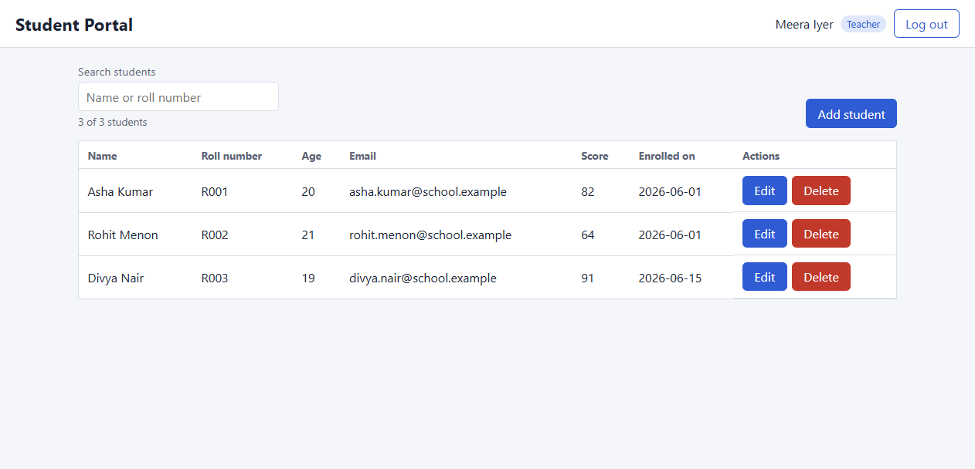
Teacher (teacher1): "Add student" plus Edit / Delete on every row.
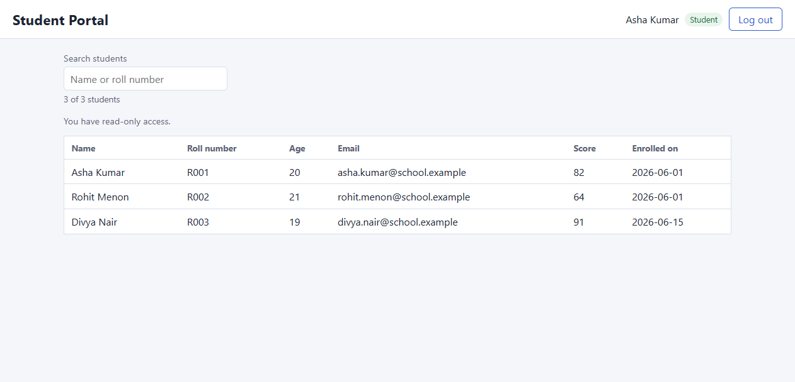
Student (student1): the same list, read-only - no write controls rendered.

Authorization header on every request
- api.test.js: "attaches the Bearer token to every request once logged in" asserts Authorization = "Bearer abc.def.ghi" on GET /api/students and DELETE /api/students/1, and "sends no Authorization header when logged out". [Insert browser DevTools Network tab screenshot here]

CORS before / after
Configuration | Preflight from http://localhost:5173
Cors:AllowedOrigins empty | 204, no Access-Control-Allow-Origin (browser blocks)
Cors:AllowedOrigins = http://localhost:5173 | 204, Access-Control-Allow-Origin: http://localhost:5173

Reflection - Why is the UI not the security boundary?
Hiding the Add, Edit and Delete buttons from a Student makes the page cleaner, but it doesn't stop anything. The buttons only send HTTP requests, and anyone can send the same requests with curl, the browser console or a script, using their own perfectly valid Student token. That's why this week moved [Authorize(Roles = "Teacher")] onto every write endpoint and added tests that call each one with a Student token and expect 403. The React role check decides what to show; the server decides what is allowed.
The same reasoning shaped the other choices. Form validation in React gives instant feedback, but the API keeps its DataAnnotations. The role is read from the JWT for display, but the server verifies the signature on every request. CORS is not authentication either: it only tells a browser which origins may read responses, so it's tightened to one origin while the real protection stays in JwtBearer and the role policy.

Testing - Coverage Summary
- Frontend: Jest + React Testing Library, 87 tests in 7 suites, all passing. Coverage: 100% statements, 96.3% branches, 100% functions, 100% lines. The 80% coverageThreshold (lines/branches/functions/statements) in jest.config.cjs fails the build below it.
- Testing Focus items: StudentList renders rows from props and shows the empty state; the search box filters live with a counter; role logic hides write controls for a Student and shows them for a Teacher; the axios interceptor attaches the token (axios adapter replaced by an echo stub); controlled forms keep Submit disabled until valid (login and registration), plus routing, ProtectedRoute, JWT decoding and every validation rule.
- Backend: StudentApi.Tests has 180 tests, all passing, with 98.8% line coverage. New this week: registration rules with a mocked store and pinned clock; registration end to end (201 then login, duplicate 409, weak password/bad designation/bad email 400, future DOB 400, Teacher 201 in Development and 403 when disabled); 401 and 403 on all five write endpoints; CORS preflight tests; the new profile columns in all three data layers. smoke-tests.ps1 passes on AdoNet, EfCodeFirst and EfDbFirst.

Submission
- Git: Week_8/ - student-portal-web (app + Jest/RTL tests), StudentApi (register, CORS, Teacher-only writes), StudentApi.Tests, Database/05_AddUserProfile.sql, smoke-tests.ps1.
- Assignments: the React client (register, login, JWT interceptor, role-based list with Teacher CRUD) and its test suite above the 80% threshold.

