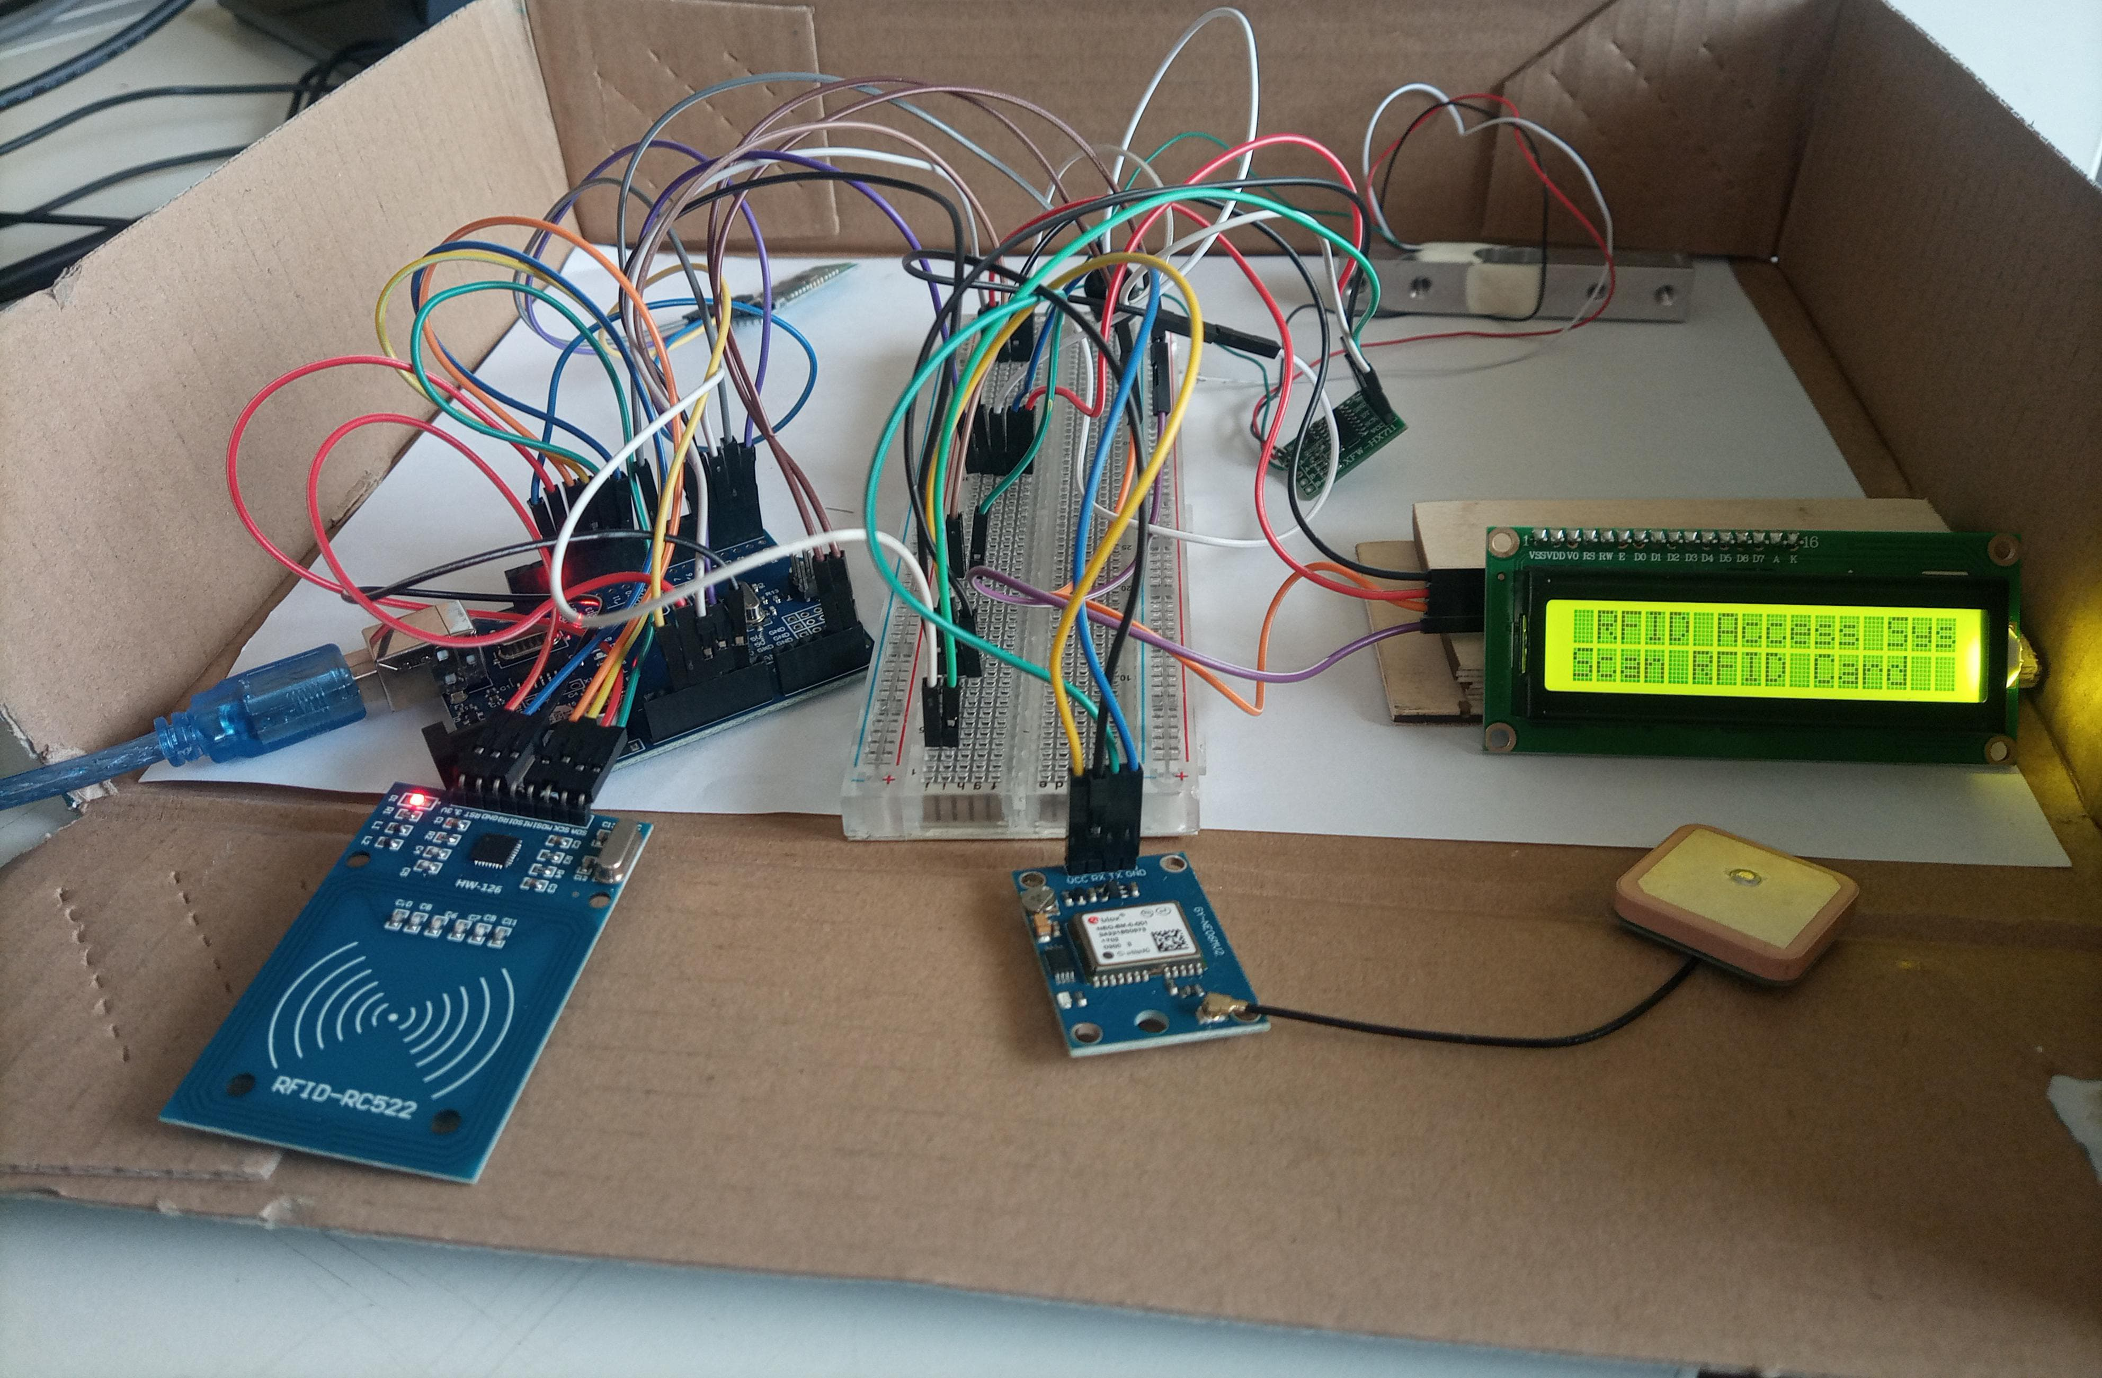The **E-Luggage** is an IoT-based solution designed to enhance the safety and tracking of personal luggage. It uses an Arduino Uno to integrate an RFID module for secure user authentication, a load cell to detect tampering through weight changes, and a GPS module to provide real-time location tracking. Data is shared with the user via the HC-05 Bluetooth module, allowing alerts and location updates to be viewed on a smartphone. A buzzer provides audio alerts for unauthorized access, while an LCD display shows system status. This system offers a cost-effective way to prevent theft, monitor luggage integrity, and track its location while traveling.