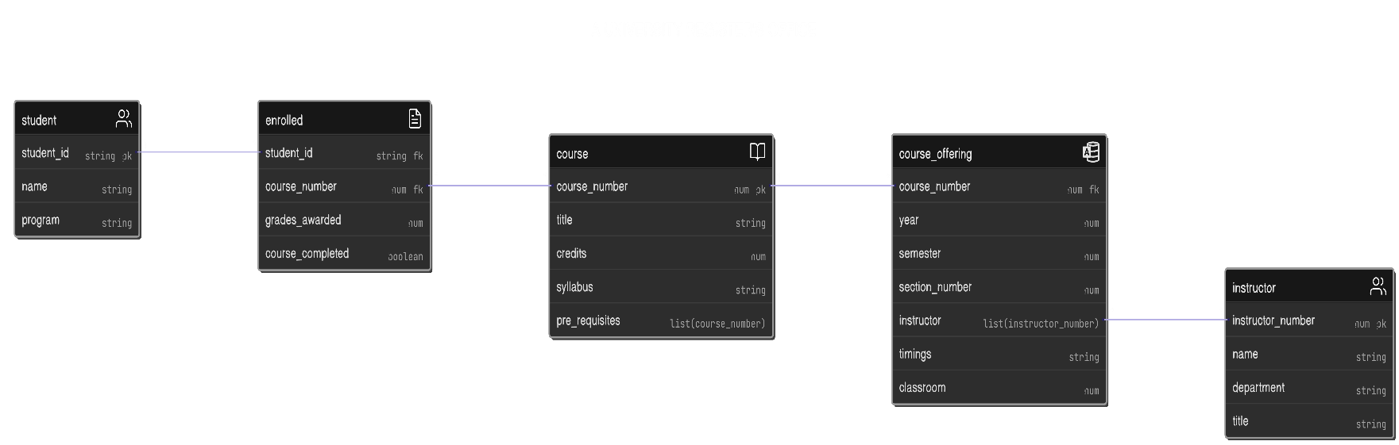

* Student table has student details with PK student_id.
* Instructor table has instructor details with PK instructor_number. Similarly course table has course_number as PK.
* A course can have multiple pre-requisites, so it’s a list if course_number that tell what courses need to be completed before enrolling for this course.
* If there are no pre-requisites or pre-requisite courses are completed then you can enroll to the course.
* The enrolled table has student_id and courses_number indicating the which student has taken which course. One enrolment has one-to-one relation with course but student has one-to-many relation as a student can be enrolled to multiple courses making it one-to-many.
* A course can have multiple course_offerings so its one-to-many. Course can offer a instructor or multiple instructors and same instructor can teach multiple courses so it many-to-many.
* Enrolment and grades of the student are taken care by the enroll table, if a enrolled course is completed then the course_completed will be marked “true” else “false”. Grades are also stored in the grades_awarded attribute of the enroll table.