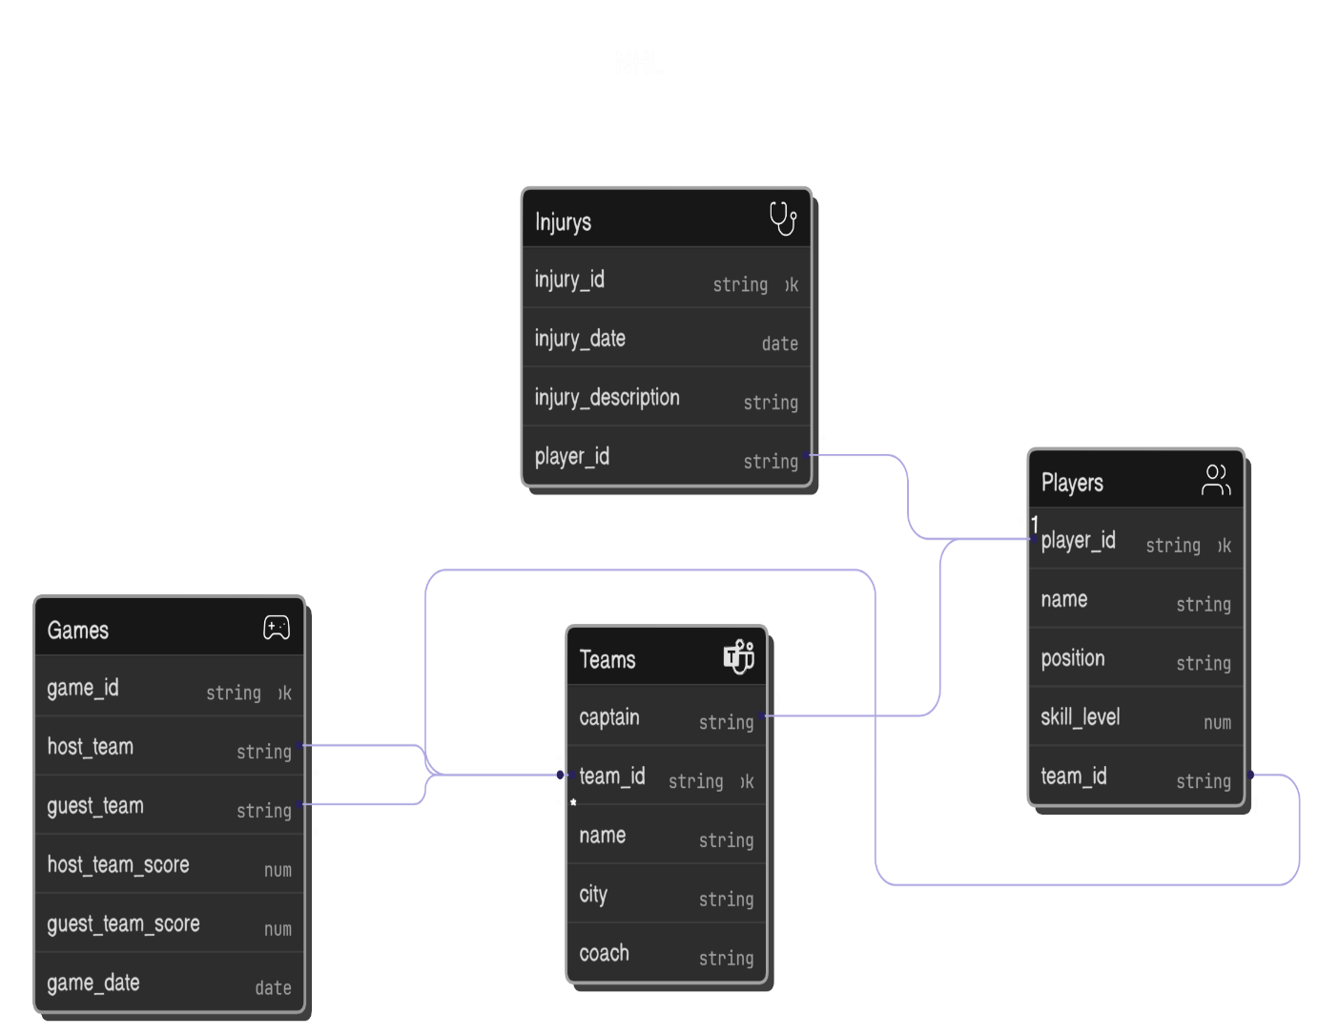

* Table “Teams” has all the team details in the NHL. “team_id” is the Primary Key.
* The captain attribute is a Foreign Key ( player_id ), each team has only one captain so its One-to-one.
* The “Player” table has the player details, player_id is the PK, team which the player belongs to know using the team_id, so it one-to-one.
* Injuries of the player is stored in the “Injurys” table, the attribute player_id is the FK in injurys table. Each player can have multiple injuries so its one-to-many. Injuries can be same but the date will different to every player that is the reason its not many-to-many.
* Table “Games” has a PK game_id representing different gaames. The host_team & guest_team and FK (team_id). A game has 2 teams and a team can play many games so its many-to-many.