**DAILY ONLINE ACTIVITIES SUMMARY**

|  |  |  |  |  |  |  |  |  |
| --- | --- | --- | --- | --- | --- | --- | --- | --- |
| **Date:** | **03/06/2020** | | | | | **Name:** | **Shreetal kalabandi** | |
| **Sem & Sec** | **6th /B** | | | | | **USN:** | **4AL17CS091** | |
| **Online Test Summary** | | | | | | | | |
| **Subject** | | **PAP assignment test** | | | | | | |
| **Max. Marks** | | **20** | | **Score** | | | **17** | |
| **Certification Course Summary** | | | | | | | | |
| **Course** | **BlockChain Essentials** | | | | | | | |
| **Certificate Provider** | | | **Cognitioclas.ai** | | **Duration** | | | **6 hrs** |
| **Coding Challenges** | | | | | | | | |
| **Problem Statement:**   1. Problem statement:   Take a list of length 3 containing integers, find out which is larger, first or last one and set all the elements in the list to be that value. Print the updated list.   1. Python program to print prime numbers in the given range. | | | | | | | | |
| **Status: Completed** | | | | | | | | |
| **Uploaded the report in GitHub** | | | | | **Yes** | | | |
| **If yes Repository name** | | | | | https://github.com/Shreetal/Dailyreport | | | |
| **Uploaded the report in slack** | | | | | **Yes** | | | |

**Online Test Details**

PAP assignment test Details:

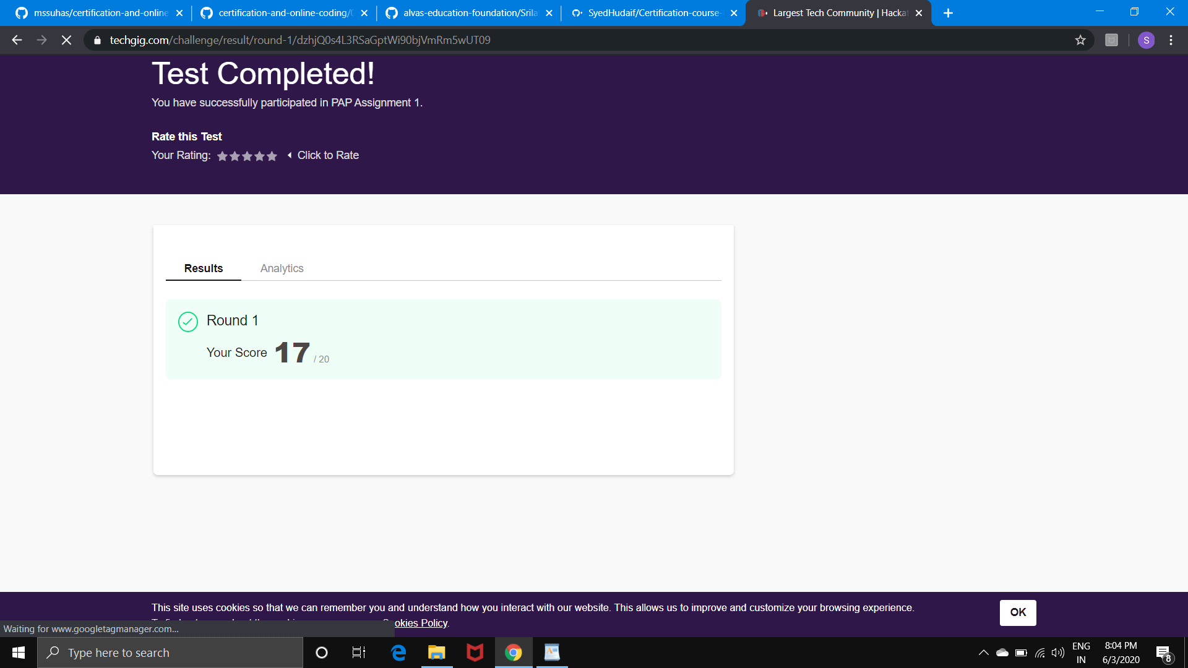

**Certification Course Details**

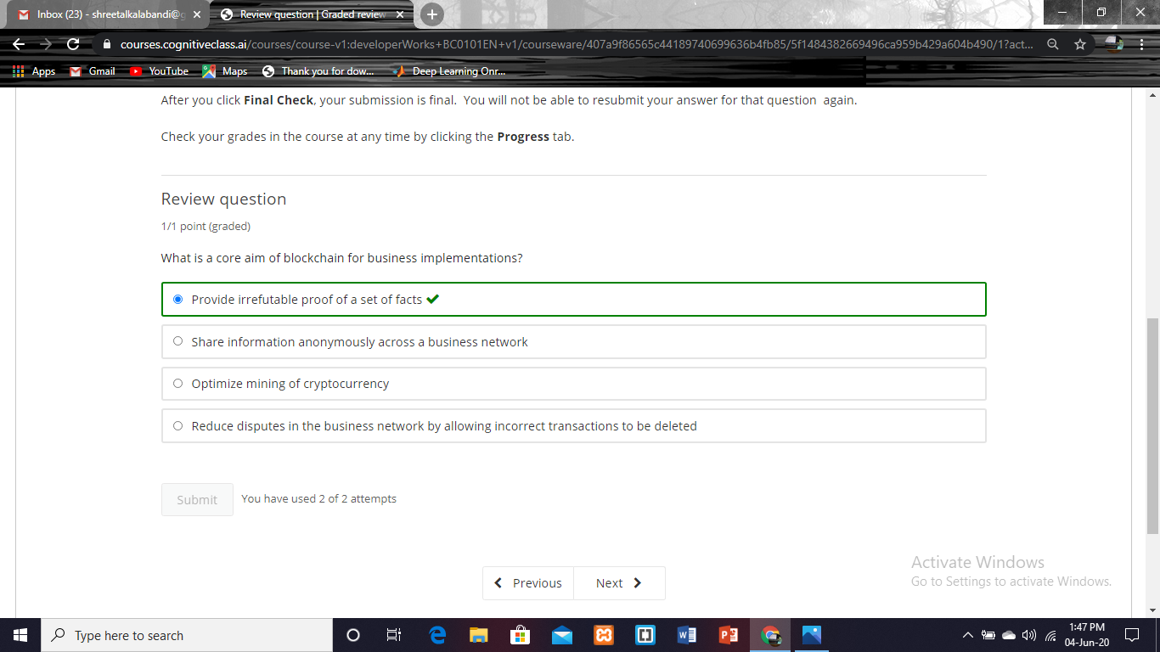

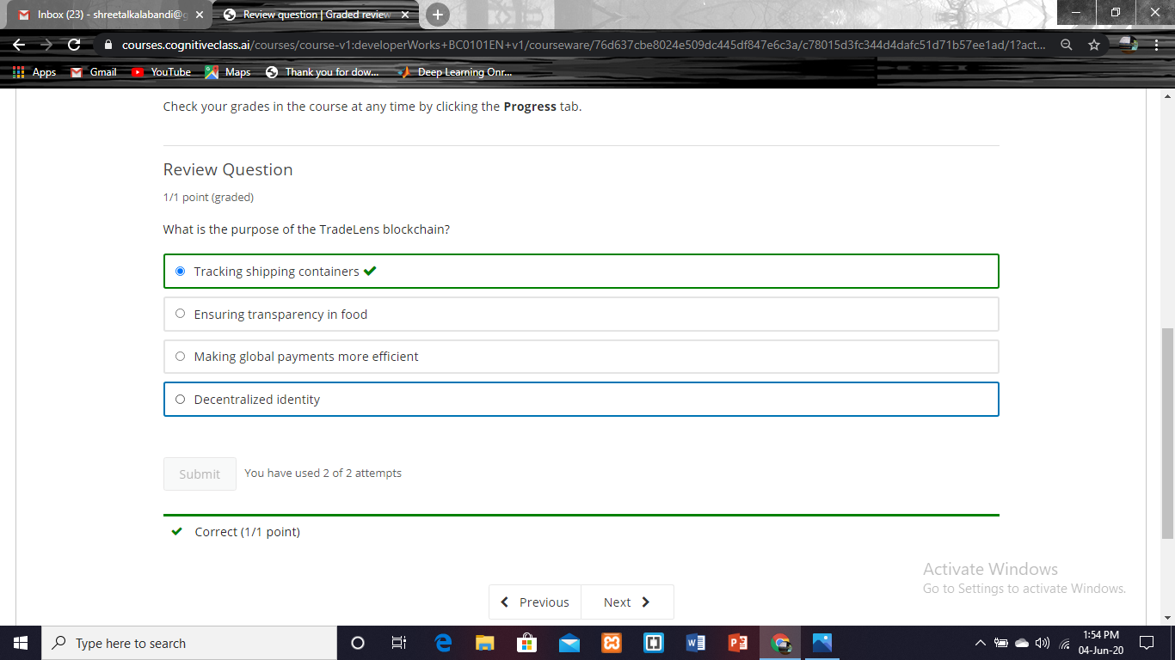

**Coding Challenge Details**

1. Problem statement:

Take a list of length 3 containing integers, find out which is larger, first or last one and set all the elements in the list to be that value. Print the updated list.

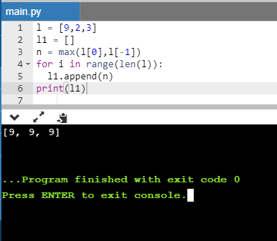

1. Python program to print prime numbers in the given range.

