**Format for uploading details in GitHub and Slack in word file format**

**Student Name: Shreetal Kalabandi**

**Class and Sec: VI B**

**USN: 4AL17CS091**

|  |  |  |  |  |
| --- | --- | --- | --- | --- |
| **Online Test Details** | | | | |
| **Subject** | **Python Application Programming.** | | | |
| **Semester** | **VI - B** | | **Duration** | **40 Minutes** |
| **83.33%** | | **24/30** | | |

**Encl: snapshot of the test result**

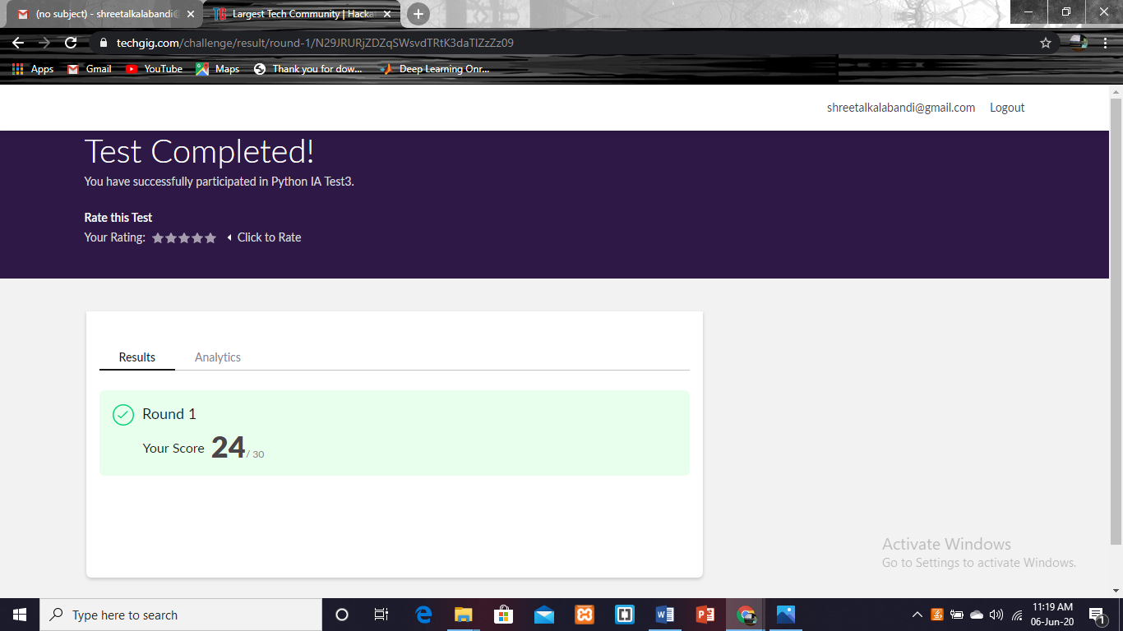

|  |  |  |  |
| --- | --- | --- | --- |
| **Certification Course Details** | | | |
| **Course** | **Cognitioclass.ai** | | |
| **Certificate Provider** | **Ebox** | **Duration** | **6 hrs** |

**Encl: snapshots of the daily class activities (at least two snap shots)**

**Progress on 06-06-2020**

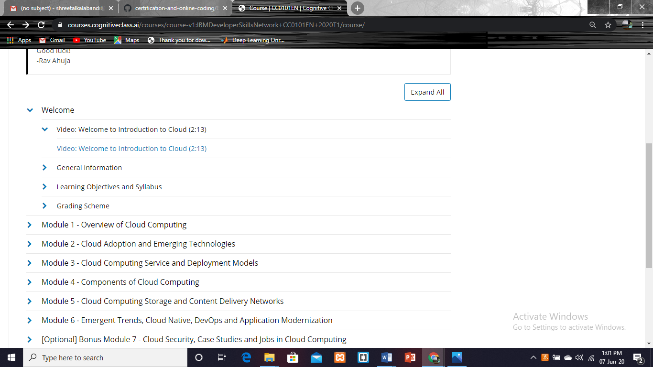

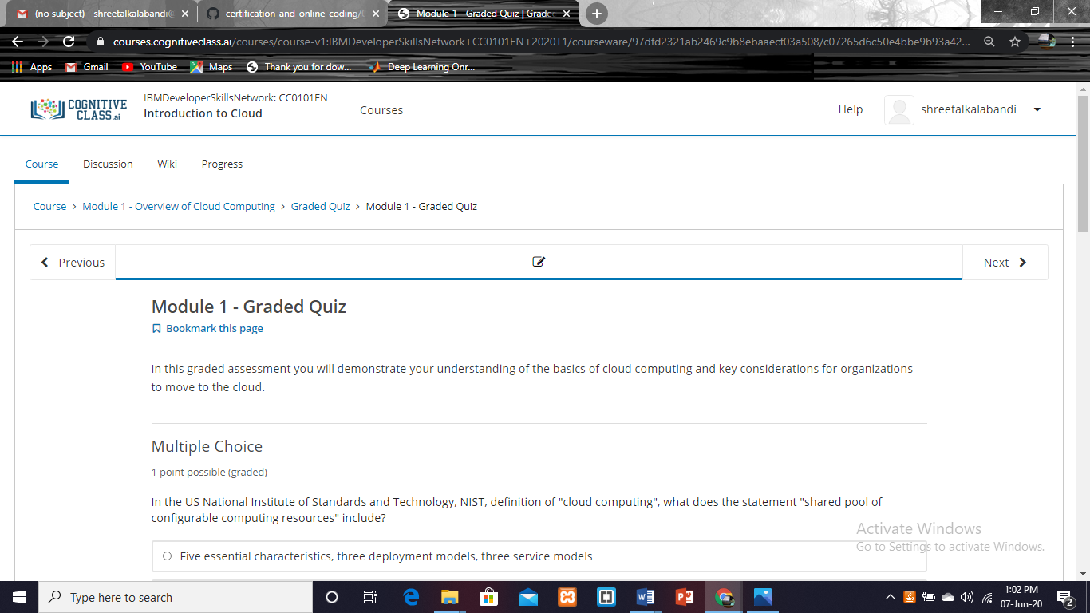

|  |  |
| --- | --- |
| **Coding Challenges** | |
| **Problem Statement: Pro1(c), Pro2(python), Pro3(python), Pro4(python).** | |
| **Status: Completed** | |
| **Uploaded the report both in GitHub & Slack** | **Yes** |

**1. Write a program in C to rotate an array by N positions.**

#include <stdio.h>

int main()

{

int a[100],n,i,r,j,k=0,b[100],l;

printf("Enter The Number Of Elements In A Array:\n");

scanf("%d",&n);

printf("Enter The Elements Into A Array:\n");

for(i=0;i<n;i++)

{

scanf("%d",&a[i]);

}

printf("Enter The Position From Where You Want To Rotate:\n");

scanf("%d",&r);

for(j=0;j<r;j++)

{

b[k++]=a[0];

for(l=0;l<n-j-1;l++)

{

a[l]=a[l+1];

}

}

printf("From %d Position The Values Of The Array Are :\n",r);

int x;

for(x=0;x<n-r;x++)

{

printf("%d\t",a[x]);

}

printf("\n");

printf("Before %d Position The Values Of The Array Are :\n",r);

int y;

for(y=0;y<k;y++)

{

printf("%d\t",b[y]);

}

int z,c=0;

for(z=n-r;z<n;z++)

{

a[z]=b[c++];

}

printf("\n");

printf("After Rotating From %d Position The Array Is:\n",r);

int d;

for(d=0;d<n;d++)

{

printf("%d\t",a[d]);

}

return 0;

}

**Output:**

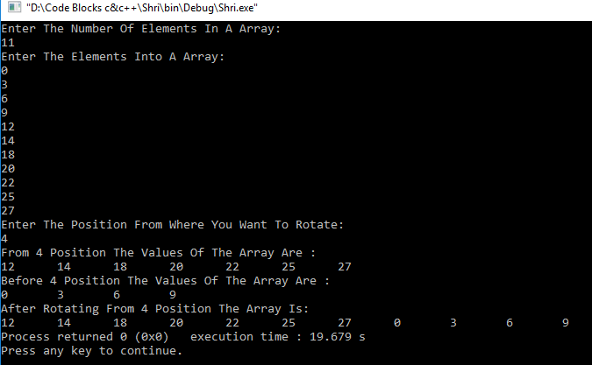

**2.Python Program to Count the Occurrences of a Word in a Text File.**

t = open("shri.txt","r")

d = dict()

for l in t:

a = l.strip()

b = a.lower()

words = b.split(" ")

for w in words:

if w in d:

d[w] = d[w]+1

else:

d[w] = 1

for i in list(d.keys()):

print(i, ":", d[i])

**shri.txt**

Blue Yellow

Red Blue

Green Black White

White Orange Voilet

**Output:**

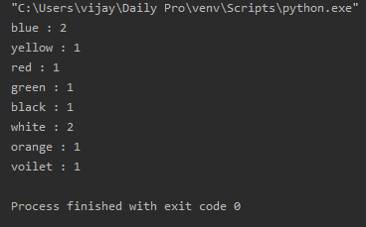

**3.Write a Python program to count the number of strings, provided string length is 2 or more and the first and last character are same from a given list of strings.**

n = int(input("Enter Number Of Strings: "))

a = []

print("Enter The Strings With Length>1: ")

for i in range(n):

a.append(input())

j=0

for i in a:

if(i[0]==i[len(i)-1]):

j+=1

print("Number Of Strings With First And Last Character Is Same: ",j)

**Output:**

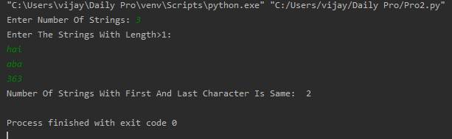

**4.Write a Python program to perform Cyclic Redundancy Check**

from math import log, ceil

def CRC(dataword, generator):

dword = int(dataword, 2)

l_gen = len(generator)

dividend = dword << (l_gen - 1)

shft = ceil(log(dividend + 1, 2)) - l_gen

generator = int(generator, 2)

while dividend >= generator or shft >= 0:

rem = (dividend >> shft) ^ generator

dividend = (dividend & ((1 << shft) - 1)) | (rem << shft)

shft = ceil(log(dividend+1, 2)) - l_gen

codeword = dword << (l_gen-1)|dividend

print("Remainder: ", bin(dividend).lstrip("-0b"))

print("Codeword : ", bin(codeword).lstrip("-0b"))

dataword = input("Enter Dataword: \n")

generator = input("Enter Key: \n")

CRC(dataword, generator)

**Output:**

