**Format for uploading details in GitHub and Slack in word file format**

**Student Name: Shreetal kalabandi**

**Class and Sec: VI B**

**USN: 4AL17CS091**

|  |  |  |  |  |
| --- | --- | --- | --- | --- |
| **Online Test Details** | | | | |
| **Subject** | **System Software and Compiler Design** | | | |
| **Semester** | **VI - B** | | **Duration** | **60 Minutes** |
| **76%** | | **23/30** | | |

**Encl: snapshot of the test result**

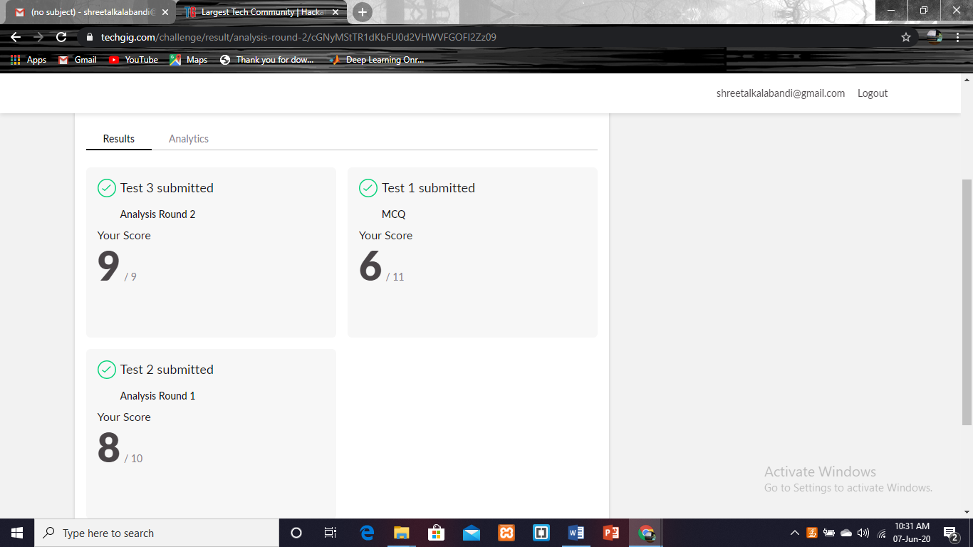

|  |  |  |  |
| --- | --- | --- | --- |
| **Certification Course Details** | | | |
| **Course** | **E-Box(no class)** | | |
| **Certificate Provider** | **E-Box** | **Duration** | **4weeks** |

**Encl: snapshots of the daily class activities (at least two snap shots)**

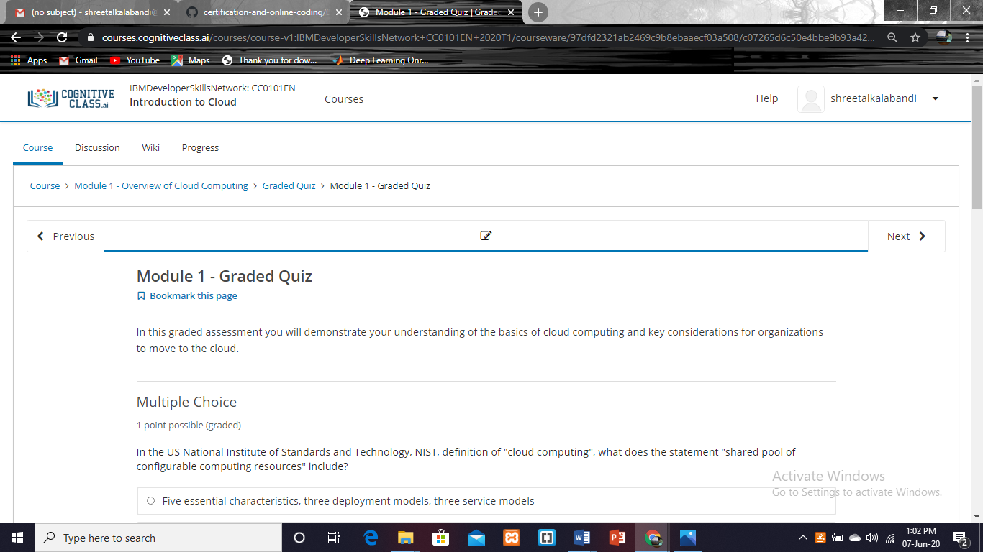

|  |  |
| --- | --- |
| **Coding Challenges** | |
| **Problem Statement: Pro1(python), Pro2(java), Pro3(python).** | |
| **Status: Completed** | |
| **Uploaded the report both in GitHub & Slack** | **Yes** |

**https://github.com/Shreetal/online_coading**

**1. Python Program to Copy the Contents of One File into Another.**

print("Contents Of File-1:\n\r",(open("shri.txt", "r")).read())

print("Before Coping Contents Of File-2: \n", (open("kunder.txt", "r")).read())

f1 = open("shri.txt", "r")

f2 = open("kunder.txt", "w")

for l in f1:

f2.write(l)

f2.close()

print("After Coping Contents Of File-2: \n", (open("kunder.txt", "r")).read())

**Output:**

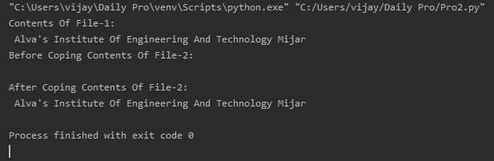

**2. write a java Program to print smallest and biggest possible palindrome word in a given string.**

package pblm;

import java.util.*;

public class pro2

{

public static void main(String[] args){

Scanner s = new Scanner(System.*in*);

System.*out*.println("Enter the string:");

String str = s.nextLine();

String w="", sp = "", bp="";

String[] ws = new String[100];

int t = 0, c = 0;

str = str.toLowerCase();

str = str + ' ';

for(int i = 0; i < str.length(); i++){

if(str.charAt(i) != ' '){

w = w + str.charAt(i);

}

else{

ws[t++] = w;

w = "";

}

}

for(int i = 0; i< t; i++){

String a=ws[i];

boolean flag = true;

for(int j = 0; j < a.length()/2; j++){

if(a.charAt(j) != a.charAt(a.length()-j-1)){

flag = false;

break;

}

}

if(flag==true){

c++;

if(c == 1)

sp = bp = ws[i];

else{

if(sp.length() > ws[i].length())

sp = ws[i];

if(bp.length() < ws[i].length())

bp = ws[i];

}

}

}

if(c == 0)

System.*out*.println("No palindrome is present in the given string");

else{

System.*out*.println("Smallest palindromic word: " + sp);

System.*out*.println("Biggest palindromic word: " + bp);

}

}

}

**Output:**

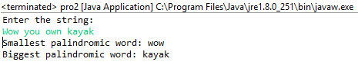

**3. Python program the first and last 5 elements where the values are square of numbers between 1 and 30 (both included).**

b = int(input("Enter Number Where Range Starts: "))

e = int(input("Enter Number Where Range Ends: "))

if(e>30):

e = 30

if(b<27):

print([i**2 for i in range(b, b+5)])

print([i**2 for i in range(e-4, e+1)])

else:

print("Not Possible To Print Square of 5 Elements Which are <= 30 In A Given Range!!!")

**Output:**

