**Format for uploading details in GitHub and Slack in word file format**

**Student Name: Shreetal kalabandi**

**Class and Sec: VI B**

**USN: 4AL17CS091**

|  |  |  |  |  |
| --- | --- | --- | --- | --- |
| **Online Test Details** | | | | |
| **Subject** | **Python Application Programming** | | | |
| **Semester** | **VI - B** | | **Duration** | **40 Minutes** |
|  | |  | | |

**Encl: snapshot of the test result**

|  |  |  |  |
| --- | --- | --- | --- |
| **Certification Course Details** | | | |
| **Course** | **Introduction to cloud** | | |
| **Certificate Provider** | **Cognitioclass.ai** | **Duration** | **6hrs** |

**Encl: snapshots of the daily class activities (at least two snap shots)**

**Progress on 13-06-2020[5th ande 6th module]**

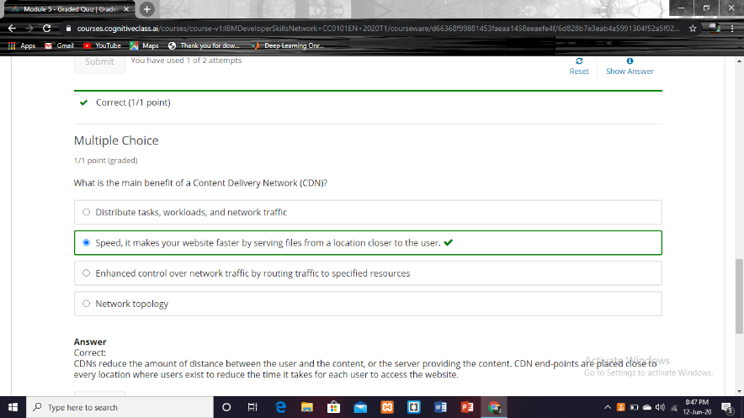

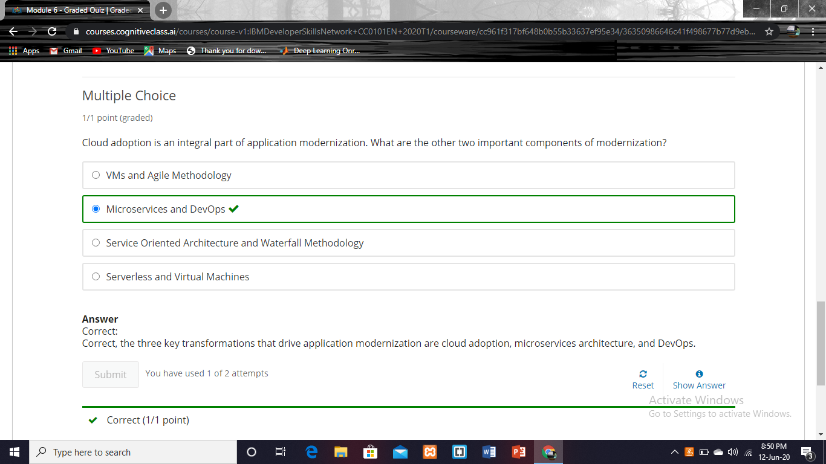

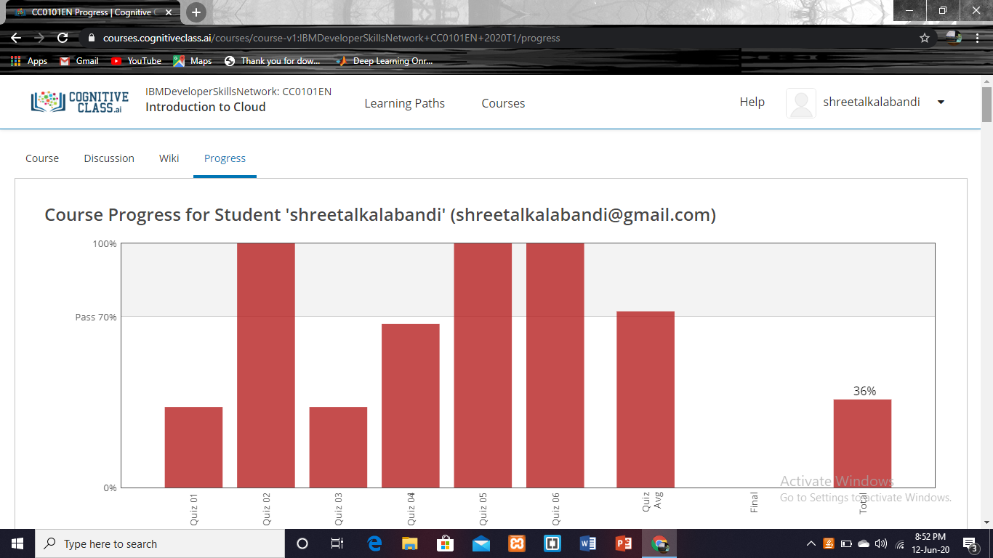

|  |  |
| --- | --- |
| **Coding Challenges** | |
| **Problem Statement: Pro1(c), Pro2(java), Prog3(java),Pro4(python).** | |
| **Status: Completed** | |
| **Uploaded the report both in GitHub & Slack** | **Yes** |

**1. Given an integer U denoting the amount of KWh units of electricity consumed, the task is to calculate the electricity bill.**

#include <stdio.h>

#include <stdlib.h>

int main()

{

int u,d,r,s;

printf("Enter The Unit Of Electricity:\n");

scanf("%d",&u);

if(u<=100)

s=u*10;

else if(u<=200)

s=100*10+(u-100)*15;

else if(u<=300)

s=100*10+100*15+(u-200)*20;

else

s=100*10+100*15+100*20+(u-300)*25;

printf("Total Electricity Bill:\n%d\n", s);

}

**Output:**

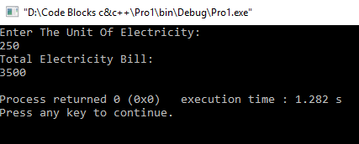

**2. Write a Java Program to determine whether a given matrix is a sparse matrix.**

**import** java.util.*;

**public** **class** SparseMatrix

{

**public** **static** **void** main(String[] args) {

**int** m, n, s, c = 0,i,j;

**int** a[][] = **new** **int**[10][10];

Scanner sc=**new** Scanner(System.***in***);

System.***out***.println("Enter Number Of Rows And Column:");

m=sc.nextInt();

n=sc.nextInt();

System.***out***.println("Enter The Array Elements:");

**for**(i=0; i<m; i++)

{

**for**(j=0; j<n; j++)

{

a[i][j] = sc.nextInt();

}

}

System.***out***.println("The Array is:");

**for**(i=0; i<m; i++)

{

**for**(j=0; j<n; j++)

{

System.***out***.print(a[i][j]+ " ");

}

System.***out***.println();

}

s = m * n;

**for**( i = 0; i < m; i++)

{

**for**( j = 0; j < n; j++)

{

**if**(a[i][j] == 0)

c++;

}

}

**if**(c > (s/2))

System.***out***.println("Given Matrix Is A Sparse Matrix");

**else**

System.***out***.println("Given Matrix Is Not A Sparse Matrix");

}

}

**Output:**

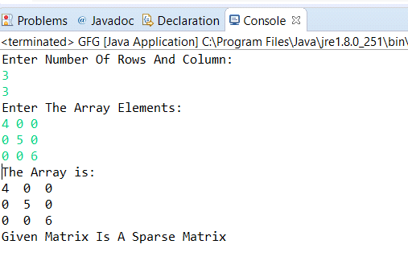

**3. How to find the first non repeated character of a given String.**

import java.util.*;

public class GFG {

static final int *NO_OF_CHARS* = 256;

static char *count*[] = new char[*NO_OF_CHARS*];

static void getCharCountArray(String str)

{

for (int i = 0; i < str.length(); i++)

*count*[str.charAt(i)]++;

}

static int firstNonRepeating(String str)

{

*getCharCountArray*(str);

int index = -1, i;

for (i = 0; i < str.length(); i++) {

if (*count*[str.charAt(i)] == 1) {

index = i;

break;

}

}

return index;

}

public static void main(String[] args)

{

Scanner sc=new Scanner(System.*in*);

System.*out*.println("Enter The String : ");

String st =sc.next() ;

String str=st.toLowerCase();

int index = *firstNonRepeating*(str);

System.*out*.println( index == -1?"Either All Characters Are Repeating Or String Is Empty":"First Non-Repeating Character Is: "+ str.charAt(index));

}

}

**Output:**

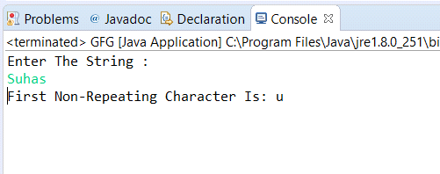

**4. Python program to print the pattern.**

asciiNumber = 65

n=int(input("number of rows is"))

for i in range(0, n):

for j in range(0, i + 1):

character = chr(asciiNumber)

print(character, end=' ')

asciiNumber += 1

print(" ")

**Output:**

