22-1-2026
We shall start a fresh. Build models U-Net ++ with EfficientNet-B0 encoder.
- We have 7 types of defect images and its masks both saved in different folders classwise.
- The structure of the dataset is
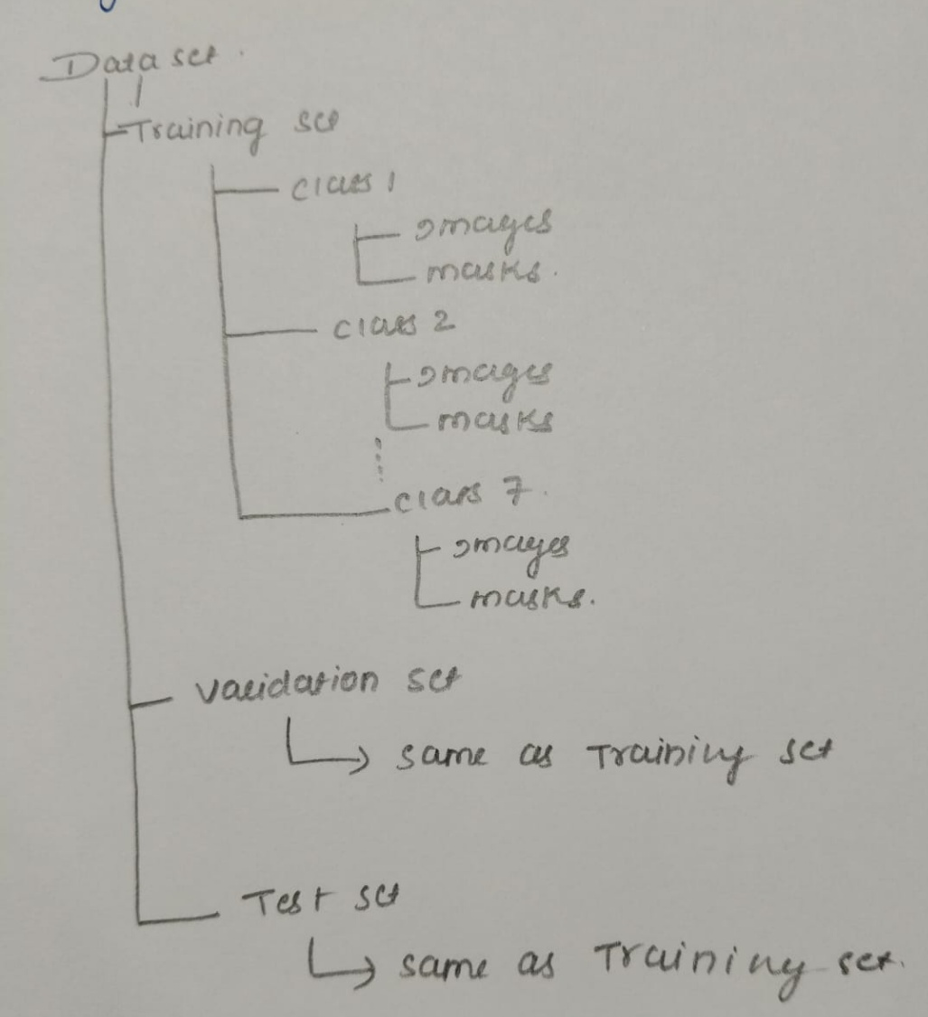
- The data is distributed as follows:
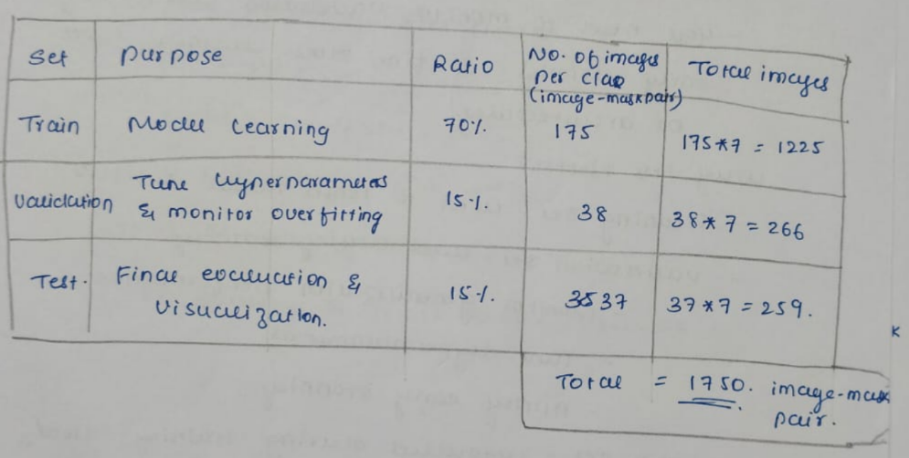
- Perform data augmentation
- Build Model UNet ++ with EfficientNet-B0 encoder
- Train the model and display accuracy and loss curves in a different style of visualisation
- Add code to calculate the performance metrics: Dice score, IoU ( Its Types mIoU/GIoU, CIoU and DIoU, whichever is suitable), Accuracy, precision, Recall, Hausdorff distance for training and validation data and test data. This should be calculated class-wise.
- Add code to calculate severity of the defect, severity logic is different for different types of defects. Get the details from the attached file. The logic is derived from MM Agarwal book.
- , from test data folder consider 3 images from each class. Display the visulaization for all 3 images in each class giving Real Image, Ground Truth Image, Predicted Mask, Severity, Action Recommended for the defect. In table format, apt for research paper.

