**AMAZECARE**

Hospital Management System

NAME : Shreetharan ST

EMAIL: [shreests07@gmail.com](mailto:shreests07@gmail.com)

BATCH: Java + angular (batch2)

SUPERSET ID: 5347489

TRAINER: Thaneshwara M

DATE : 16.07.2025

Application. Properties



Database schema

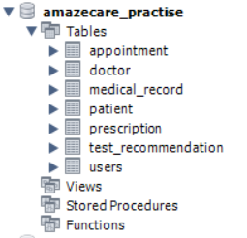

User table

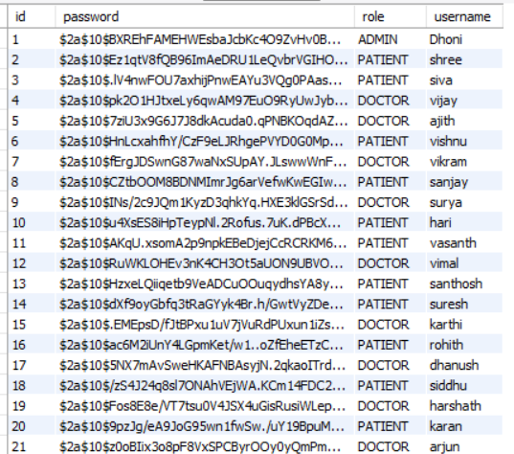

Patient table

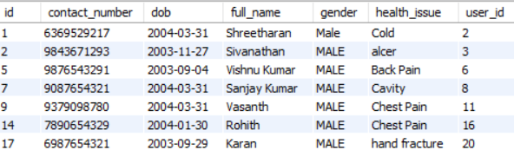

Doctor table

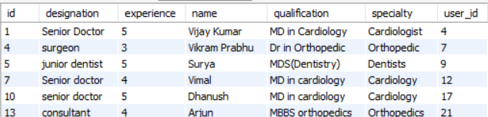

Appointment table

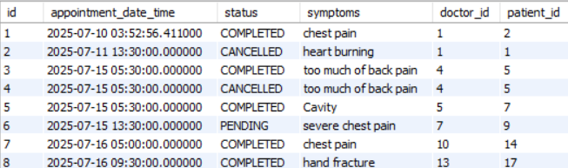

Prescription table

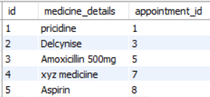

Medical Record table

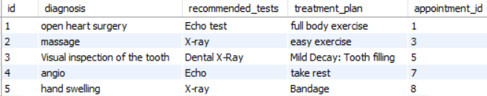

THANK YOU