|  |  |
| --- | --- |
| DATA VISUALIZATION Credit Card Transaction Data Analysis Report | By: Shreevidya Sharma  P03EH23M015048 |

# Credit Card Transaction Data Analysis Report

## 1. Business Understanding

Understanding customer spending patterns is crucial for financial institutions and businesses. This analysis helps identify key spending behaviors, popular transaction categories, and customer demographics.

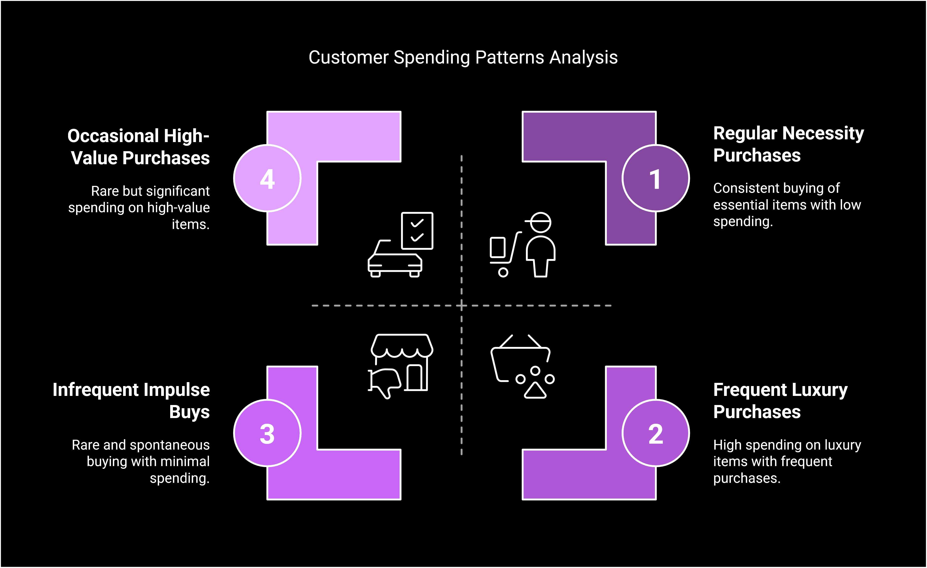

## 2. Data Requirement

The dataset should include the following key attributes:

* • Customer ID – Unique identifier
* • Gender – For spending behavior analysis
* • Birthdate – To determine customer age groups
* • Transaction Amount – Amount spent in each transaction
* • Date – Transaction date for trend analysis
* • Merchant Name – Where the transaction occurred
* • Category – Classifies spending (e.g., Travel, Electronics, Clothing)
* 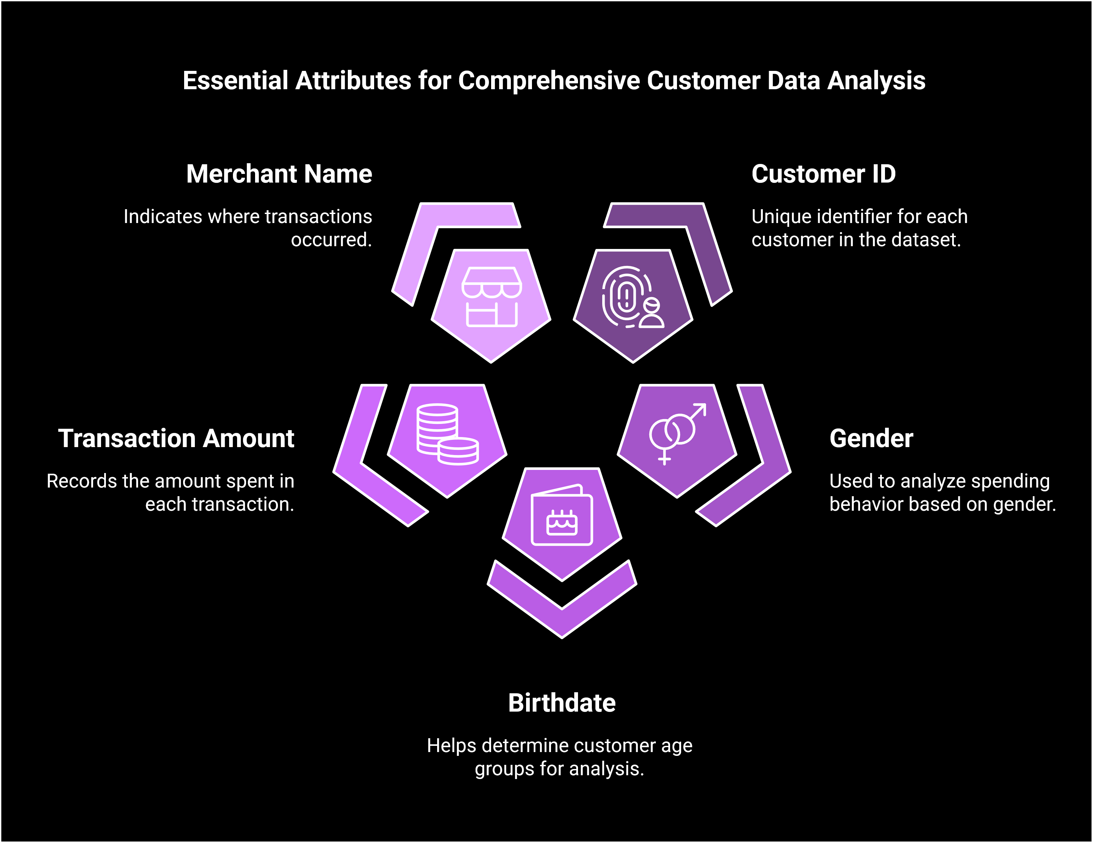

## 3. Data Collection

The dataset was collected from a financial institution’s transaction records, consisting of 50,000 records covering various spending categories and customer demographics.

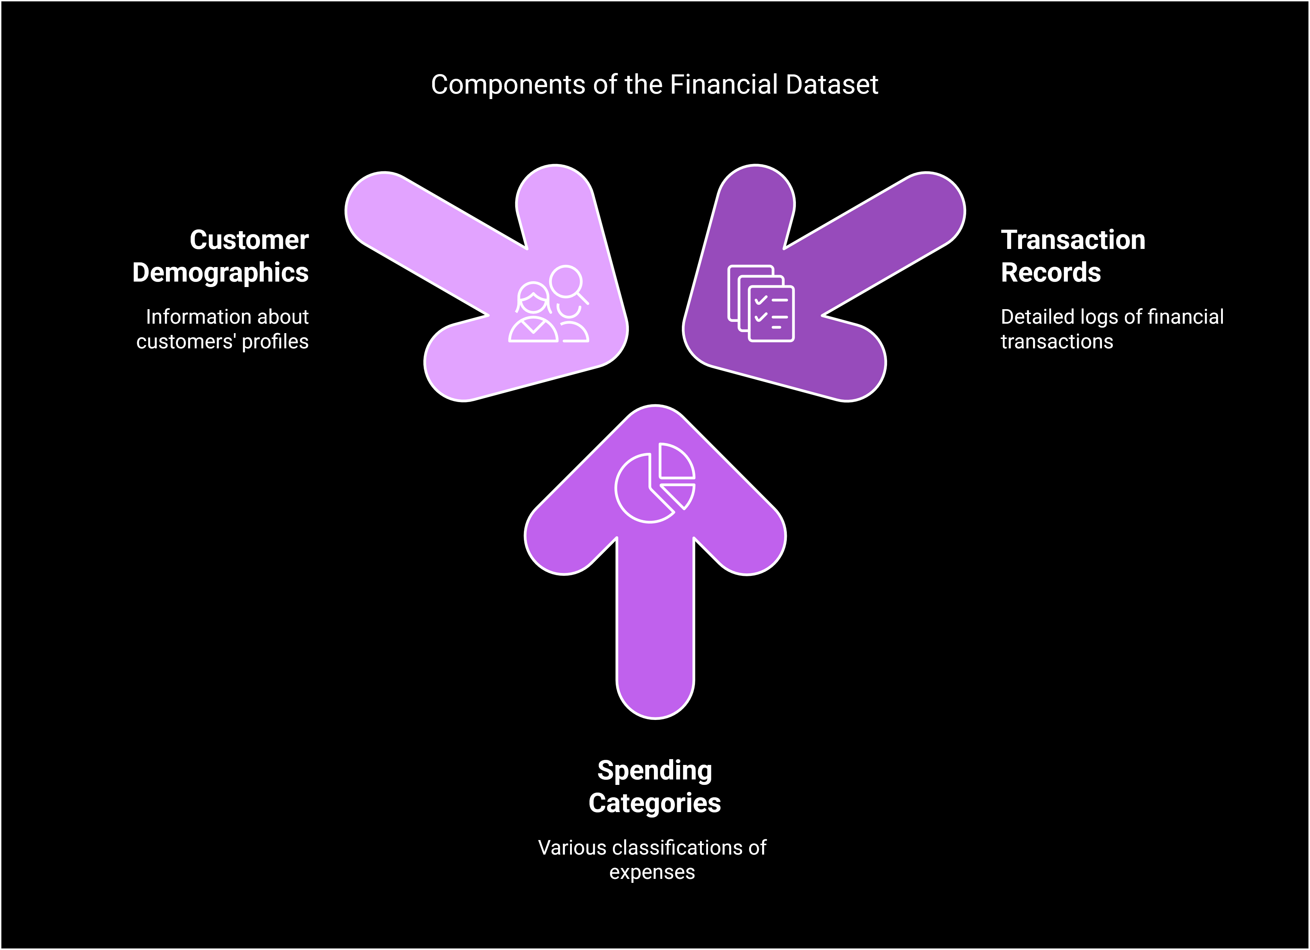

## 4. Data Understanding and Data Validation

Key observations during data validation:

* ✓ The dataset consists of 50,000 transactions.
* ✓ Missing values were found in the 'Gender' column.
* ✓ 'Birthdate' and 'Date' were stored as strings and required conversion to datetime format.
* ✓ No duplicate records were found.
* 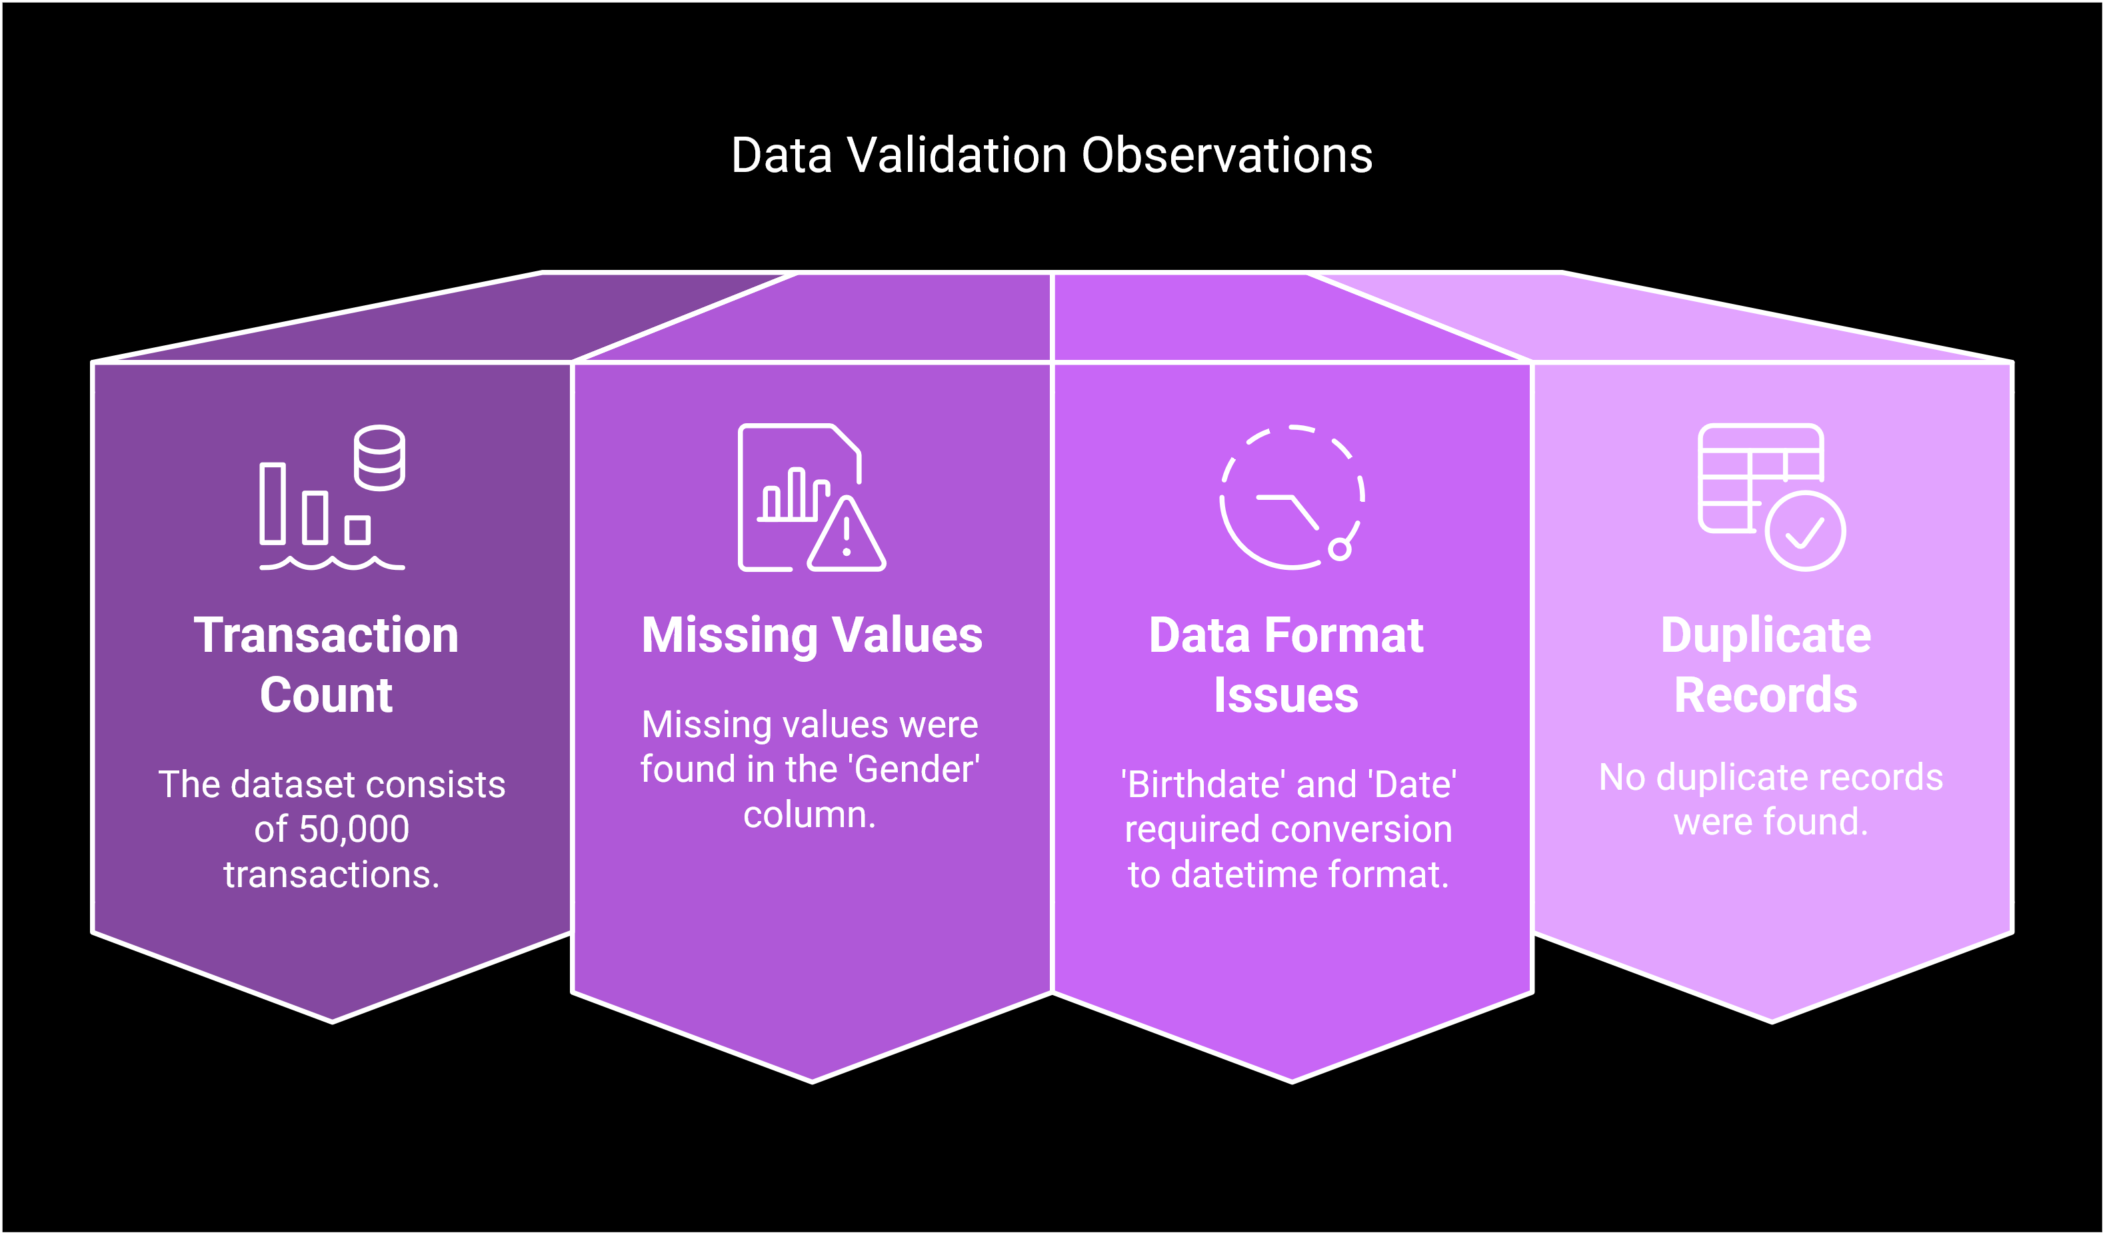

## 5. Data Cleaning

To improve data quality, the following steps were taken:

* ✔ Converted 'Birthdate' and 'Date' columns to datetime format.
* ✔ Filled missing values in 'Gender' with 'Unknown'.
* ✔ Dropped unnecessary columns ('Name' and 'Surname').
* ✔ Checked for and removed duplicates (none found).
* 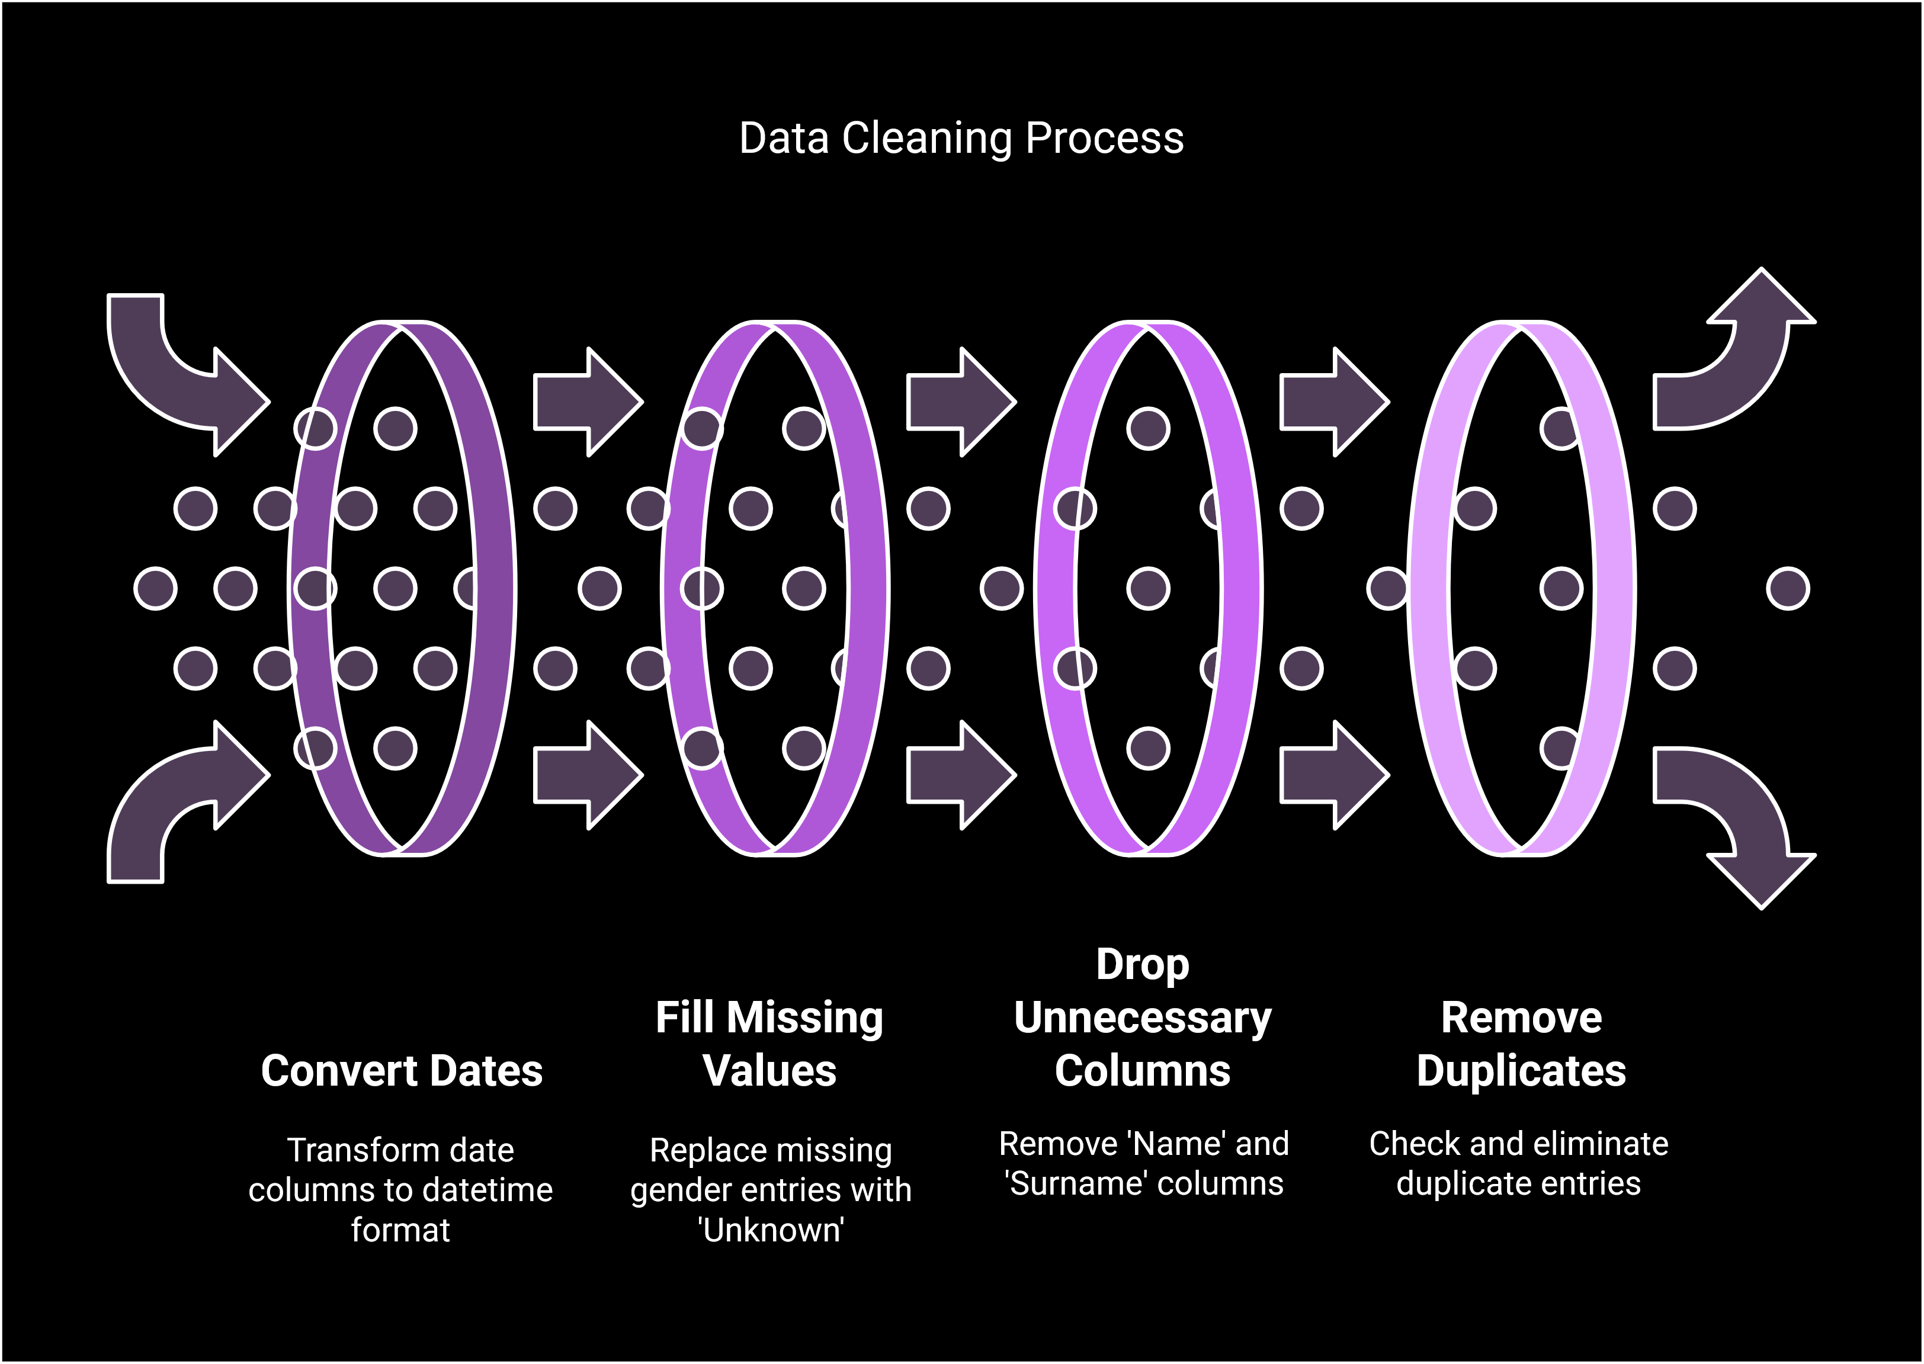

## 6. Tools Selection

The following tools were used for analysis:

* 🔹 ChatGPT – For summarizing findings and generating insights.
* 🔹 Python (Pandas, Matplotlib, Seaborn) – For data cleaning, exploration, and visualization.
* 🔹 Tableau / Power BI – Recommended for interactive business dashboards.
* 🔹 Julius & Quadratic AI – Alternative AI tools for automating insights.
* 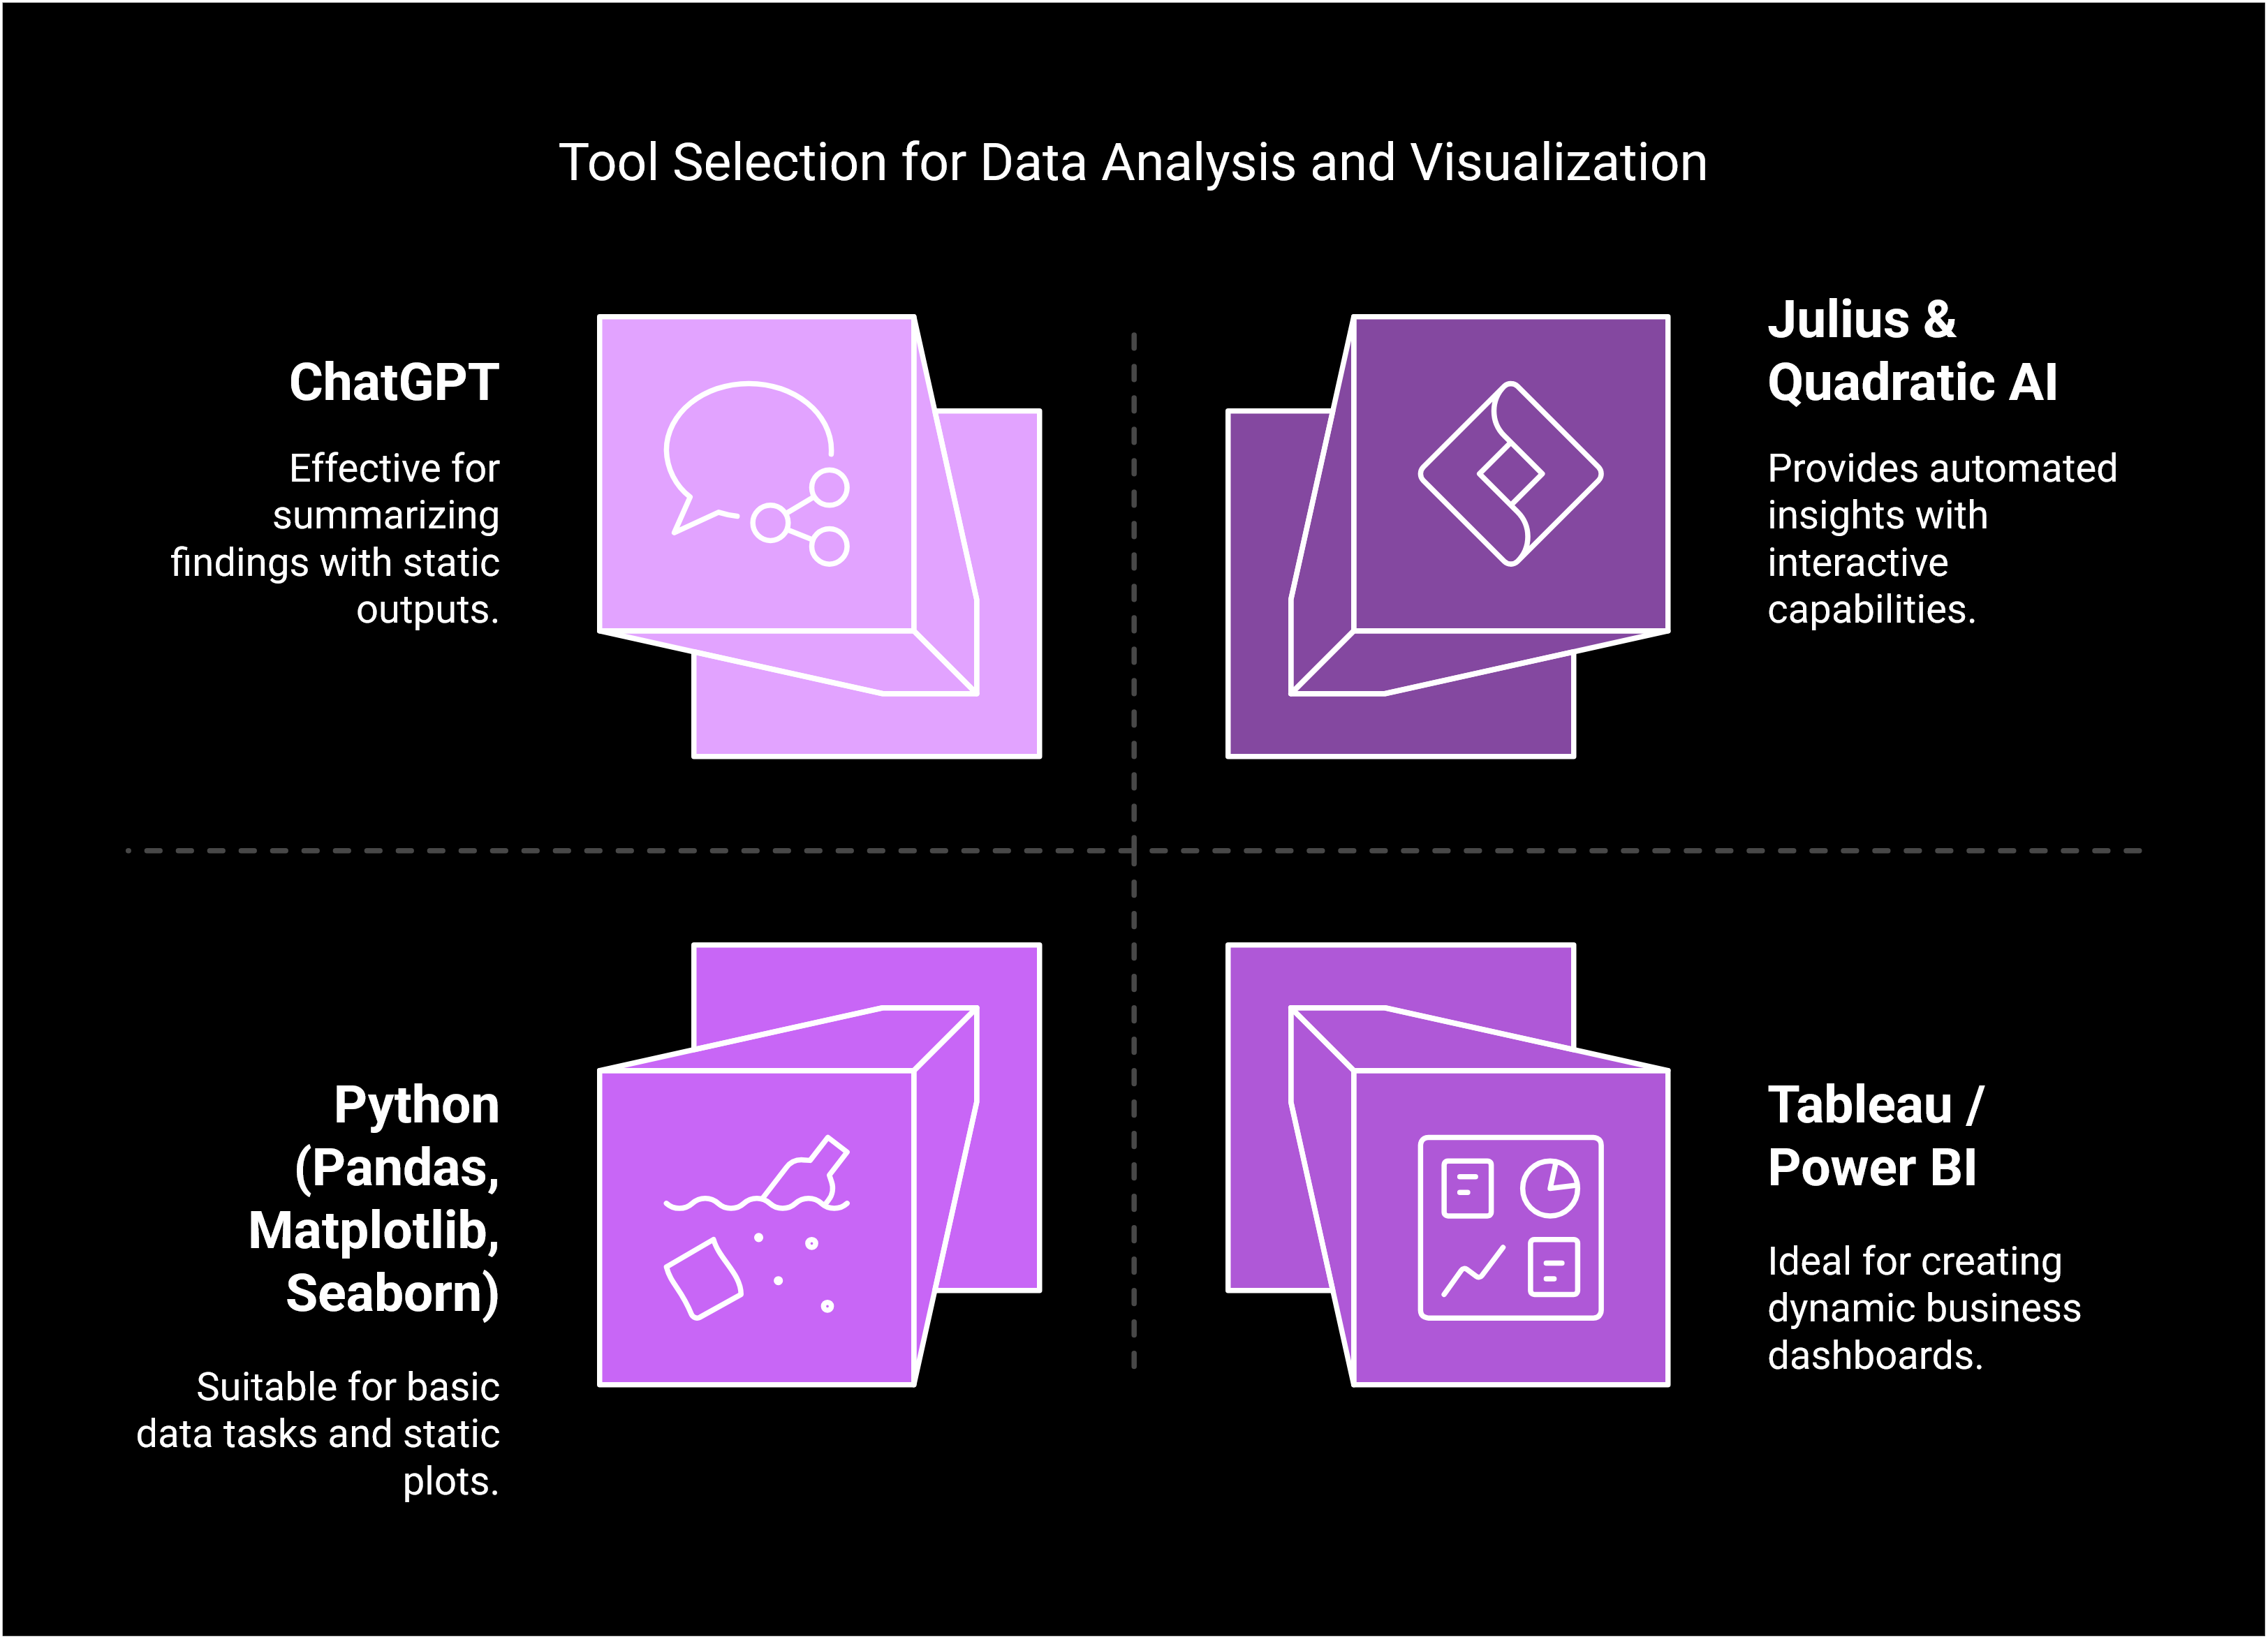

**7 & 8. DASHBOARD**

**CHATGPT:** 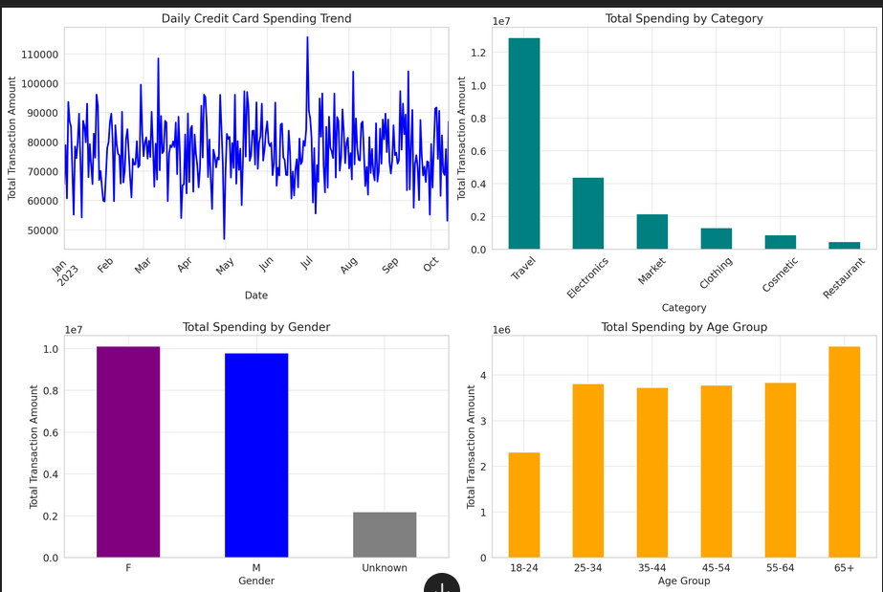

**📊 Key Business Insights from the Dashboard:**

Based on the credit card transaction analysis, here are the most important insights:

**1️Spending Trends Over Time**

✅ **Fluctuating transaction volumes** indicate that spending is influenced by external factors like holidays, promotions, or salary dates.  
✅ **Spikes in spending** on specific days suggest opportunities to introduce targeted discounts or promotional campaigns.

**📌 Business Recommendation:**

* Run promotions or cashback offers on low-spending days to boost transactions.
* Analyze peak spending days to align marketing strategies with customer behavior.

**2️Top Spending Categories**

✅ **Travel, Electronics, and Clothing** are the highest-spending categories.  
✅ Lower spending in **Cosmetics and Groceries**, which may indicate price sensitivity or alternative purchasing channels.

**📌 Business Recommendation:**

* Increase rewards or discounts in **high-spending categories** to drive customer loyalty.
* Offer personalized discounts in **low-spending categories** to boost sales.

**3️Gender-Based Spending Patterns**

✅ **Male customers spend the most**, followed by **female customers**.  
✅ A notable portion of transactions are from customers with an **"Unknown"** gender, possibly due to incomplete data.

**📌 Business Recommendation:**

* Develop gender-targeted promotions based on spending patterns.
* Encourage customers to update their profiles to reduce missing data.

**4️Age-Based Spending Trends**

✅ The **25-34 age group spends the most**, followed by **35-44** and **45-54**.  
✅ Spending drops significantly after **age 55**, possibly due to fixed incomes or reduced credit usage.

**📌 Business Recommendation:**

* Focus marketing efforts on **young professionals (25-44 age group)**, as they are the most active spenders.
* Offer tailored financial products or discounts for **older customers** to encourage credit card usage.

**💡 Final Takeaways:**

🔹 **Optimize marketing strategies** for high-spending categories like Travel & Electronics.  
🔹 **Leverage demographic data** to create personalized financial products & promotions.  
🔹 **Encourage engagement with older customers** through targeted incentives.

Would you like any additional insights or recommendations? 🚀

**JULIUS AI:**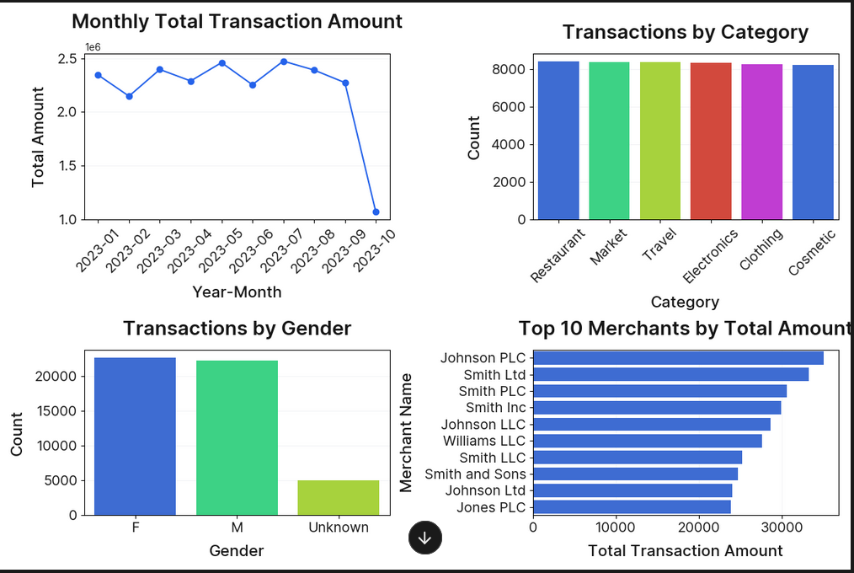

* **Below are the meaningful insights derived from the dashboard:**
* **Monthly Trends:  
  The trend in total transaction amounts over time provides a pulse on revenue flow. For example, consistent increases or periodic spikes may indicate seasonal trends or promotional effects that can be leveraged for planning future campaigns.**
* **Category Analysis:  
  The bar chart showing transaction counts by category highlights which sectors are highly active. This suggests where customer spending is concentrated (e.g., Cosmetics or Travel), so focusing on these areas could yield higher returns in targeted marketing or partnership offerings.**
* **Customer Segmentation:  
  The gender distribution graph, including entries labeled as "Unknown," reveals potential gaps or data quality issues. This segmentation helps tailor specific offers and understand potential under-served customer groups.**
* **Merchant Partnerships:  
  Analysing the top 10 merchants by total transaction amounts points out the leading players within the ecosystem. These merchants can be deemed strategic partners for loyalty programs or preferential deals, benefiting both customer satisfaction and merchant performance.**

**POWER BI:**

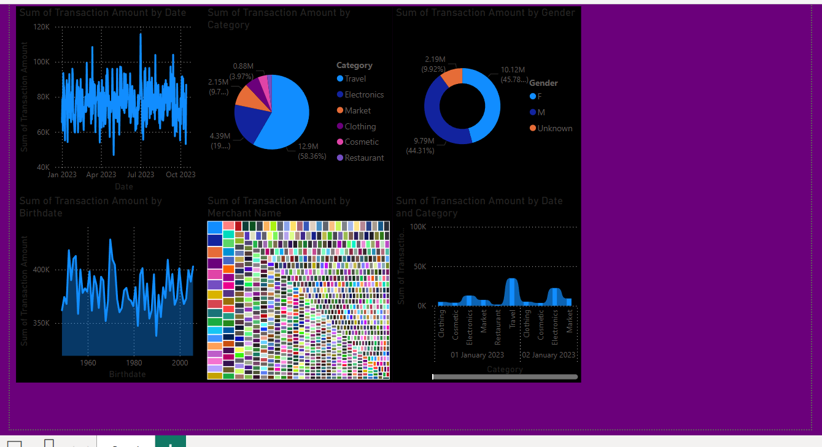

**Interpretation**

* **📊 Key Insights from the Given Power BI Dashboard**
* **Based on the visualizations provided in your credit card transaction dashboard, here are some meaningful insights:**
* **1️⃣ Transaction Trends Over Time (Line Chart - Top Left & Bottom Right)**
* **✅ High transaction fluctuations indicate variations in spending behavior across the year.  
  ✅ There are noticeable spikes in spending, particularly around mid-2023 and late-2023.  
  ✅ These peaks may be due to seasonal effects, promotions, or salary cycles.**
* **📌 Business Recommendation:**
* **Identify what caused these spikes (e.g., festive seasons, salary days, promotions).**
* **Offer targeted promotions during low-activity periods to boost transactions.**
* **2️⃣ Spending Distribution by Category (Pie Chart - Top Center)**
* **✅ The Travel category dominates spending, accounting for 58.36% of total transactions.  
  ✅ Electronics (19.7%) and Market (9.7%) are also significant spending categories.  
  ✅ Lower spending in Clothing, Cosmetics, and Restaurants suggests either lower demand or competitive alternatives.**
* **📌 Business Recommendation:**
* **Enhance travel-related offers (e.g., cashback, discounts) to maintain high engagement.**
* **Consider cross-selling travel deals with electronics (e.g., travel gadgets).**
* **Offer targeted promotions in lower-spending categories to encourage spending.**
* **3️⃣ Gender-Based Spending Behavior (Donut Chart - Top Right)**
* **✅ Male customers (45.78%) and Female customers (44.31%) have almost equal spending.  
  ✅ A small percentage (9.92%) of transactions belong to "Unknown" gender, indicating missing or incomplete data.**
* **📌 Business Recommendation:**
* **Since spending is almost balanced between males and females, gender-neutral marketing may work best.**
* **Improve data collection processes to capture gender data more accurately.**
* **4️⃣ Age Group Spending Trends (Line Chart - Bottom Left)**
* **✅ Customers born between 1950-2000 (aged 24-74) contribute the most to total transactions.  
  ✅ Spending peaks for customers born in the 1960s-1980s, suggesting that middle-aged individuals are the highest spenders.**
* **📌 Business Recommendation:**
* **Focus premium financial products and loyalty programs on middle-aged customers.**
* **Introduce youth-oriented campaigns to attract younger spenders (born after 2000).**
* **5️⃣ Merchant-Wise Spending Distribution (Treemap - Center Bottom)**
* **✅ There are many merchants, each capturing a small portion of the total transactions.  
  ✅ No single merchant dominates spending, which suggests diverse consumer preferences.**
* **📌 Business Recommendation:**
* **Identify top-performing merchants and strengthen partnerships.**
* **Offer exclusive merchant discounts to increase customer retention at preferred stores.**
* **💡 Final Business Takeaways:**
* **🔹 Capitalize on Travel & Electronics spending with targeted offers.  
  🔹 Leverage middle-aged consumers (1960s-1980s birth years) as they are the highest spenders.  
  🔹 Balance gender-focused campaigns, as both male and female spending is almost equal.  
  🔹 Improve missing gender data collection to refine insights further.  
  🔹 Offer strategic merchant partnerships to boost customer engagement.**

**9. Recommended Tool for effective Dashboard**

**POWER BI:**



**Why Power BI Dashboard is Better Than an AI-Generated Dashboard?**

Power BI dashboards offer several advantages over AI-generated dashboards, making them more **customizable, interactive, and insightful**. Here are **five key reasons** why Power BI dashboards are superior:

**1️Interactive & Dynamic Visualizations**

✅ **Power BI:** Users can interact with the dashboard by applying filters, drill-downs, and slicers to explore data in **real time**.  
❌ **AI-Generated Dashboards:** Often static, meaning users cannot explore different dimensions of the data interactively.

**📌 Example:** In Power BI, you can click on a specific category (e.g., Travel) in a pie chart, and all other charts will update to reflect only Travel-related transactions. AI-generated dashboards typically lack this interactivity.

**2️Advanced Data Integration & Customization**

✅ **Power BI:** Can **connect to multiple data sources** (Excel, SQL, APIs, etc.) and allows custom calculations using **DAX formulas**.  
❌ **AI-Generated Dashboards:** Usually rely on pre-processed datasets and have limited **customization options** for formulas and metrics.

**📌 Example:** If you want to calculate a **custom KPI like "Average Spend per Customer"**, Power BI allows you to create a DAX measure, whereas AI-generated reports may not support such flexibility.

**3️Better Data Security & Sharing Capabilities**

✅ **Power BI:** Allows organizations to **control data access**, ensuring that only **authorized users** can view or edit dashboards.  
❌ **AI-Generated Dashboards:** May not have strong security features, especially if hosted on third-party platforms.

**📌 Example:** Power BI dashboards can be published **within a company's Microsoft ecosystem** with role-based access, ensuring **data privacy**. AI-generated dashboards may not provide such controlled access.

**4️Real-Time Data Updates**

✅ **Power BI:** Supports **real-time data refresh**, enabling dashboards to reflect **live data** changes automatically.  
❌ **AI-Generated Dashboards:** Often rely on **static datasets**, meaning the dashboard must be regenerated each time data updates.

**📌 Example:** A **finance team** monitoring transactions can get **live updates on spending trends** in Power BI, while an AI-generated report would require reprocessing every time.

**5️Seamless Integration with Business Tools**

✅ **Power BI:** Easily integrates with **Microsoft Office Suite (Excel, Teams, SharePoint)** and other business intelligence tools.  
❌ **AI-Generated Dashboards:** May not have direct integration capabilities with enterprise tools.

**📌 Example:** A **finance manager** can embed a Power BI dashboard directly into **Microsoft Teams**, allowing **real-time collaboration** with colleagues. AI-generated dashboards lack such seamless business tool integration.

**🚀 Final Verdict: Power BI Wins!**

🔹 If you need **interactive, real-time, and customizable dashboards**, **Power BI** is the better choice.  
🔹 AI-generated dashboards can be **useful for quick insights**, but they lack **customization, security, and interactivity**.