Lab Practical #11:
Study the concept of routing using packet tracer. (Dynamic Routing)
Practical Assignment #11:
- Connect the three different networks based on the calculated IP addresses and subnet using a packet tracer.

- Dynamic Routing is a network routing technique where routers automatically adjust and choose optimal paths for data packets based on real-time network conditions, rather than using a static, fixed path.

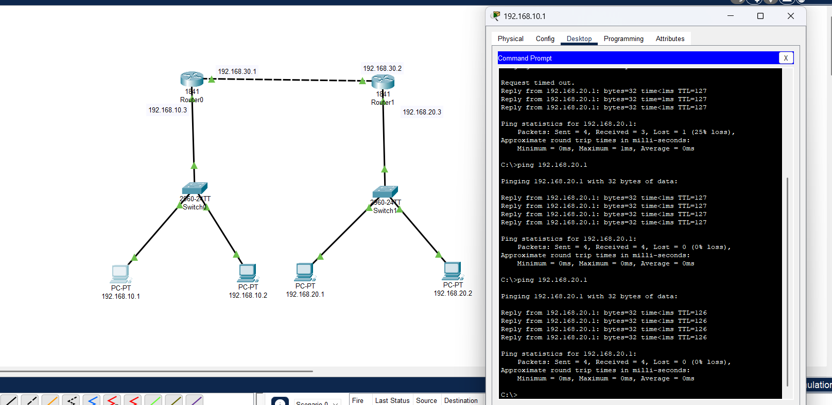F
Dynamic - ping
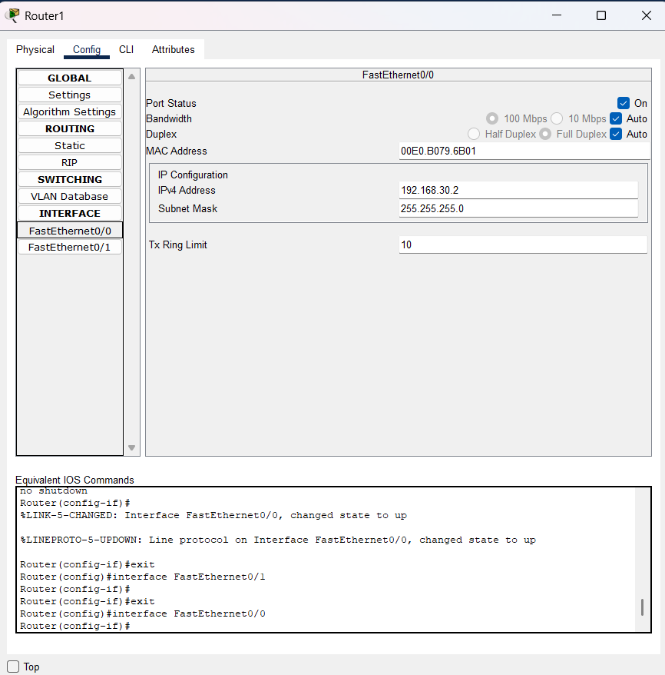
FastEthernet0/0
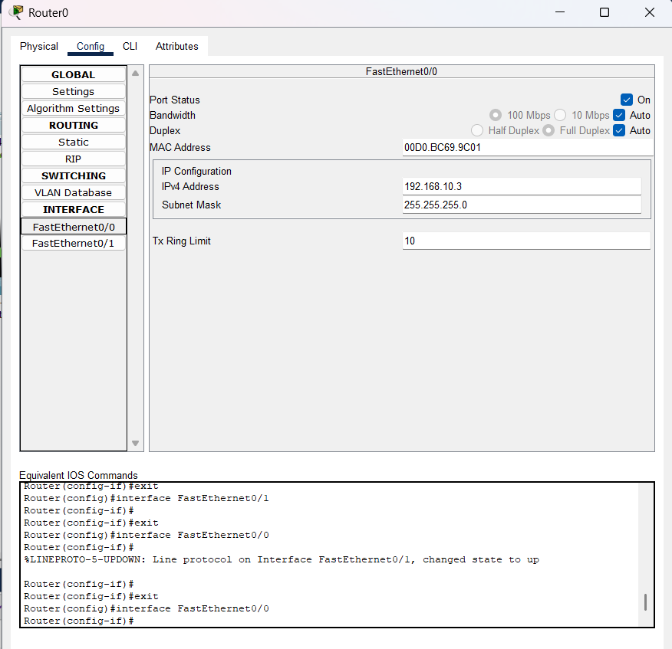
FastEthernet0/0
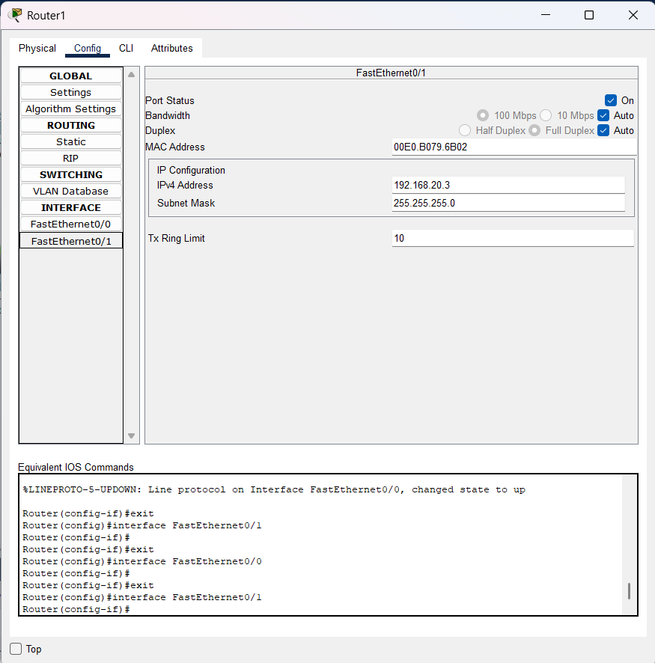
FastEthernet0/1
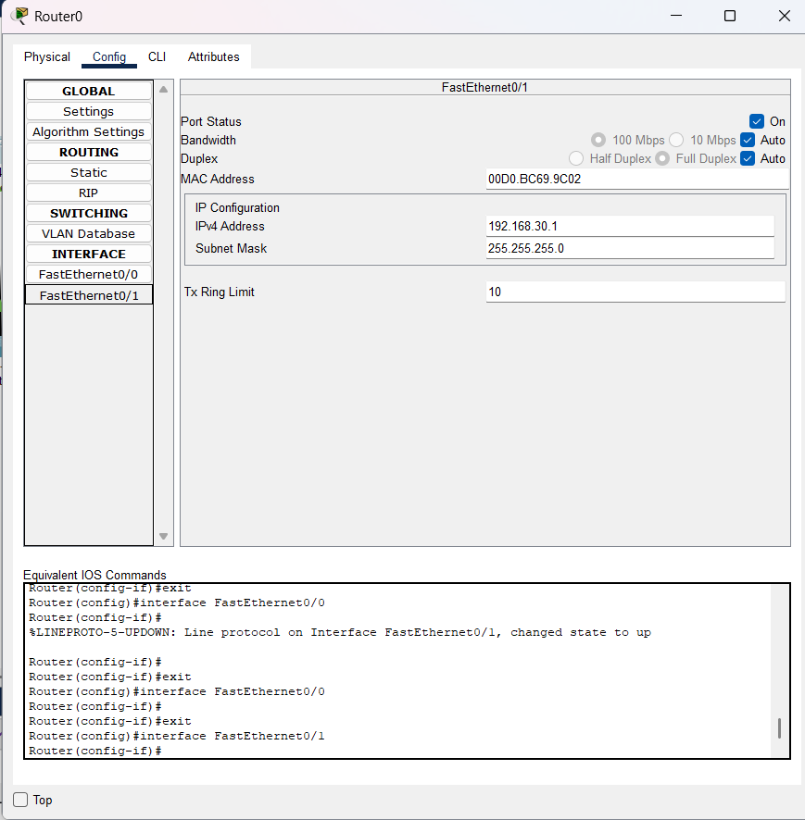
FastEthernet0/1

- Connect the two different networks based on the calculated IP addresses and subnet using a packet tracer.
