Lab Practical #03:
Study of different types of network cables & connectors and crimping a LAN.
Practical Assignment #03:
- List various networks cable. Also, write short description.
- Difference between guided and unguided media.
- Give cross-wired cable and straight through cable diagram (Color Code wise).

List various networks cable and connectors. Also, write short description.

- Coaxial Cable:
  - Description:
    - A single copper conductor in the centre with insulating layers and shielding.
    - Used in early Ethernet networks and cable TV.
    - Provides good resistance to signal interference.
  - Diagram:
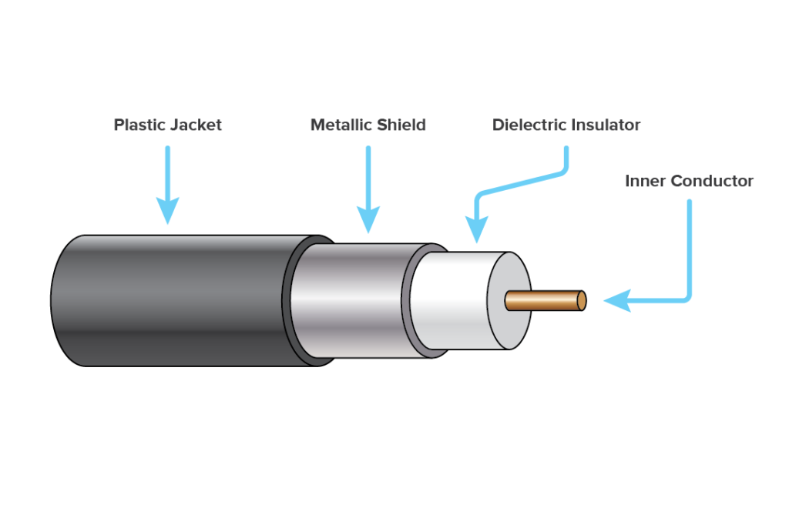

- Twisted Pair Cable:
  - Description:
    - Consists of pairs of insulated copper wires twisted together.
    - Reduces electromagnetic interference (EMI).
Types:
- UTP (Unshielded Twisted Pair): Common in LANs, cheaper, and easy to install.
- STP (Shielded Twisted Pair): Includes additional shielding for better noise protection.
  - Diagram:

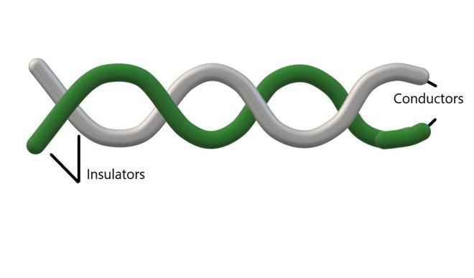

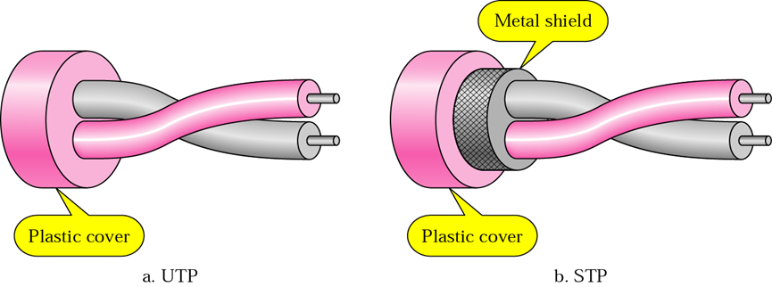

- Fiber Optic Cable:
  - Description:
      - Uses light to transmit data through glass or plastic fibres.
      - High-speed data transfer over long distances.
      - Immune to electrical interference and used in backbone networks
  - Diagram:

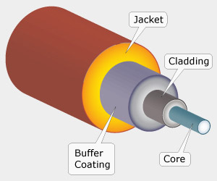

- Difference between guided and unguided media.

  Feature
  Guided Media
  Unguided Media
Definition
  Uses physical cables to transfer data.
  Transfers data wirelessly through air.
Medium
  Wires like twisted pair, coaxial, fiber optic.
  No wires; uses air, radio waves, or light.
 | Signals follow a specific path.
  Direction of signal
  Signals spread in all directions.
Speed
  Generally faster and more stable.
  Slower and affected by environment.
  Installation cost
  Higher due to cables.
  Lower as no cables are used.
Mobility | Less mobile, fixed connections.
  More mobile, supports movement.
Examples | LAN cables, telephone lines, fiber optics. | Wi-Fi, Bluetooth, radio, infrared.

Give cross-wired cable and straight through cable diagram (Color Code wise).
- Cross-wired Cable Diagram (Color Code)

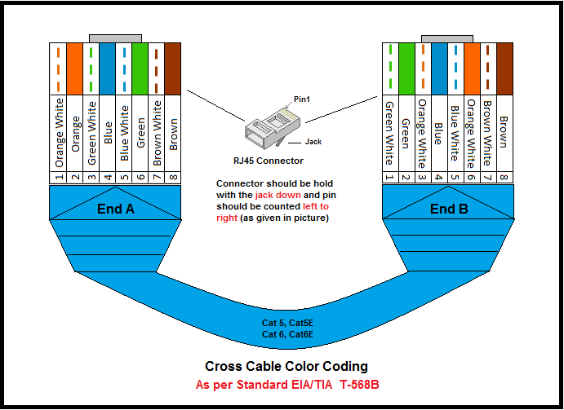
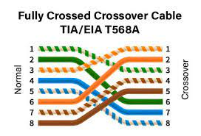

- Straight Through Cable Diagram (Color Code)
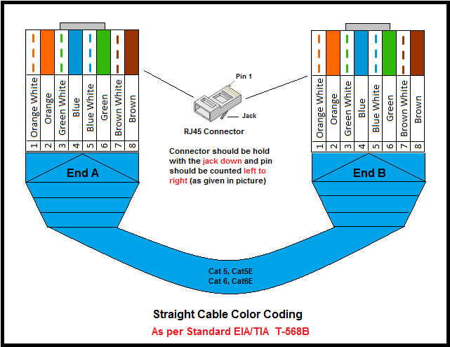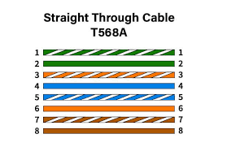

**Connection**

