Lab Practical #12:
Study the concept of routing using packet tracer. (Static Routing)
Practical Assignment #12:
- Static routing is a method where routes are manually configured and fixed by the network administrator, rather than being automatically determined by routing protocols. It’s simple, predictable, and used in smaller or stable networks.
- Connect the two different networks based on the calculated IP addresses and subnet using a packet tracer.
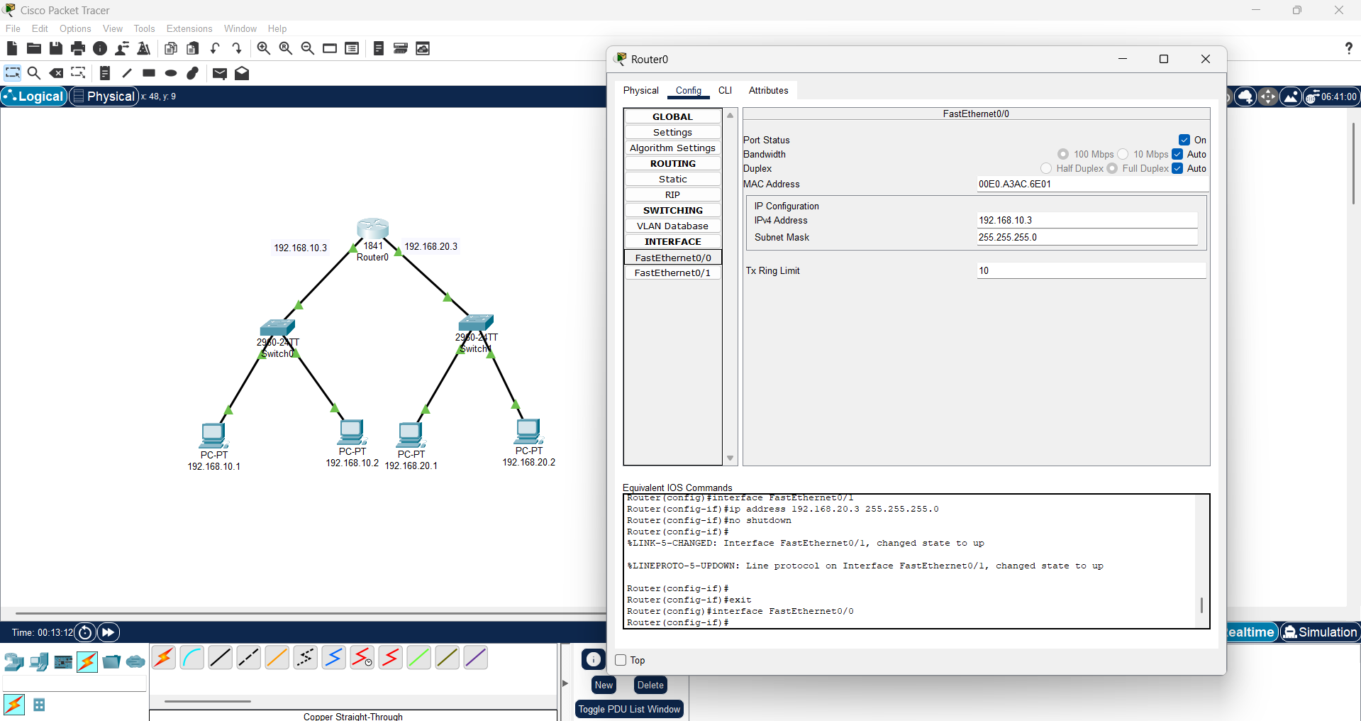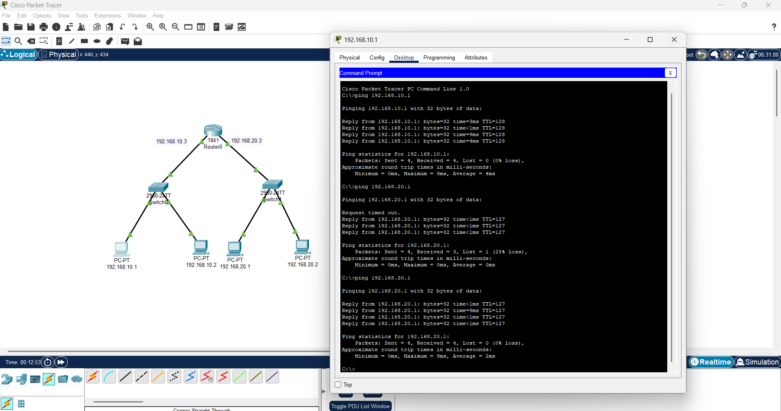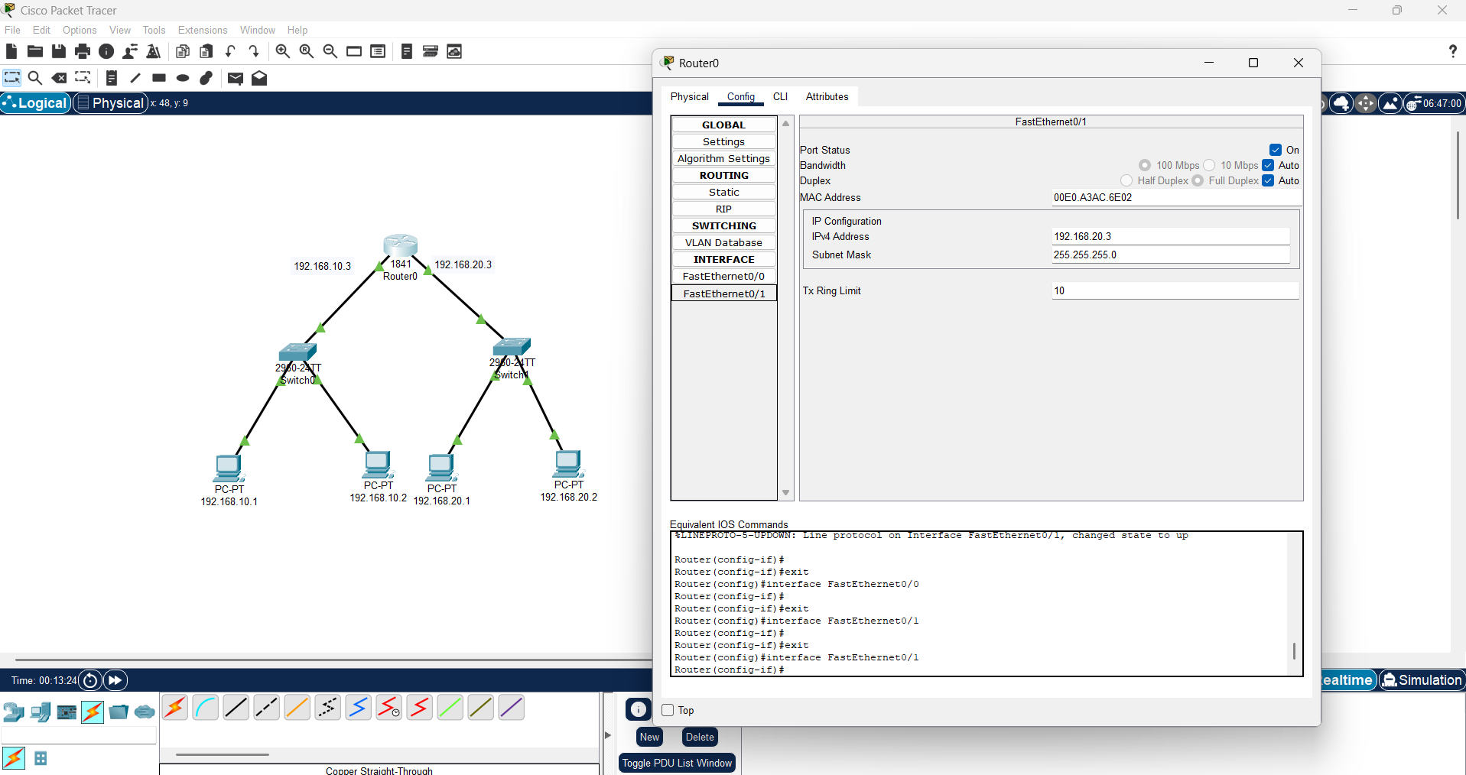

- Connect the three different networks based on the calculated IP addresses and subnet using a packet tracer.
