Lab Practical #05:
Study the concept of VLAN using packet tracer.
Practical Assignment #05:
- Implement the different network structures in VLAN and VLAN trunking. Also check connectivity between them using ping command or PDU utility.

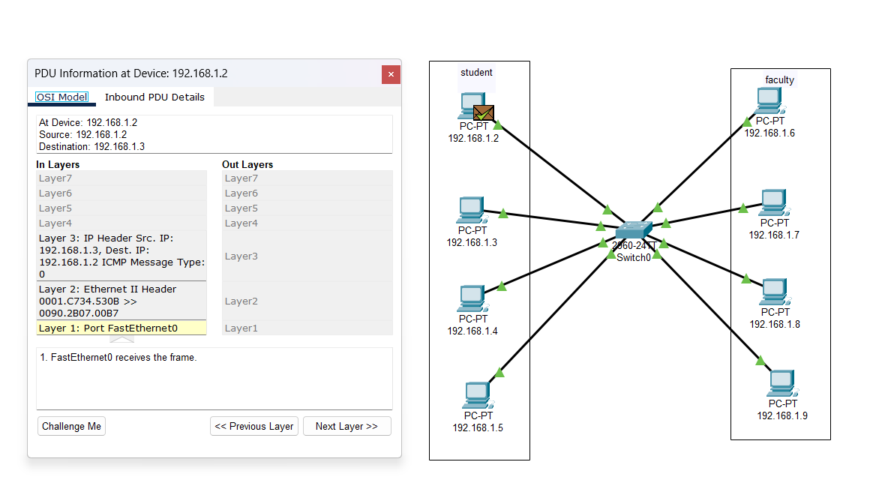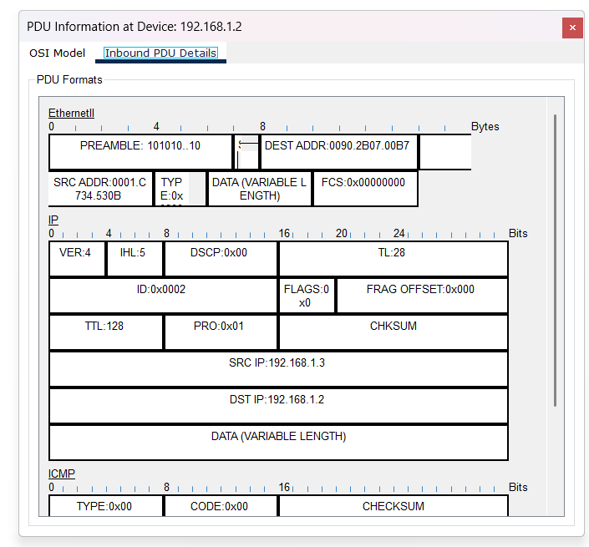

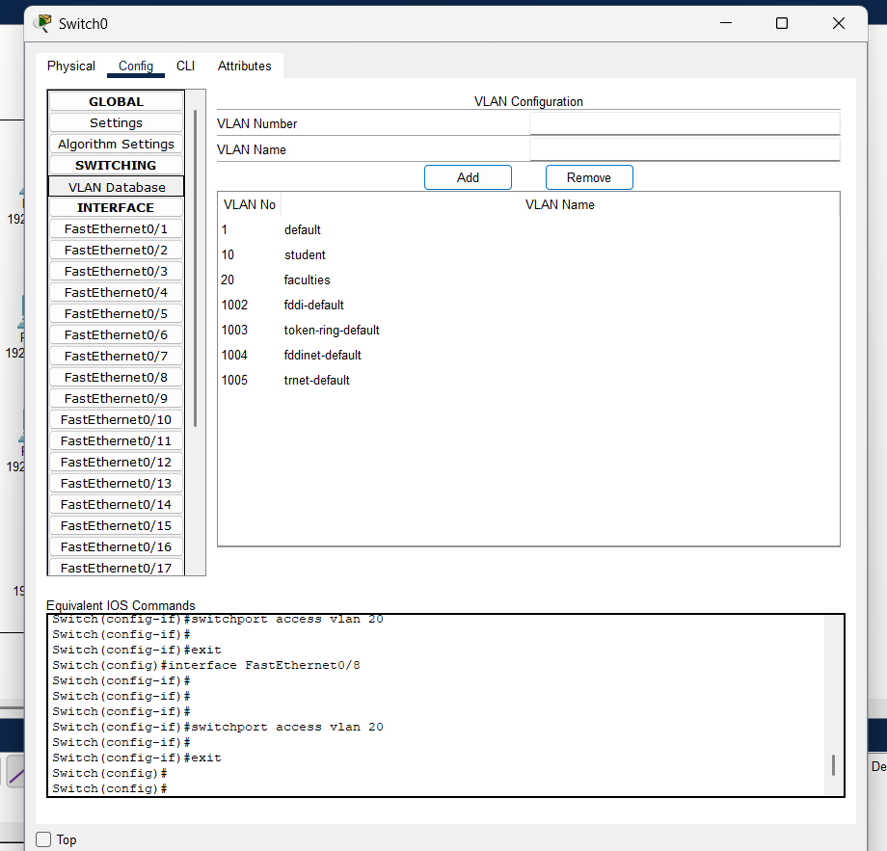

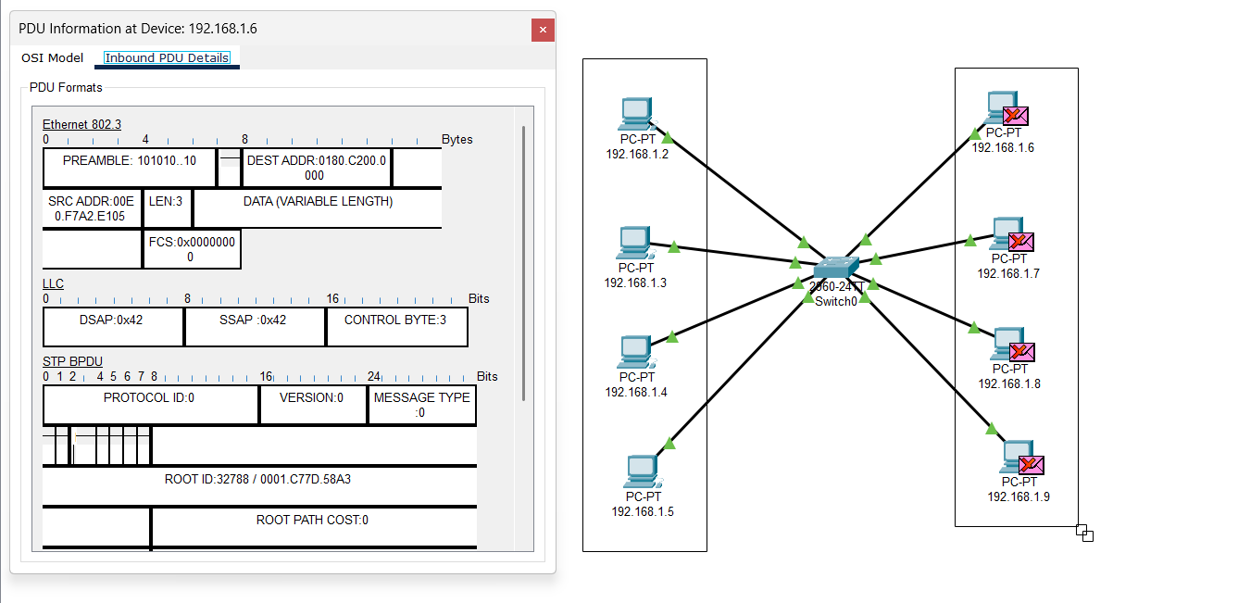
Steps :
- Open Switch Config
  - Click on the switch → Go to Config tab.
- Go to VLAN Database
  - Under Switching, click VLAN Database.
- Add VLANs
  - Type VLAN Number (ex=10) and VLAN Name (ex=student).
  - Click Add.
  - Do the same for VLAN 20 with name faculties.
- Assign Ports to VLANs
  - On the left side, click an Interface (ex=FastEthernet0/1).
  - Set VLAN ID to 10 or 20 as needed.
  - Repeat for each PC port.
- Verify
  - VLAN 10 (student) and VLAN 20 (faculties) will show in the list with assigned ports.

Instructions:
- Different VLANs configuration setup screenshot. (VLAN example given by lab faculty)
- Write steps to create VLANs in packet tracer.
- Mention IP address of each pc as label.
- Ping command or PDU screenshot between two VLANs.

