Lab Practical #01:
Study of basic networking commands and IP configuration.
Practical Assignment #01:
- Perform and explain various networking commands listed below:
  - ping
  - ipconfig
  - getmac
  - systeminfo
  - traceroute / tracert
  - netstat
  - nslookup
  - hostname
  - pathping
  - arp

ping

Description:
The ping command checks if another computer or device is reachable over a network. It sends a signal and waits for a reply to test connection and speed.
No. | Option | Description
1 | ping -a | Finds the hostname of an IP address by sending a network signal and showing its name if available.
2 | ping -t | Keeps pinging the target until you stop it manually, used to check continuous connection.
3 | ping -l | Sets the size of the packet sent, useful for testing with bigger or smaller data packets.
4 | ping -n | Sets how many times to ping the target instead of the default 4 times.
5 | Ping -f | Sends ping packets without allowing fragmentation, used to test network’s ability to handle large packets without breaking.

Implementation:

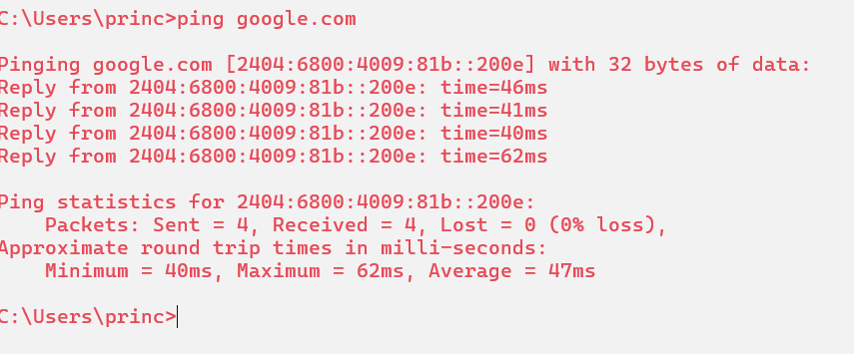

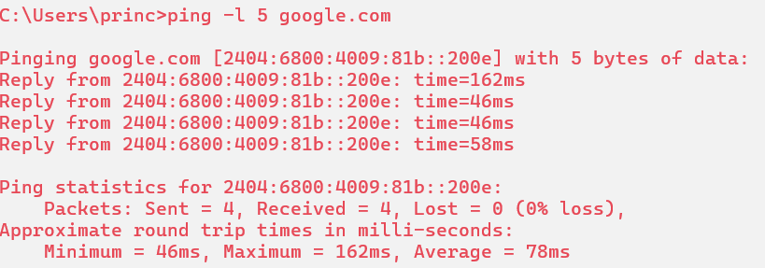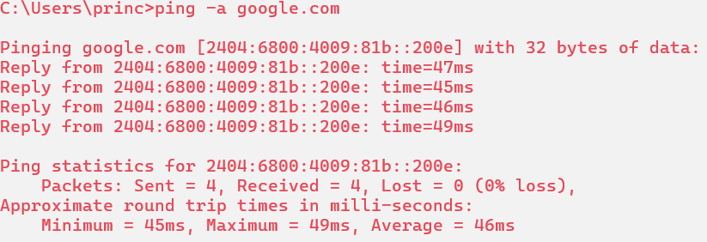

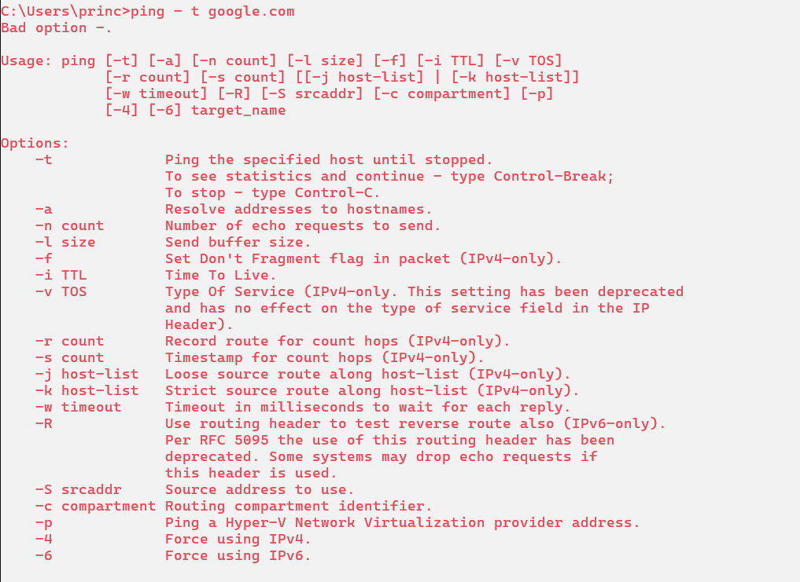

ipconfig

Description:
ipconfig shows your computer’s internet details—like IP address and connection info. It helps check, fix, and understand how your device connects to a network or internet.
No. | Option | Description
1 | Ipconfig -all | Shows full network details, including IP address, MAC address, and DNS info for all adapters.
2 | Ipconfig -release | Removes the current IP address from your computer, disconnecting it from the network temporarily.
3 | Ipconfig -renew | Requests a new IP address from the network, reconnecting your computer with fresh connection settings.
4 | ipconfig -flushdns | Clears the DNS cache on your computer, helping fix website loading or name resolution problems.
5 | Ipconfig - displaydns | Shows the list of recently visited website addresses stored in your computer's DNS cache to speed up future access.

Implementation:
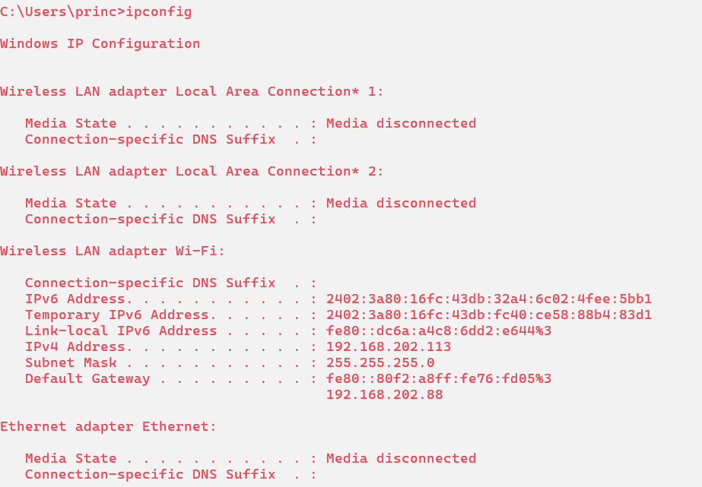

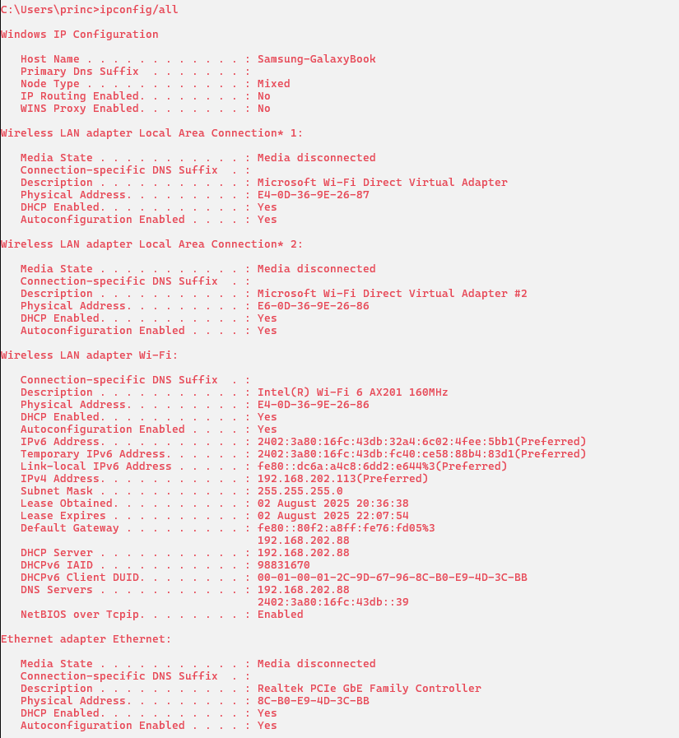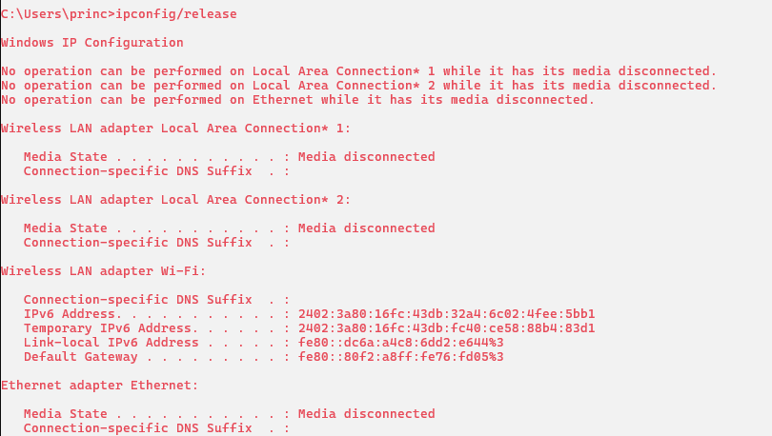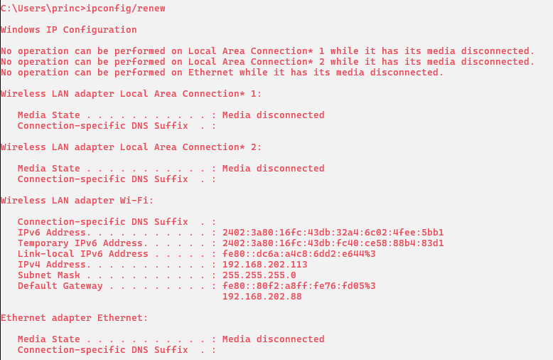

getmac

Description:
getmac is a command used to show the MAC (Media Access Control) address of your computer's network adapter. It helps identify devices connected to a network.
No. | Option | Description
1 | getmac /s | Connects to a remote computer by name or IP address to get its MAC address information from your system.
2 | getmac /u | Specifies the username for connecting to the remote computer to get MAC address details under a different user context.
3 | getmac /p | Provides the password for the specified user. If not included, it asks you to type the password manually.
4 | getmac /fo | Changes how results are displayed. Options are: TABLE (grid), LIST (detailed), or CSV (comma-separated values for Excel use).
5 | getmac /nh | Removes column headers from the output. Useful for clean data display, especially in scripts or automated tasks.

Implementation:

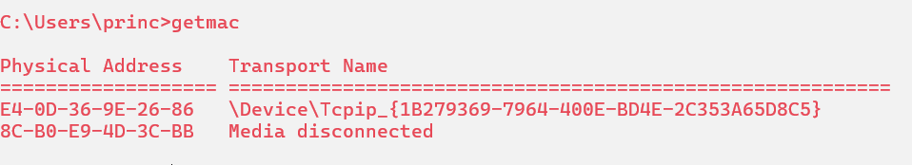

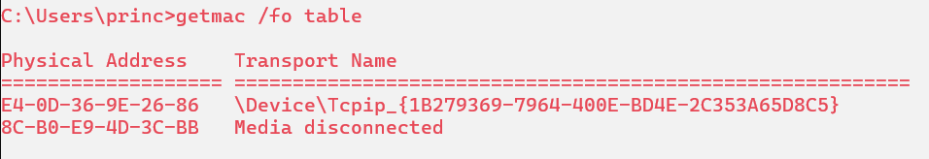

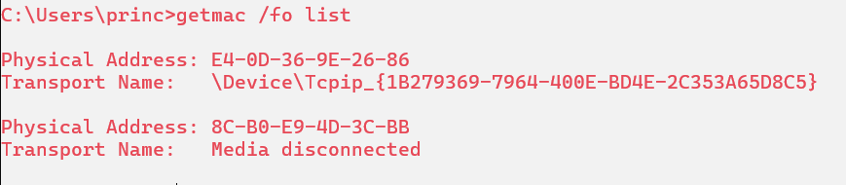

systeminfo

Description:
systeminfo is a command that shows detailed information about your computer, like system name, OS version, memory, processor, network, and more — helpful for checking system details quickly.
No. | Option | Description
1 | Systeminfo /s | Connects to a remote computer using its name or IP to get system information from that remote machine.
2 | Systeminfo /u | Lets you enter a specific username to access the remote computer and view its system information securely.
3 | Systeminfo /p | Provides the password for the username used to connect to the remote computer. Needed if the user account is protected.
4 | Systeminfo /fo | Changes how the system info is displayed. Options are: table, list, or CSV (for spreadsheet use).
5 | Systeminfo /nh | Hides column headers from the output. Useful when using the data in scripts or for simpler output.

Implementation:

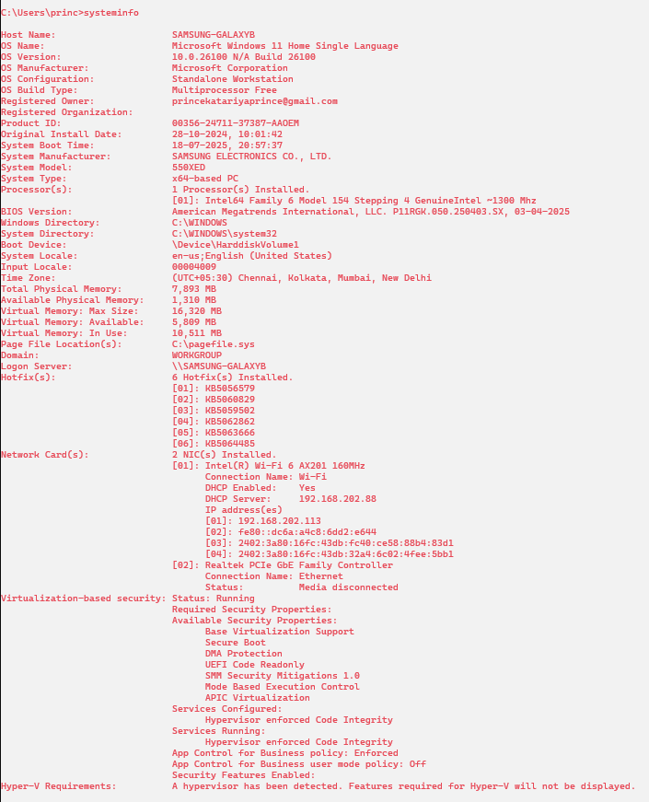

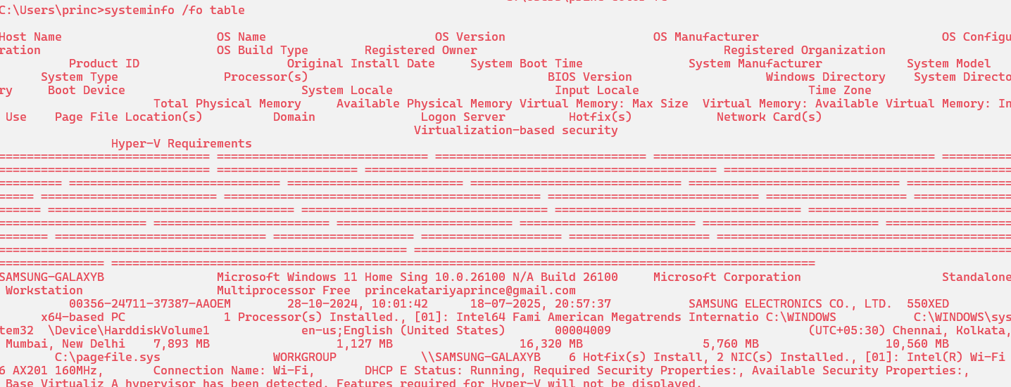

tracert

Description:
tracert is a command that shows the path your data takes to reach another computer or website, including all the stops (hops) between your system and the destination.
No. | Option | Description
1 | tracert -d | Stops resolving IP addresses to hostnames. Shows only IPs, making the command run faster without DNS lookups.
2 | tracert -h | Sets the maximum number of hops (routers) to trace. Helps control how far the tracert command will go.
3 | tracert -w | Sets the wait time (in milliseconds) for each reply. Useful if the network is slow or unresponsive.
4 | tracert -j | Lets you specify a list of routers for the packet to pass through (loose source routing). Rarely used today.
5 | tarcert -R | Traces the route to a destination and back (round trip), showing the path in both directions. Windows-only option.

Implementation:

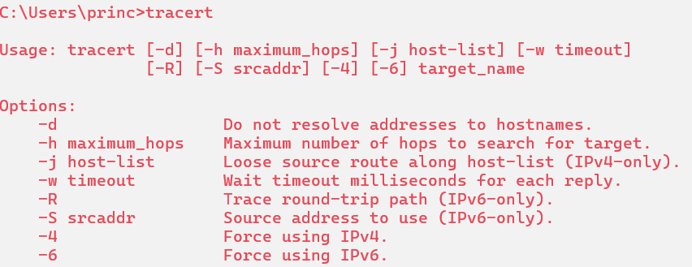
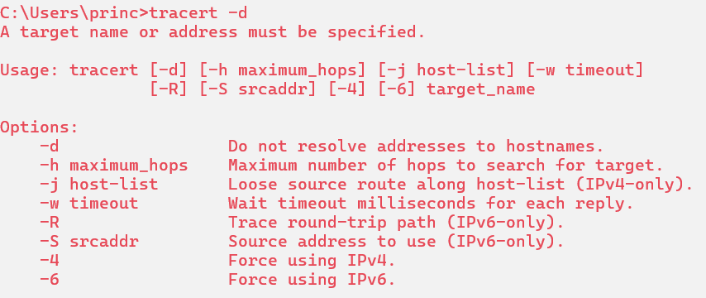
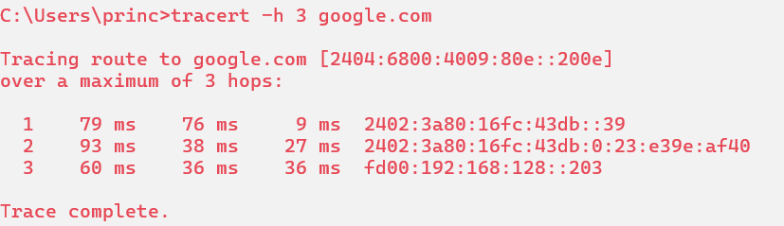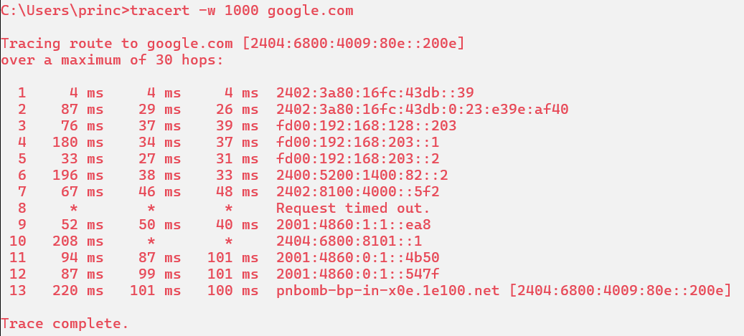

netstate

Description:
netstat is a command that shows network connections, open ports, and network statistics. It helps check which programs are using the internet or network on your computer.
No. | Option | Description
1 | netstat -a | Shows all active connections and listening ports on your computer, including both TCP and UDP ports.
2 | netstat -b | Shows the program or app (executable) using each connection or port. Needs admin rights and may run slower.
3 | netstat -c | Lists processes sorted by how many network ports (TCP/UDP) they are using. Helps find network-heavy apps.
4 | netstat -d | Displays DSCP (priority) values for each connection, showing how network traffic is being handled or prioritized.
5 | netstat -e | Shows network statistics, like bytes sent and received, errors, and dropped packets — useful for checking connection performance

Implementation:
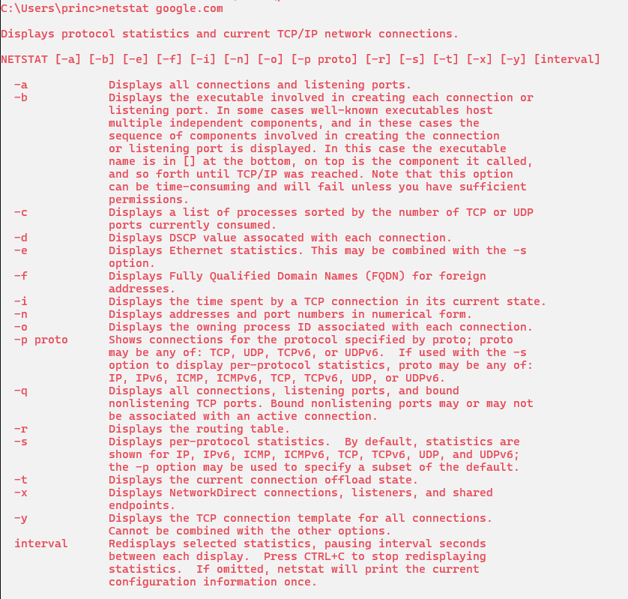
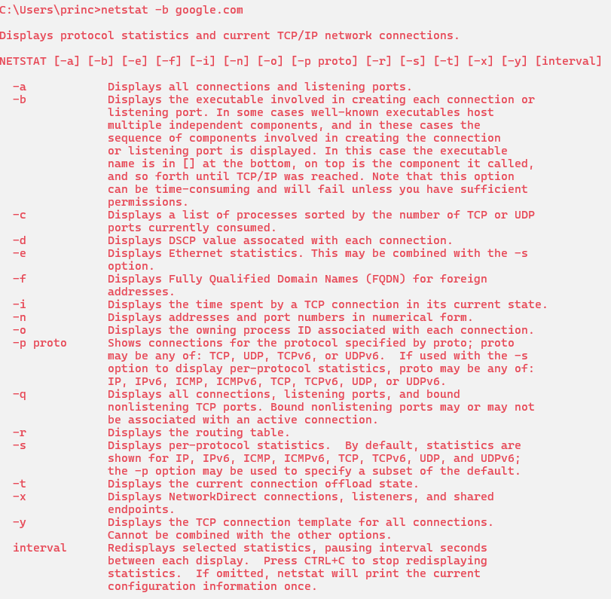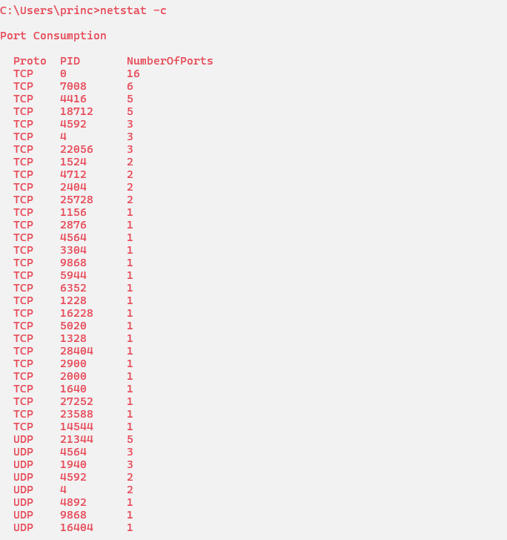

nslookup

Description:
nslookup is a command used to find the IP address of a website or domain name. It helps check and troubleshoot DNS (Domain Name System) problems easily.
No. | Option | Description
1 | nslookup -server | Lets you choose a specific DNS server to send your query to, instead of using your default one.
2 | nslookup -host | Sends a DNS query to find the IP address of the given hostname or domain, like google.com.

Implementation:
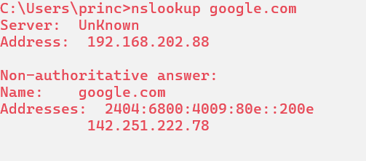
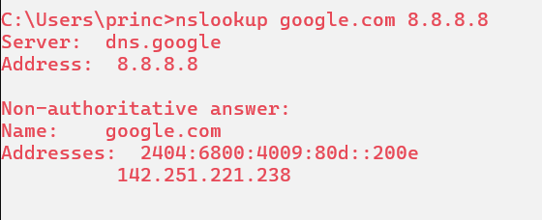
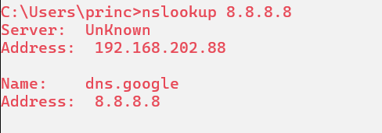

hostname

Description:
hostname is a command that shows the name of your computer on a network. It helps identify your device when sharing files or using remote access.

Implementation:

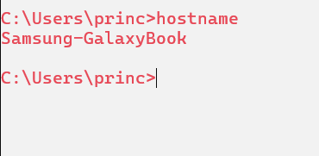

pathping

Description:
pathping is a command that checks the route and network issues between your computer and another device. It shows packet loss and delay at each network hop.
No. | Option | Description
1 | pathping -g | Lets you specify gateway addresses the packet should go through, controlling the route manually (source routing).
2 | pathping -h | Sets the maximum number of hops the packet can take before stopping. Helps limit how far the trace goes.
3 | pathping -i | Specifies the network interface (like Wi-Fi or Ethernet) to use for sending packets during the test.
4 | pathping -n | Stops converting IP addresses to hostnames. Faster results since it skips name resolution.
5 | pathping -p | Sets the wait time in milliseconds between each ping. Useful when testing slow or distant networks.

Implementation:
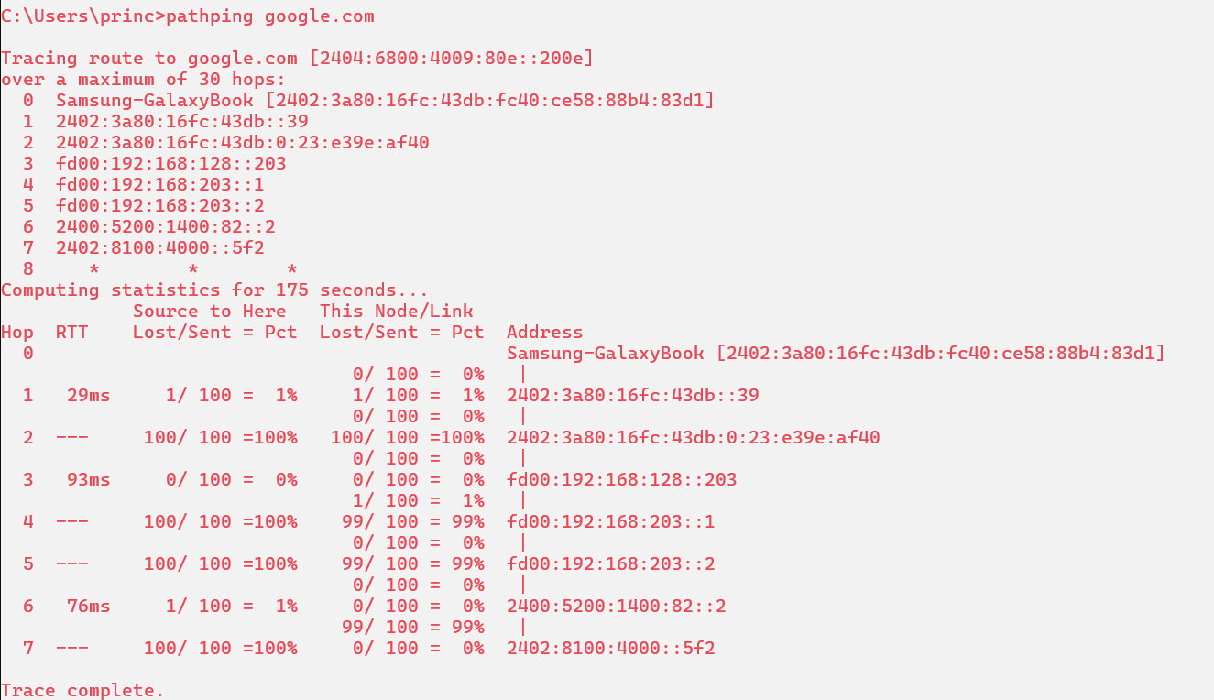
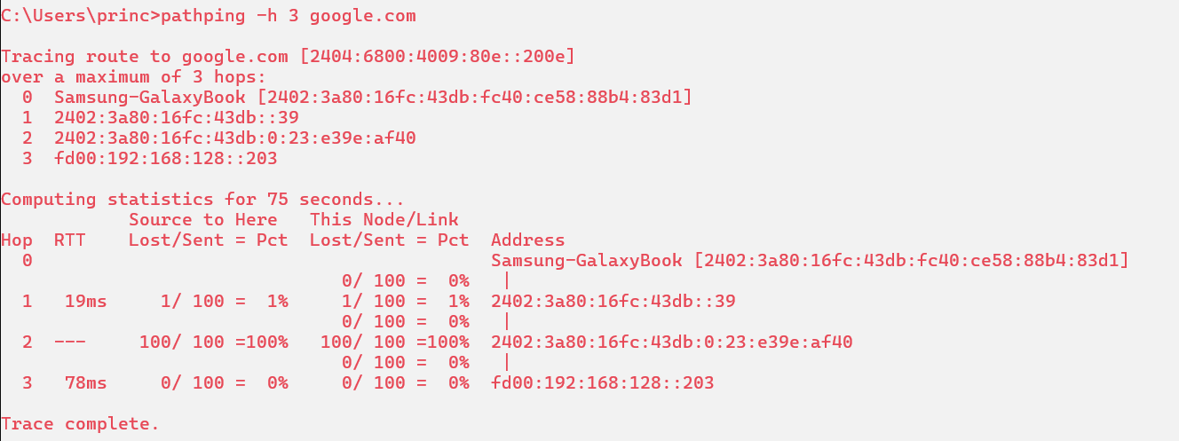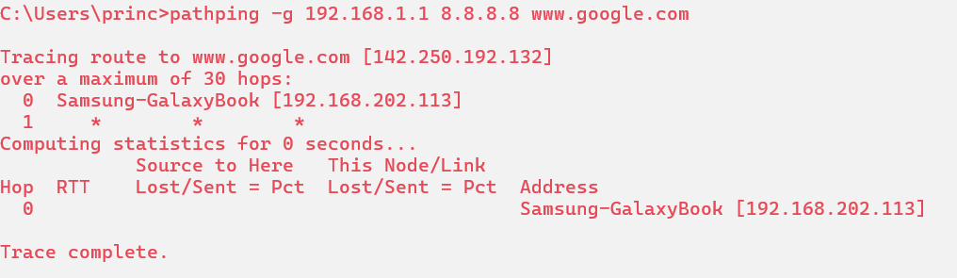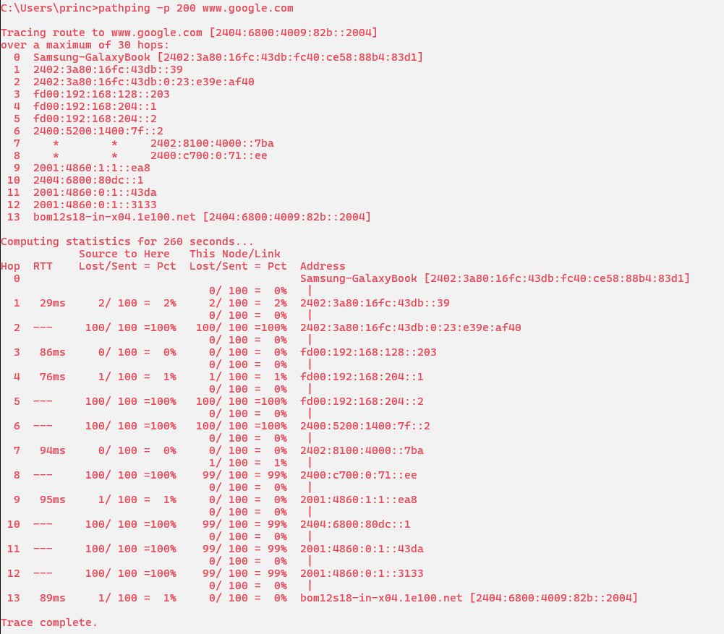

arp

Description:
arp is a command that shows or changes the Address Resolution Protocol table, which maps IP addresses to MAC addresses on a local network for communication.
No. | Option | Description
1 | arp -a | Displays the current ARP table, showing IP addresses and their matching MAC addresses on your local network.
2 | arp -d | Deletes a specific ARP entry from the table using its IP address. Helps clear outdated or incorrect entries.
3 | arp -s | Adds a static ARP entry by linking an IP address to a MAC address manually in your table.
4 | arp -g | Same as arp -a, shows the ARP table with IP and MAC address mappings for all network interfaces.
5 | arp -v | Displays verbose output. Shows extra details about the ARP entries for better understanding or troubleshooting.

Implementation:
