Lab Practical #07:
Study the application layer protocol DNS, DHCP, FTP.
Practical Assignment #07:
- Implement the application layer protocol DNS, DHCP, and FTP. Also check connectivity between them using ping command or PDU utility.

- DNS (Domain Name System): It changes website names (like google.com) into numbers (IP addresses) that computers understand.
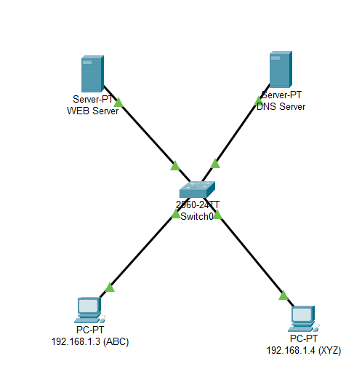

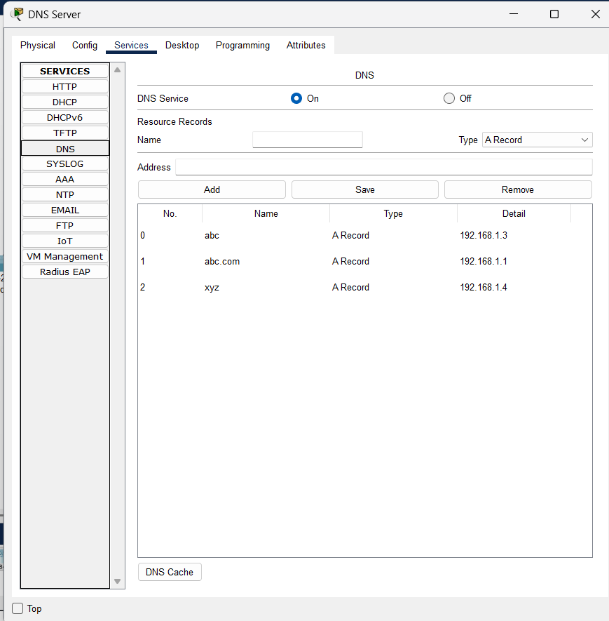
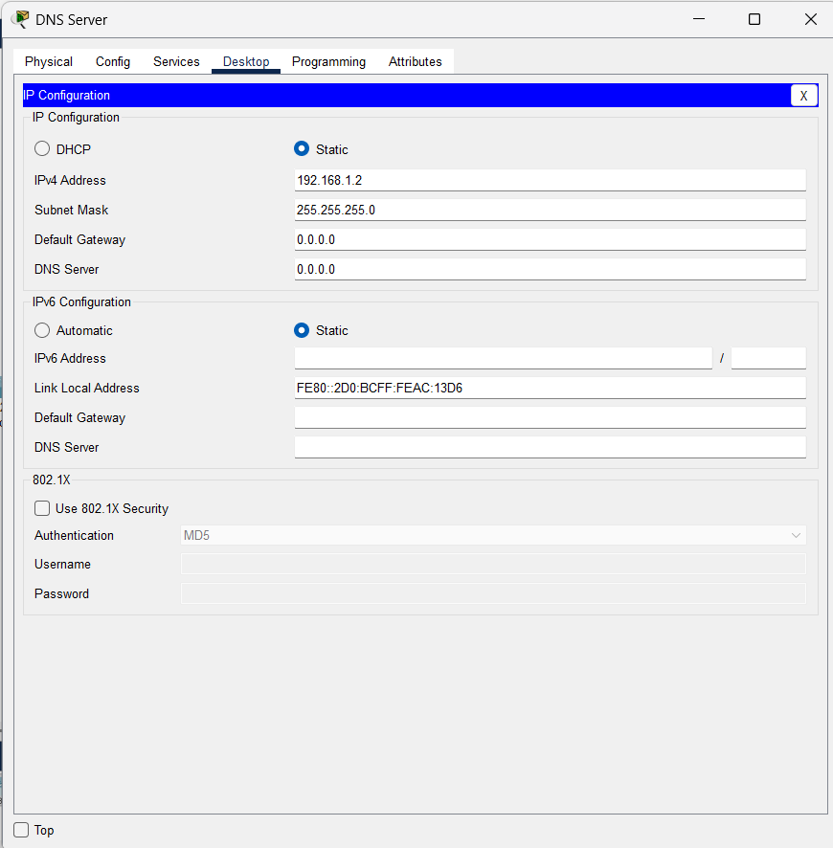

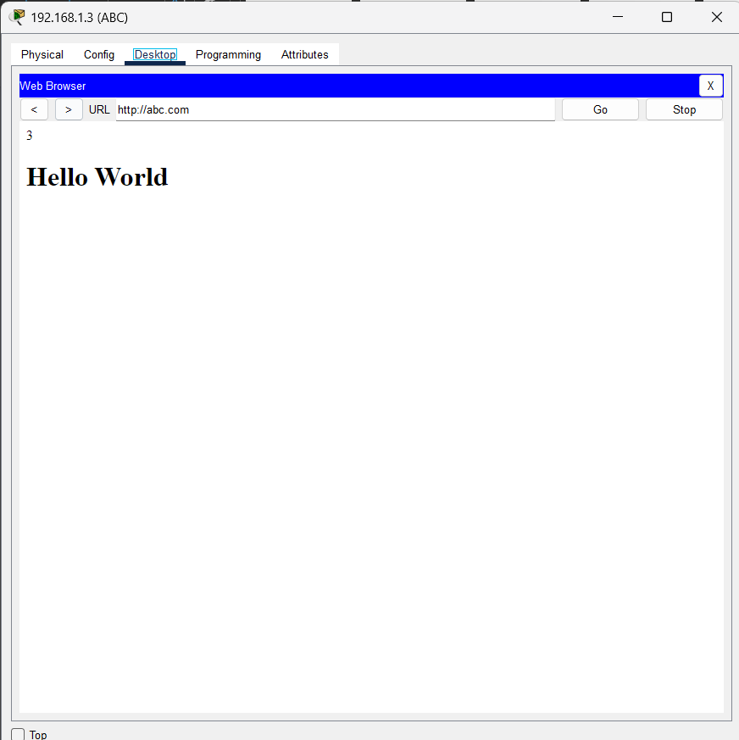
- DHCP (Dynamic Host Configuration Protocol): It automatically gives IP addresses to computers in a network so they can connect easily.
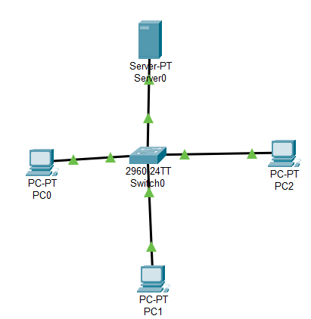

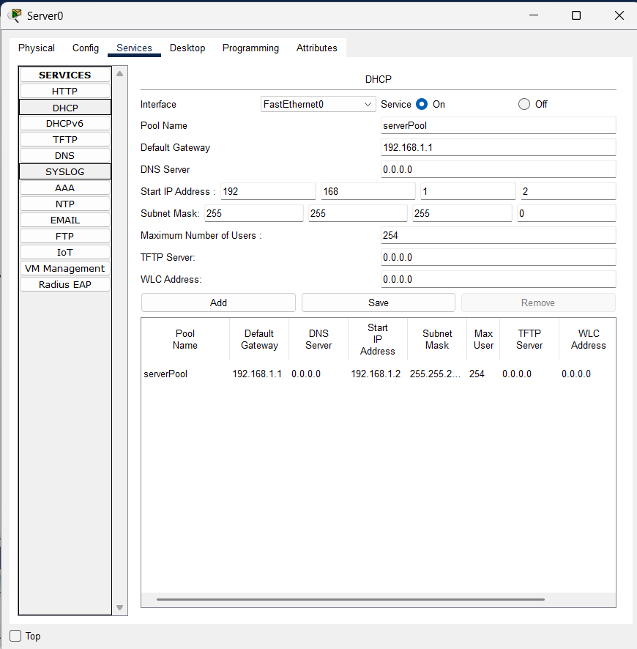

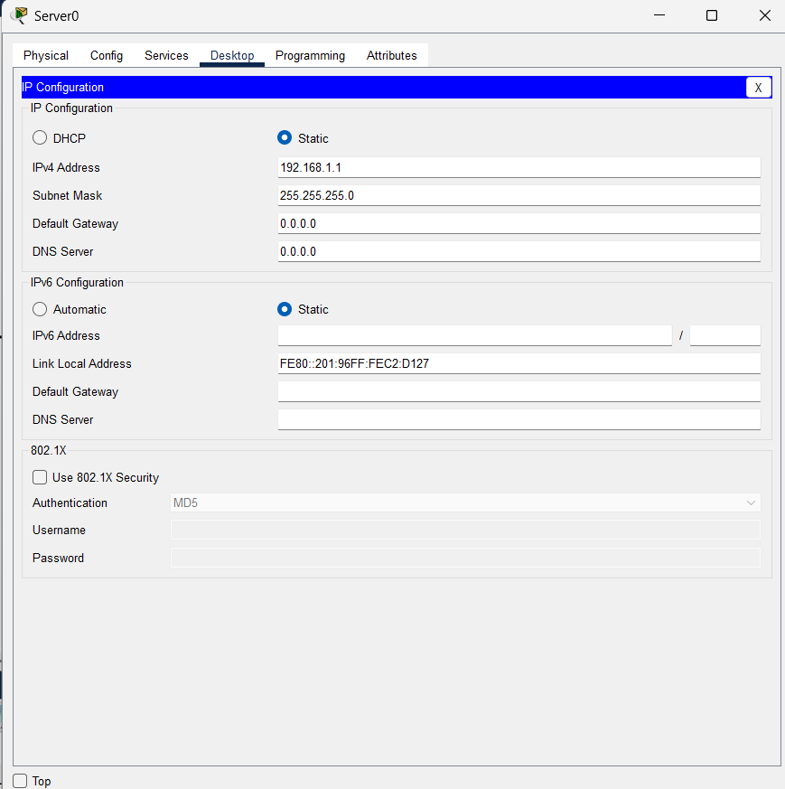

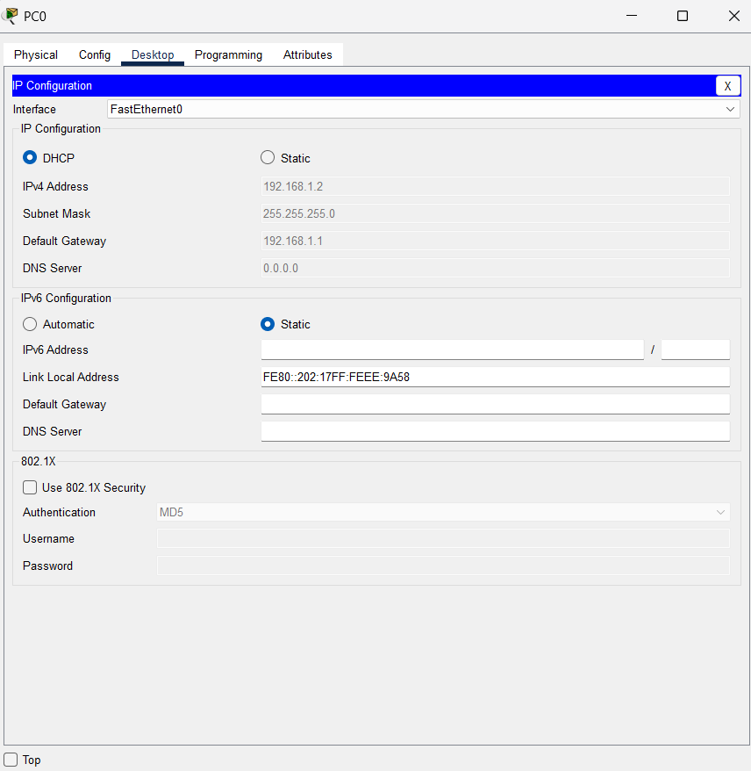

- FTP(File Transfer Protocol): It is used to send or receive files between computers over the internet or a network.
