Lab Practical #09:
Study Packet capture and header analysis by Wireshark (HTTP, TCP, UDP, IP, etc.)
Practical Assignment #09:
- Explain usage of Wireshark tool.
- What is Wireshark?
- Wireshark is a network monitoring tool.
- It lets you see all the data (packets) moving in and out of your computer or network.
- Think of it like a CCTV camera for internet traffic – it records and shows you exactly what is happening on the network.

- Why is it useful?
- To troubleshoot network problems (e.g., slow internet, dropped connections).
- To analyse security issues (e.g., suspicious traffic, hacking attempts).
- To learn how networks work (great for students and professionals).
- To check protocols (HTTP, DNS, FTP, etc.) and see how they behave.

- How does it work?
- You open Wireshark and start capturing packets.
- Wireshark shows you a list of packets going through your computer/network.
- You can filter packets (e.g., show only HTTP or DNS packets).
- You can inspect details inside each packet (like source IP, destination IP, protocol, message contents)
- Packet capture and header analysis by Wireshark (HTTP, TCP, UDP, IP, etc.)

- Packet capture and header analysis by Wireshark (HTTP, TCP, UDP, IP, etc.)
1. Packet Capture
- Packet = small chunk of data sent over a network.
- Wireshark can capture packets in real-time while they travel from source to destination.
- Each captured packet can be saved, filtered, and analyzed later.

2. Header Analysis
1. HTTP Packets
- In your screenshots, we clearly see HTTP requests/responses (e.g., GET /login, HTTP/1.1 200 OK).
- This shows Application Layer capture.
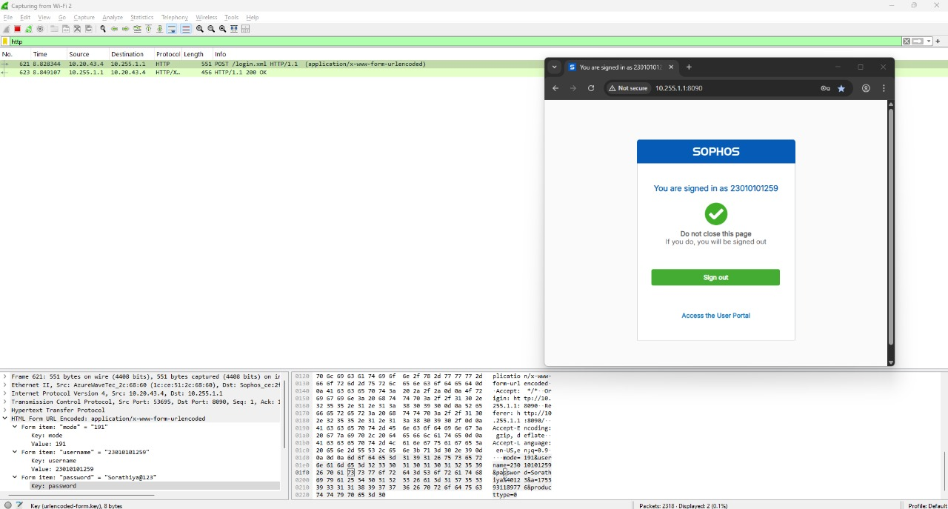

2. TCP Packets
- Multiple TCP connections with sequence/ack numbers (SYN, ACK, FIN) are visible.
- This is Transport Layer (TCP) analysis.
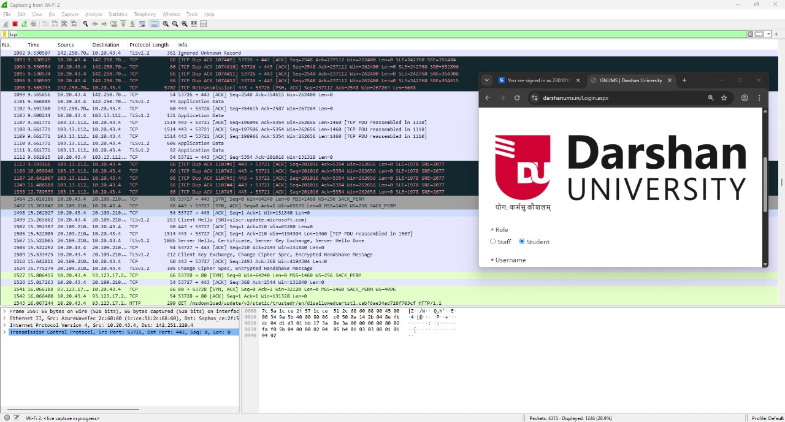

3. UDP Packets
- In the YouTube capture, UDP packets are shown (ports, length, etc.).
- This confirms UDP traffic analysis.
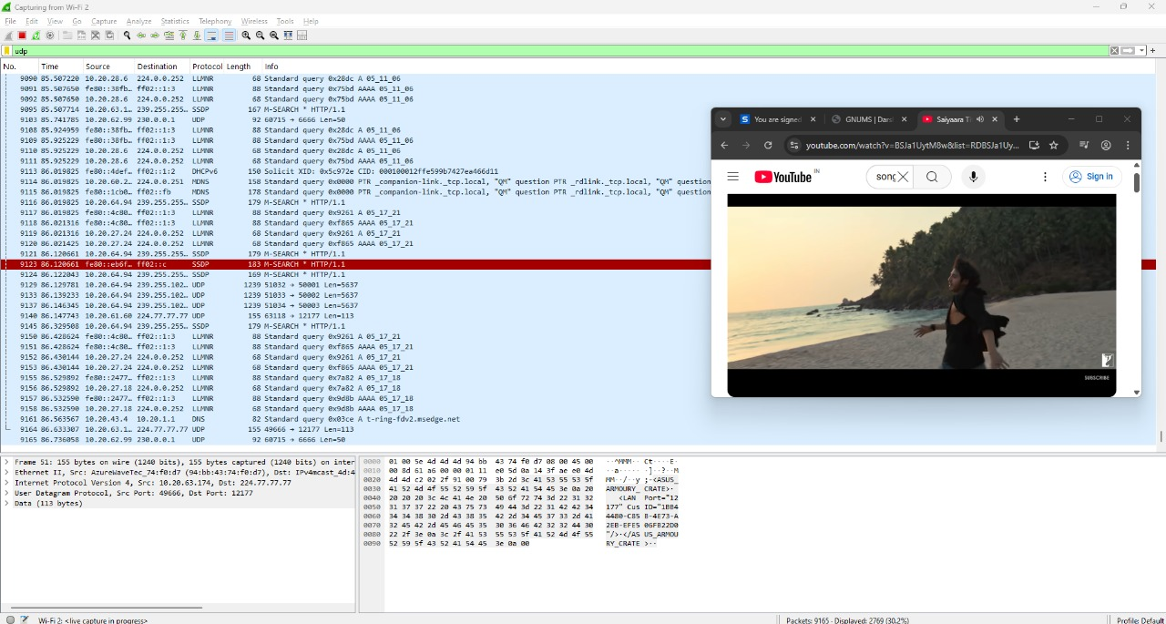
4. DNS Packets
- Before your browser can talk to www.example.com, it needs the IP address.
- That’s done by DNS (Domain Name System).
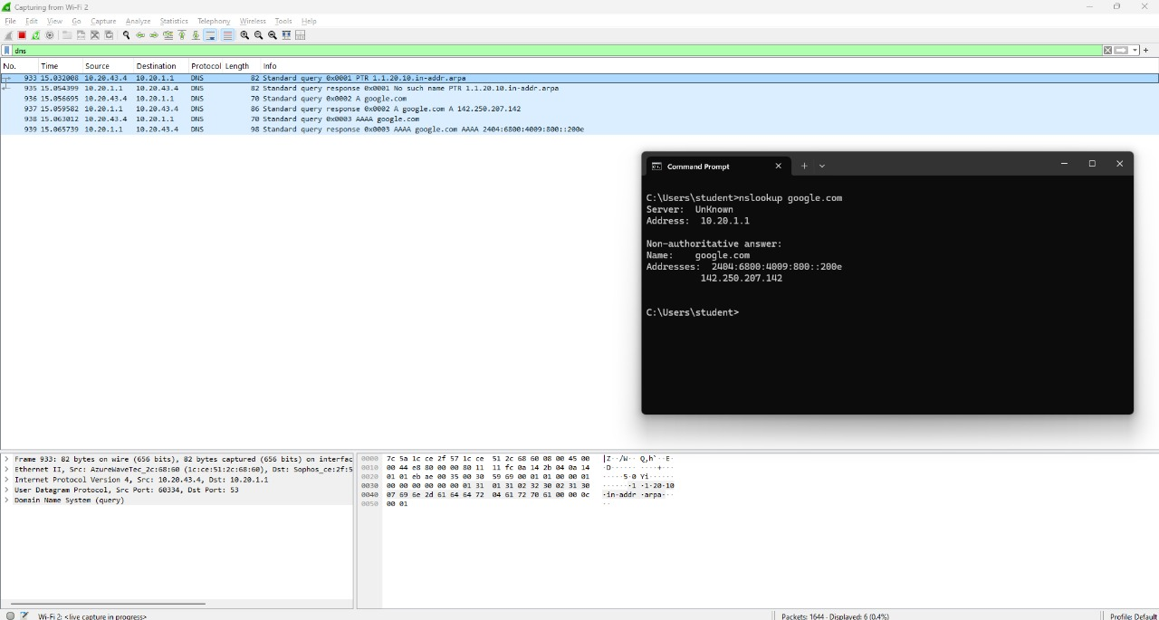
5. ICMP Packets
- The ping google.com screenshot shows ICMP Echo Request and Reply.
- This proves analysis of control messages at the Network Layer.
