Pune Institute of Computer Technology

(An Autonomous Institute Affiliated to Savitribai Phule Pune University)

Department of Computer Engineering

AY : 2026-27



DWML MINI PROJECT REPORT

ON

“ Customer Segmentation using Clustering Techniques ”

Submitted By

31474 Shreeya Tapaswi

Class : TY
Batch : N4

Under the guidance of
Prof. M. S. Chavan

Contents
1. Introduction 3
2. Theoretical Background 4
2.1 Distance and Standardisation 4
2.2 Partitioning Methods 4
2.3 Hierarchical Methods 4
2.4 Density-Based Methods 4
2.5 Evaluation of Clustering 4
2.6 Outlier Detection Methods 5
3. Dataset Description 5
4. Methodology and Tools 5
5. Implementation and Results 7
5.1 Exploratory Data Analysis 7
5.2 Clustering Tendency 7
5.3 Partitioning Methods 7
5.4 Hierarchical Methods 9
5.5 Density-Based Methods 9
5.6 Evaluation of the Clusterings 10
5.7 Outlier Detection 12
5.8 Final Model after Outlier Removal 13
5.9 Segment Profiling and Business Strategy 14
6. Comparative Discussion 15
7. Conclusion, Limitations and Future Scope 16
References 16

1. Introduction
Retailers collect large amounts of data about their customers, but treating every customer alike is wasteful: a discount that attracts a price-sensitive student is unnecessary for a wealthy frequent shopper, and a luxury promotion is lost on someone who rarely spends. Customer segmentation divides the customer base into groups whose members are similar to each other and different from other groups, so that marketing effort can be matched to each group. It is a classic use of cluster analysis, an unsupervised technique in which there is no target label; the algorithm decides which records belong together using distance or density. Because there is no answer key, validating the result is as important as running the algorithm.
Problem statement. A shopping mall wants to understand its customers. Given each customer’s annual income and spending score, group the customers into meaningful segments using different clustering algorithms, evaluate how reliable the groups are, detect abnormal customers and recommend a marketing strategy for every segment.
Objectives of the project are:
- to apply partitioning methods (K-Means, K-Medoids) and choose a suitable number of clusters;
- to apply hierarchical clustering, compare linkage criteria and interpret the dendrogram;
- to apply density-based methods (DBSCAN, OPTICS), which need no K and identify noise;
- to evaluate the clusterings with tendency tests, internal indices, stability and inter-method agreement;
- to detect outliers with several detector families and combine them by voting; and
- to profile the final segments and propose a strategy for each.
The project uses one public dataset and clusters on annual income and spending score; age and gender are used only to describe the segments. It is implemented in Python on Google Colab.

2. Theoretical Background

2.1 Distance and Standardisation
Similarity is measured with the Euclidean distance d(x, y) = √(Σ(xᵢ − yᵢ)²). Because attributes with large numeric ranges dominate distances, features are standardised with the z-score z = (x − μ)/σ before clustering.

2.2 Partitioning Methods
K-Means represents each cluster by its centroid (the mean of its members) and minimises the within-cluster sum of squares J = Σₖ Σ(x∈Cₖ) ‖x − μₖ‖². It alternates between assigning every point to the nearest centroid and recomputing the centroids until nothing changes. The k-means++ initialisation spreads the starting centroids and gives better, more consistent results. K-Means is fast, but needs K in advance, prefers compact round clusters and is sensitive to outliers because a mean is pulled by extreme values.
K-Medoids (PAM) uses a medoid, an actual data point with the smallest total distance to the other members, as the cluster centre, and minimises Σₖ Σ(x∈Cₖ) d(x, mₖ). Using real points and plain (not squared) distances makes it more robust to outliers. Here a simplified alternating version was written from scratch: assign points to the nearest medoid, replace each medoid by the member with the smallest total within-cluster distance, repeat until no medoid changes, and keep the best of ten restarts.

2.3 Hierarchical Methods
Agglomerative clustering starts with every point as its own cluster and repeatedly merges the two closest clusters; the merges are recorded as a dendrogram that can be cut at any height. The distance between clusters depends on the linkage: single (smallest pairwise distance; prone to the chaining effect), complete (largest pairwise distance; compact clusters), average (mean pairwise distance) and Ward (smallest increase in within-cluster variance; compact, balanced clusters). The cophenetic correlation measures how faithfully the dendrogram preserves the original distances.

2.4 Density-Based Methods
DBSCAN defines clusters as dense regions separated by sparse regions using a radius ε and a minimum number of points MinPts. A core point has at least MinPts points within ε, a border point lies within ε of a core point, and every other point is noise (label −1). It needs no K and finds arbitrary shapes, but one ε must suit all clusters. The k-distance graph (sorted distance to the k-th neighbour) helps choose ε near its bend. OPTICS orders the points and records a reachability distance for each; in the reachability plot clusters appear as valleys. Clusters can be extracted automatically (ξ method) or by cutting the plot at a chosen height.

2.5 Evaluation of Clustering
- Hopkins statistic: H = Σu/(Σu + Σw), where u are distances from random points to the nearest real point and w from real points to their nearest neighbour; about 0.5 means random data, near 1 strongly clustered data.
- Silhouette: s = (b − a)/max(a, b) with a the mean distance within the cluster and b to the nearest other cluster (higher is better). Calinski-Harabasz is the between-to-within dispersion ratio (higher is better); Davies-Bouldin is the mean similarity of each cluster to its closest cluster (lower is better).
- Adjusted Rand Index (ARI): chance-corrected agreement between two labellings (1 = identical). With no true labels it is used for stability (re-clustering random subsamples) and for agreement between algorithms.

2.6 Outlier Detection Methods
The detectors used are: Z-score (|z| > 3) and the IQR rule (outside Q1 − 1.5·IQR and Q3 + 1.5·IQR) as univariate statistical tests; Mahalanobis distance, a multivariate statistical test that accounts for correlation and flags D² above the 97.5 % chi-square quantile; distance to the own K-Means centroid (IQR rule); DBSCAN noise points; Local Outlier Factor (LOF), which compares a point’s local density with that of its neighbours; and Isolation Forest, which isolates outliers in few random splits.

3. Dataset Description
The Mall Customer Segmentation Data (Kaggle) holds 200 customers collected through membership cards, with no missing values and no duplicates. The attributes are listed in Table 1 and the statistics of the numeric ones in Table 2. The average customer is about 39 years old, earns 60.6k dollars a year and has a spending score of about 50. Income reaches 137k while its 75th percentile is only 78k, which hints at a few high-income extremes.
Table 1: Attributes of the dataset
Attribute | Type | Description
CustomerID | Integer | Unique identifier of the customer (1 to 200)
Gender | Categorical | Female (112 customers) or Male (88 customers)
Age | Integer | Age in years (18 to 70)
Annual Income (k$) | Integer | Annual income in thousands of dollars (15 to 137)
Spending Score (1-100) | Integer | Score assigned by the mall from customer behaviour and spending (1 to 99)

Table 2: Descriptive statistics (n = 200)
Attribute | Mean | Std | Min | Median | Max | Q1 / Q3
Age | 38.85 | 13.97 | 18 | 36 | 70 | 28.75 / 49
Annual Income (k$) | 60.56 | 26.26 | 15 | 61.5 | 137 | 41.5 / 78
Spending Score | 50.20 | 25.82 | 1 | 50 | 99 | 34.75 / 73

4. Methodology and Tools
The project uses Python 3 on Google Colab with NumPy, pandas, Matplotlib and Seaborn for data handling and plots, scikit-learn for the algorithms and metrics, and SciPy for the dendrogram, cophenetic correlation and chi-square distribution. The workflow was:
- Load the data and explore it (distributions, boxplots, gender split, correlations).
- Select and standardise the clustering features; test the clustering tendency (Hopkins statistic).
- Choose K with the elbow method and the silhouette score.
- Apply K-Means, K-Medoids, agglomerative clustering, DBSCAN and OPTICS.
- Evaluate all methods (internal indices, stability, agreement) and detect outliers with seven detectors combined by voting (at least 3 votes).
- Remove the consensus outliers, re-fit K-Means, compare quality, then profile and name the segments.
Annual Income and Spending Score were chosen as clustering features because they describe purchasing power and behaviour, are almost uncorrelated (0.010) and allow every result to be drawn in a 2-D scatter plot. Age and Gender were kept out of the clustering and used afterwards only to describe the segments. Both features were z-score standardised; a second scaler was fitted on the cleaned data for the final model.

5. Implementation and Results

5.1 Exploratory Data Analysis
The data is clean (200 rows, no missing values, no duplicates). Figure 1 shows that age is right-skewed with most customers between 25 and 50, income is roughly bell-shaped with a long right tail (a few points beyond the upper whisker), and spending score is spread over its whole range. In Figure 2 the sample has 112 women (56 %) and 88 men (44 %) spread evenly over all regions, so gender does not separate groups. Income and spending are essentially uncorrelated (0.010); age is mildly negatively correlated with spending (−0.327), so younger customers tend to spend more. The income-versus-spending scatter plot already shows five blobs: a central group and one group in each corner, which is the structure clustering should recover.
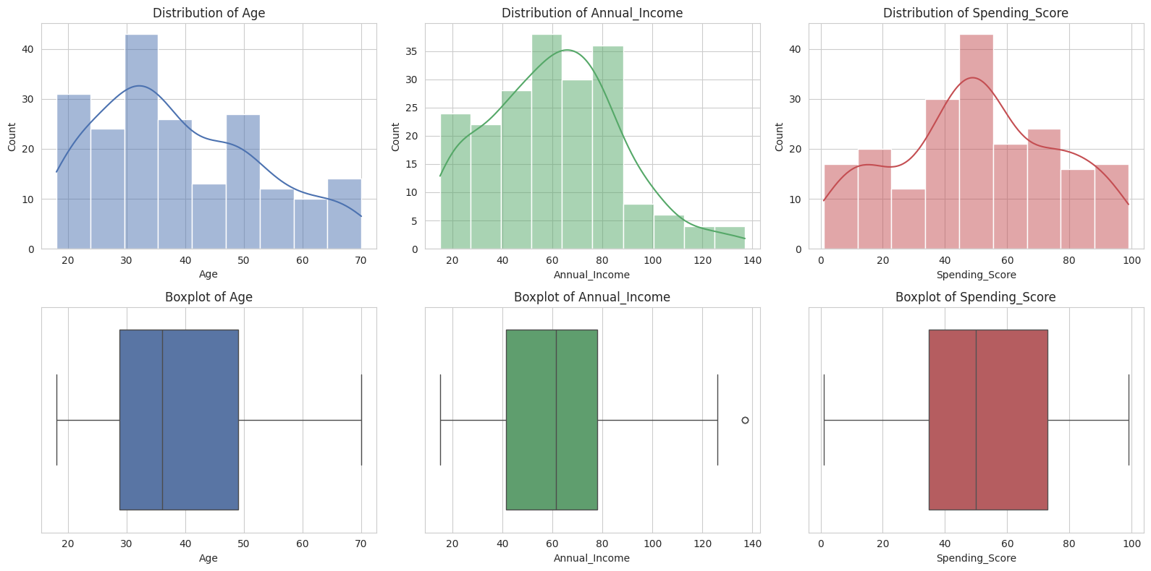
Figure 1: Distribution (top) and boxplot (bottom) of Age, Annual Income and Spending Score
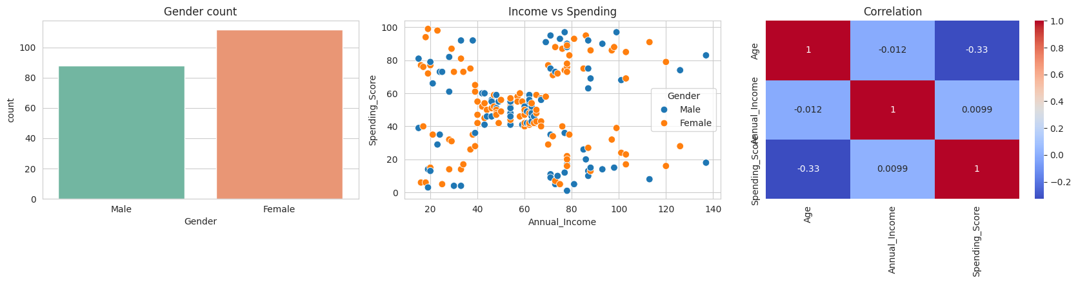
Figure 2: Gender count, income versus spending scatter plot, and correlation heatmap

5.2 Clustering Tendency
The Hopkins statistic on the standardised features, averaged over ten seeds, was H = 0.693: above the 0.5 of random data and in the moderate range (0.6 to 0.75). It is not close to 1 because the groups lie fairly near each other, but it confirms genuine cluster structure.

5.3 Partitioning Methods
K-Means was run for K = 2 to 10 (Table 3, Figure 3). The WCSS drops steeply until K = 5 (108.9 at K = 4 to 65.6 at K = 5) and then flattens (about 10.5 more to K = 6), giving a clear elbow at K = 5, and the silhouette score also peaks at K = 5 (0.555). The dendrogram in Section 5.4 agrees, so K = 5 was used.
Table 3: WCSS and silhouette score for different K (K-Means)
K | 2 | 3 | 4 | 5 | 6 | 7 | 8 | 9 | 10
WCSS | 269.7 | 157.7 | 108.9 | 65.6 | 55.1 | 44.9 | 37.2 | 32.4 | 30.0
Silhouette | 0.321 | 0.467 | 0.494 | 0.555 | 0.540 | 0.528 | 0.455 | 0.457 | 0.443

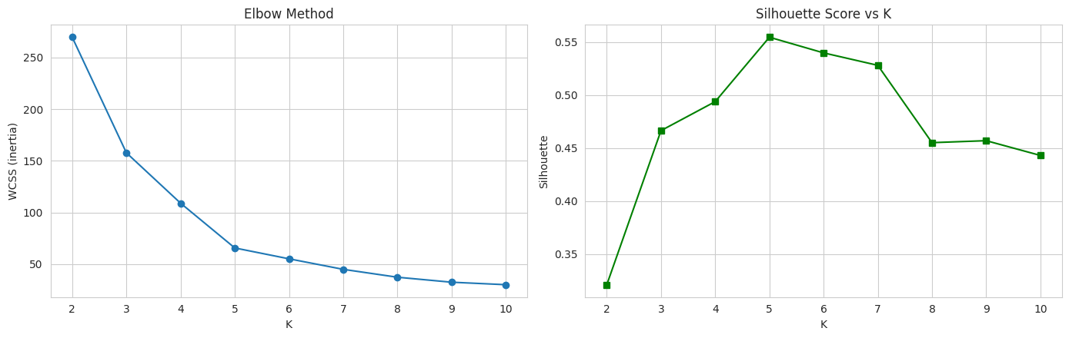
Figure 3: Elbow method (left) and silhouette score versus K (right); both indicate K = 5
With K = 5, K-Means (k-means++, 10 restarts) gave clusters of 81, 39, 22, 35 and 23 customers. The centroids (Table 4) match the five visible blobs: a central moderate group and the high-income/high-spending, low-income/high-spending, high-income/low-spending and low-income/low-spending groups. K-Medoids, using the from-scratch implementation, reached a total cost of 101.89 with sizes 35, 21, 25, 80 and 39: it finds the same five groups and differs only on a few borderline points (Figure 4); its medoids are real customers.
Table 4: K-Means centroids (original units, all 200 customers)
Cluster | Annual Income (k$) | Spending Score | Customers
0 | 55.3 | 49.5 | 81
1 | 86.5 | 82.1 | 39
2 | 25.7 | 79.4 | 22
3 | 88.2 | 17.1 | 35
4 | 26.3 | 20.9 | 23

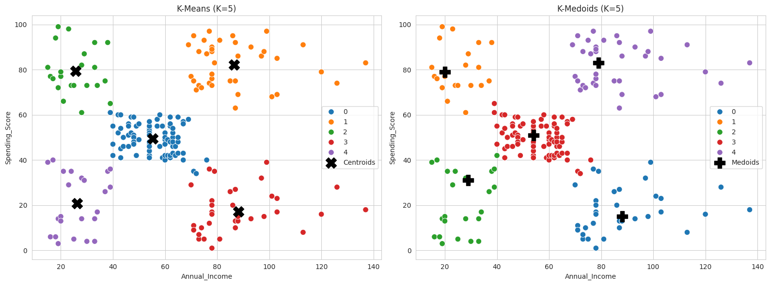
Figure 4: K-Means clusters with centroids (left) and K-Medoids clusters with medoids (right), K = 5

5.4 Hierarchical Methods
Four linkages were compared with K = 5 (Table 5). Single linkage shows the chaining effect (one cluster of 195 customers, the others 2, 1, 1 and 1; silhouette 0.276) and average linkage is also unbalanced (102 and 3). Complete and Ward give balanced clusters with silhouettes of 0.553 and 0.554. The cophenetic correlations of single, average and Ward are practically equal (about 0.72), so Ward was chosen. The Ward dendrogram (Figure 5a) has five long branches and a large vertical gap above the cut for K = 5 (dashed line), supporting five clusters. The agglomerative result (Figure 5b) has sizes 85, 39, 32, 23 and 21 and differs from K-Means for only four of the 200 customers (ARI 0.94).
Table 5: Comparison of linkage criteria (K = 5)
Linkage | Cophenetic corr. | Silhouette | Cluster sizes
Single | 0.722 | 0.276 | 195, 2, 1, 1, 1
Complete | 0.667 | 0.553 | 79, 39, 38, 23, 21
Average | 0.722 | 0.479 | 102, 38, 36, 21, 3
Ward | 0.721 | 0.554 | 85, 39, 32, 23, 21

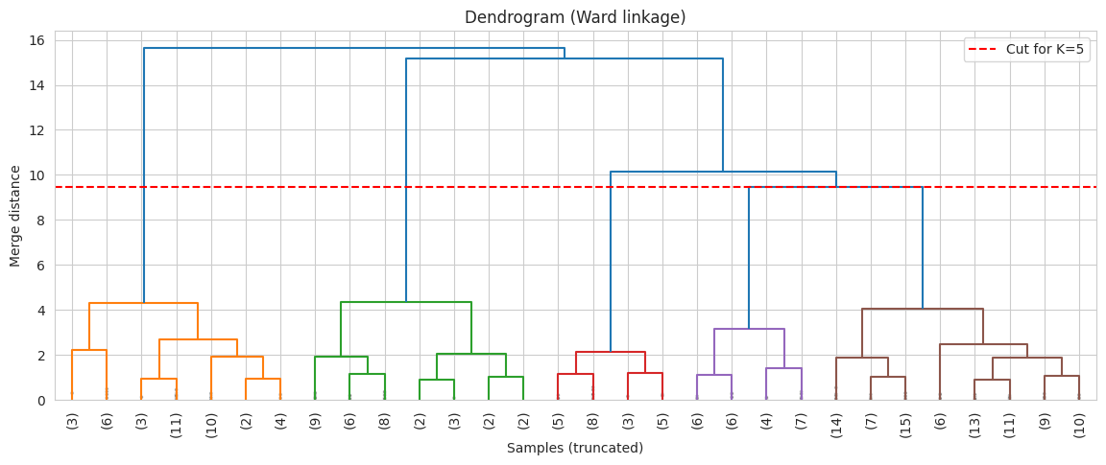 | 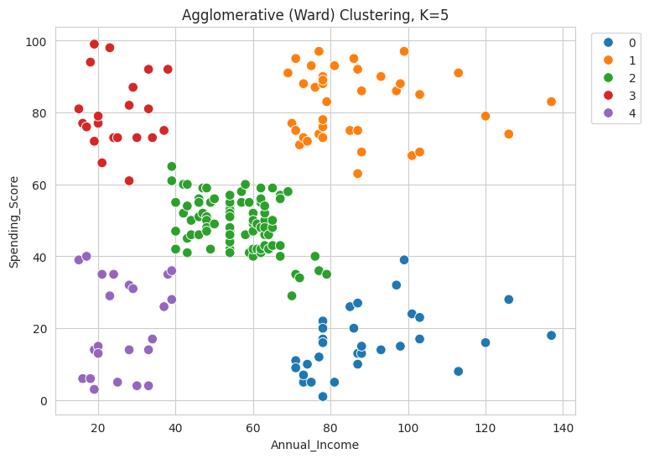
Figure 5: (a) Ward dendrogram with the cut for K = 5; (b) agglomerative clusters, K = 5

5.5 Density-Based Methods
For DBSCAN the k-distance graph with k = 5 (Figure 6a) bends upward at ε of about 0.3 to 0.4 on the standardised scale. A grid search over ε from 0.20 to 0.80 and min_samples in {3, 4, 5, 6, 8}, keeping settings with 2 to 8 clusters and at most 12 % noise and ranking by the silhouette of the non-noise points, selected ε = 0.35 and min_samples = 5 (silhouette 0.558). DBSCAN found six clusters of 16, 12, 7, 88, 31 and 23 customers and labelled 23 customers (11.5 %) as noise (Figure 6b). The central group and three corner groups are recovered cleanly, the low-income/low-spending group is split into two small dense pieces (12 and 7), and the noise points lie on the outer edges and include all the very-high-income customers, so DBSCAN also acts as an outlier detector.
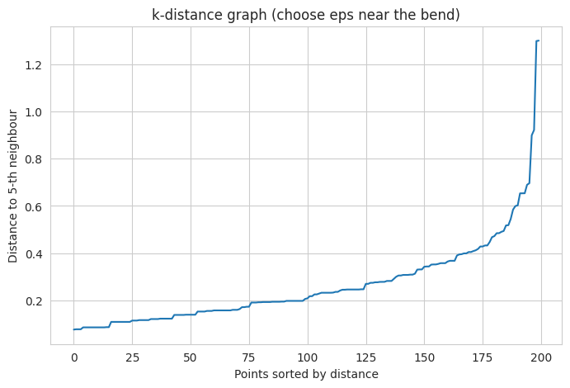 | 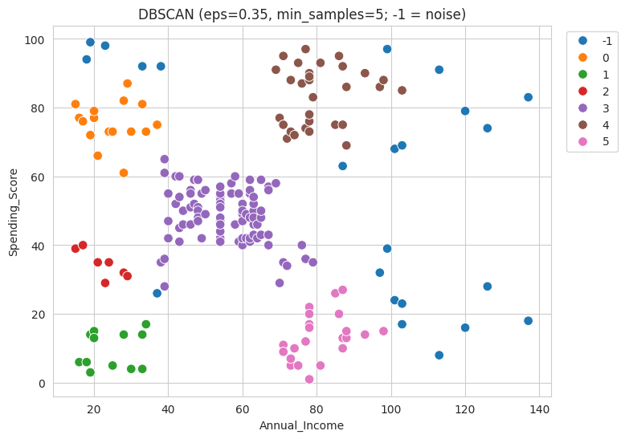
Figure 6: (a) k-distance graph (k = 5); (b) DBSCAN clusters (ε = 0.35, min_samples = 5; −1 = noise)
OPTICS (min_samples = 5) was cut at ε = 0.35 on the reachability plot (Figure 7). The automatic ξ extraction labelled almost half the customers as noise on this small dataset and was not used. The cut gives six clusters (sizes 5, 88, 16, 23, 11, 31) and 26 noise points; valleys are the dense groups and the tall bars at the ends of the ordering are the sparse outer customers. The result is almost identical to DBSCAN (ARI 0.99), as expected for the same ε.
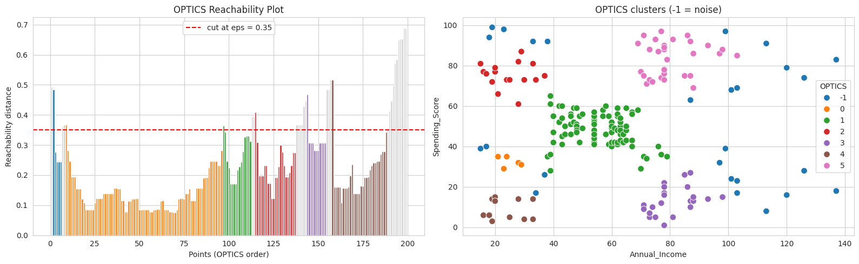
Figure 7: OPTICS reachability plot cut at ε = 0.35 (left) and the resulting clusters (right)

5.6 Evaluation of the Clusterings
Table 6 and Figure 8 give the internal indices (noise points excluded for DBSCAN and OPTICS) and the stability of each method, measured as the mean ARI between clusterings of two random 80 % subsamples over 20 repetitions. K-Means, K-Medoids and Ward are almost indistinguishable (silhouette 0.547 to 0.555, Davies-Bouldin 0.572 to 0.587), and K-Means has the best Calinski-Harabasz value (248.6) among the methods that cluster every point. DBSCAN and OPTICS obtain the lowest Davies-Bouldin values (0.511, 0.490), but partly because discarding border points makes the remaining clusters look tighter. K-Means is by far the most stable (0.984), Ward and DBSCAN are also stable (0.936, 0.897), while K-Medoids is clearly less so (0.736): the simple alternating algorithm is sensitive to its starting medoids and settles in different local optima.
Table 6: Internal validity indices and stability of all methods
Method | Clusters | Noise pts | Silhouette ↑ | Calinski-Harabasz ↑ | Davies-Bouldin ↓ | Stability (ARI)
K-Means | 5 | 0 | 0.555 | 248.649 | 0.572 | 0.984
K-Medoids | 5 | 0 | 0.547 | 244.111 | 0.587 | 0.736
Hierarchical (Ward) | 5 | 0 | 0.554 | 244.410 | 0.578 | 0.936
DBSCAN | 6 | 23 | 0.558 | 245.356 | 0.511 | 0.897
OPTICS | 6 | 26 | 0.552 | 237.675 | 0.490 | –

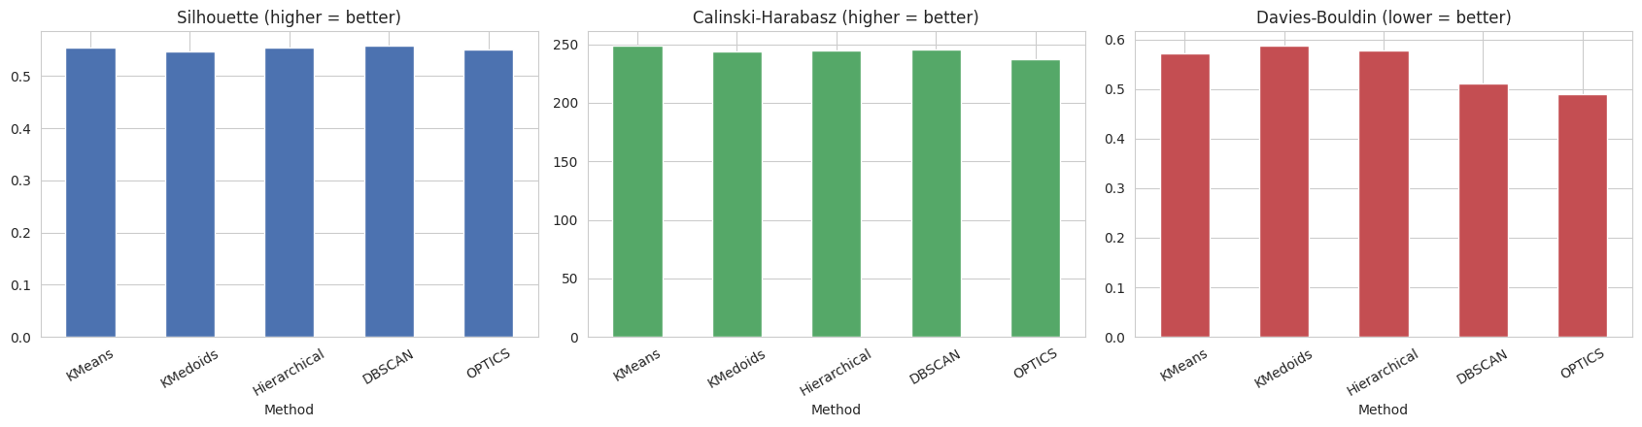
Figure 8: Silhouette, Calinski-Harabasz and Davies-Bouldin indices of the five methods
Table 7 and Figure 9a show the ARI between every pair of methods. K-Means, K-Medoids and Ward agree very strongly (0.93 to 0.96); DBSCAN and OPTICS agree almost perfectly with each other (0.99) and moderately with the rest (0.77 to 0.85) because of their noise points and the split of one group. Such agreement between algorithms built on completely different principles is strong evidence that the five-group structure is genuine. The silhouette plot of K-Means (Figure 9b) shows mostly positive values for all five clusters around or above the mean of 0.555; only a few border customers score low.
Table 7: Adjusted Rand Index between methods
 | K-Means | K-Medoids | Hierarchical | DBSCAN | OPTICS
K-Means | 1.00 | 0.96 | 0.94 | 0.79 | 0.78
K-Medoids | 0.96 | 1.00 | 0.93 | 0.78 | 0.77
Hierarchical | 0.94 | 0.93 | 1.00 | 0.85 | 0.84
DBSCAN | 0.79 | 0.78 | 0.85 | 1.00 | 0.99
OPTICS | 0.78 | 0.77 | 0.84 | 0.99 | 1.00

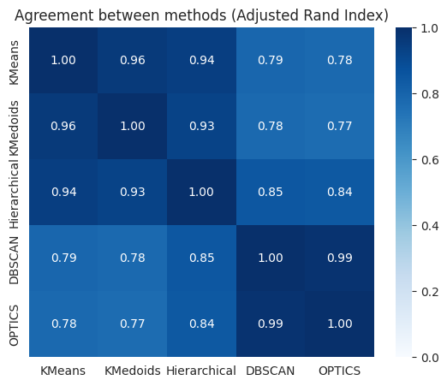 | 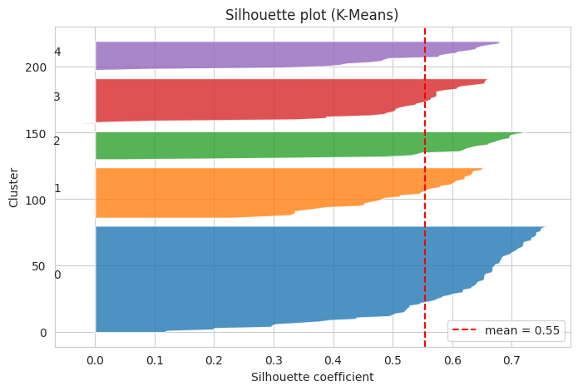
Figure 9: (a) Agreement between methods (ARI); (b) silhouette plot of the K-Means clustering

5.7 Outlier Detection
Real customers carry no “outlier” label, so seven detectors were compared by their agreement (Table 8, Figure 10). The Z-score flags nobody because the largest standardised value (income of 137k) is about 2.9, just under 3, showing that a simple univariate rule can miss genuine extremes in a small sample. The IQR rule and Mahalanobis distance flag the same two customers (IDs 199 and 200). LOF and Isolation Forest flag exactly 10 because their contamination was set to 5 %, and DBSCAN flags the most (23) because it marks every point outside a dense region. The overlap between detectors (Jaccard index) is moderate to low for most pairs; the highest is K-Means distance with LOF (0.60), then K-Means distance with Isolation Forest (0.45). Since each detector has weaknesses, a customer flagged by at least three detectors was treated as a consensus outlier.
Table 8: Number of customers flagged by each detector
Detector | Family | Customers flagged
Z-score (|z| > 3) | Statistical | 0
IQR rule | Statistical | 2
Mahalanobis (χ², 97.5 %) | Statistical | 2
K-Means distance (IQR rule) | Distance / clustering | 6
DBSCAN noise | Density-based | 23
LOF (20 neighbours, 5 %) | Density-based | 10
Isolation Forest (5 %) | Isolation-based | 10

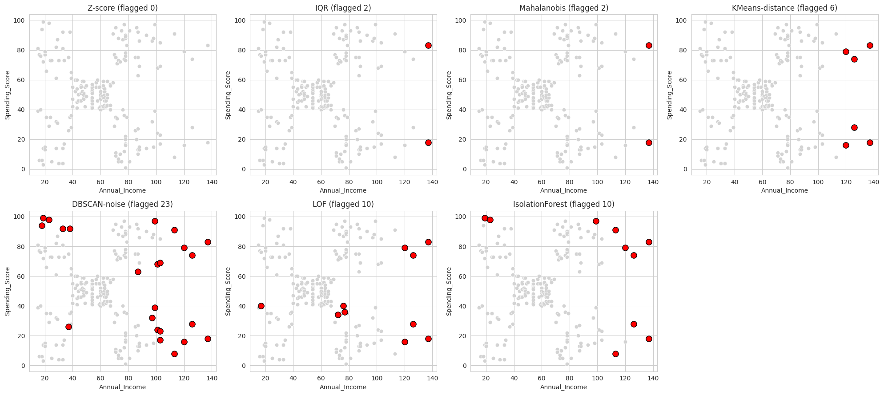
Figure 10: Customers flagged by each outlier detector (red points)
Six customers meet the consensus rule (Table 9): IDs 199 and 200 are flagged by six detectors, 196, 197 and 198 by four, and 195 by three. All have annual incomes of 120k to 137k, the very top of the range, with spending scores from 16 to 83. Five customers with two votes were kept: two low-income customers with a spending score near 99 (IDs 12 and 20) and three with incomes of 99k to 113k (IDs 186, 193, 194).
Table 9: Consensus outliers (flagged by three or more detectors)
CustomerID | Gender | Age | Income (k$) | Spending | Votes | Outlier
199 | Male | 32 | 137 | 18 | 6 | Yes
200 | Male | 30 | 137 | 83 | 6 | Yes
196 | Female | 35 | 120 | 79 | 4 | Yes
197 | Female | 45 | 126 | 28 | 4 | Yes
198 | Male | 32 | 126 | 74 | 4 | Yes
195 | Female | 47 | 120 | 16 | 3 | Yes

5.8 Final Model after Outlier Removal
The six outliers were removed, the remaining 194 customers re-standardised and K-Means (K = 5) re-fitted. All indices improved (Table 10): silhouette 0.555 to 0.569, Davies-Bouldin 0.572 to 0.557 and Calinski-Harabasz 248.6 to 287.0 (about 15 % higher). The extreme-income customers had stretched the high-income clusters. Figure 11 shows the final segments in the centre and four corners of the income-spending plane; the removed customers (red circles) lie beyond the right edge of the high-income clusters.
Table 10: Cluster quality before and after outlier removal (K-Means, K = 5)
Index | Before (200 customers) | After (194 customers)
Silhouette ↑ | 0.555 | 0.569
Davies-Bouldin ↓ | 0.572 | 0.557
Calinski-Harabasz ↑ | 248.649 | 286.952

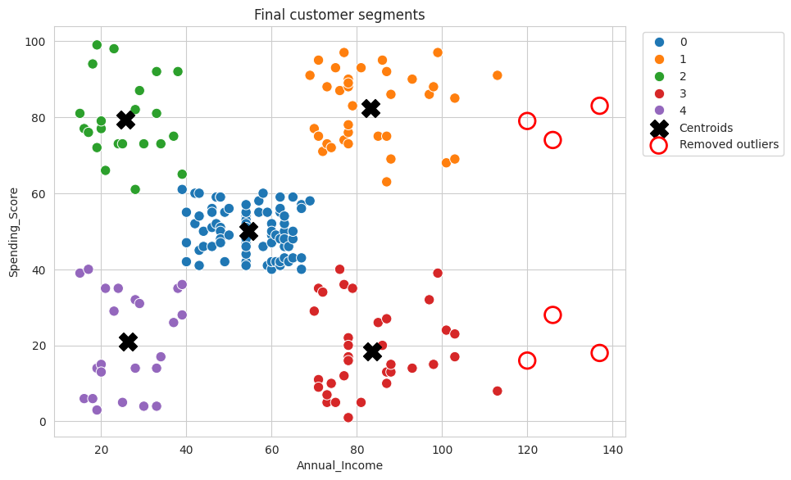
Figure 11: Final customer segments; red circles are the removed consensus outliers

5.9 Segment Profiling and Business Strategy
Each final cluster was profiled with the clustering features and with Age and Gender, which were held back (Table 11, Figure 12); names were assigned by comparing each cluster’s average income and spending with the medians over the clusters. Table 12 gives the recommended strategies.
Table 11: Profile of the final segments (194 customers)
ID | Segment | Customers | Share | Avg Age | Avg Income (k$) | Avg Spending | Female %
0 | Standard Customers | 78 | 40.2 % | 43.1 | 54.6 | 50.0 | 59.0
1 | Premium / VIP | 36 | 18.6 % | 32.7 | 83.1 | 82.4 | 55.6
2 | Trendy Spenders | 22 | 11.3 % | 25.3 | 25.7 | 79.4 | 59.1
3 | Careful Spenders | 35 | 18.0 % | 40.3 | 83.5 | 18.5 | 45.7
4 | Budget Customers | 23 | 11.9 % | 45.2 | 26.3 | 20.9 | 60.9

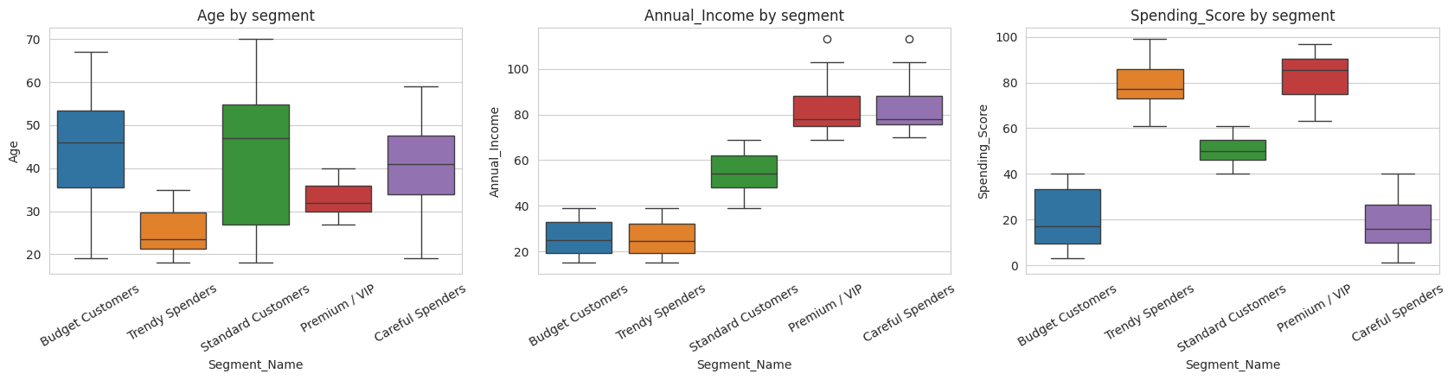
Figure 12: Age, Annual Income and Spending Score of each segment
Table 12: Segments and recommended strategies
Segment | Who they are | Recommended strategy
Standard (40 %) | Largest group: middle-aged (about 43), moderate income (about 55k) and spending. Reliable everyday shoppers. | General promotions, seasonal sales, bundles; upsell and cross-sell nudges.
Premium / VIP (19 %) | Young (about 33), high income (about 83k), very high spending (about 82). Most valuable segment. | Tiered loyalty programme, early access, exclusive events, personalised premium offers.
Trendy Spenders (11 %) | Youngest (about 25), low income (about 26k) but very high spending (about 79); trend-driven. | Discounts, cashback and EMI offers, youth campaigns, social-media and influencer marketing.
Careful Spenders (18 %) | About 40 years old, high income (about 83k) but very low spending (about 18); 46 % female. | Quality- and value-focused messaging, personalised recommendations; biggest growth opportunity.
Budget (12 %) | Oldest (about 45), low income (about 26k), low spending (about 21). | Value deals, clearance sales, low-cost retention; avoid costly acquisition.

Note on the removed customers. The six outliers were removed only to get cleaner clusters; they are real customers with the highest incomes (120k to 137k), not data errors. Those with high spending (IDs 196, 198, 200) are natural VIP candidates and those with low spending (IDs 195, 197, 199) belong to the Careful Spenders opportunity. The final model can also assign new customers: income 85k with spending 80 falls in Premium / VIP, and income 20k with spending 15 in Budget Customers.

6. Comparative Discussion
Table 13: Comparison of the clustering methods on this dataset
Method | Result | Strengths observed | Weaknesses observed
K-Means | 5 clusters; silhouette 0.555; stability 0.984 | Fast, most stable, clear centroids | Needs K; centroids pulled by extreme incomes
K-Medoids | 5 clusters; silhouette 0.547; stability 0.736 | Real customers as centres | Slower; less stable with the simple algorithm
Hierarchical (Ward) | 5 clusters; silhouette 0.554; stability 0.936 | No random start; dendrogram checks K | Merges cannot be undone; costly for large data
DBSCAN | 6 clusters + 23 noise; silhouette 0.558 | No K needed; finds noise directly | Sensitive to ε; splits one group
OPTICS | 6 clusters + 26 noise; silhouette 0.552 | Reachability plot shows density structure | Automatic ξ extraction unreliable on 200 points

All methods recover essentially the same five-group structure, which is the key finding. K-Means is the most practical choice here: simple, extremely stable and easy to interpret for business use, while hierarchical and density-based methods act as independent confirmations (the dendrogram supports K = 5 without assuming it, and DBSCAN/OPTICS show which customers sit at the edges). No single outlier detector was reliable alone, so the consensus vote gave a short, defensible list.

7. Conclusion, Limitations and Future Scope
- The Hopkins statistic (0.693) showed moderate but genuine cluster structure, and the elbow, silhouette and dendrogram all pointed to K = 5.
- K-Means, K-Medoids and Ward produced almost the same five segments (ARI 0.93 to 0.96), K-Means being the most stable (0.984); DBSCAN and OPTICS independently found the same dense regions and marked peripheral customers as noise.
- Seven outlier detectors were compared and combined by voting; six high-income customers were flagged and removing them improved all internal indices.
- The five final segments are interpretable and each has a specific marketing strategy.
Limitations. Only 200 customers and two clustering features; the spending score is a mall-assigned index, not purchase data; there are no true labels, so validity rests on internal indices, stability and agreement; the K-Medoids version is a simplified PAM; the vote threshold and contamination values are judgement-based.
Future scope. Add age and purchase-history features, try Gaussian Mixture Models, BIRCH and full swap-based PAM, validate the segments with real campaign response, and deploy the model as a Streamlit dashboard.

References
[1] J. Han, M. Kamber and J. Pei, Data Mining: Concepts and Techniques, 3rd ed., Morgan Kaufmann, 2011.
[2] P.-N. Tan, M. Steinbach and V. Kumar, Introduction to Data Mining, Pearson, 2006.
[3] J. MacQueen, “Some methods for classification and analysis of multivariate observations,” Proc. 5th Berkeley Symp. on Math. Statistics and Probability, 1967.
[4] D. Arthur and S. Vassilvitskii, “k-means++: The advantages of careful seeding,” Proc. ACM-SIAM SODA, 2007.
[5] L. Kaufman and P. J. Rousseeuw, Finding Groups in Data, Wiley, 1990.
[6] M. Ester, H.-P. Kriegel, J. Sander and X. Xu, “A density-based algorithm for discovering clusters in large spatial databases with noise,” Proc. KDD, 1996.
[7] M. Ankerst, M. M. Breunig, H.-P. Kriegel and J. Sander, “OPTICS: Ordering points to identify the clustering structure,” Proc. ACM SIGMOD, 1999.
[8] M. M. Breunig, H.-P. Kriegel, R. T. Ng and J. Sander, “LOF: Identifying density-based local outliers,” Proc. ACM SIGMOD, 2000.
[9] F. T. Liu, K. M. Ting and Z.-H. Zhou, “Isolation forest,” Proc. IEEE ICDM, 2008.
[10] P. J. Rousseeuw, “Silhouettes: a graphical aid to the interpretation and validation of cluster analysis,” J. Comput. Appl. Math., vol. 20, 1987.
[11] F. Pedregosa et al., “Scikit-learn: Machine learning in Python,” J. Machine Learning Research, vol. 12, 2011.
[12] Kaggle, “Customer Segmentation Tutorial in Python” (Mall Customers dataset), https://www.kaggle.com/vjchoudhary7/customer-segmentation-tutorial-in-python.

