Community Development Project
On
Cyber Security Awareness Drive through WNS Cares Foundation
Submitted by: Shreeyansh janu
Registration Number: 12419027
In partial fulfillment for the requirements of the award of the degree of
Bachelor of Technology(Computer Science and Engineering)
Lovely Professional University Phagwara, Punjab

Certification by the NGO regarding the Student Project
This is to certify that the Mr. Shreeyansh janu carried out the project titled “Cyber Security Awareness Drive through WNS Cares Foundation” under the supervision of the NGO representative in our organization.
It is further certified that he spent a minimum of 30 hours on the Project and his contribution because of the Project undertaken has been significant in educating community members on crucial digital safety practices, improving awareness regarding cyber threats, and promoting responsible online behaviour across different age groups.
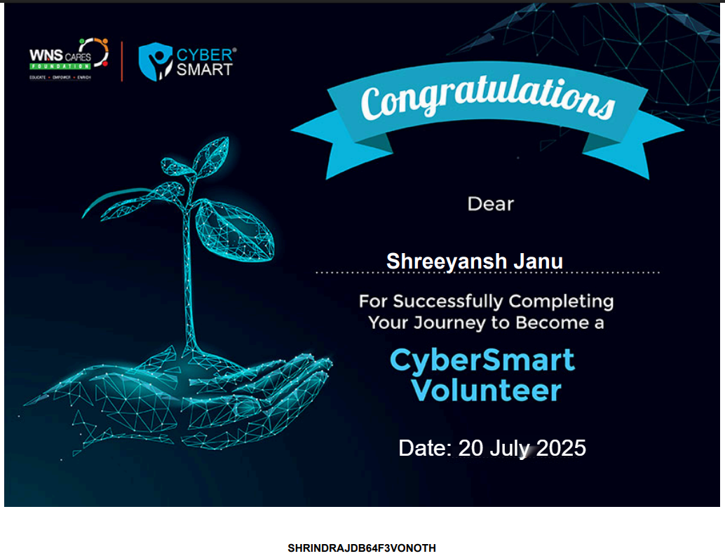

1. Introduction
In an increasingly interconnected world, cybersecurity awareness has become paramount for individuals of all ages and backgrounds. This project aimed to bridge the knowledge gap by delivering comprehensive cybersecurity awareness training to two distinct and vulnerable demographics: government students and elderly individuals. Recognizing the unique challenges faced by each group—from the digital exposure of students to the potential susceptibility of seniors to online scams—this program was designed to equip them with essential knowledge and practical skills. Through interactive sessions and accessible materials, participants learned about common cyber threats, secure online practices, data privacy, and how to identify and report suspicious activities. This initiative sought to empower both government students, who are the future digital citizens, and elderly people, who are increasingly engaging with online platforms, to navigate the digital landscape safely and confidently, fostering a more secure and resilient online community.

2.Problem Identification and Cause of the Problem
Problem: There are a significant number of threats from cyber incidents including online financial fraud, data theft, and cyberbullying that students and the general public face in the local community.
Cause: The problem originates from the general lack of formal instruction and hands-on experience in cyber security. Digital tools are dominant in people's lives, but there is no standard direction around safe online behaviours. This leads to a lack of password hygiene good (or known) password choices, inability to spot phishing attempts, and forgetting that, once posted online, personal information can be shared with no limits.
3. Objective to be achieved
The goal of this project was to establish a culture of cyber safety by educating and empowering students to become advocates for their communities. The initiative focused on recruiting and training student volunteers from a local tuition center and other locations, such as Randhawa Hospital, to build their understanding of key cyber security concepts. These included safe social media practices, cyberbullying, financial security, public internet usage, and cyber grooming.
The campaign aimed to help participants identify online threats like phishing, fake messages, and malware; use strong, unique passwords and two-factor authentication; and adopt safe browsing habits and content verification techniques. Additionally, topics such as digital addiction and cyberbullying were addressed to build resilience and awareness.
Ultimately, the project not only sought to inform but to empower individuals to share their knowledge, creating a multiplier effect of cyber security awareness across their communities.

4. Various Steps Taken to Achieve the Objectives
To meet the stated objectives, I followed a structured and practical approach throughout the one-month project duration. The process was designed to be community-focused, simple to execute, and impactful across various levels of awareness and digital literacy.

a. Collaboration with WNS Cares Foundation
I registered with the WNS Cares Foundation and enrolled in their CyberSmart digital safety awareness program. This gave me access to high-quality training material, including short and engaging videos on key topics like password protection, phishing, social media safety, cyberbullying, and online fraud. I thoroughly reviewed this material and created a custom learning plan by selecting the most relevant videos and translating them into interactive, discussion-based sessions for my local audience.

b. Selection of Participants
I identified and invited 40 participants from my local community. The group was diverse—it included students, homemakers, and working adults, each with different levels of digital exposure. Some had basic knowledge of mobile phones and social media, while others were completely unfamiliar with concepts like phishing or digital identity theft. This diversity made the sessions more inclusive and enriched peer-to-peer learning during group discussions.

c. Session Planning and Delivery
I organized the training in multiple small group sessions to ensure better engagement. Each session focused on one or two topics and included:
- Short, topic-specific educational videos from the CyberSmart portal
- Real-life Indian examples, such as fake UPI links, OTP scams, and misuse of social media photos
- Live demonstrations, like changing privacy settings on WhatsApp or identifying a phishing email
- Open Q&A discussions after every topic to clear doubts
- Interactive activities and storytelling, especially to explain concepts like cyberbullying and digital addiction in a relatable way
The sessions were kept simple, free of jargon, and fully interactive. Even those with minimal digital experience could follow along and contribute.

- Materials Distribution
To ensure that the key takeaways stayed with the participants, I created easy-tounderstand tip sheets summarizing the top safety tips from each session. These handouts were prepared in the local language, using large fonts, minimal text, and relevant icons to make them accessible for everyone. Participants took these home to refer to and share with family members.

- Feedback and Impact Monitoring
At the end of the training period, I circulated a short feedback form to understand the impact of the sessions. The feedback showed that most participants had learned at least three new concepts they weren’t aware of before, such as the importance of two-factor authentication or how to spot suspicious links. Many admitted that they had previously used weak passwords or shared personal information online without thinking.
Some even shared how they had already started applying the tips, like updating their passwords, avoiding unsecured public Wi-Fi, and talking to their children or parents about safe social media use.

- Encouraging Peer Learning and Community Sharing
One of the most important steps was motivating participants to become digital safety ambassadors in their homes, workplaces, and friend circles. I encouraged them to share what they had learned, whether it was how to report online harassment or how to set a strong password. This peer-learning approach helped amplify the message beyond just the training group.
Some participants even volunteered to help conduct future sessions or spread awareness in nearby schools and community groups.

This step-by-step approach not only ensured effective knowledge delivery but also promoted a community-driven model of digital safety awareness, where each participant took ownership of spreading the message further. The combination of engaging content, relatable delivery, and local language material made the sessions meaningful and impactful.
5. Geo Tagged Pictures
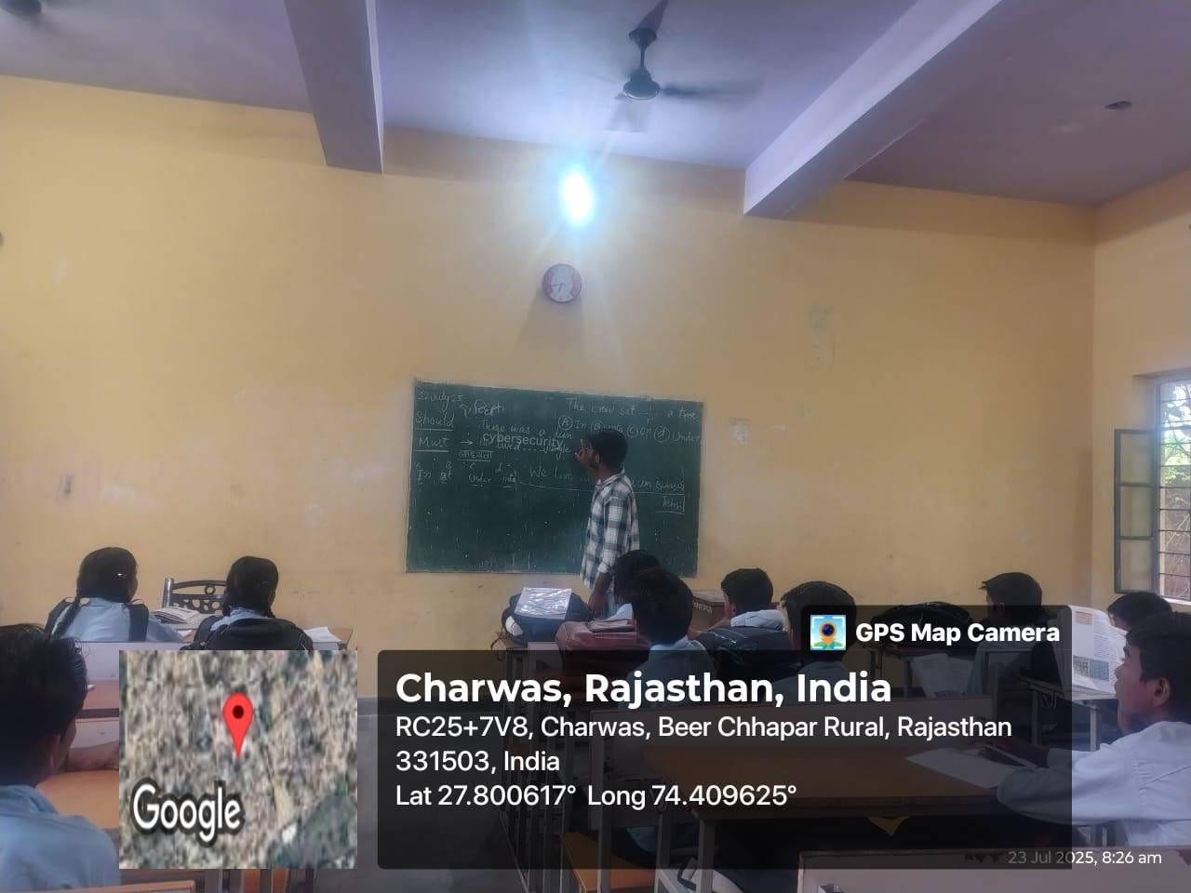

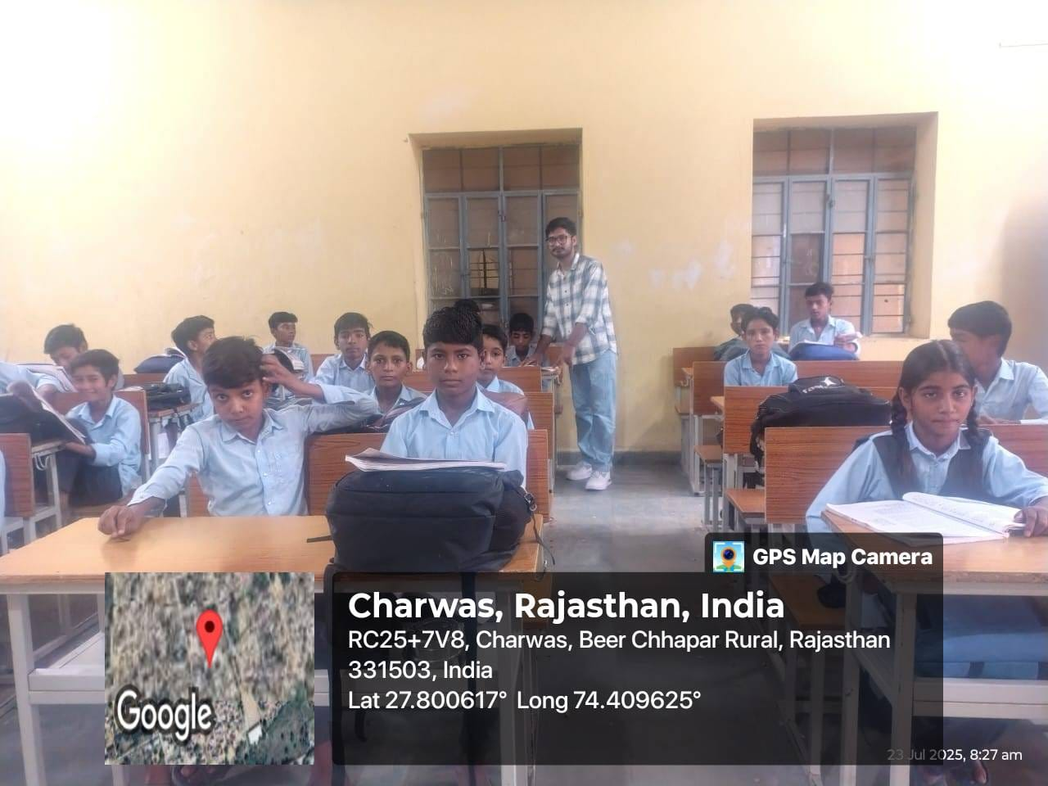

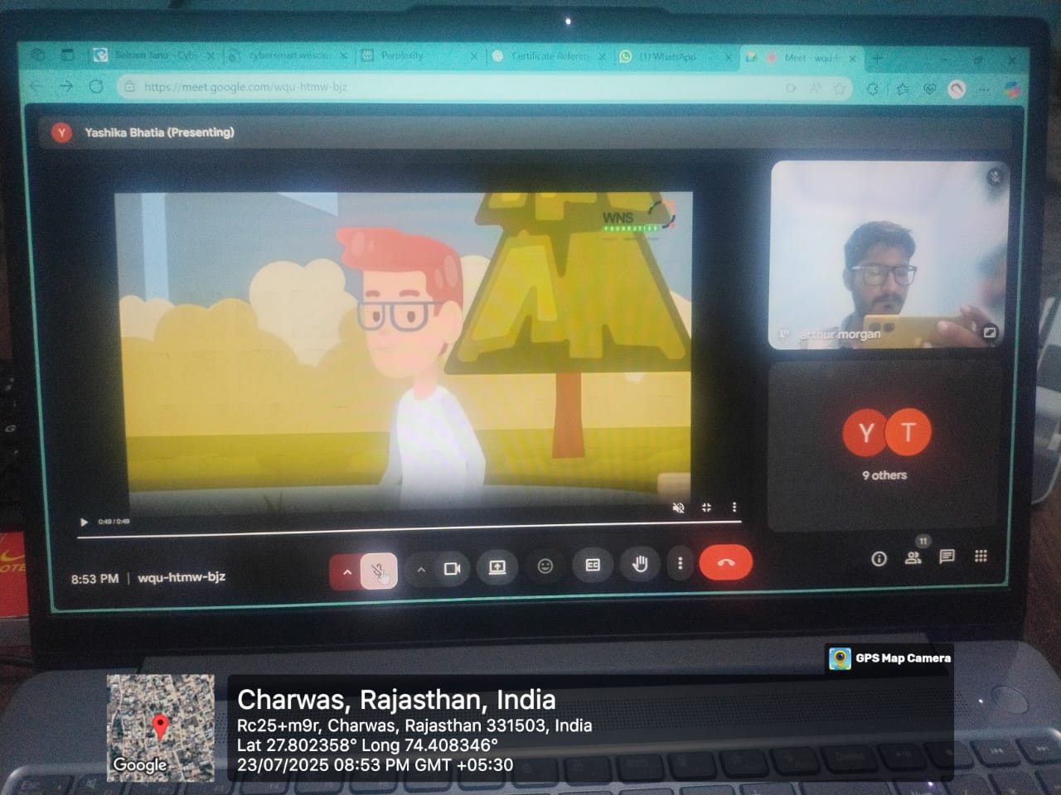

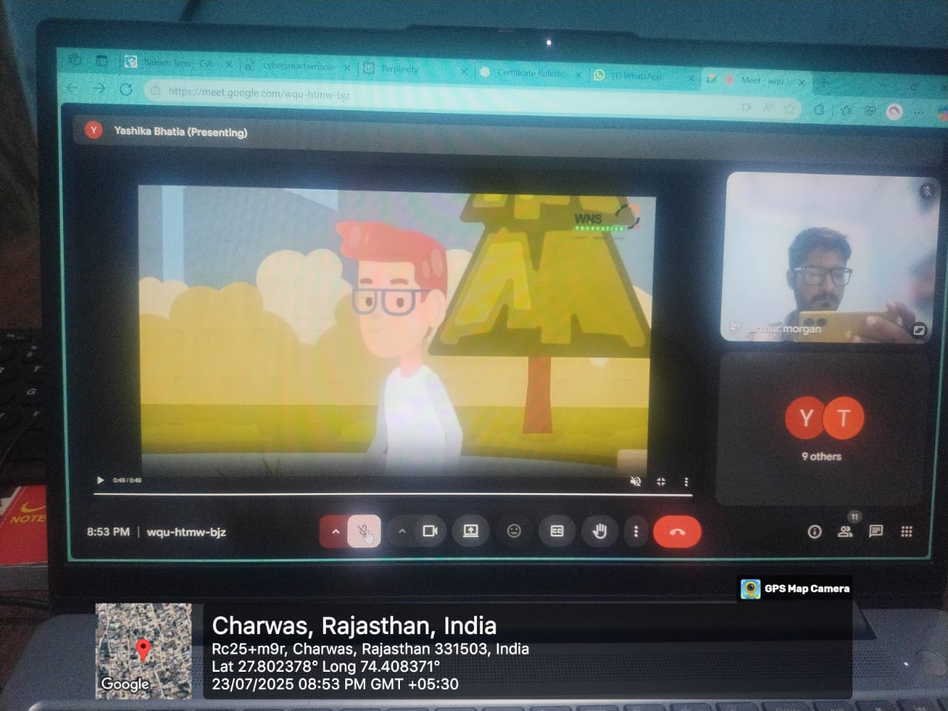

6. Effectiveness of the Project
Effectiveness of the Project The effectiveness of the project's impact came through the experiences of the participants in their engagement level, change in behaviour, and enthusiasm exhibited throughout the training sessions. Participants reported they were unaware of how vulnerable their online habits were—primarily using public hot spots or sharing details of their lives on social media. After the sessions, the majority of participants had adopted safer online practices such as changing their passwords, being cautious when clicking on links from unknown sources, and limited asking for their social circle to stop over-sharing on social media sites.
The participants appreciated the many visual elements and the opportunity to connect with the material by using real-life situations. Many participants shared how they had "been had" by spam calls or a suspicious message before the session and now felt much more capable of recognizing them in the future.
Participants told me that the simple handouts from the sessions were taken home, put up on walls, or shared it with those in their household. This initiative had concrete learning extending past the direct audience. Some participants even followed up in the days after with phone calls or messages to ask me questions about the training sessions, again, supporting the idea that the project had lasting effects.
The training ultimately was, "successful," as it aimed to build cyber-awareness, in hopes of establishing a safer digital environment at a grassroots level.

7. Identified Societal Problems
- Lack of Basic Digital Literacy:
Despite increasing smartphone and internet usage, a large segment of the community lacks foundational knowledge about online threats. Many users are unaware of basic cybersecurity measures, making them easy targets for scams, phishing, or data theft.
- Normalization of Cyberbullying and Misinformation:
Cyberbullying and fake news have become increasingly common, especially among younger users. However, due to limited awareness and absence of dialogue around these topics, many do not realize the mental and emotional damage they can cause or the role each user plays in curbing misinformation.

8. Conclusion
Working on this project has been a learning experience, and the chance to facilitate real change. I shared more than just information on cyber safety, I engaged them in impactful conversations around how technology affects our lives, and the way we interact with each other every day. It was rewarding to see them engage with the discussions, ask questions, and then apply the learnings for a sense of purpose that only the academic context cannot provide.
I think it is the growth mindset that really drove home for me the difference between digital awareness and digital literacy. One major take away is that people don't need to know the technical aspects that demonstrate knowledge, they need to know the mindset. People need to know when they see the signs of online danger; the responsibility that comes with sharing responsibility as well as the few simple steps they can take to protect themselves and others. More importantly, it is the way information is delivered, shared and circulated in practice, rather than a perfect, pristine example that carries weight and impact.
As a result of the support of the WNS Cares Foundation and access to structured tools for training, I was able to provide relevant guidance with a practical focus in the context of a community. This project has motivated me to take this project further stretching the community out to engage into the schools and other low-tech areas that need the awareness. Promoting safe digital habits is not simply a project objective - it is a societal responsibility we must all take seriously.

