FoodWise
Requirements Specification & Design Document
Assignment 1 – Task 2

Shreeyash Pandey (E2300578)
Pujan Shrestha (E2400005)
Sandhya Dhami (E2300577)

Contents
1. Requirement Specification Document 3
1.1. Functional Requirements 3
1.2. Non-Functional Requirements 7
2. Modeling Requirements 10
2.1. Use Case 1 – Register & Privacy Settings 10
2.2. Use Case 4 – Food Analytics 15
2.3. Use Case 3: Browse Food Items 19
2.4. Use Case 6: Plan Weekly Meals 24
2.5. UC2 – Manage Food Inventory 30
2.6. UC5 – View Notifications 34
3. Design Specification Document (Group Work) 37
3.1. Architectural Design 37
3.2. High-Level Design Components 38
3.3. Site Map 39
4. Generic UX / Wireframe 40
5. System Design Summary 47
5.0. Overview 47
5.1. Meeting the Functional Requirements 47
6. Database Design (Data Dictionary) 48
6.0. Table: USER 48
6.1. Table: FOOD_ITEM 49
6.2. Table: NOTIFICATION 49
6.3. Table: DONATION 50
6.4. Table: MEAL_PLAN 50
6.5. Table: MEAL_PLAN_ITEMS 51

Requirement Specification Document
Shreeyash Pandey (E2300578) | Sandhya Dhami (E2300577) | Pujan Shrestha (E2400005)

Functional Requirements
The functional requirements specify the particular behaviour and functions that the FoodWise system should execute. All functional requirements are listed below, in the table, by Prio (High, Medium, Low) for each of 6 use cases.
Priority Key: High = must be implemented for core functionality | Medium = important but not blocking | Low = desirable enhancement

ID | Use Case | Requirement | Priority | Description
FR-01 | UC1 – Register & Privacy | User Registration | High | New users shall be able to register an account in the system by entering a username, email address and password.
FR-02 | UC1 – Register & Privacy | User Login & Logout | High | The system should enable registered users to log in with their email and password, and securely log out of the system.
FR-03 | UC1 – Register & Privacy | Two-Factor Authentication (2FA) | High | The system shall be capable of providing optional two factor authentication (2FA) with a one time code sent to the user's email.
FR-04 | UC1 – Register & Privacy | Privacy Settings | Medium | The system shall provide users with the ability to set their privacy preferences such as who can view their profile, and who they do or do not wish to share information with.
FR-05 | UC1 – Register & Privacy | Password Reset | Medium | A feature for resetting the password shall be available in the system, using an email verification link.
FR-06 | UC2 – Manage Inventory | Add Food Item | High | The system shall provide the ability for the user to input food products into their own inventory, with the following details: the food name, food category, quantity, food expiration date and food storage location.
FR-07 | UC2 – Manage Inventory | Edit Food Item | High | The system must enable users to modify the information of their existing foods inventory.
FR-08 | UC2 – Manage Inventory | Delete Food Item | High | The system will enable the user to remove food from the stock.
FR-09 | UC2 – Manage Inventory | Expiry Date Tracking | High | The system shall automatically alert and show prominently food items that are within 3 days of their expiry date.
FR-10 | UC2 – Manage Inventory | Inventory Search & Filter | Medium | Users should be able to search and filter their inventory by category, expiry date, and/or name.
FR-11 | UC3 – Browse Food Items | Browse Donation Listings | High | The system should show all listings of food donations to registered users.
FR-12 | UC3 – Browse Food Items | Filter Listings | Medium | Users shall be able to sort donation listings by category, expiry date and location.
FR-13 | UC3 – Browse Food Items | Claim Food Item | High | The system shall enable the user to select any available food item from a list of food items being donated.
FR-14 | UC3 – Browse Food Items | Claim Confirmation | Medium | The system shall notify the donor and the recipient by sending a confirmation message when a food item is successfully claimed.
FR-15 | UC4 – Food Analytics | Analytics Dashboard | High | The system shall create a dashboard with visual data on how much food is being saved from waste, and how much food is being donated in total.
FR-16 | UC4 – Food Analytics | Date Range Filter | Medium | The system shall enable users to view analytics data for a specific custom date range.
FR-17 | UC4 – Food Analytics | Category Breakdown | Medium | The system shall provide a breakdown of food saved and donated by food category.
FR-18 | UC4 – Food Analytics | Personal Impact Summary | Low | The system shall show a personal impact summary for the user of the total reduction of food waste due to the user's contributions.
FR-19 | UC5 – View Notifications | Expiry Alerts | High | The system shall automatically notify the user of approaching expiry date (within 3 days) of the food item in their inventory.
FR-20 | UC5 – View Notifications | Donation Notifications | High | The system shall inform the users when something is changed in their donation listing such as when it has been claimed.
FR-21 | UC5 – View Notifications | Meal Planning Reminders | Medium | The system shall remind users regarding the planned meals from their meal plan.
FR-22 | UC5 – View Notifications | Manage Notifications | Medium | The system shall enable users to be able to view, dismiss and set their notification preferences.
FR-23 | UC6 – Meal Planning | Create Meal Plan | High | The system shall enable user to develop a weekly meal plan by choosing meal for every day of the week.
FR-24 | UC6 – Meal Planning | Inventory Integration | High | The system should recommend ingredients available in the user's fridge while meal planning.
FR-25 | UC6 – Meal Planning | Meal Planning Reminders | Medium | The system shall schedule reminder of meals set for tomorrow.
FR-26 | UC6 – Meal Planning | Edit & Delete Meal Plan | Medium | Users shall be able to add and remove items from their weekly meal plan.

Non-Functional Requirements

Non-functional requirements are the quality aspects and limitations of the FoodWise system. The requirements are for the system's functions rather than what it does. The following are the non-functional requirements that apply to the system as a whole.

ID | Category | Requirement | Description
NFR-01 | Performance | Page Load Time | Under normal network conditions, all pages will be loaded within 3 seconds on XAMPP in localhost.
NFR-02 | Performance | Database Query Speed | Standard CRUD operations on the MySQL database shall result in a database query that returns results within 1 second.
NFR-03 | Security | Password Hashing | All user passwords will be saved in a hashed form, using PHP's password_hash() function (bcrypt algorithm). Never store POTWs.
NFR-04 | Security | Input Validation | All input fields for users shall be validated and sanitised, on the server-side, with PHP, to prevent SQL injection and XSS attacks.
NFR-05 | Security | Session Management | Inactivity for 30 minutes will end user sessions. Regenerate session token when user logs in to avoid session fixation.
NFR-06 | Usability | Responsive Design | It should be fully responsive and usable across screen sizes (desktop, tablet, mobile) using Bootstrap 5.
NFR-07 | Usability | Intuitive Navigation | The application should have uniform navigation and a coherent menu system that allows a new user to be able to do the key functions without instructions.
NFR-08 | Usability | Error Messages | The system shall provide simple, easily read error messages for all failures of validation and system errors.
NFR-09 | Reliability | Data Persistence | All user information will be stored in the MySQL database. No data will be lost when refreshing or when the session expires.
NFR-10 | Reliability | Error Handling | Unexpected errors shall be gracefully handled in the system, which shall show a friendly error page but shall not reveal any information to the user that may be helpful in diagnosing the system.
NFR-11 | Maintainability | Code Structure | The code will be organized in a consistent manner with a file and folder structure and have comments on PHP functions to help maintainability and readability.
NFR-12 | Compatibility | Browser Support | The application must be compatible with the latest versions of Google Chrome, Microsoft Edge and Mozilla Firefox.

Modeling Requirements
Epics, user stories, and acceptance criteria for all six use cases, derived individually by each team member (2 use cases per student).
Shreeyash Pandey (E2300578) – Use Case 1, Use Case 4

Use Case 1 – Register & Privacy Settings
The following epics and user stories define the requirements for UC1. This use case covers all functionality related to user account creation, authentication, security settings, and privacy configuration within the FoodWise application.
[Epic 1]: User Account Creation & Authentication — All features and functionalities related to registering, logging in, logging out, and recovering access to a FoodWise user account.
[User Story 1.1] | As a new user, I need to create an account using my email address and password in order to use the FoodWise app to manage my food stock.
Acceptance Criteria | Given that I am a new visitor at the registration page,  When I input my correct username, email address, and password and press 'Register',  Then I will be able to successfully register an account.  Given I enter an email address that is already registered in the system,  When I click 'Register',  Then the system displays an error message: 'This email address is already in use.'  Given I leave the password field empty,  When I click 'Register',  Then the system displays a validation error: 'Password is required.'  Given I enter a password with fewer than 8 characters,  When I click 'Register',  Then the system displays a validation error: 'Password must be at least 8 characters.'
MoSCoW | Must Have (M)
Tasks | 1. Design the registration form UI using Bootstrap 5 (username, email, password, confirm password fields)  2. Implement server-side input validation in PHP (required fields, email format, password length)  3. Hash the password using PHP password_hash() before storing in the database  4. Insert the new user record into the users table in MySQL  5. Redirect to the login page upon successful registration
Test Cases

[User Story 1.2] | As a registered user, I need to log in to my account using my email and password, so that I can securely access my personal FoodWise dashboard and data.
Acceptance Criteria | Given I am a registered user on the login page,  When I enter my correct email and password and click 'Login',  Then I am authenticated and redirected to my personal dashboard.  Given I enter an incorrect password for a registered email,  When I click 'Login',  Then the system displays an error message: 'Invalid email or password.' and I remain on the login page.  Given I have been inactive for more than 30 minutes,  When I try to access any page,  Then the system logs me out automatically and redirects me to the login page.
MoSCoW | Must Have (M)
Tasks | 1. Design the login form UI using Bootstrap 5 (email, password fields)  2. Validate input server-side using PHP  3. Verify credentials against hashed password in the database using password_verify()  4. Create a session upon successful login and store user ID and role  5. Implement session timeout of 30 minutes  6. Display appropriate error messages on failed login
Test Cases

[User Story 1.3] | As a registered user, I need to enable two-factor authentication (2FA) on my account, so that I can add an extra layer of security to protect my personal data.
Acceptance Criteria | Given I am logged in and on the security settings page,  When I click 'Enable Two-Factor Authentication',  Then the system sends a one-time verification code to my registered email address.  Given a 2FA code has been sent to my email,  When I enter the correct code within 10 minutes and click 'Verify',  Then 2FA is successfully enabled on my account and a confirmation message is displayed.  Given I enter an expired or incorrect 2FA code,  When I click 'Verify',  Then the system displays an error: 'Invalid or expired code. Please request a new one.'
MoSCoW | Should Have (S
Tasks | 1. Add a 2FA toggle option in the user account settings page  2. Generate a random 6-digit one-time code upon 2FA activation  3. Store the code with an expiry timestamp in the database  4. Implement PHP mail() to send the code to the user's email  5. Verify the entered code against the stored value  6. Update the users table to flag 2FA as enabled upon successful verification
Test Cases

[User Story 1.4] | As a registered user, I need to configure my privacy settings, so that I can control who can see my profile and food listings.
Acceptance Criteria | Given I am logged in and on the privacy settings page,  When I change my profile visibility to 'Private' and click 'Save',  Then my profile and food listings are no longer visible to other users.  Given I set my donation listings to 'Public',  When another user browses food items,  Then my listed food items are visible to other users.
MoSCoW | Could Have (C)
Tasks | 1. Design the privacy settings form in the user account settings page  2. Add a privacy_settings column to the users table in MySQL  3. Implement PHP logic to save and retrieve privacy preferences  4. Apply visibility filters to food listing queries based on privacy settings
Test Cases

[User Story 2.1] | As a registered user, I need to reset my password via email, so that I can regain access to my account if I forget my password.
Acceptance Criteria | Given I am on the login page and click 'Forgot Password',  When I enter my registered email address and click 'Send Reset Link',  Then the system sends a password reset link to my email address.  Given I click the reset link in my email,  When I enter and confirm a new valid password,  Then my password is updated and I am redirected to the login page with a success message.  Given the reset link has expired (after 60 minutes),  When I click the link,  Then the system displays: 'This reset link has expired. Please request a new one.'
MoSCoW | Must Have (M)
Tasks | 1. Create a 'Forgot Password' page with an email input form  2. Generate a unique token and store it with an expiry time in the database  3. Send the reset link to the user's email using PHP mail()  4. Create a 'Reset Password' page that validates the token  5. Update the hashed password in the database upon successful reset
Test Cases

Use Case 4 – Food Analytics
The following epics and user stories define the requirements for UC4. This use case covers all functionality related to the food analytics dashboard, including visual summaries, date filtering, category breakdowns, and personal impact reporting within the FoodWise application.
[Epic 1]: Analytics Dashboard & Reporting — All features and functionalities related to viewing, filtering, and understanding a user's food-saving and donation analytics within FoodWise.
[User Story 1.1] | As a registered user, I need to view an analytics dashboard showing my total food saved from waste, so that I can track my personal contribution to reducing food waste.
Acceptance Criteria | Given I am logged in and navigate to the Analytics page,  When the page loads,  Then the dashboard displays my total number of food items saved from waste and total donations made.  Given I have no food items saved or donated yet,  When I visit the Analytics page,  Then the dashboard displays zero values with a message: 'Start adding food items to track your impact.'  Given the analytics data is available,  When the page loads,  Then the data is displayed as a visual chart (bar or pie chart) and a numeric summary.
MoSCoW | Must Have (M)
Tasks | 1. Design the analytics dashboard layout using Bootstrap 5 cards and chart containers  2. Write PHP/MySQL queries to aggregate total food items saved and donations made per user  3. Implement a bar or pie chart using Chart.js to display the data visually  4. Display numeric summaries (total items saved, total donated, total meals planned)  5. Handle empty state with a friendly message when no data exists
Test Cases

[User Story 1.2] | As a registered user, I need to filter my analytics data by a custom date range, so that I can view my food-saving activity for a specific time period.
Acceptance Criteria | Given I am on the Analytics dashboard,  When I select a start date and end date using the date filter and click 'Apply',  Then the dashboard updates to show only analytics data within the selected date range.  Given I select a date range with no recorded activity,  When I click 'Apply',  Then the dashboard displays: 'No activity recorded for the selected date range.'  Given I select an end date that is earlier than the start date,  When I click 'Apply',  Then the system displays a validation error: 'End date must be after start date.'
MoSCoW | Should Have (S)
Tasks | 1. Add a date range filter form (start date, end date) to the analytics page  2. Validate that start date is before end date using PHP  3. Modify MySQL queries to filter records by the selected date range  4. Refresh the chart and summary values dynamically based on filtered results
Test Cases

[User Story 1.3] | As a registered user, I need to view a breakdown of my food analytics by food category, so that I can identify which types of food I waste or save the most.
Acceptance Criteria | Given I am on the Analytics dashboard,  When I view the category breakdown section,  Then the system displays the quantity of food saved and donated per food category (e.g. Vegetables, Dairy, Grains).  Given I have saved food items across multiple categories,  When the dashboard loads,  Then each category is displayed with its own count and percentage of total food saved.
MoSCoW | Could Have (C)
Tasks | 1. Write a MySQL GROUP BY query to aggregate food data by category  2. Display the category breakdown as a separate chart or table on the analytics page  3. Style the category breakdown table using Bootstrap 5
Test Cases

[Epic 2]: Personal Impact Summary — Features related to displaying the user's cumulative all-time contribution to reducing food waste.
[User Story 2.1] | As a registered user, I need to view a personal impact summary, so that I can understand the overall positive contribution I have made towards reducing household food waste.
Acceptance Criteria | Given I am on the Analytics dashboard,  When I view the impact summary section,  Then the system displays my cumulative totals: total food items saved, total items donated, and total meals planned.  Given I have been active for multiple months,  When I view my impact summary,  Then the summary shows all-time totals regardless of any active date filter.
MoSCoW | Could Have (C)
Tasks | 1. Add an impact summary section to the analytics dashboard  2. Write aggregate MySQL queries for all-time user totals (saved, donated, meals planned)  3. Display the summary in Bootstrap 5 stat cards with icons
Test Cases

Sandhya Dhami (E2300577) – Use Case 3, Use Case 6

Use Case 3: Browse Food Items
[Epic 1] : Food Discovery and Donation Browsing
As a household user, I want to know about the food that is available in my community, so that I can minimize food waste by accessing surplus food, learn about ingredients for my meals, and provide assistance to my neighbours.
[User Story 3.1] | As a household user,  I need to see a list of all foods that are available in my area for donation,  so that I can easily check what excess food is available from others.
Acceptance Criteria | Given I am already logged in to the FoodWise application,  when I go to the "Browse Food Items" section,  then the system shows all available food donation listings including the food name, quantity, expiration date, pick up location, and food donor contact information.
MoSCoW | Must Have (M)
Tasks | - Create the browse food items page layout  - Given an active listing, write a SQL query to return all the active listings from the database.  - Implement PHP backend logic to get and show donation listings  - Develop Database to store the food data  - Only show what is available (not claimed)  - Implement pagination or infinite scroll for large number of listings
Test Cases

[User Story 3.2] | As a household user,  I need to see a list of all items of food that can be donated in my area,  so that I can easily check what extra food they are providing.
Acceptance Criteria | Given I am on the food listings page,  when adding filters on category, expiry date range, or location ,  then the system updates the listings on the screen to only include items that match.  Given no items that satisfy the selected filters,  when once the results are displayed that were filtered,  then the system displays a message: "No items found. Please change your filters.
MoSCoW | Must Have (M)
Tasks | - Create filter interface using dropdowns and date pickers  - Use PHP code to filter on the server  - Write dynamic SQL statements using filters of choice  - Create JavaScript to process the filter changes and to call the page to be updated without a full refresh (AJAX)  - Try various filters combinations for correctness  - Add "clear filters" option
Test Cases

[User Story 3.3] | As a household user,  I need to be able to see all the details of a food item, when I click on it,  so that I can make an informed decision before making a claim to a donation.
Acceptance Criteria | Given I am browsing the food listings,  when I click on a specific food item listing,  then a detailed system view is displayed, which includes the item name, the quantity, the expiry date, the category, the storage location, the pickup location, the donor contact method, and/or any additional notes.
MoSCoW | Must Have (M)
Tasks | - Create an item view page/layout  - Generate SQL statement to get all item data from the item ID  - Implement PHP backend to fetch anddisplay detailed information  - Create front page view for the item details  - Add a "Back to Browse" navigation button  - Only allow authenticated users to view item details
Test Cases

[User Story 3.4] | As a household user,  I need to ask for or claim a donation item, so that I can acquire surplus food and prevent it from going to waste.
Acceptance Criteria | Given I am viewing a food donation listing, when I click the "Claim" or "Request Donation" button,  then the system will ask for confirmation and change the status of the item to "claimed" or "pending".  Given a donation item has been successfully claimed,  when the system processing of the claim,  then the system notifies the donor and the claimant with a confirmation.
MoSCoW | Should Have (S)
Tasks | - Design claim/request button and confirmation modal.  - Create the various pages for the user to access and utilize the PHP logic Assist in the creation of a claim confirmation notification trigger.  - Create an email/In-app notification system for donors/claimants.  - Prevent an item from being claimed by more than one user (concurrency control)  - This indicates that a particular listing has been claimed by someone.  - This means that a specific listing has been claimed by a person.
Test Cases

[User Story 3.5] | As a household user,  I need to see just the items that I have claimed or marked for later,  so that I can keep tabs on my donation history and follow-up on pickups.
Acceptance Criteria | Given I am logged into the system,  when I navigate to "My Claims" or "My Activity" section,  then the system lists all the food items I have claimed, with the status (pending, confirmed, picked up) and pickup plans.
MoSCoW | Could Have (C)
Tasks | - Create the layout for "My Claims" page.  - Develop SQL to obtain user's claim history  - Create PHP logic to retrieve and print out items that have been claimed  - Create a frontend view that has status indicators.  - Add a feature to cancel a claim if it hasn't been picked up.
Test Cases

Use Case 6: Plan Weekly Meals
[Epic 2] : Weekly Meal Planning and Inventory Optimisation
As a household user, I want to be able to plan meals for my household, using the food I have available, to minimise food waste, save money and make efficient use of ingredients before their 'best before' date.
[User Story 6.1] | As a household user,  I need to look at what food I have on hand in a meal planning interface,  so that I can view all the ingredients I have to use before I plan my meals.
Acceptance Criteria | Given I am logged in in FoodWise application,  when I 'Plan Weekly Meals' section,  then it will present a calendar view of the current week and a list of all of my current food inventory items with quantity and expiration date.  Given I don't have anything in my inventory,  when I'm in the meal planning area,  then it shows you a message: "No inventory items found. Add food items to your inventory to begin planning meals.
MoSCoW | Must Have (M)
Tasks | - Apply business logic to create a weekly meal planning interface showing calendar view  - Write a SQL query to get a user's inventory items.  - Create PHP logic to allow for inventory retrieval and display, along with meal planner  - Create front end calendar component with day and meal slot selection  - Ensure inventory items are sorted by expiry date (soonest first) 7. Include a call to action in every slide of the presentation.8. Use a narrative style presentation layout.Implement responsive design for mobile and desktop views
Test Cases

[User Story 6.2] | As a household user,  I need to allocate specific food items to specific time of day (breakfast, lunch, dinner, snacks) and specific day(s),  so that I can make my weekly meal plan using the food I already have.
Acceptance Criteria | Given I am viewing the weekly meal planner with my inventory list,  when I choose a day and the time I want to eat the meal (such as Monday - Dinner),  then I can add one or many items of inventory to that meal slot.  Given there are items added to a meal slot,  when I confirm the meal assignment,  then the system will save the meal plan and notify the quantity in my inventory as "reserved".
MoSCoW | Must Have (M)
Tasks | - Design meal slot selection interface using drag and drop or click to add functionality.  - Generate a column chart for the meal plan data items: id, user_id, day, meal_slot, item_id, quantity, date.  - Draw a column chart for the meal plan data items: id, user_id, day, meal_slot, item_id, quantity, date.  - Implement PHP logic to save assignments to database for meal.  - Design an interface for the front-end to select items and assign them to meal slots.  - Make sure it doesn't assign too much quantity if it isn't present.  - Ensure that items assigned to meals have visual cues.
Test Cases

[User Story 6.3] | As a household user,  I need he system to recommend meals from my items about to expire,  so that I can use up ingredients that are close to the expiration date to ensure that food is not wasted.
Acceptance Criteria | Given I am in the weekly meal plan section,  when I click on Get Suggestions" or the system automatically points out the expiring items, then it shows some meal suggestions based on the ingredients that are near the expiration date (within 3 days) in my inventory.  Given a few items are coming up for renewal in the near future, During the system's suggestion phase, and in other instances,  then it sorts the recipes by the most expiring first.  Given there are no recipes that fit my ingredients,  when the system suggests,  then it shows me some basic meal suggestions or prompts me to create my own.
MoSCoW | Should Have (S)
Tasks | - Identify items that have an expiration date within 3 days from inventory  - Add logic to coordinate expiration of items with recipe suggestions (may be a simple, basic recipe database)  - Design suggestion display interface  - Write PHP function to create suggestions and prioritise them  - Provide suggestions to users and enable them to accept and incorporate these suggestions into the meal plan directly.  - Write inventory item use by priority labels in meal planner
Test Cases

[User Story 6.4] | As a household user,  I need to write custom meal plan manually,  so that I can have meals I wouldn't mind having (or use ingredients in order to fit my tastes).
Acceptance Criteria | Given I am have just come off of a week-long of being in the weekly meal planner,  when I click on a meal time and select "Create Custom Meal",  then I can type in a Meal Name and choose ingredients from my inventory, and optionally add notes.  Given I have already developed a custom meal plan,  when I save the plan,  then the system will save it in my weekly meal plan and reserve the selected ingredients.
MoSCoW | Should Have (S)
Tasks | - Create custom form/modal for creating meals.  - Display the selected ingredients on the screen  - Develop PHP code to store customised meal plans in DB  - Include notes/instructions field for each meal  - Make sure that custom meals are saved and shown in the weekly calendar view.  - Allow editing and deletion of custom meals
Test Cases

[User Story 6.5] | As a household user,  I need to receive reminders for my planned meals,  so that I can don't forget to cook and can prepare ingredients in advance.
Acceptance Criteria | Given I have saved a weekly meal plan,  when an intended meal day,  then the system reminds/reminds me on the following meal, what the meal is called and what food is needed.  Given I have a meal planned for today,  When I lauch the application,  then a new ‘Today's Meals' section with reminders appears on the dashboard.
MoSCoW | Could Have (C)
Tasks | - Create a notification/reminder system to go along with meal plans.  - Use a cron job or scheduled task to see if there are any meals coming up in the next 24 hours for each day.  - Design email or in-app notification templates  - Create PHP scripts for sending reminders for meals to be eaten for the day  - On the dashboard add the “Today's Meals” widget.  - Give users the option to set notification preferences (time, email/in-app)
Test Cases

[User Story 6.6] | As a household user,  I need to see and change my weekly diet plan,  so that I can adapt my plans if my plans or stock run out during the week.
Acceptance Criteria | Given I have saved plans for the week of meals,  when my weekly overview of the meal plan,  then all planned meals with food assignments will be displayed in the system.  Given I want to make changes,  when I click on an existing meal slot,  then I can edit the ingredients, change the name of the meal or delete the meal altogether.  Given I edit or remove a meal, When I click on the Save button,  then the system updates the meal plan and returns the ingredient to inventory.
MoSCoW | Could Have (C)
Tasks | - Create a feature to edit existing meal plans  - Add inventory to add new meals to the meals plan.  - Write PHP logic to update meal plan records Add an "Remove meal" option that will ask for confirmation.  - The following is an outline of the functionality that needs to be developed on the system:  - Have changes happen as they happen in the calendar view  - Add 'Copy previous week's plan' option for convenience.
Test Cases

Pujan Shrestha (E2400005) – Use Case 2, Use Case 5

UC2 – Manage Food Inventory
Epic
As a user, I want to easily manage my food inventory, I want to know what food is available, when it will expire and food will be waste.
User Story 1: Add Food Item

[User Story 1] | As a user,  I wish to add food to my stock,  To ensure I can see what food I have at my disposal at this time.
Acceptance Criteria | If I am logged in to the system and click on "Add Food Item", I should be able to enter the name of the food, quantity, expiry date, category and storage location.  Given I have entered all required information, when I click "Save", then the food item should be added to my inventory.  Given a food item has been successfully added, when I view my inventory, then the new item should appear in the list.
MoSCoW | Must Have (M)
Tasks | - Design Add Food Item form.  - Validate user input.  - Store food item information in the database.  - Display confirmation message.
Test Cases

User Story 2: Edit Food Item
[User Story 2] | As a user,  I want to edit existing food items,  So that my inventory information remains accurate and up to date.
Acceptance Criteria | If there are food items in my inventory, then when I select an item and click "Edit", then I should have the ability to edit the details of that item.  As I've updated the food item information, and subsequently saved the changes, the inventory should show the new information.  Given I have completed editing, when I return to the inventory page, then the updated item should be visible.
MoSCoW | Must Have (M)
Tasks | - Create Edit Food Item functionality.  - Update records in the database.  - Refresh inventory display.
Test Cases

User Story 3: Delete Food Item
[User Story 3] | As a user,  I want to delete food items from my inventory,  So that outdated or consumed items are removed.
Acceptance Criteria | Given food items exist in my inventory, when I select a food item and click "Delete", then the system should ask for confirmation.  If I confirm deletion, then when the delete action is completed, selected item should be deleted from inventory.  Given the item has been deleted, when I view my inventory, then the item should no longer appear.
MoSCoW | Must Have (M)
Tasks | - Create Delete functionality.  - Implement confirmation dialog.  - Remove food item from database.
Test Cases

User Story 4: Receive Expiry Alerts
[User Story 4] | As a user,  I want the system to notify me when food items are close to their expiry dates,  So that I can consume, donate, or use them before they expire.
Acceptance Criteria | Given a food item is approaching its expiry date, when the notification threshold is reached, then the system should generate an alert.  Given an expiry alert exists, when I open the application, then I should be able to view the alert.  If I have seen the alert, then as a result of taking action on the alert, the alert notification's status should be updated.
MoSCoW | Must Have (M)
Tasks | - Implement expiry date tracking.  - Create notification generation logic.  - Display alerts on dashboard.
Test Cases

UC5 – View Notifications
Epic
As a user, I want to receive and manage notifications so that I can stay informed about food expiry dates, donation updates, and important reminders.

[User Story 1] | As a user,  I want to receive expiry date notifications,  So that I can consume food before it becomes spoiled.
Acceptance Criteria | Given food items are approaching expiry, when the notification threshold is reached, then the system should send an expiry notification.  Given I receive a notification, when I open it, then I should be able to view detailed information.  If I have read the notification, then when I dismiss it, it shouldn't be displayed as unread.
MoSCoW | Must Have (M)
Tasks | - Generate expiry notifications.  - Create notification panel.  - Display notification details.
Test Cases

User Story 2: View Donation Status Updates
[User Story 2] | As a user,  I want to receive donation status updates,  So that I know whether my donated food has been accepted or collected.
Acceptance Criteria | Given I have donated food, when the donation status changes, then the system should generate a notification.  Given a donation update notification exists, when I access notifications, then I should see the latest donation status.  Given I have viewed the update, when I dismiss the notification, then it should be marked as completed.
MoSCoW | Should Have (S)
Tasks | - Track donation status changes.  - Generate status notifications.  - Update notification history.
Test Cases

User Story 3: Manage Notification Preferences
[User Story ] | As a user,  I want to manage my notification preferences,  So that I only receive notifications relevant to me.
Acceptance Criteria | Given I am in the notification settings page, when I enable or disable a notification type, then my preferences should be saved.  Given I have disabled a notification category, when an event occurs, then the system should not send that notification.  Given I have updated my preferences, when I revisit the settings page, then my saved preferences should be displayed.
MoSCoW | Could Have (C)
Tasks | - Create notification settings page.  - Save user preferences.  - Update notification delivery rules.
Test Cases

Design Specification Document (Group Work)

Architectural Design
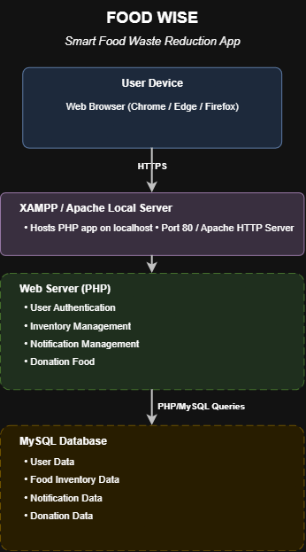
Fig. Deployment Architecture — FoodWise

High-Level Design Components
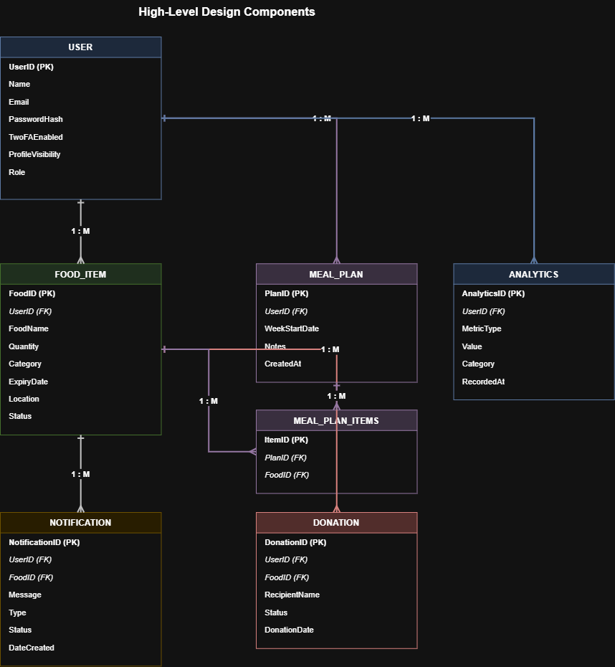
Fig. High-Level Design Components / Entity Relationship Diagram — FoodWise

Site Map
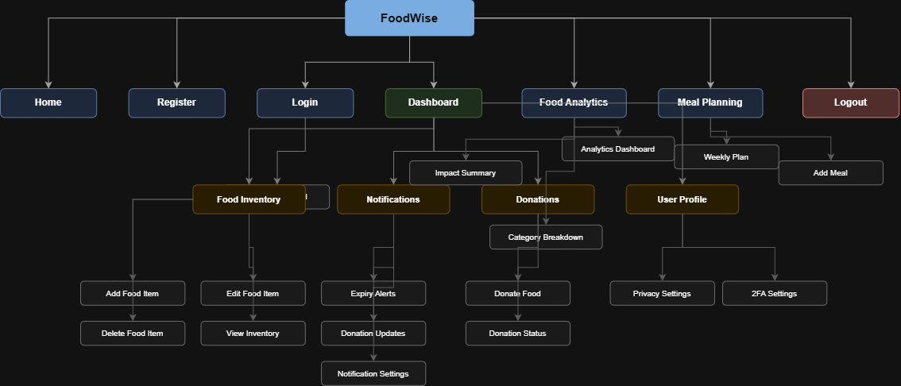
Fig. Site Map — FoodWise

Generic UX / Wireframe
Low-fidelity wireframe sketches for the core FoodWise screens, covering account access, food inventory management, donations, and notifications.
Wireframes
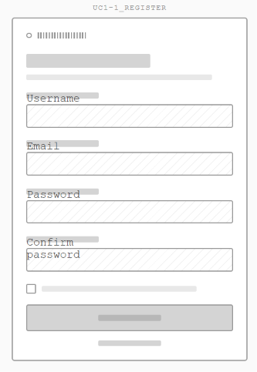
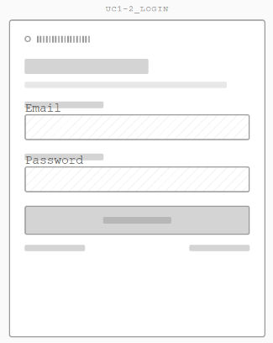
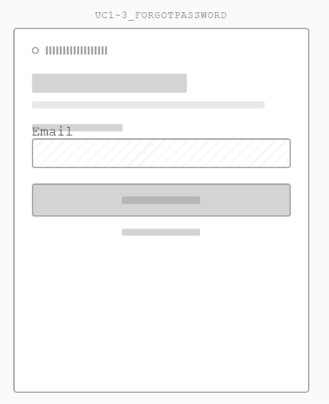
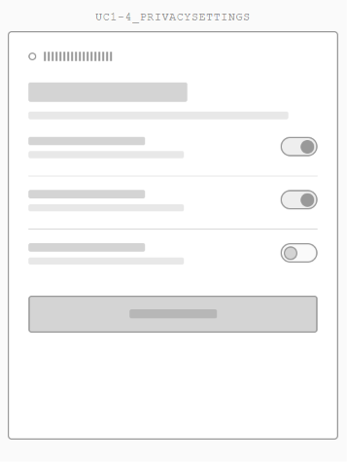
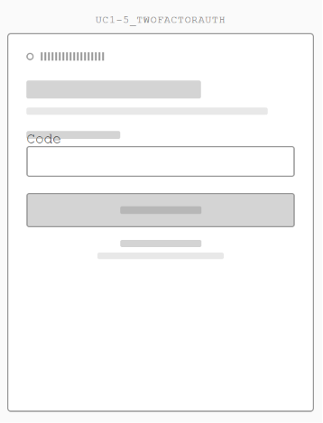

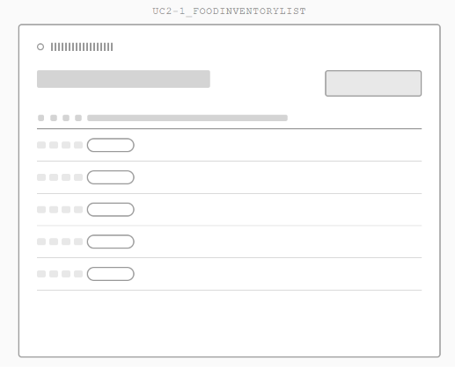

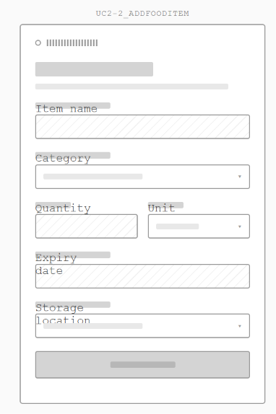

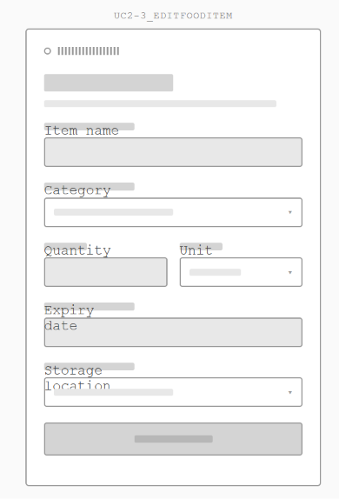

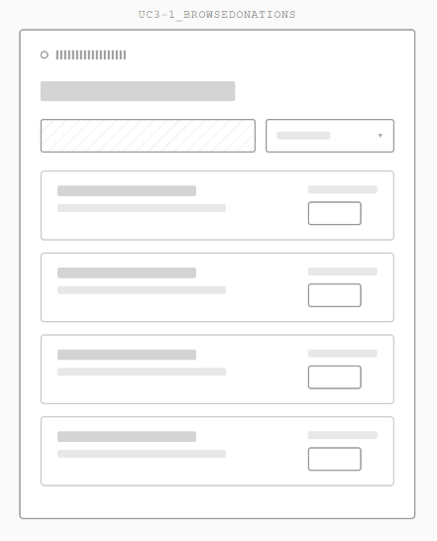

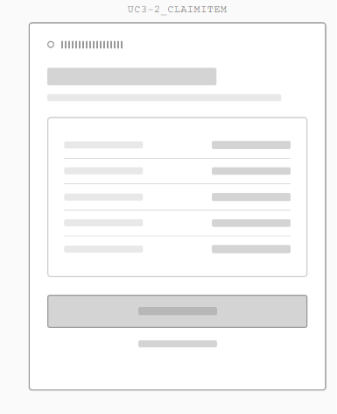
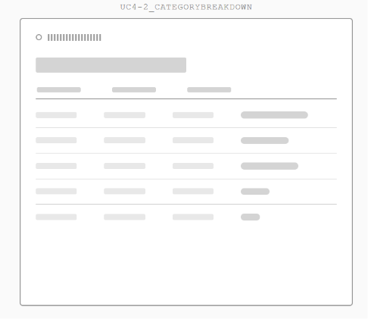

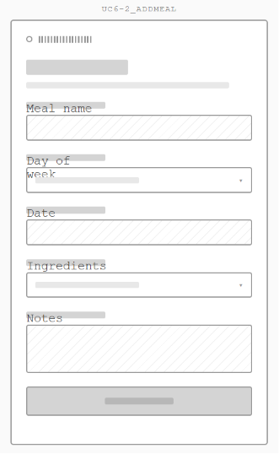

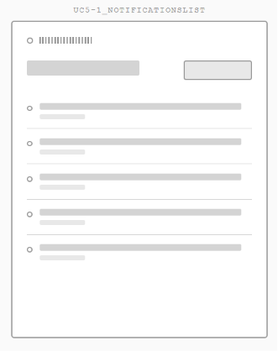

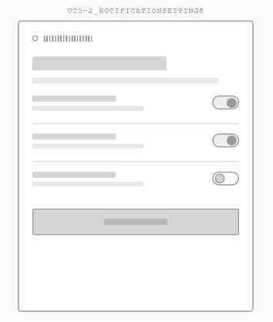

System Design Summary

Overview
The FoodWise system design is based on a classic 3-tier web architecture: a browser based front end (HTML, Bootstrap 5, JavaScript), an Apache/XAMPP server running PHP and a MySQL relational database. This structure directly aligns with the functional and non-functional requirements from Section 1.0 and 2.0, as well as to the six core use cases (Register & Privacy, Manage Inventory, Browse Food Items, Food Analytics, View Notifications, and Plan Weekly Meals).

Meeting the Functional Requirements
The different use cases in the High-Level Design diagram are associated with a set of different PHP controllers and MySQL tables: USER – user authentication, registration, 2FA, user privacy (FR-01–FR-05); FOOD_ITEM – inventory CRUD, expiry tracking, search/filter (FR-06–FR-10); DONATION – browse, claim and confirm food listings (FR-11–FR-14); ANALYTICS – dashboard, date range filtering, category breakdowns (FR-15–FR-18); NOTIFICATION – expiry, donation, meal planning alerts (FR-19–FR-22); MEAL_PLAN / MEAL_PLAN_ITEMS – weekly meal creation, inventory based suggestions (FR-23–FR-26). To attend the Non-Functional Requirements meeting.
Meeting the Non-Functional Requirements
Performance requirements (NFR-01 – NFR-02) are met by the use of indexed MySQL queries and deployments using the localhost XAMPP deployment which is needed for the low latency testing. Security requirements have been implemented using password_hash()/password_verify(), PHP side validation and sanitisation of inputs, and 30 minute timeout of sessions with regeneration upon login (NFR-03 – NFR-05). Responsive Bootstrap 5 layout, consistent navigation structure (as mirrored in Site Map), as well as friendly and validated error messages fulfil the usability requirements (NFR-06 - NFR-08). The use of persistent MySQL storage, graceful error handling, and consistently organised PHP file structure are support for reliability and maintainability requirements (NFR-09 - NFR-11). Compatibility (NFR-12) targets the latest version of the browser(s): Chrome, Edge, and Firefox.
Traceability
The combination of the Architectural Design, High-Level Design Components/ERD, Site Map, and Database Design (Data Dictionary) proves that each functional and non-functional requirement listed in this document is a concrete component, table, or design decision within the proposed FoodWise system.

Database Design (Data Dictionary)
DATABASE DESIGN (DATA DICTIONARY)

Table: USER
Field Name | Data Type | Key | Description
UserID | INT | PK | Unique User ID
Name | VARCHAR(100) | - | User Full Name
Email | VARCHAR(100) | - | User Email
Password | VARCHAR(255) | - | Encrypted Password
TwoFAEnabled | TINYINT(1) | - | Two-Factor Authentication enabled flag (0=disabled, 1=enabled). Default: 0
TwoFACode | VARCHAR(10) | - | One-time 2FA verification code. Nullable
TwoFAExpiry | DATETIME | - | Expiry timestamp of the 2FA code. Nullable
ProfileVisibility | ENUM | - | Controls profile visibility: public or private. Default: public
CreatedAt | DATETIME | - | Account creation timestamp. Default: CURRENT_TIMESTAMP

Table: FOOD_ITEM
Field Name | Data Type | Key | Description
FoodID | INT | PK | Unique Food Item ID
UserID | INT | FK | References User
FoodName | VARCHAR(100) | - | Food Name
Quantity | INT | - | Food Quantity
Category | VARCHAR(50) | - | Food Category
ExpiryDate | DATE | - | Expiry Date
Location | VARCHAR(50) | - | Storage Location

Table: NOTIFICATION
Field Name | Data Type | Key | Description
UserID | INT | FK | References USER.UserID — identifies the user receiving the notification
NotificationID | INT | PK | Unique Notification ID
FoodID | INT | FK | References Food Item
Message | TEXT | - | Notification Content
Status | VARCHAR(20) | - | Read / Unread
CreatedDate | DATETIME | - | Notification Creation Date

Table: DONATION
Field Name | Data Type | Key | Description
DonationID | INT | PK | Unique Donation ID
FoodID | INT | FK | References Food Item
DonationDate | DATE | - | Date of Donation
Status | VARCHAR(30) | - | Pending / Accepted / Collected

Table: MEAL_PLAN
Field Name | Data Type | Key | Description
MealPlanID | INT | PK | Unique Meal Plan record ID. Auto Increment
UserID | INT | FK | References USER.UserID — owner of the meal plan
MealName | VARCHAR(100) | - | Name of the planned meal
PlannedDate | DATE | - | Date the meal is planned for
DayOfWeek | ENUM | - | Day of the week: Mon, Tue, Wed, Thu, Fri, Sat, Sun
MealSlot | ENUM | - | Meal time slot: Breakfast, Lunch, Dinner, Snack
Notes | TEXT | - | Optional notes or cooking instructions for the meal. Nullable
CreatedAt | DATETIME | - | Record creation timestamp. Default: CURRENT_TIMESTAMP

Table: MEAL_PLAN_ITEMS
Field Name | Data Type | Key | Description
MealItemID | INT | PK | Unique Meal Plan Item record ID. Auto Increment
MealPlanID | INT | FK | References MEAL_PLAN.MealPlanID — the meal this item belongs to
FoodID | INT | FK | References FOOD_ITEM.FoodID — the food item used in this meal
QuantityUsed | INT | - | Quantity of the food item reserved/used for this meal

