Assignment 2: Create, Configure, Connect to, Monitor, and Terminate a Virtual Machine Instance using AWS EC2
Name: Shreeyash Patil
Division: B
PRN: 123B1B133

Aim
To create, configure, connect to, monitor, and terminate a virtual machine instance using Amazon EC2.

1. Objectives
- To understand the concept of virtual machines in cloud computing.
- To create and configure an EC2 instance on AWS.
- To connect to an EC2 instance using SSH.
- To monitor the running EC2 instance.
- To understand the EC2 instance lifecycle.
- To stop and terminate an EC2 instance.

2. Theory

2.1 Amazon EC2
Amazon Elastic Compute Cloud (EC2) is an AWS service that provides virtual servers in the cloud. An EC2 instance can be used to run applications and perform computing tasks without requiring a physical server.

2.2 EC2 Instance
An EC2 instance is a virtual machine running on AWS infrastructure. It can be configured with the required operating system, computing resources, storage, and network settings.

2.3 Security Group
A security group acts as a virtual firewall for an EC2 instance. It controls incoming and outgoing network traffic. For SSH access, port 22 is allowed.

2.4 SSH
SSH (Secure Shell) is used to securely connect to a remote EC2 Linux instance.
The private key is given appropriate permissions using:
chmod 400 devops1.pem

The instance can then be accessed using:
ssh -i devops1.pem ec2-user@<EC2-PUBLIC-IP>

2.5 EC2 Monitoring
AWS provides monitoring for EC2 instances to observe their status and resource usage, such as CPU utilization and network activity.

2.6 EC2 Lifecycle
An EC2 instance can be:
Launch → Running → Stop → Stopped → Start → Running → Terminate

Stopping allows the instance to be started again, while terminating permanently removes the instance.

3. Procedure
- Log in to the AWS Management Console.
- Open the EC2 service.
- Launch a new EC2 instance.
- Configure the required instance settings.
- Configure the security group to allow SSH access on port 22.
- Launch the instance.
- Copy the instance's public IPv4 address.
- Set permissions for the private key:
chmod 400 devops1.pem

- Connect to the instance using SSH:
ssh -i devops1.pem ec2-user@<EC2-PUBLIC-IP>

- Verify the connection using commands such as:
whoami
pwd
ls

- Monitor the instance from the AWS EC2 console.
- Stop the instance after testing.
- Start it again if required.
- Terminate the instance after completing the experiment.

4. Commands Used

Set private key permissions
chmod 400 devops1.pem

Connect to EC2
ssh -i devops1.pem ec2-user@<EC2-PUBLIC-IP>

Check current user
whoami

Check current directory
pwd

List files
ls

Exit SSH
exit

5. Output

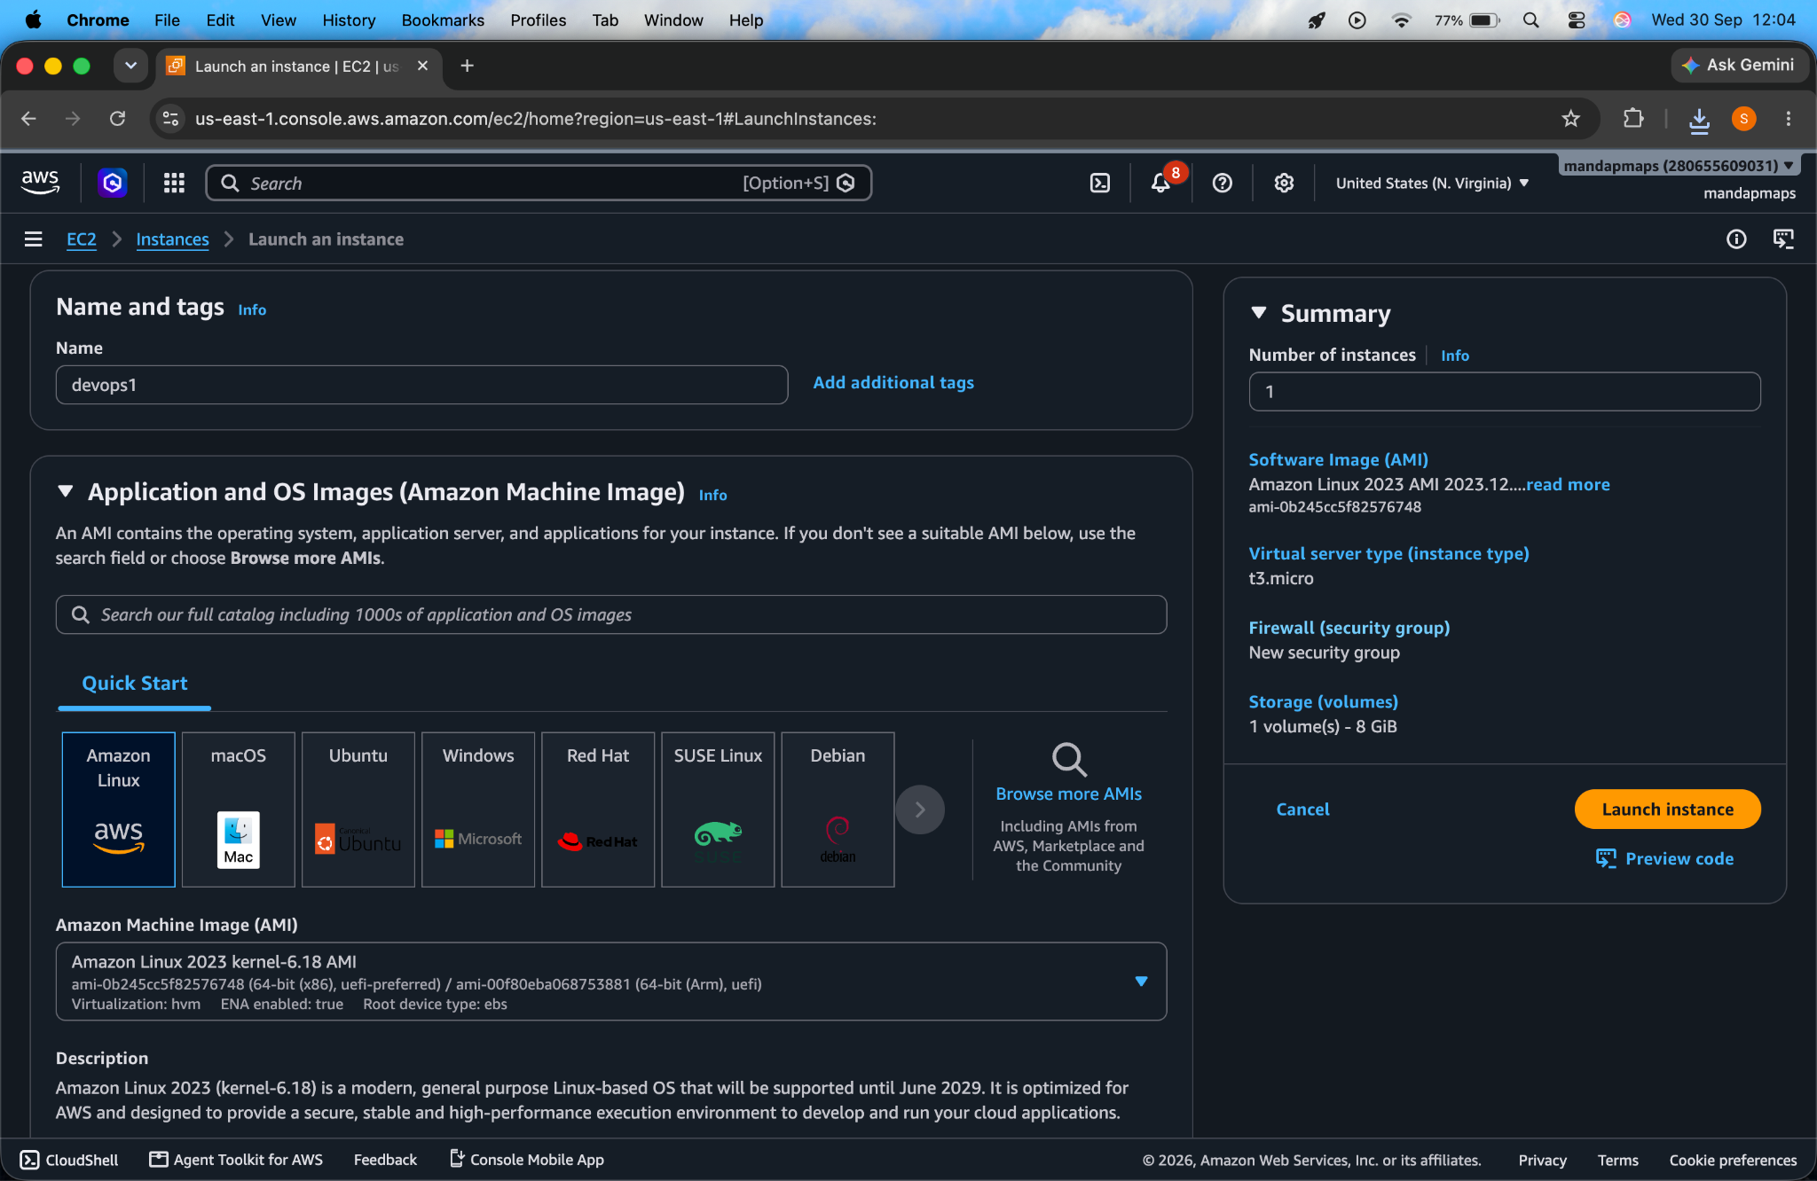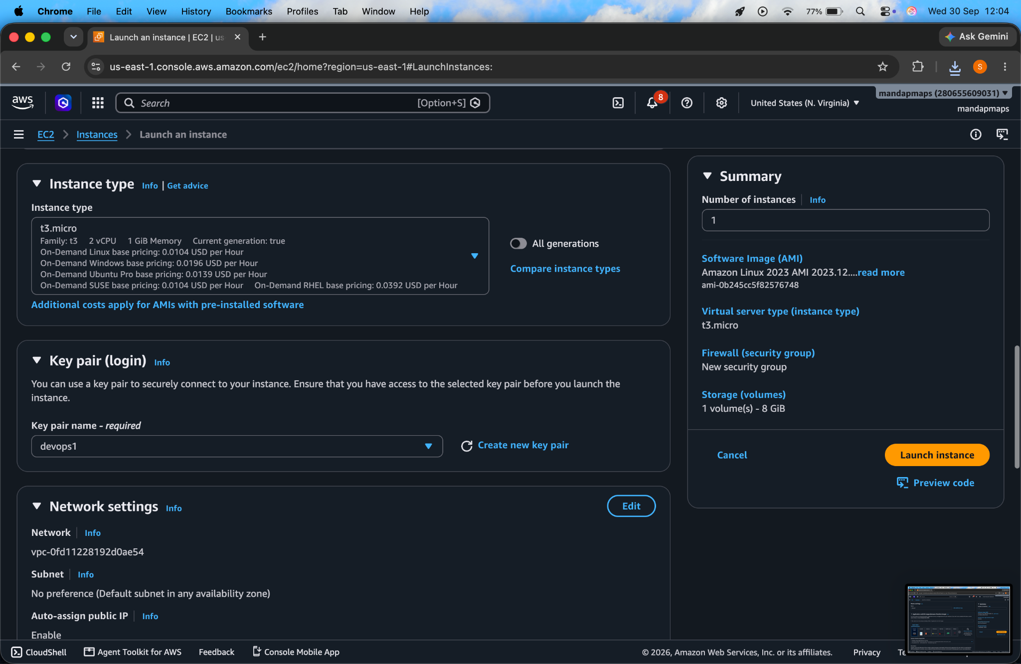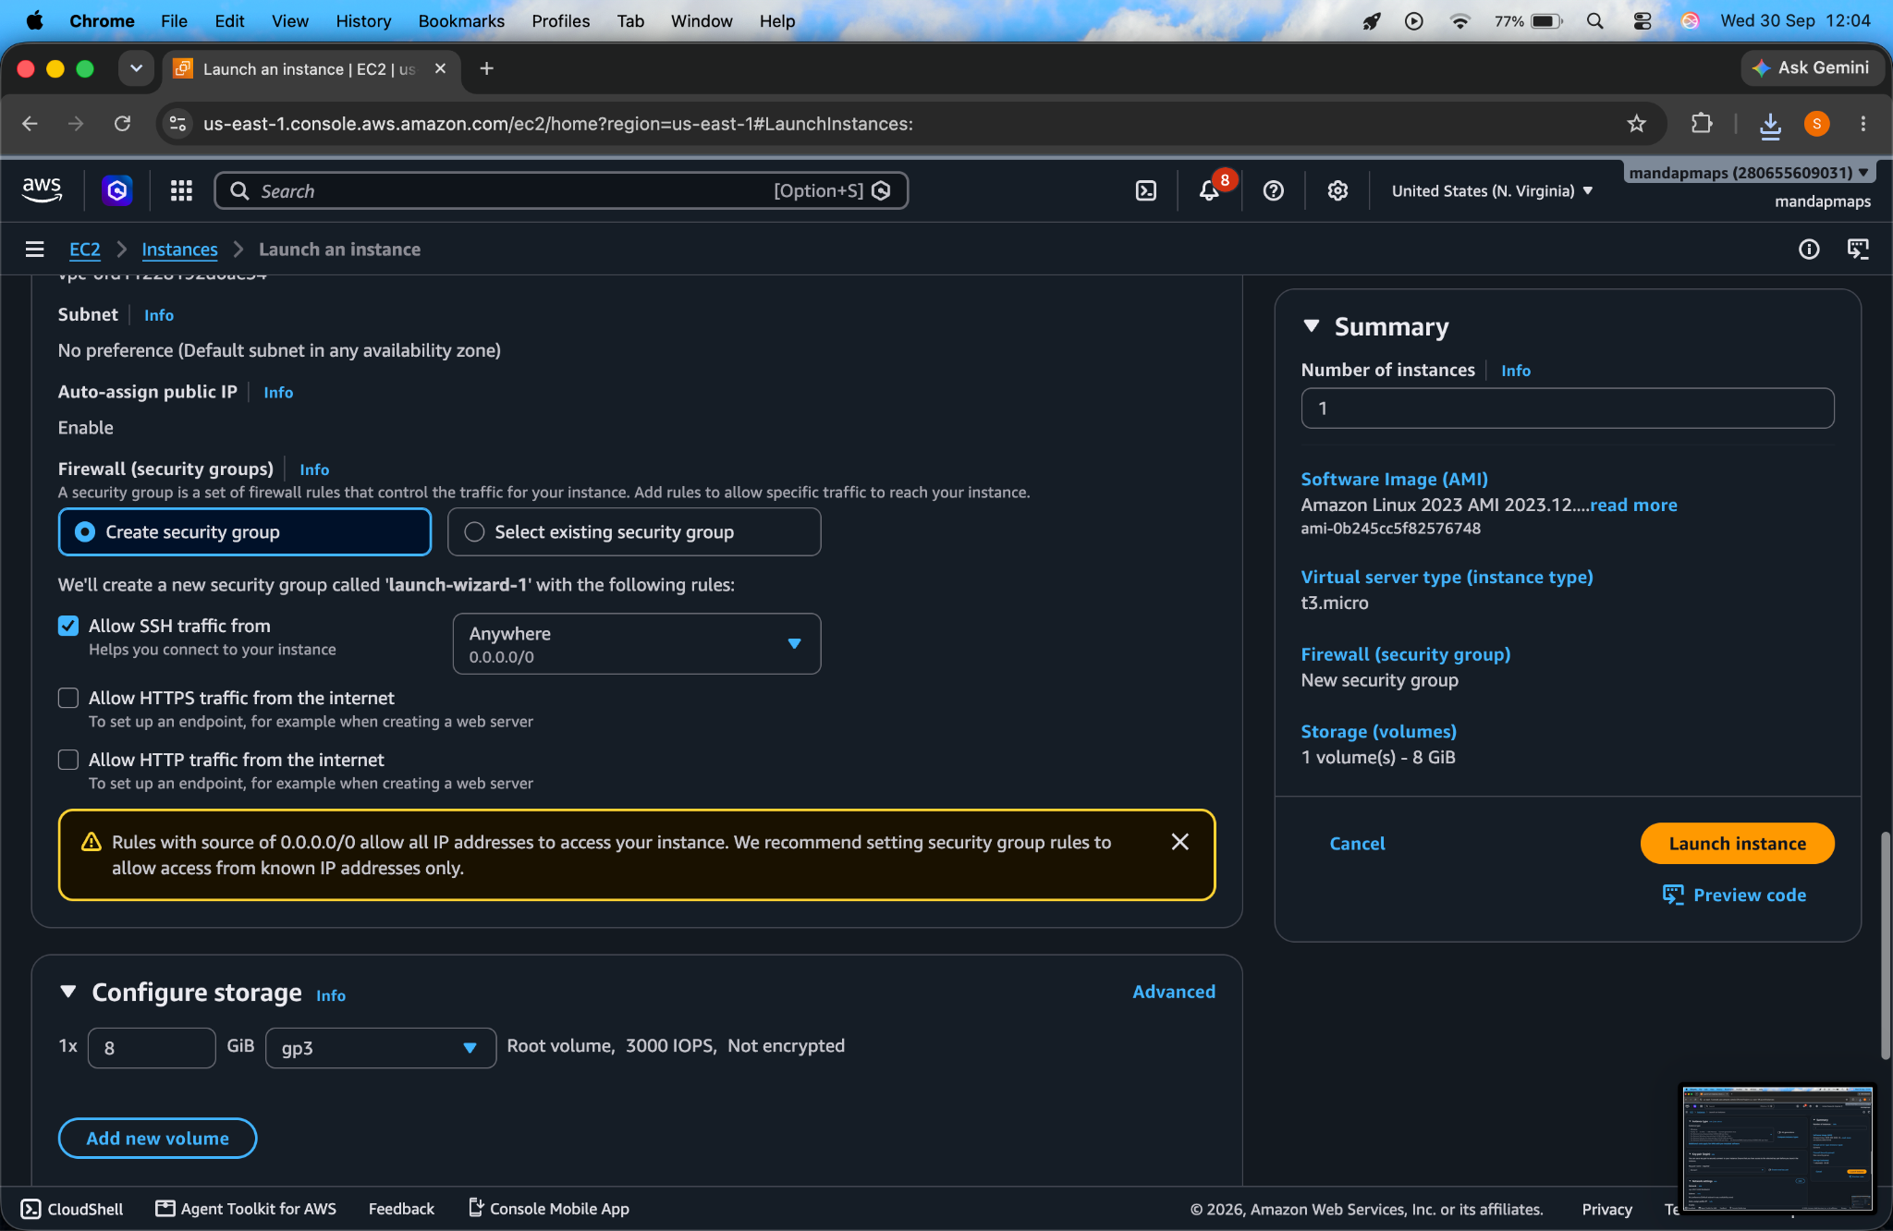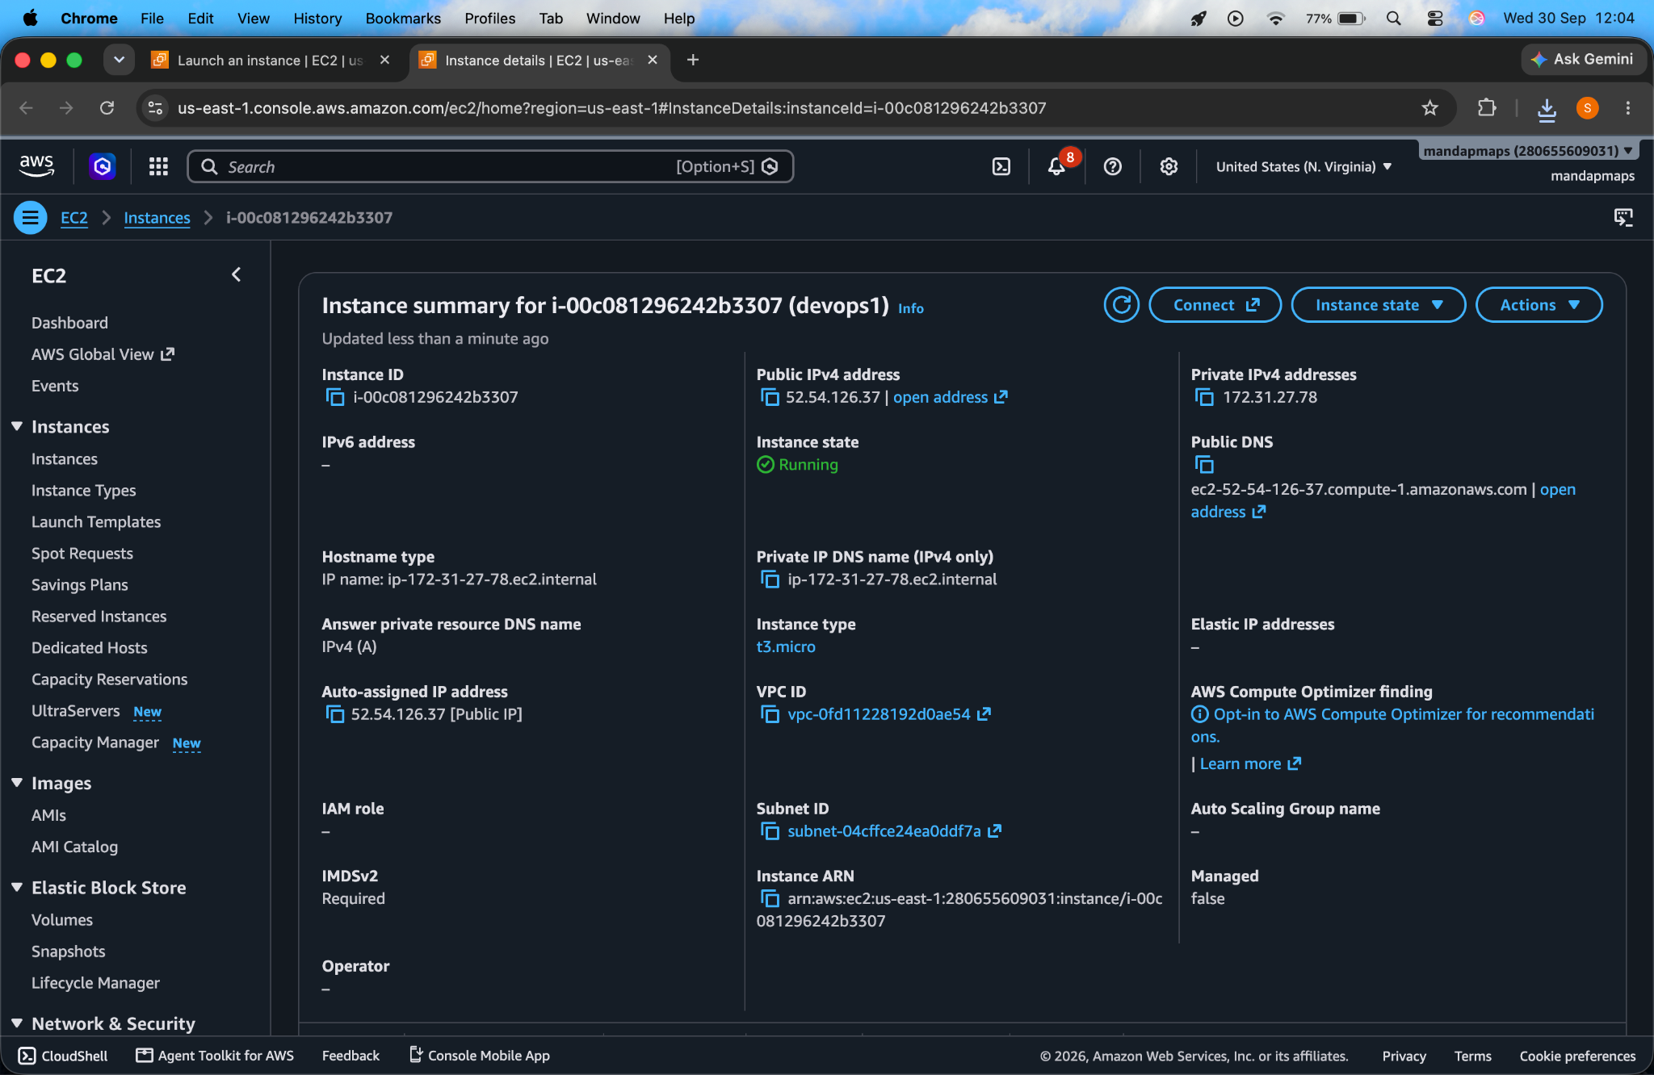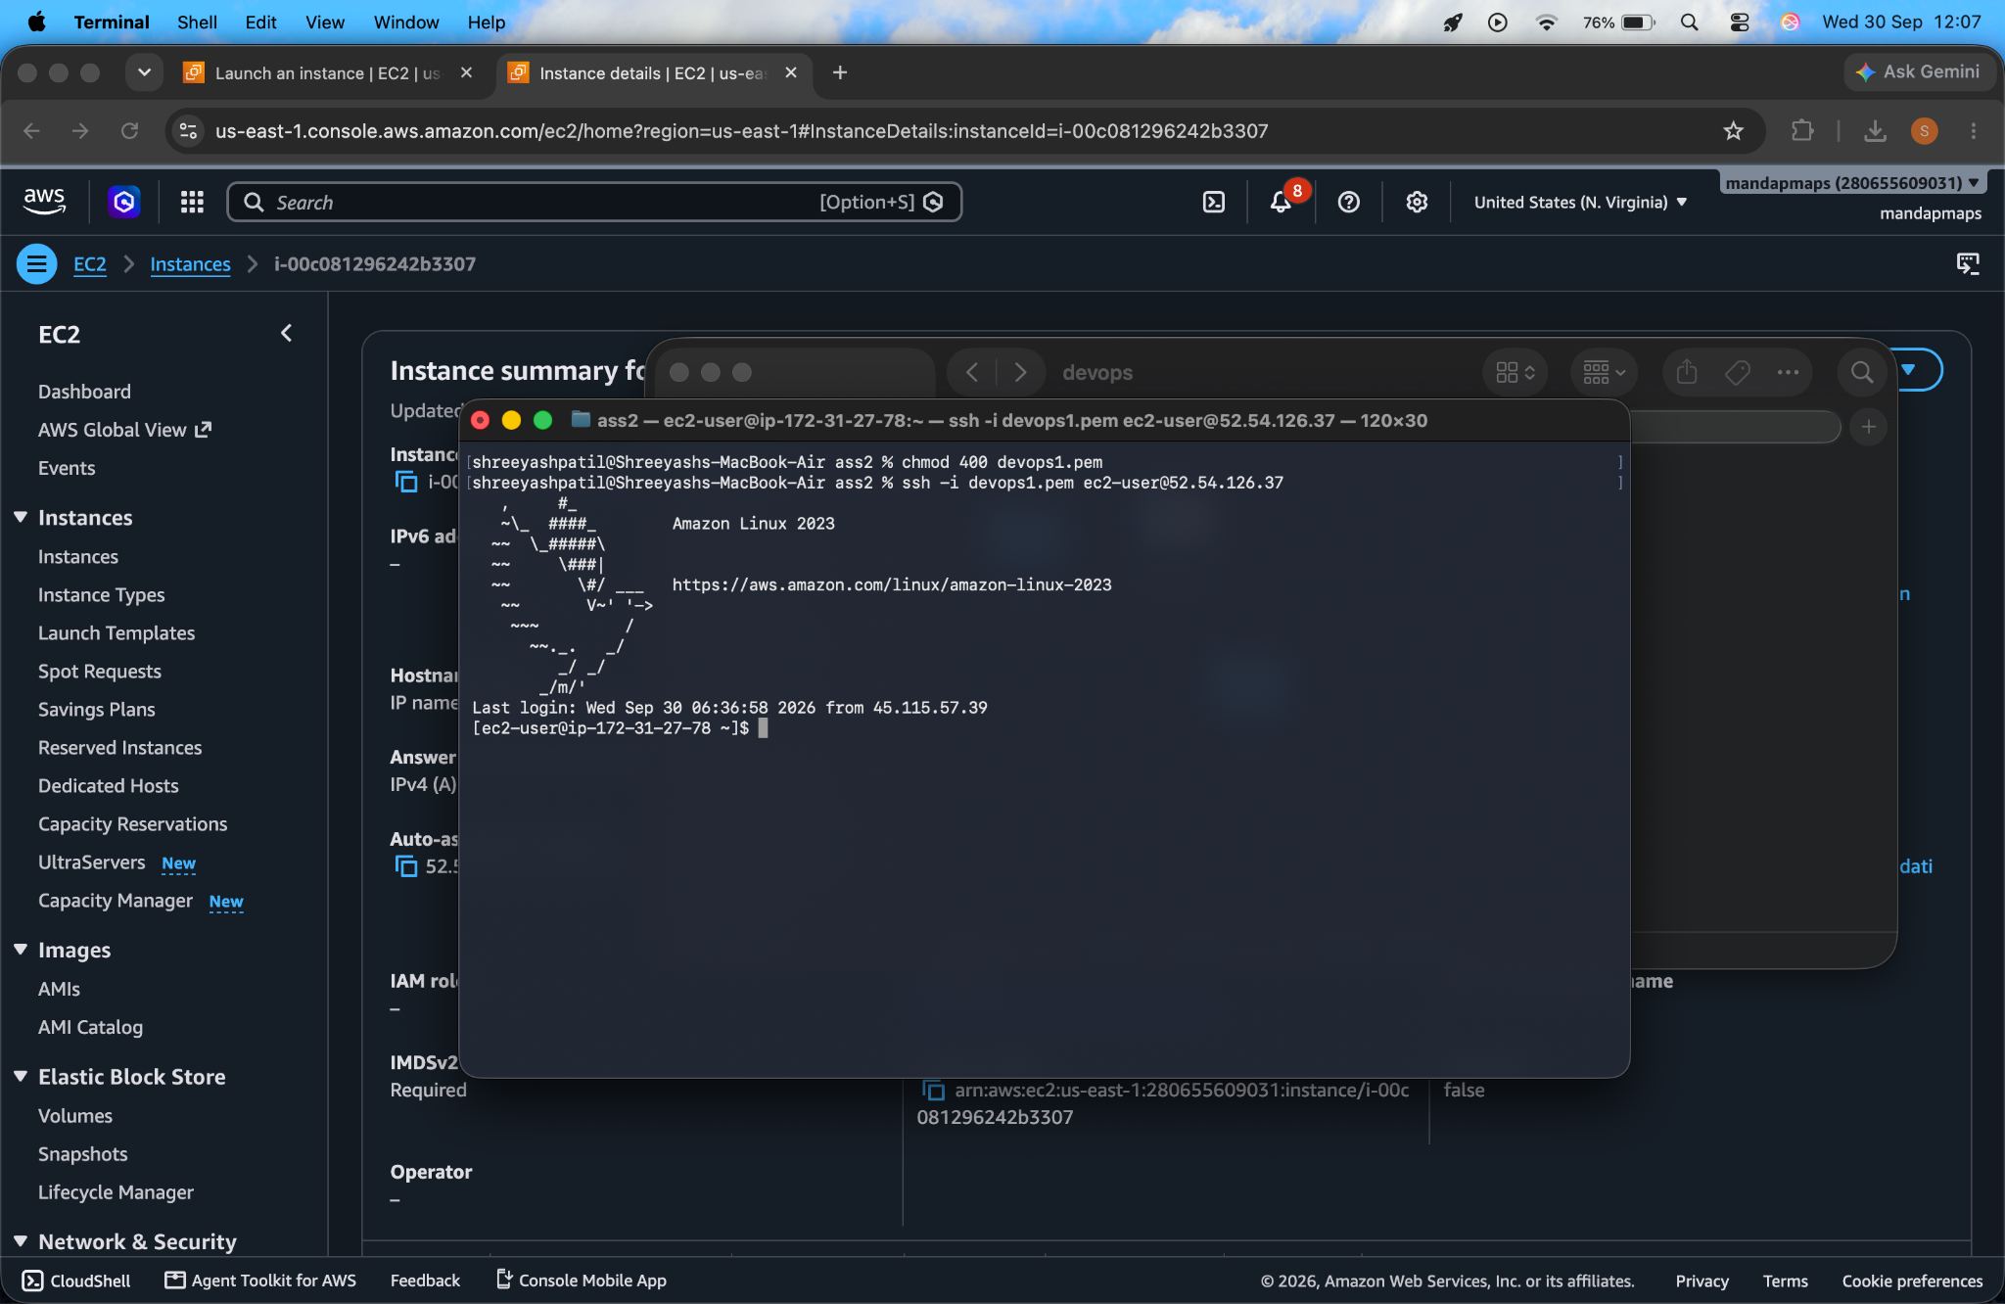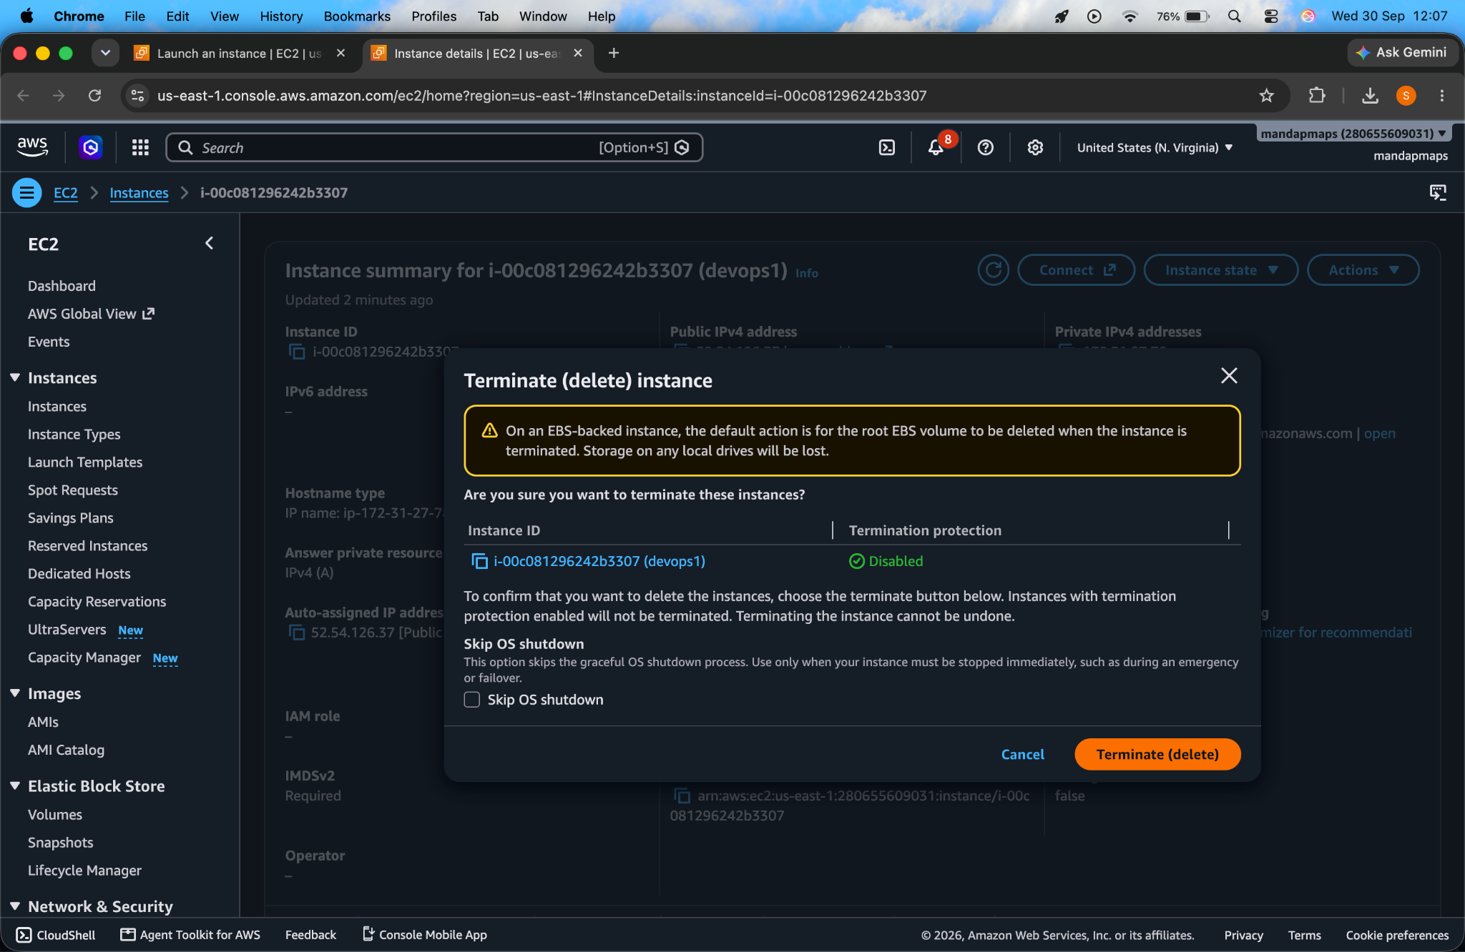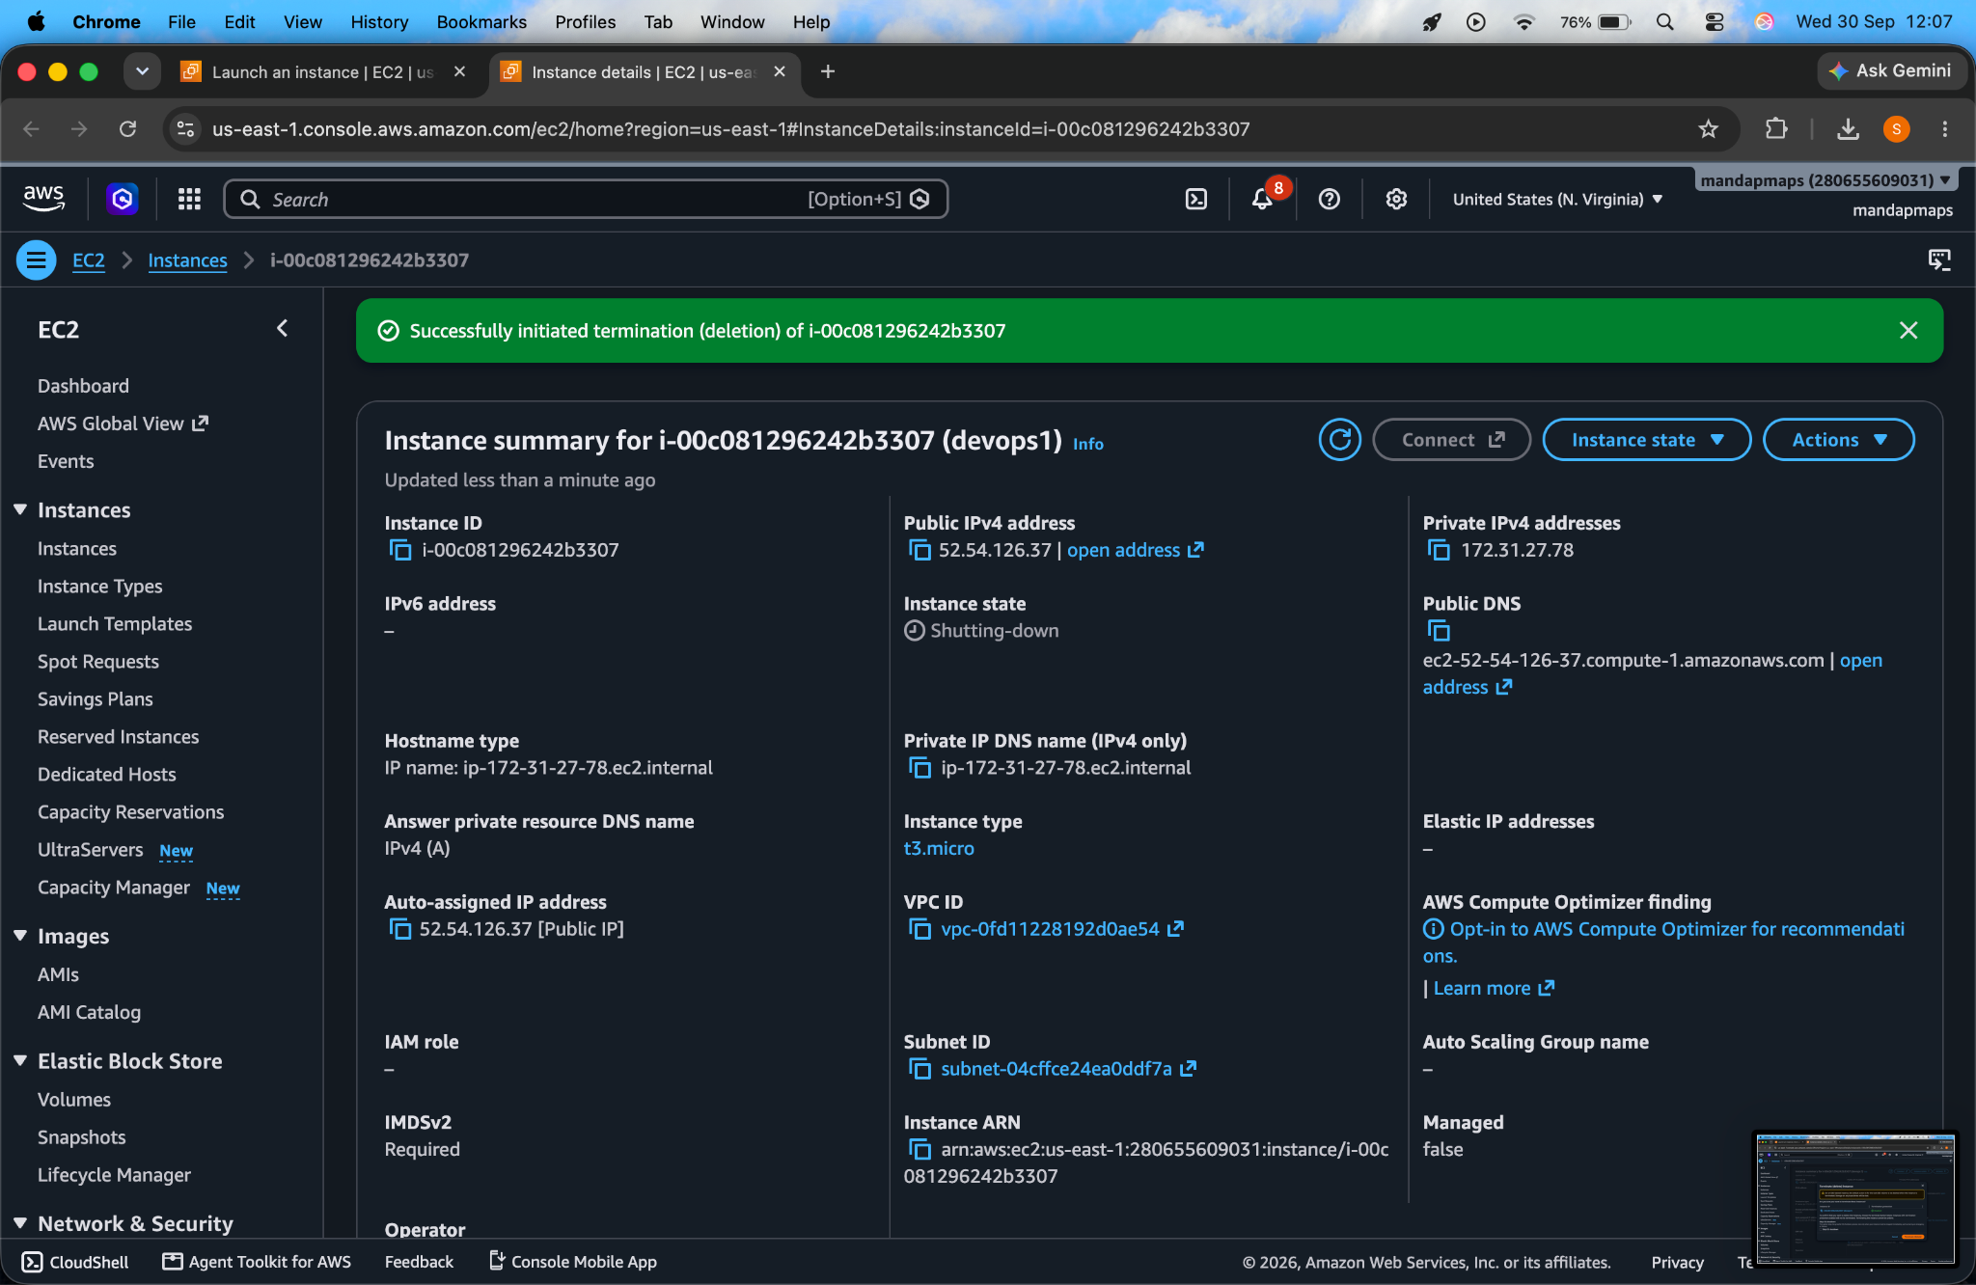

6. Conclusion

Result
The AWS EC2 virtual machine was successfully created, configured, connected to using SSH, monitored, and terminated.

Conclusion
The experiment demonstrated how AWS EC2 can be used to create and manage a virtual machine in the cloud. SSH provided secure remote access, while AWS monitoring and instance lifecycle operations allowed the virtual machine to be managed effectively.

