Assignment 3: Infrastructure as Code using Terraform
Name: Shreeyash Patil
Division: B
PRN: 123B1B133

Aim
To study the concepts and workflow of Infrastructure as Code (IaC), install and configure Terraform, and use Terraform to provision an AWS EC2 instance.

1. Objectives
- To understand the concept of Infrastructure as Code (IaC).
- To install and configure Terraform.
- To understand Terraform configuration files.
- To configure the AWS provider.
- To define an EC2 resource using Terraform.
- To use variables and outputs in Terraform.
- To provision and manage an AWS EC2 instance using Terraform.

2. Theory

2.1 Infrastructure as Code
Infrastructure as Code (IaC) is the practice of managing and provisioning infrastructure using configuration files instead of manually creating resources through a cloud provider's console.
IaC makes infrastructure easier to reproduce, modify, and manage.

2.2 Terraform
Terraform is an Infrastructure as Code tool developed by HashiCorp. It allows cloud resources to be defined in configuration files and created or managed automatically.
The basic Terraform workflow is:
Write Configuration
↓
terraform init
↓
terraform plan
↓
terraform apply
↓
Infrastructure Created

2.3 Terraform Provider
A provider allows Terraform to communicate with a specific cloud platform or service.
In this assignment, the AWS provider is used to communicate with AWS.

2.4 Terraform Resource
A resource defines the infrastructure that Terraform should create.
In this assignment, an aws_instance resource is used to create an EC2 instance.

2.5 Variables
Variables allow values such as the AWS region, AMI ID, instance type, and instance name to be defined separately from the main configuration.

2.6 Outputs
Outputs display useful information about the resources created by Terraform, such as the EC2 instance ID and public IP address.

3. Terraform Configuration

main.tf
terraform {
required_providers {
aws = {
source = "hashicorp/aws"
version = "~> 6.0"
}
}
}

provider "aws" {
region = var.aws_region
}

resource "aws_instance" "example" {
ami = var.ami_id
instance_type = var.instance_type

tags = {
Name = var.instance_name
}
}

variables.tf
variable "aws_region" {
default = "ap-south-1"
}

variable "ami_id" {
description = "AMI ID for the EC2 instance"
type = string
}

variable "instance_type" {
default = "t2.micro"
}

variable "instance_name" {
default = "Shreeyash-Terraform-EC2"
}

terraform.tfvars
ami_id = "ami-0351a972f17e4d123"

outputs.tf
output "instance_id" {
description = "ID of the EC2 instance"
value = aws_instance.example.id
}

output "public_ip" {
description = "Public IP address of the EC2 instance"
value = aws_instance.example.public_ip
}

output "instance_name" {
description = "Name of the EC2 instance"
value = aws_instance.example.tags.Name
}

4. Commands Used

Check Terraform installation
terraform --version

Initialize Terraform
terraform init

Format configuration
terraform fmt

Validate configuration
terraform validate

Preview changes
terraform plan

Create the EC2 instance
terraform apply
Enter:
yes

Display outputs
terraform output

Destroy the infrastructure
terraform destroy
Enter:
yes

5. Output
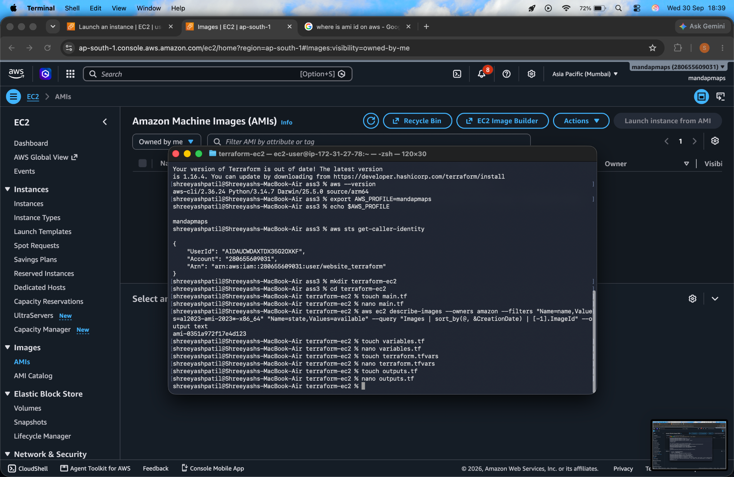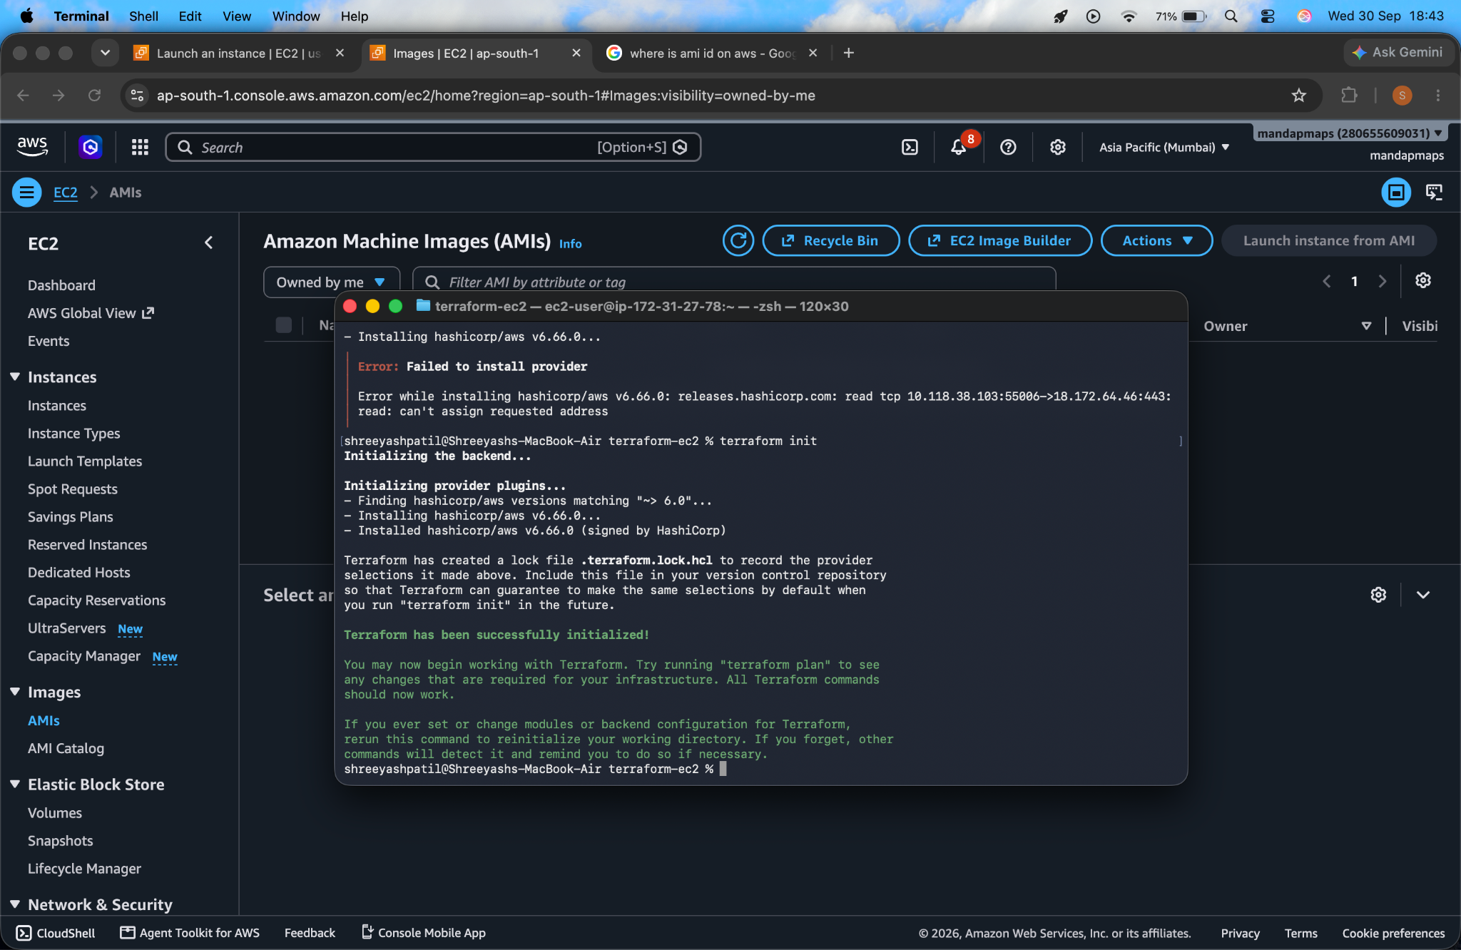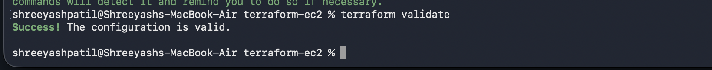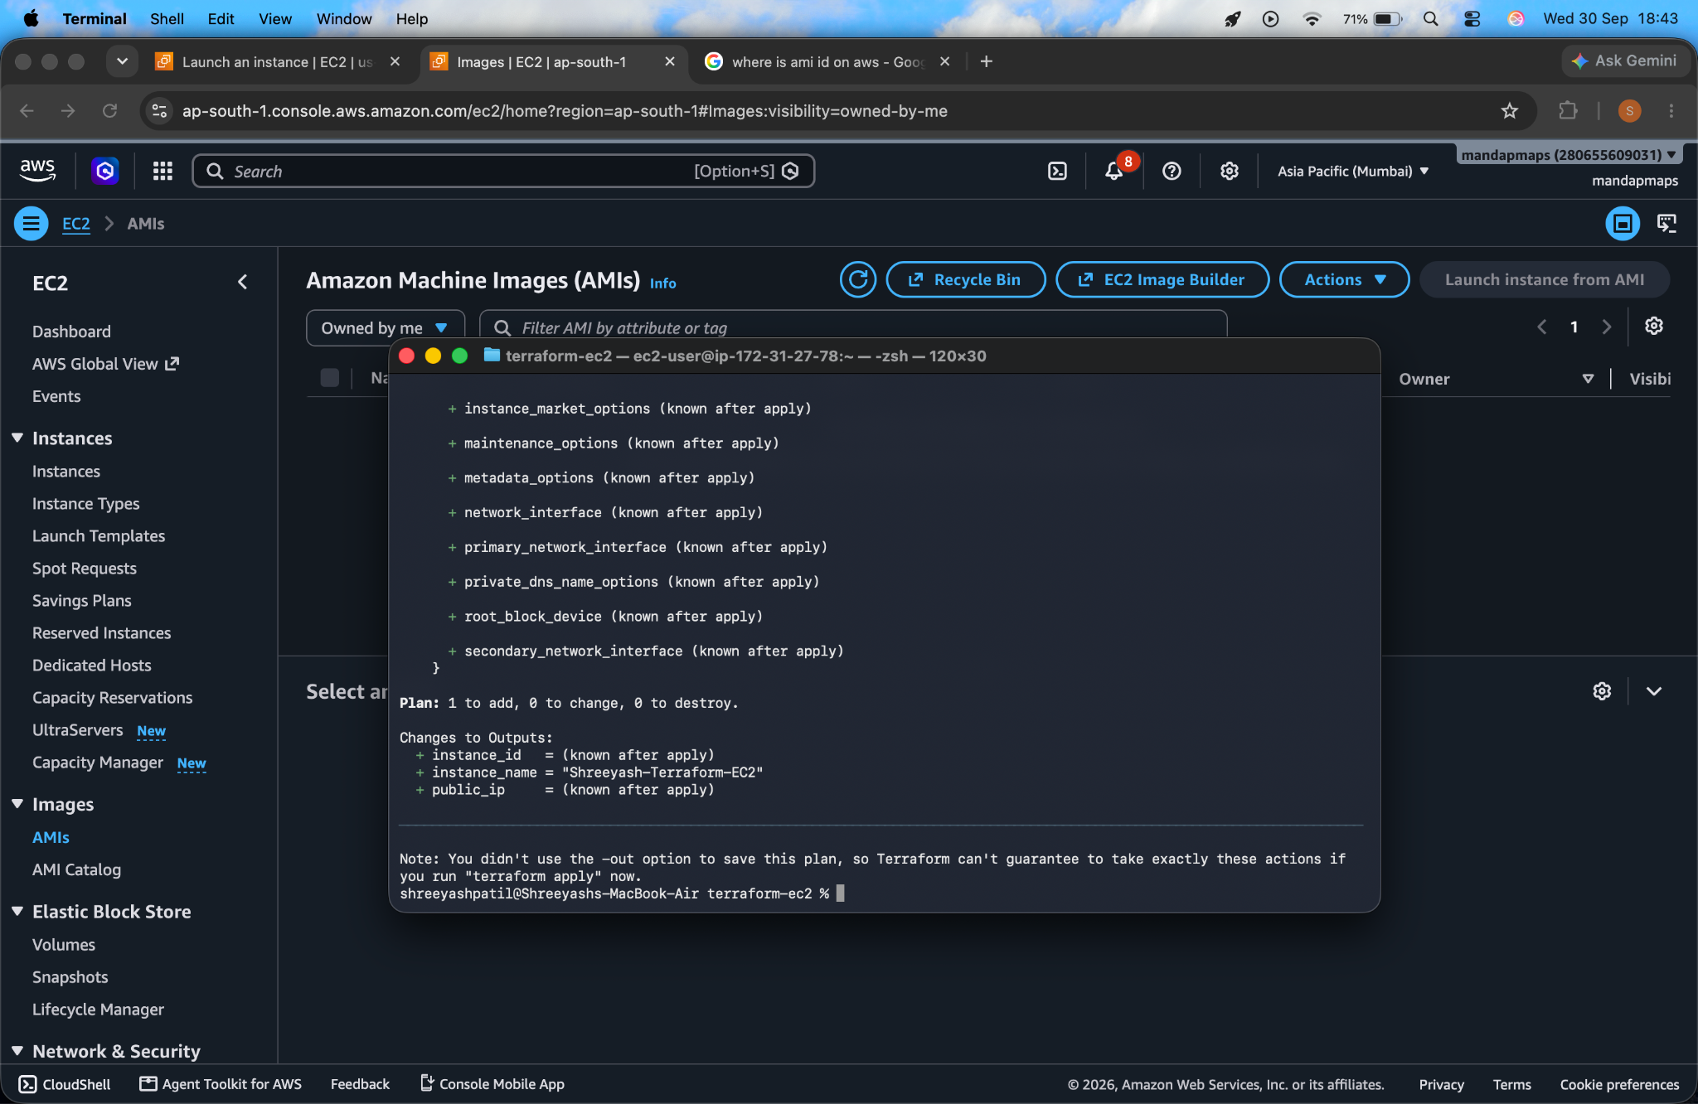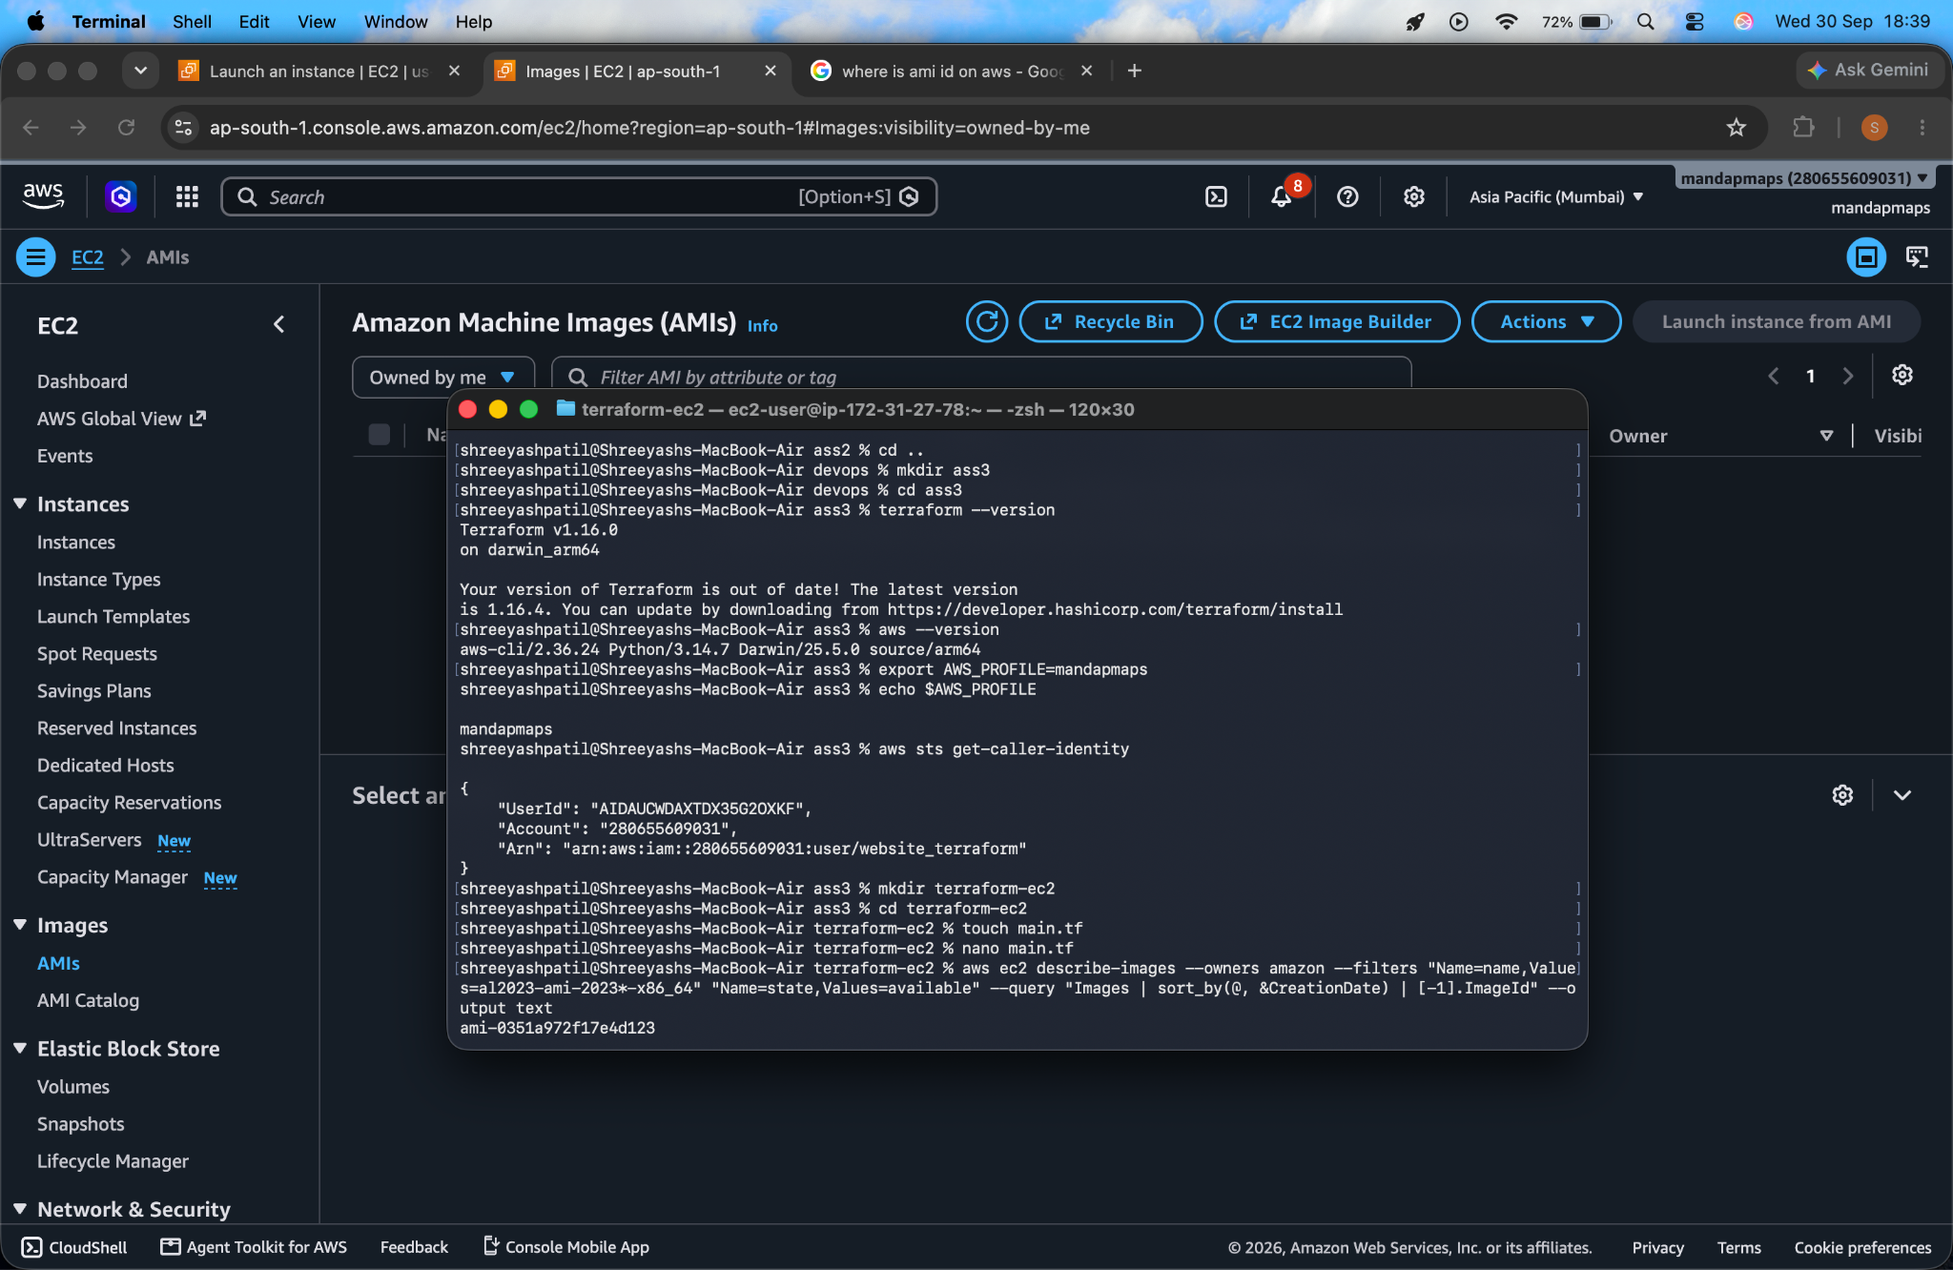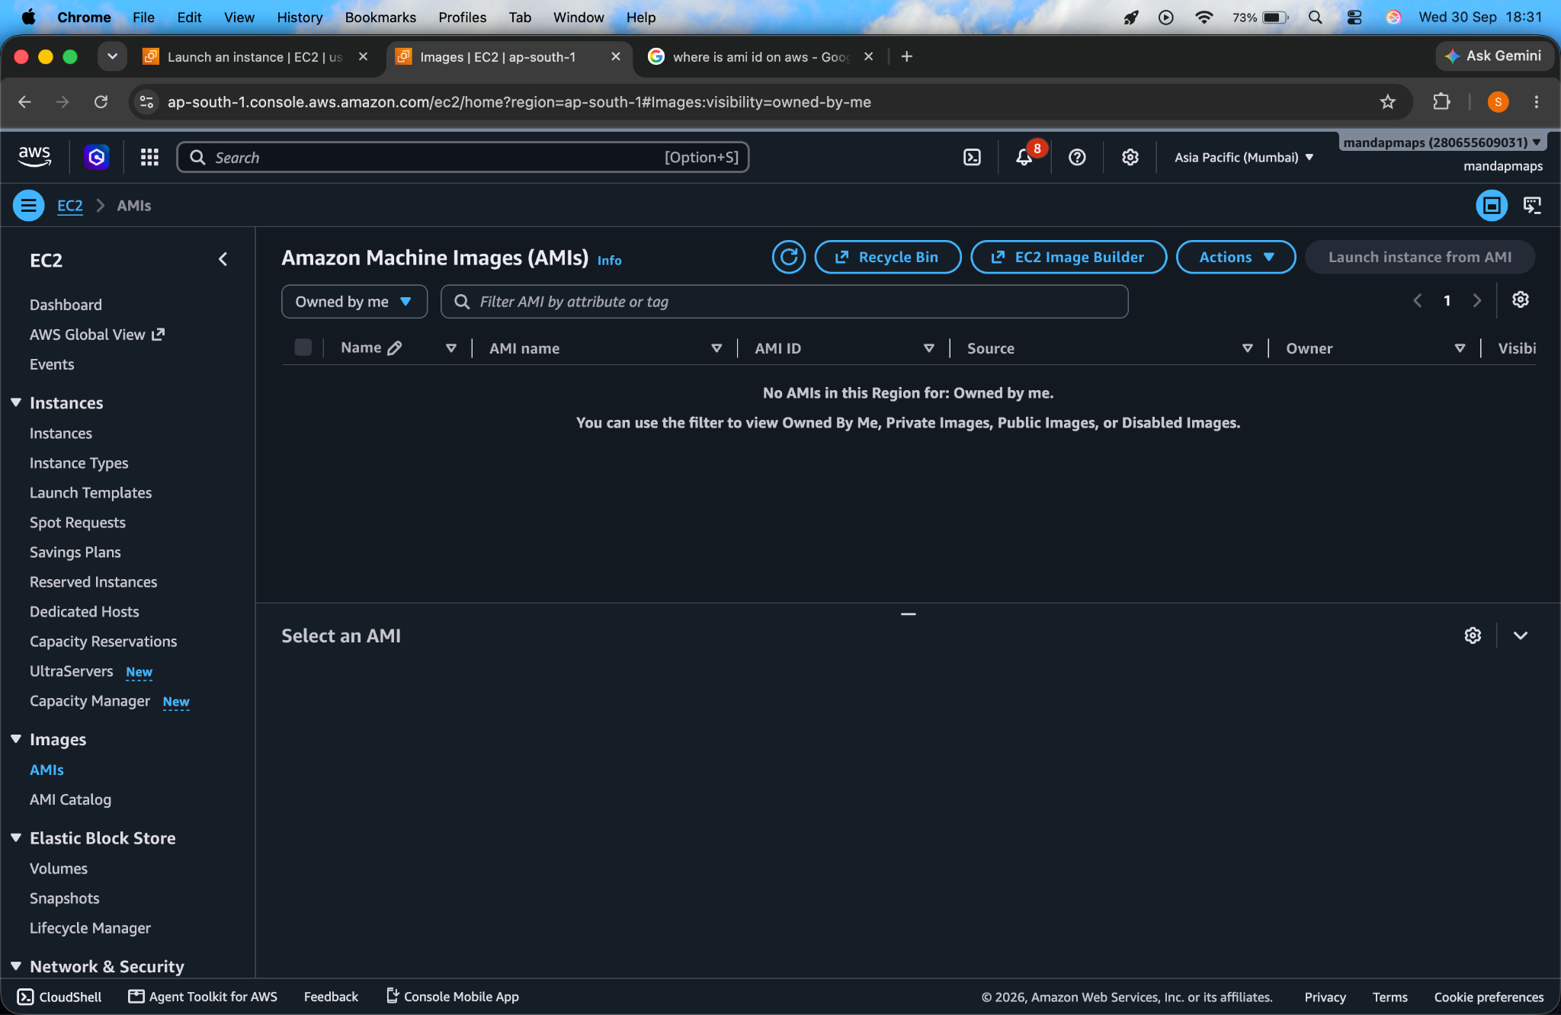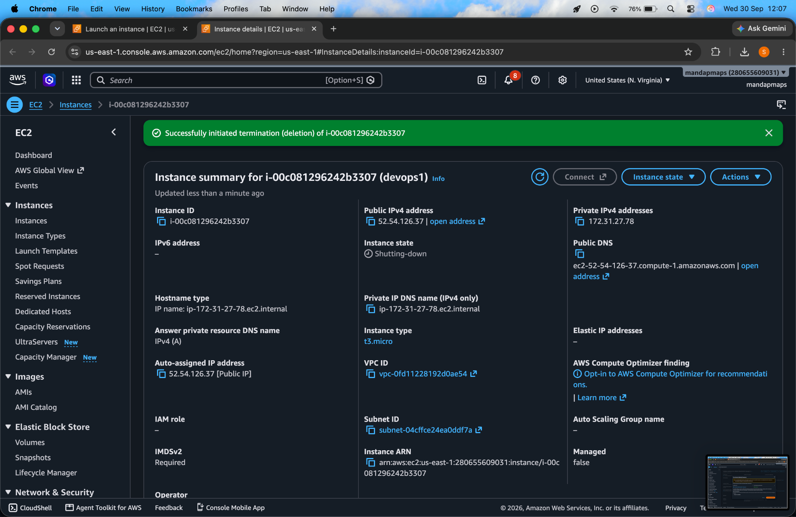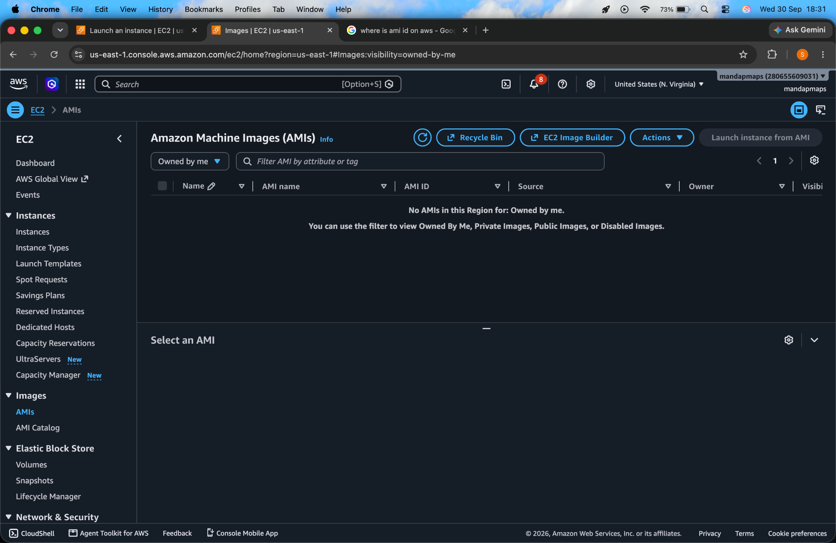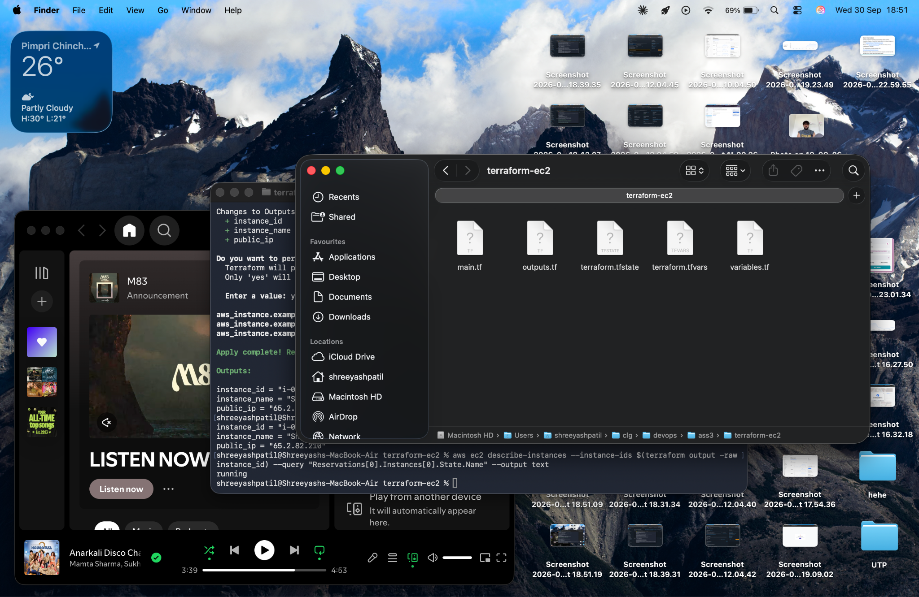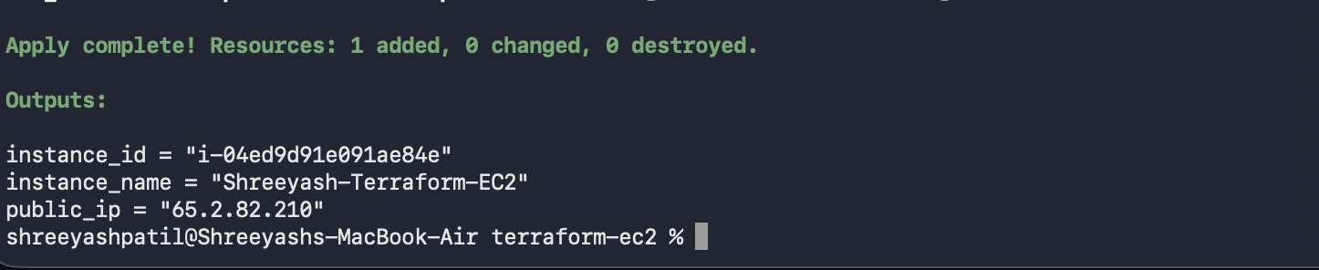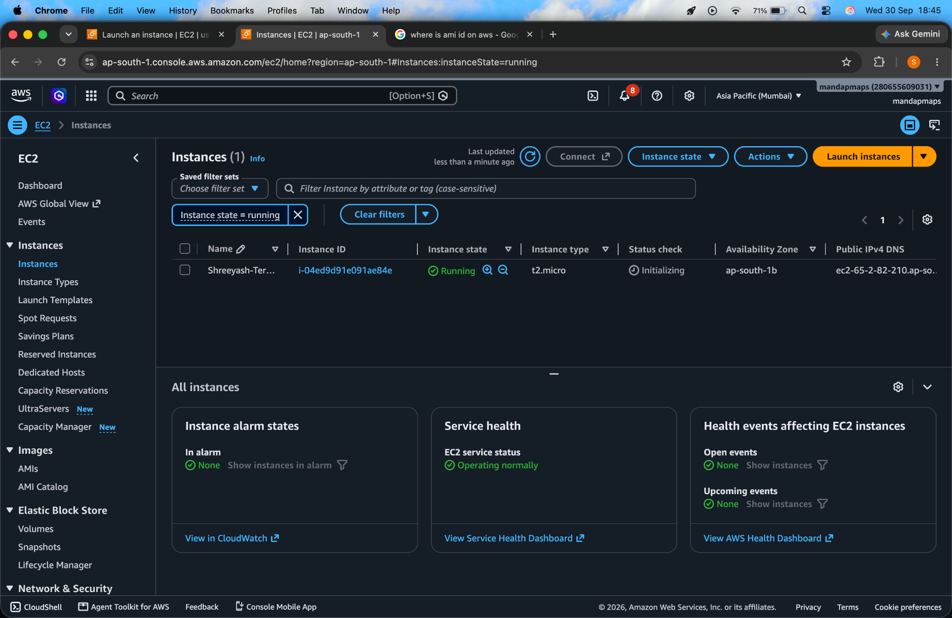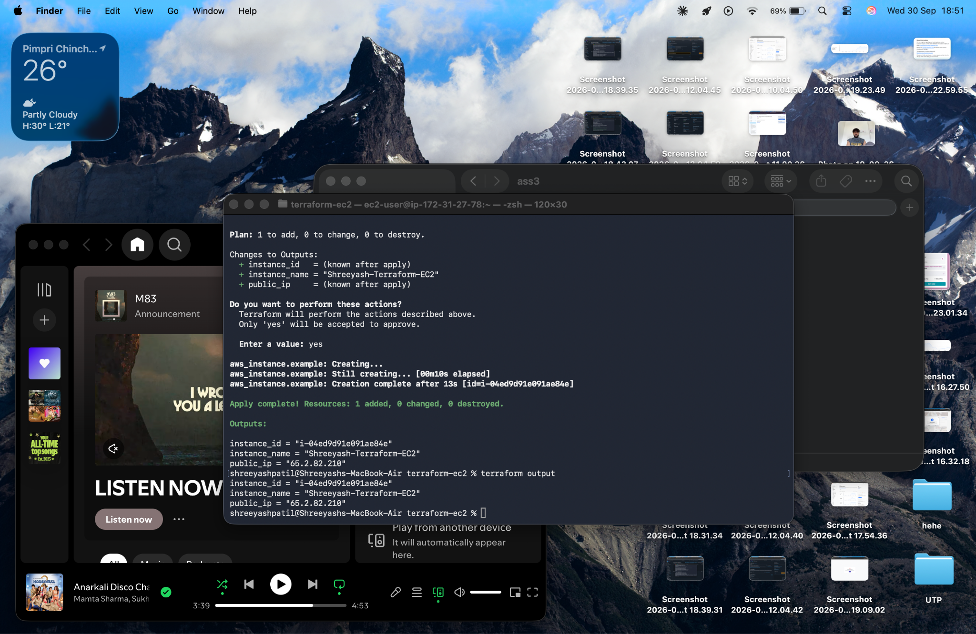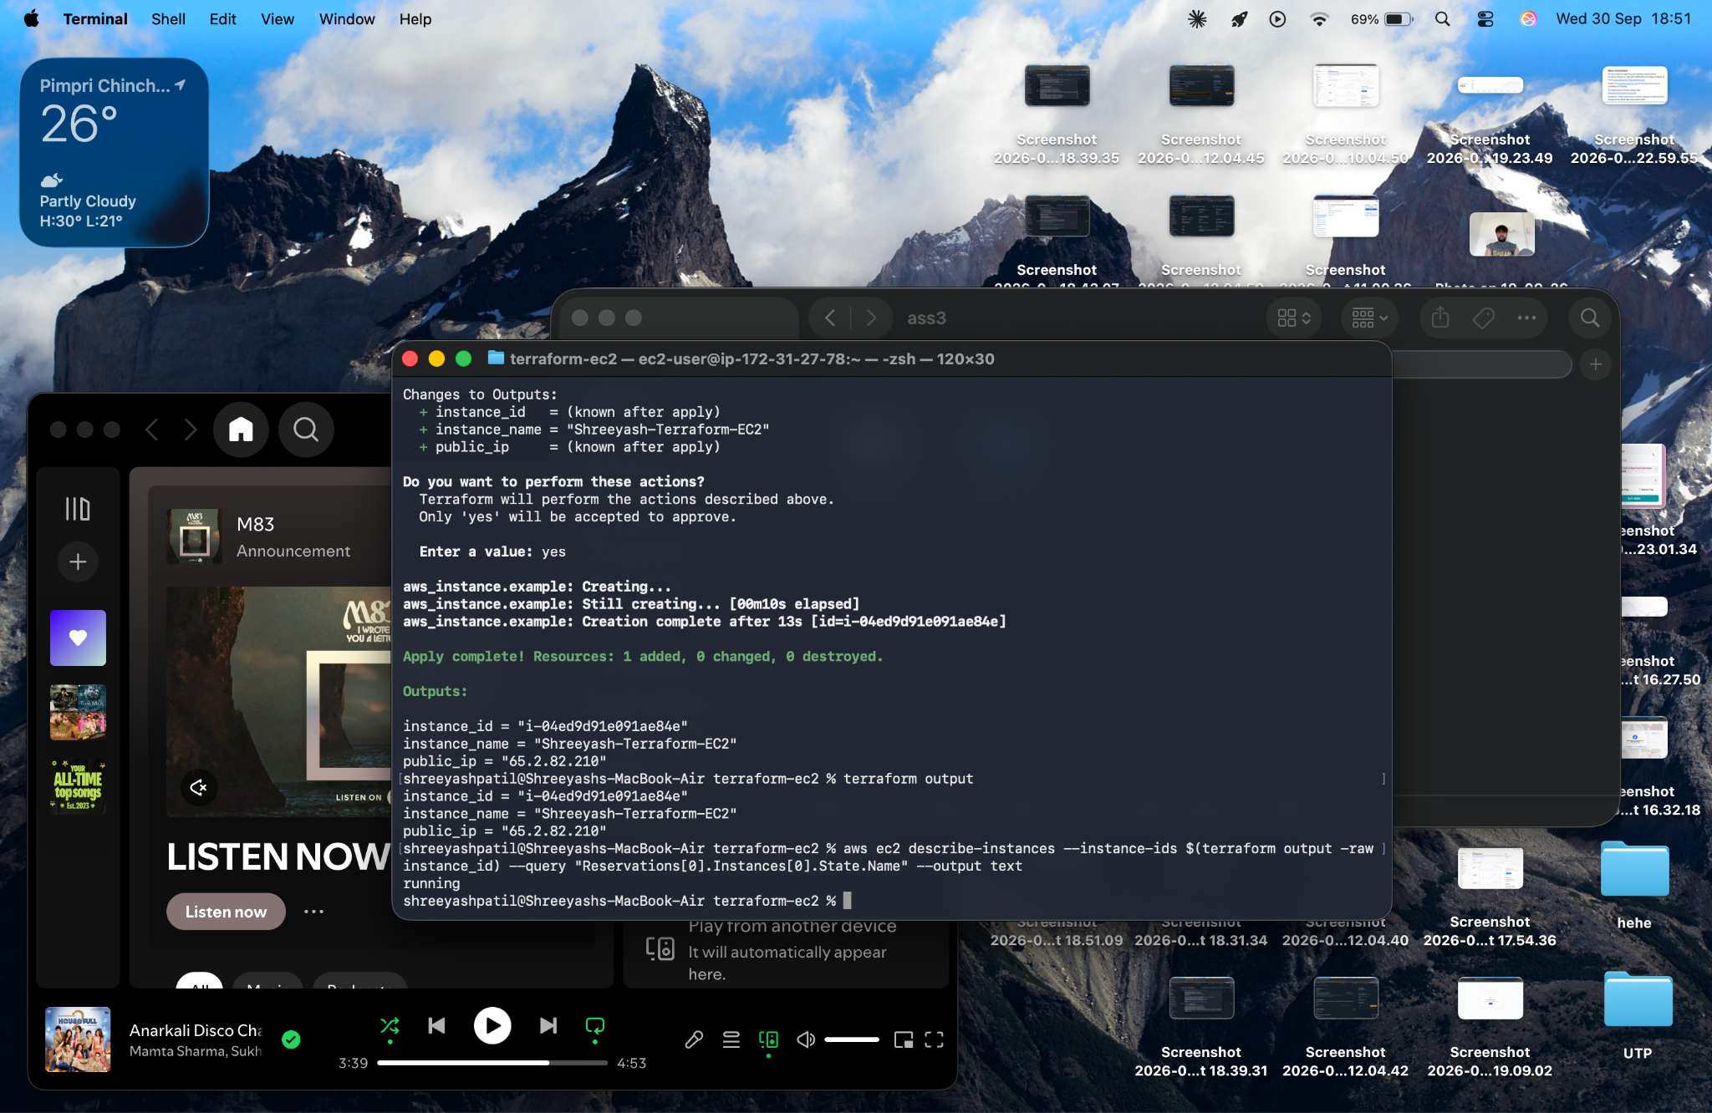

6. Result / Conclusion

Result
An AWS EC2 instance was successfully provisioned using Terraform. The configuration included an AWS provider, EC2 resource, variables, and outputs.

Conclusion
The experiment demonstrated the basic workflow of Infrastructure as Code using Terraform. Terraform was used to define, validate, provision, view, and remove AWS infrastructure through configuration files instead of manually creating the resource.
The workflow was:
Terraform Configuration
↓
terraform init
↓
terraform validate
↓
terraform plan
↓
terraform apply
↓
AWS EC2 Instance
↓
terraform output
↓
terraform destroy

