Assignment 7: Kubernetes Architecture and Helm
Name: Shreeyash Patil
PRN: 123B1B133
Division: B

Aim
To study Kubernetes architecture and understand container orchestration by deploying and managing an Nginx application using Helm.

Objectives
- To understand container orchestration and Kubernetes architecture.
- To identify control-plane and worker-node components.
- To create and customize a Helm chart.
- To perform Helm operations such as linting, templating, installation, upgrading, rollback, and uninstallation.

Theory

1. Container Orchestration
Container orchestration is the automated management of containers. It handles deployment, scaling, networking, load balancing, and recovery of applications. Kubernetes is a popular container orchestration platform that ensures applications run according to the desired configuration.

2. Kubernetes Architecture
A Kubernetes cluster consists of control-plane components and worker-node components.
Control Plane Components
- kube-apiserver: Acts as the entry point for Kubernetes API requests.
- etcd: Stores the cluster's configuration and state.
- kube-scheduler: Assigns newly created Pods to suitable nodes.
- kube-controller-manager: Maintains the desired state of the cluster.
Worker Node Components
- kubelet: Ensures that Pods and containers run as instructed.
- kube-proxy: Manages network rules for Kubernetes Services.
- Container Runtime: Pulls images and executes containers, for example, containerd.
Kubernetes also provides Deployments for managing replicas, Services for stable networking, CoreDNS for service discovery, and self-healing to replace failed Pods.

3. Helm
Helm is a package manager for Kubernetes. It simplifies application deployment through reusable packages called Helm charts.
Important chart components:
- Chart.yaml: Contains chart metadata, name, version, and application version.
- values.yaml: Stores configurable values such as replica count, image, and service type.
- templates/: Contains Kubernetes YAML templates.
- charts/: Stores chart dependencies.
Helm maintains releases and their revision history, allowing applications to be upgraded and rolled back easily.

Procedure

Part A: Kubernetes Architecture
- Checked the installed versions of Docker, kubectl, and Helm.
- Installed the required tools using Homebrew:
brew install kind helm
- Created a local Kubernetes cluster:
kind create cluster --name assignment7
Verified the cluster:
kubectl get nodes
- kubectl cluster-info
Examined the nodes and system Pods:
kubectl get nodes -o wide
kubectl get pods -n kube-system -o wide
- kubectl describe node <node-name>
- Identified the control-plane components, kubelet, kube-proxy, container runtime, and networking components from the running cluster.
The local kind cluster used a single node that served as the control-plane node and also hosted application workloads.

Part B: Creating and Deploying a Helm Chart
Step 1: Create a Helm chart
helm create myapp
This generated the chart directory containing Chart.yaml, values.yaml, and templates.
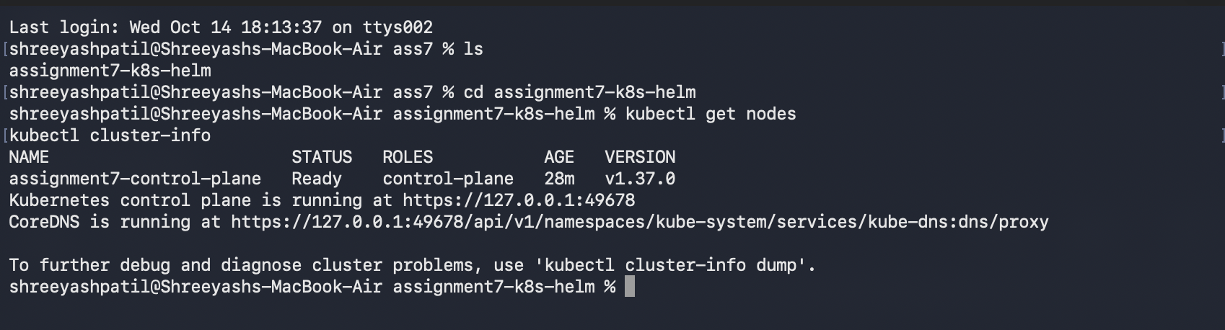
Step 2: Configure the chart
Updated Chart.yaml:
apiVersion: v2
name: myapp
description: Sample Kubernetes application
type: application
version: 0.1.0
appVersion: "1.0"
Updated the relevant values in values.yaml:
replicaCount: 2

image:
repository: nginx
pullPolicy: IfNotPresent
tag: "1.27"

service:
type: NodePort
port: 80
This configuration deployed two Nginx replicas and exposed them through a NodePort Service.
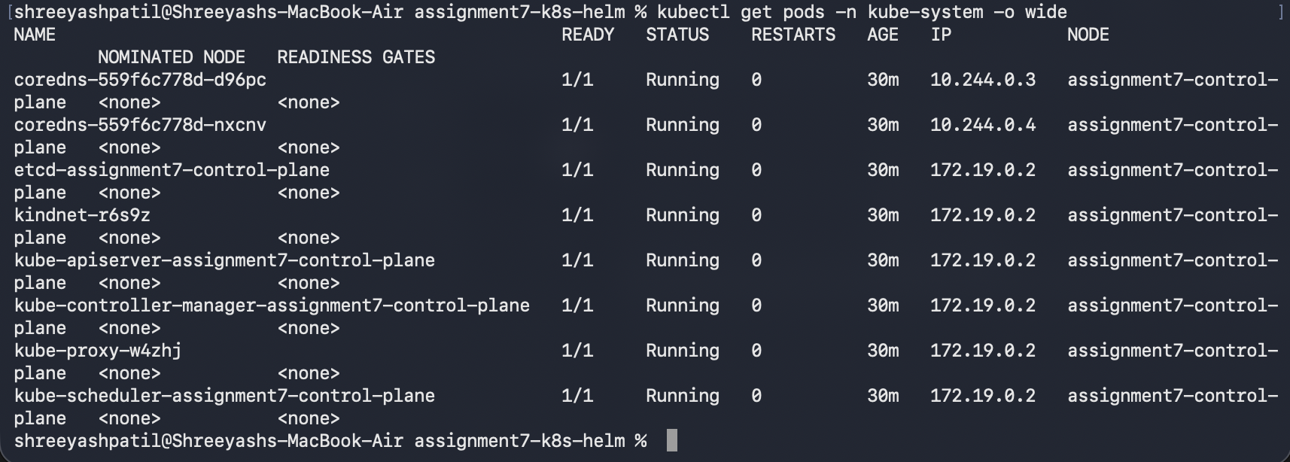

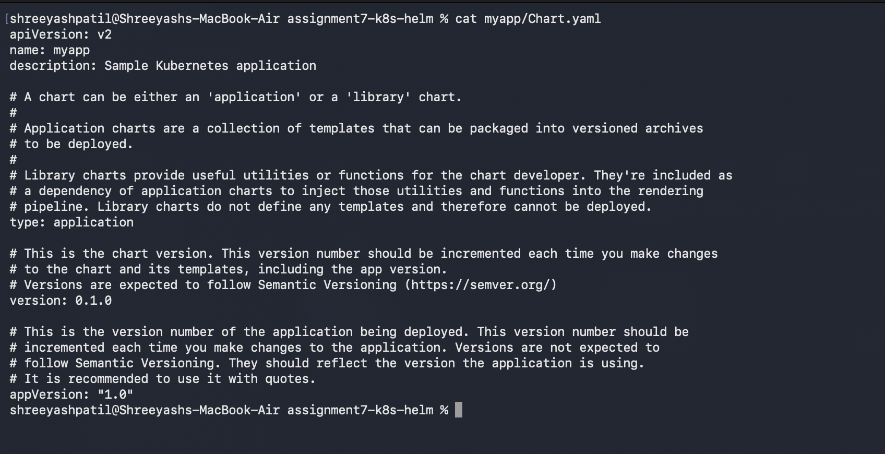
Step 3: Validate and render the chart
helm version
helm lint ./myapp
helm template myapp ./myapp
The lint command checked the chart for errors, while the template command generated Kubernetes YAML without installing the application.
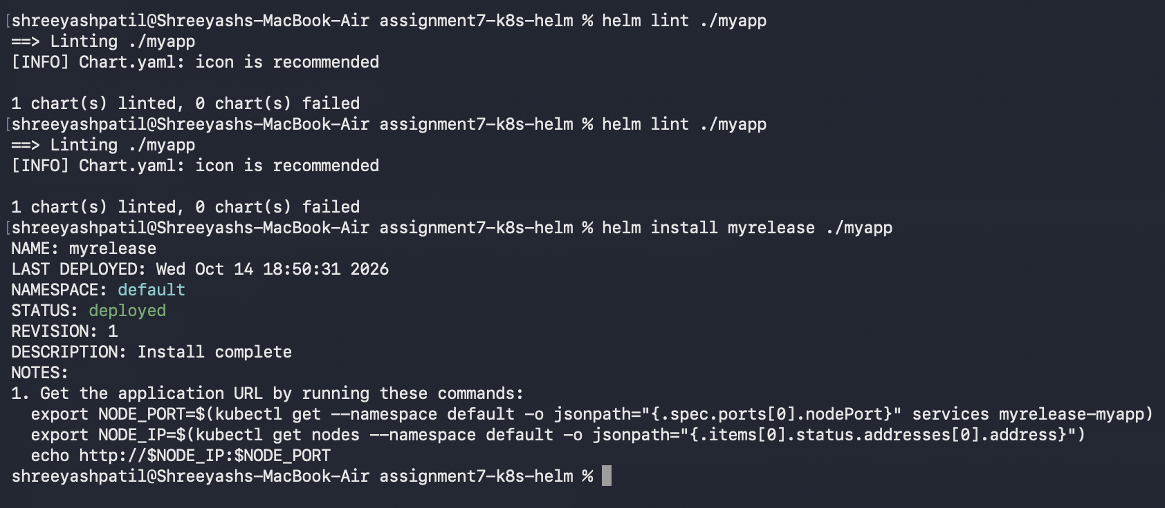
Step 4: Install the application
helm install myrelease ./myapp
Step 5: Verify deployment
helm list
helm status myrelease
kubectl get pods
kubectl get deployments
kubectl get services
The Deployment successfully created two running Nginx Pods, and the Service exposed port 80 through NodePort 30540.
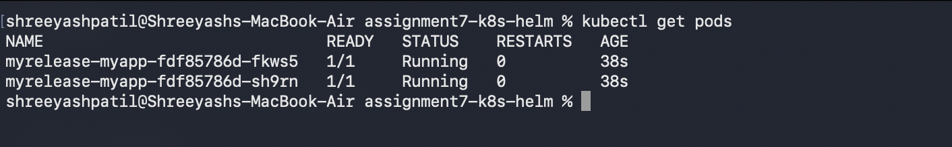
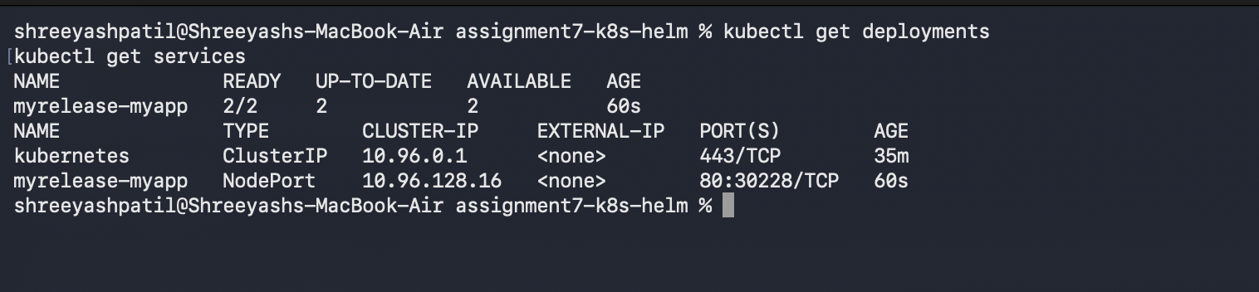
Step 6: Access the application
kubectl port-forward service/myrelease-myapp 8080:80
In another terminal, executed:
curl http://localhost:8080
The Nginx welcome page was returned successfully with an HTTP 200 OK response.
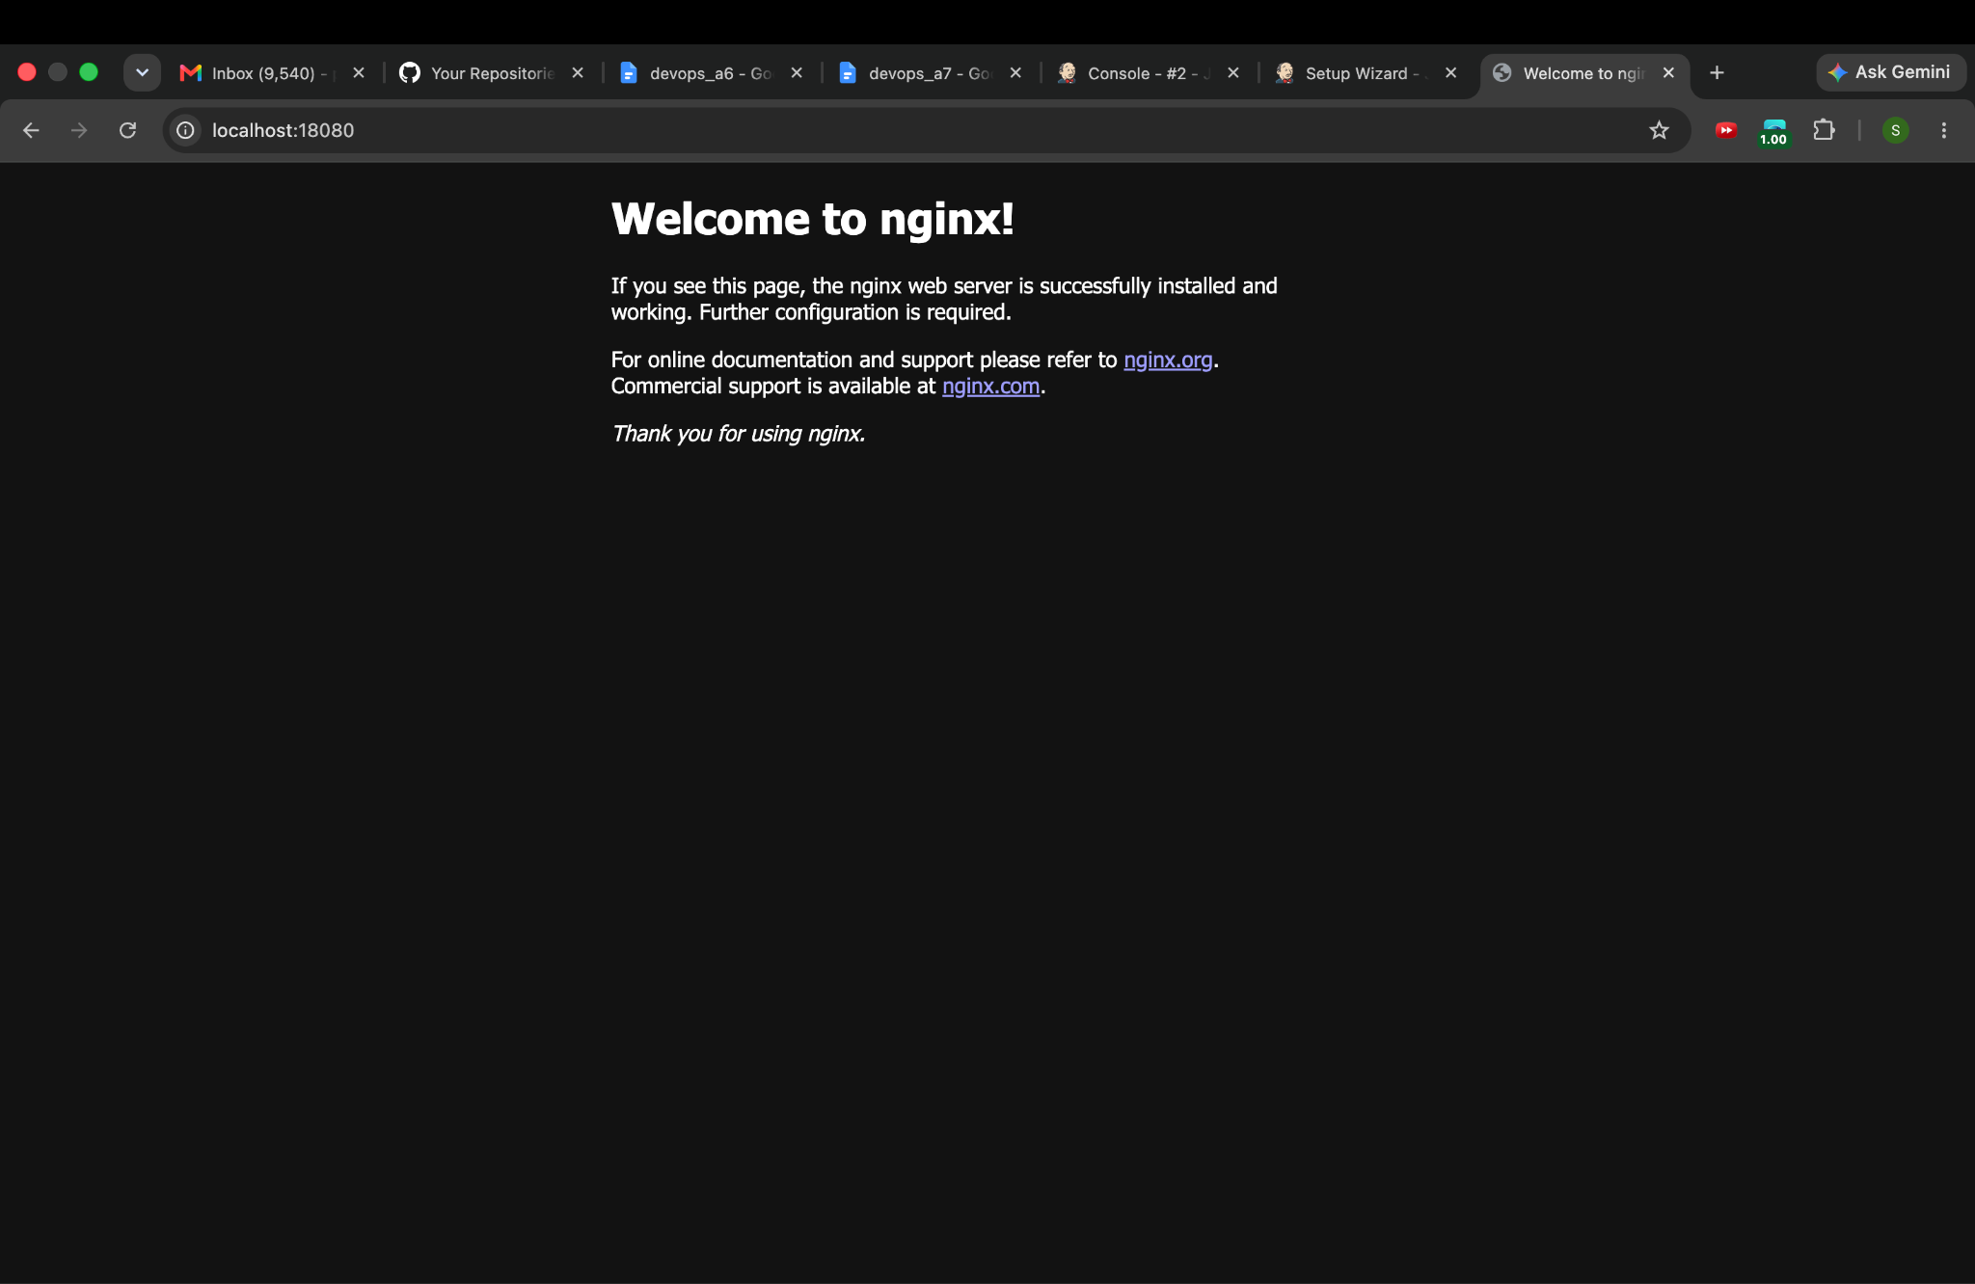
Step 7: Upgrade the application
helm upgrade myrelease ./myapp --set replicaCount=3
helm history myrelease
kubectl get pods
The application was upgraded from two replicas to three, and Helm recorded a new revision.
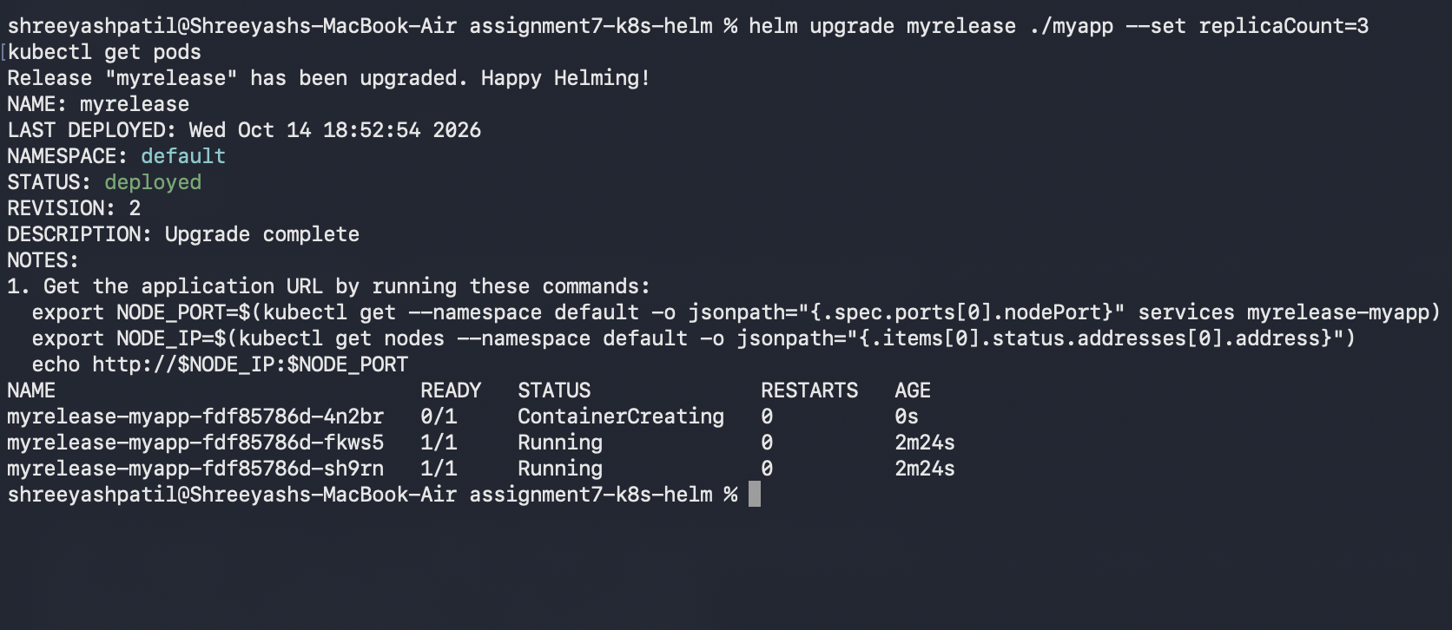
Step 8: Roll back the application
helm rollback myrelease 1
kubectl get pods
helm history myrelease
The rollback restored the configuration from revision 1, reducing the number of replicas to two. Helm recorded the rollback as a new revision.
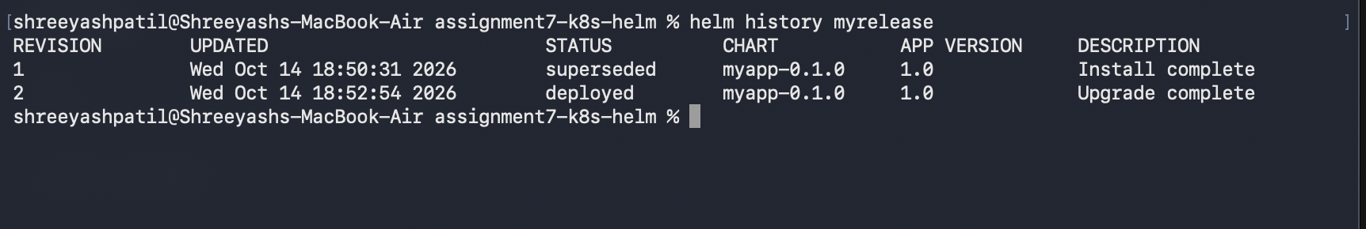

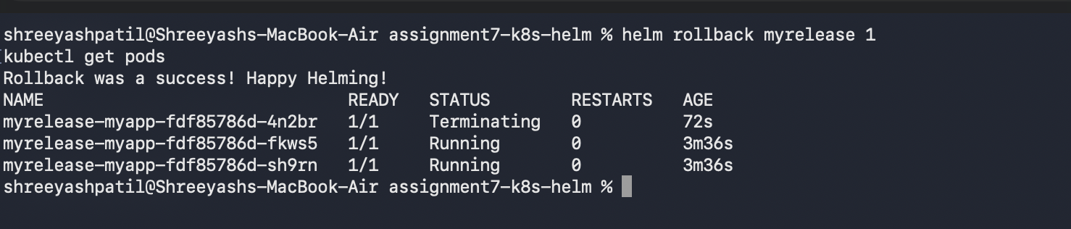
Step 9: Uninstall the application
helm uninstall myrelease
helm list
kubectl get all
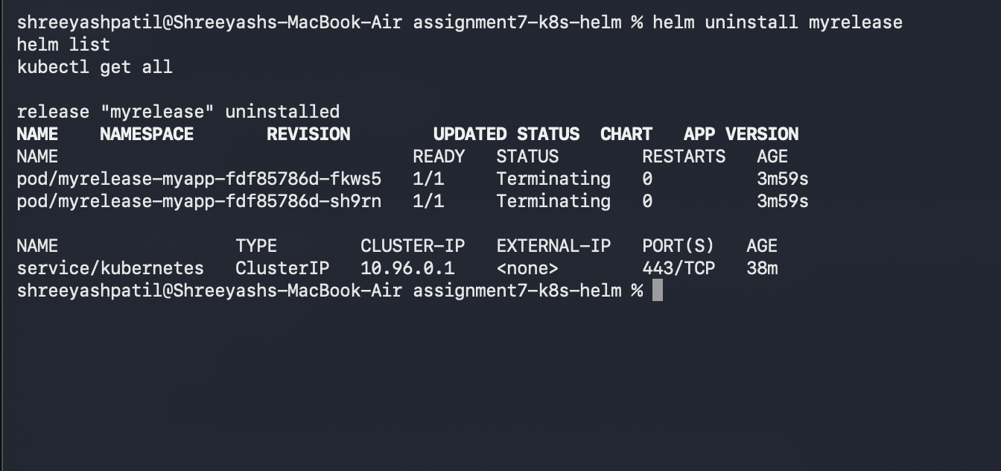
The Helm release and its application resources were removed successfully.

Observations
- The local Kubernetes cluster was created successfully using kind.
- The Kubernetes system Pods helped identify the major cluster components.
- helm lint completed successfully with zero chart failures.
- The Helm chart generated valid Kubernetes manifests.
- The Nginx application was deployed with two running Pods and a NodePort Service.
- The application returned an HTTP 200 OK response.
- Upgrading the release increased the replica count from two to three.
- Rolling back to revision 1 restored the replica count to two.
- Uninstalling the release removed the application resources successfully.

Conclusion
Kubernetes architecture was studied using a running local cluster, and the roles of its major components were identified. An Nginx application was packaged and deployed using Helm. Installation, verification, scaling, release history, rollback, and uninstallation were performed successfully. The experiment demonstrated how Kubernetes manages containerized applications and how Helm simplifies their deployment and version management.

