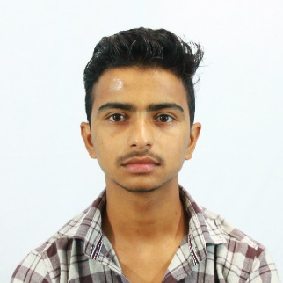

Jiwan Pokhrel

Developer

Phone: (977) 9846788917 | Email: jiwanpokhrel143@gmail.com | Website: www.jiwanpokhrel.com

Address: Fulbari-11, Pokhara City, Nepal

|  |  |  |
| --- | --- | --- |
|  | Experience |  |
|  |  |
| Code Sastra Private Limited, Zero km, Pokhara – Present  Web Developer, Support Team,  Effective Training   * Proin semper, ante vitae sollicitudinposuere, metus quam iaculisnibh, vitae scelerisquenuncmassaegetpede.   Basic and Diploma Computer Training- AlphaBeta Computer  Office Package, Photoshop, HTML, C programming | | |

|  |  |  |
| --- | --- | --- |
|  | Education |  |
|  |  |
| Bachelor in Software Engg.  Gandaki College of Engineering and Science  Pokhara | +2 (HSEB)  Pokhara Higher Secondary School  Pokhara | SLC  Kuleshwor Awas Secondary English School,  Kathmandu |

|  |  |  |
| --- | --- | --- |
|  | Key Skills |  |
|  |  |
| Professional  Web Development  WordPress  Php  JavaScript  MySQL | Related  SEO  Marketing  Entrepreneur  JAVA  C++ | Personal  Technical analysis  Software Testing  C Programming  Photoshop  Office Package |