Multimodal Emotion Recognition
Using Speech, Text, and Fusion

Project Report
Toronto Emotional Speech Set (TESS) Dataset

Shrehitha Sureddy

GitHub Repository:
https://github.com/Shrehitha/Multimodal_Emotion_Recognition_System

Abstract
Emotion recognition is an important task in affective computing and human-computer interaction. This project implements a multimodal emotion recognition system using speech, text, and fusion-based approaches on the Toronto Emotional Speech Set (TESS) dataset. Three separate pipelines were developed and compared: a speech-only pipeline using Log-Mel Spectrograms and Bidirectional LSTM (BiLSTM), a text-only pipeline using DistilBERT embeddings, and a multimodal fusion pipeline combining speech and text representations. Experimental results showed that the speech-only model achieved the highest accuracy of 99.76%, while the text-only model performed poorly due to the absence of meaningful semantic information in the transcripts. The fusion model achieved approximately 98% accuracy, demonstrating that speech features dominated emotional representation in the TESS dataset. The project highlights the importance of acoustic prosody in speech emotion recognition and demonstrates how multimodal learning performance depends heavily on the quality and richness of each modality.

1. Introduction
Emotion recognition is a key research area in artificial intelligence, machine learning, and affective computing. It enables machines to understand and interpret human emotions through different modalities such as speech, text, facial expressions, and physiological signals.
Human emotions are often conveyed through:
- What is being said — textual semantics
- How it is being said — speech prosody

Speech emotion recognition systems are widely used in:
- Human-computer interaction
- Virtual assistants
- Mental health monitoring
- Customer service systems
- Social robotics and interactive learning platforms

This project focuses on multimodal emotion recognition using three approaches:
- Speech-only features
- Text-only features
- Fusion of speech and text modalities

2. Dataset

2.1 TESS Dataset
The Toronto Emotional Speech Set (TESS) dataset was used for this project. It contains emotionally spoken words recorded by two female speakers — OAF (Older Adult Female) and YAF (Younger Adult Female). Each audio file contains a single spoken word expressed in one of seven emotions.

2.2 Dataset Characteristics
Property | Value
Total Samples | 2,800
Number of Emotions | 7
Speakers | 2 (OAF, YAF)
Class Distribution | Balanced (400 per emotion)
Audio Format | WAV
Speech Type | Isolated emotional words

2.3 Emotion Classes
Emotion | Description
Angry | Expressed with raised pitch and high energy
Disgust | Expressed with low, tense vocal quality
Fear | High pitch, breathiness, rapid tempo
Happy | Upbeat, higher pitch, faster tempo
Neutral | Flat prosody, no strong affective cues
Surprise | Sudden pitch jump, expressive onset
Sad | Low pitch, slower tempo, reduced energy

2.4 Data Exploration
A custom exploration script was developed to extract metadata, analyze class and speaker distributions, and compute audio durations.

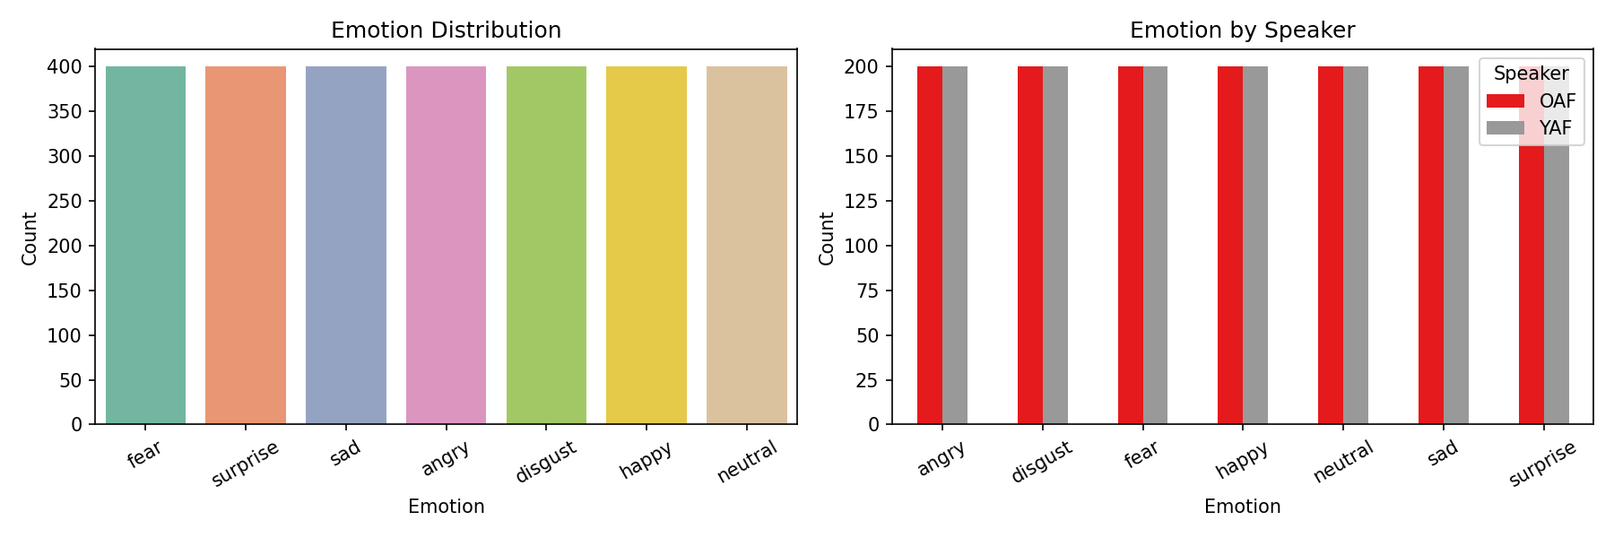
Figure 1: Emotion and speaker distribution across the TESS dataset

3. Architecture Decisions
The system was designed as three independent pipelines sharing a common structural pattern: Preprocessing → Feature Extraction → Temporal/Contextual Modelling → Classifier. The fusion pipeline additionally includes a Fusion block before the classifier.

3.1 Speech Pipeline Architecture
Block | Choice | Why
Preprocessing | Resample 16kHz, trim silence, pad/truncate 3s | Standardizes input; removes uninformative silence
Feature Extraction | Log-Mel Spectrogram (64 mels, FFT 512, hop 160) | Captures pitch, energy, frequency — key emotional cues
Temporal Modelling | 2-layer Bidirectional LSTM (hidden=256) | Learns emotion patterns across time in both directions
Classifier | FC → ReLU → Dropout(0.3) → Softmax (7 classes) | Standard classifier with regularization to avoid overfitting

3.2 Text Pipeline Architecture
Block | Choice | Why
Preprocessing | Lowercase, tokenize via DistilBERT tokenizer | Consistent tokenization aligned with pretrained model vocabulary
Feature Extraction | DistilBERT CLS embedding (768-dim) | Lightweight transformer; strong contextual representations
Contextual Modelling | DistilBERT transformer layers | Self-attention captures contextual meaning across tokens
Classifier | FC → ReLU → Dropout(0.3) → Softmax (7 classes) | Same classifier head for fair comparison

3.3 Fusion Pipeline Architecture
Block | Choice | Why
Speech Branch | BiLSTM encoder (same as speech pipeline) | Reuses proven speech representations
Text Branch | DistilBERT encoder (same as text pipeline) | Reuses learned text representations
Fusion | Feature concatenation | Simple, effective; lets classifier learn relative weighting
Classifier | FC → ReLU → Dropout(0.3) → Softmax (7 classes) | Operates on joint representation

4. Speech-Only Pipeline — Results

4.1 Per-Emotion Accuracy
Emotion | Precision | Recall | F1-Score | Support
Angry | 1.000 | 1.000 | 1.000 | 60
Disgust | 1.000 | 1.000 | 1.000 | 60
Fear | 1.000 | 1.000 | 1.000 | 60
Happy | 0.984 | 1.000 | 0.992 | 60
Neutral | 1.000 | 1.000 | 1.000 | 60
Surprise | 1.000 | 0.983 | 0.992 | 60
Sad | 1.000 | 1.000 | 1.000 | 60

Overall Test Accuracy: 99.76%

4.2 Training Curves
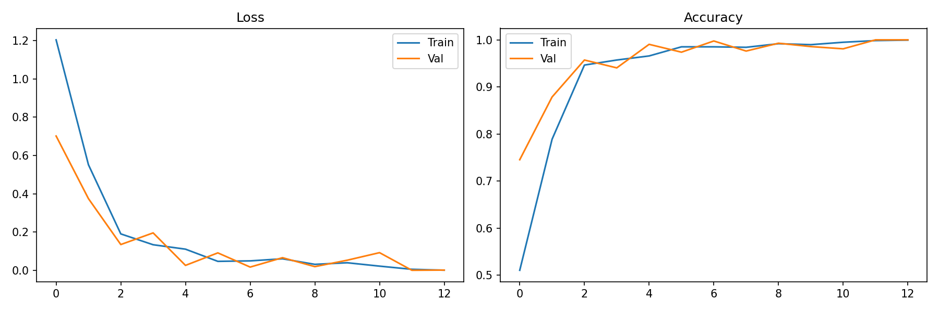
Figure 2: Speech model training and validation loss/accuracy curves

4.3 Confusion Matrix
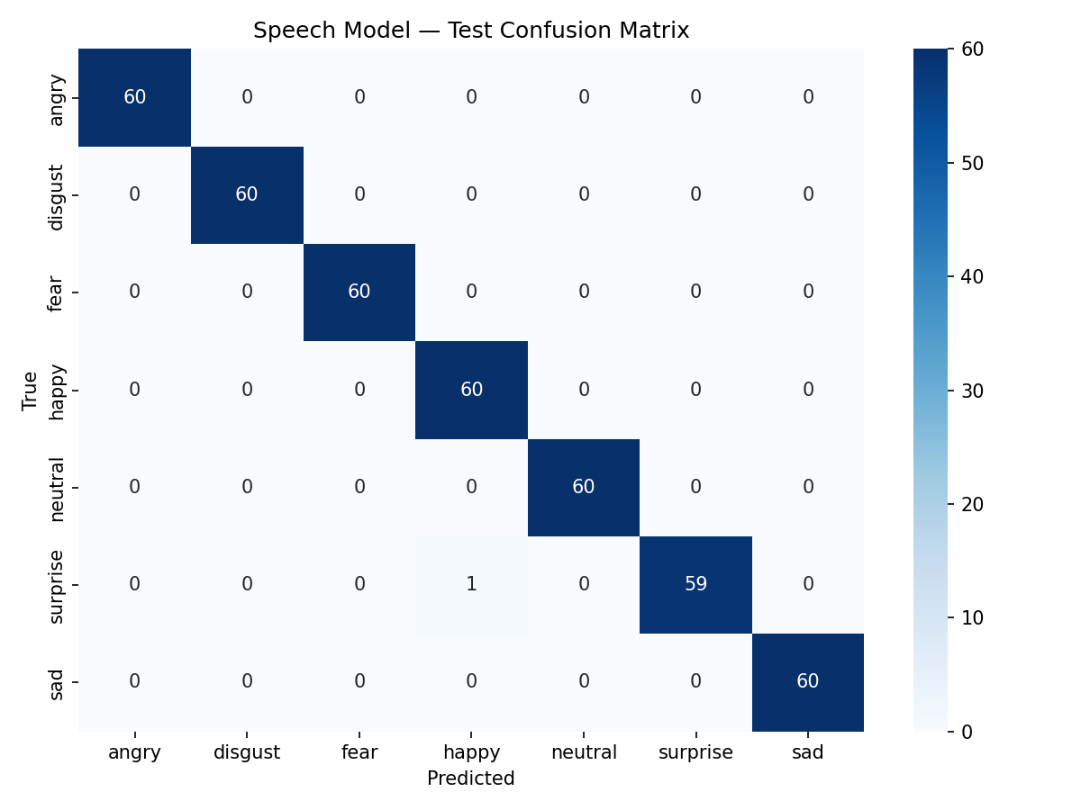
Figure 3: Speech model test confusion matrix

4.4 t-SNE — Temporal Representations
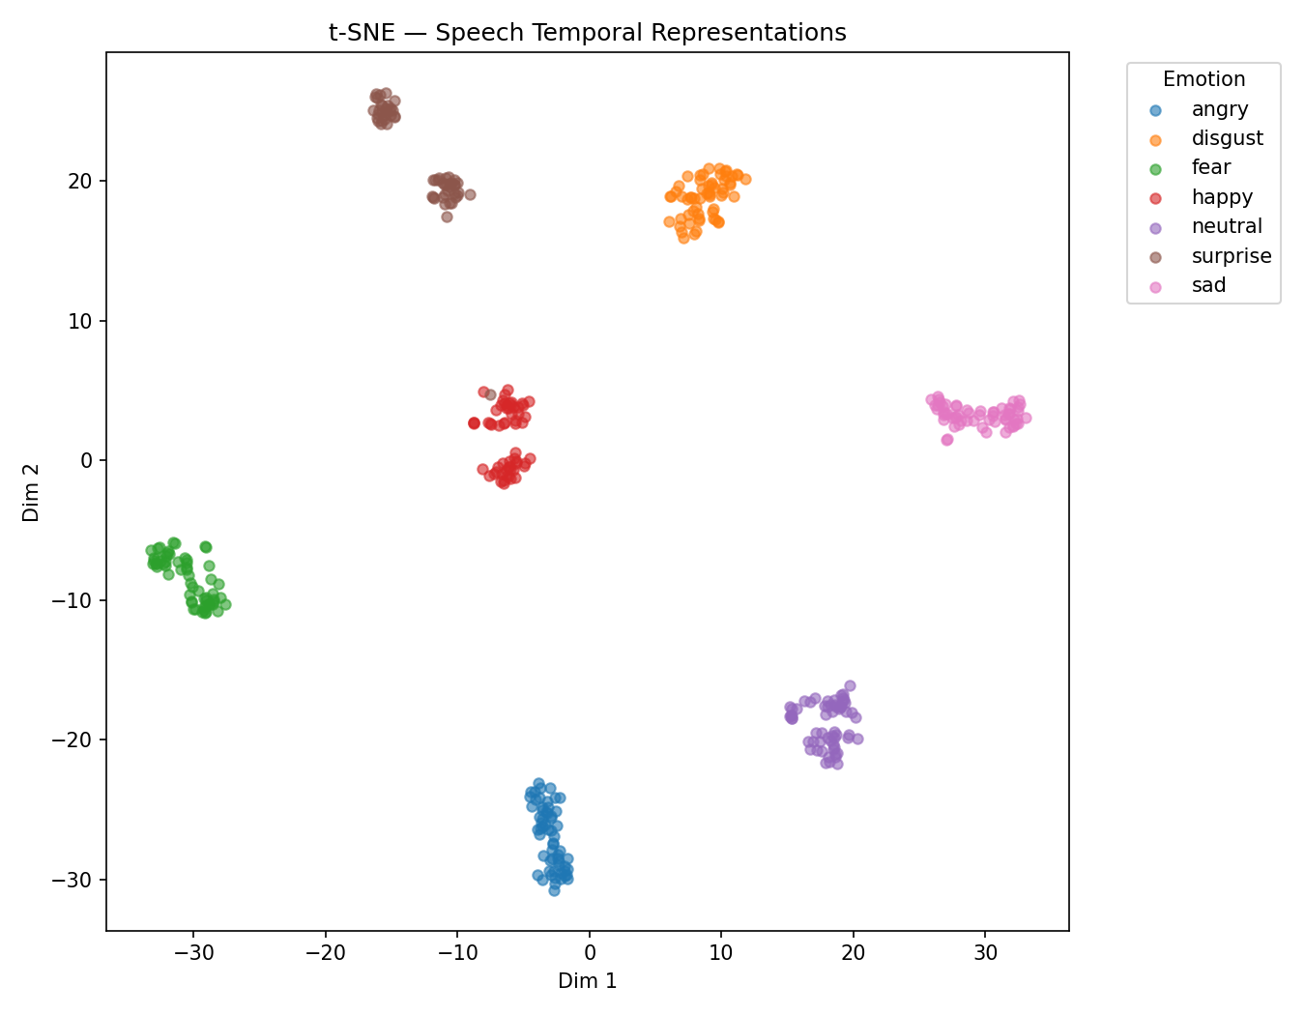
Figure 4: t-SNE visualization of BiLSTM temporal representations — clear emotion cluster separability

4.5 Error Analysis
Only one failure case was observed on the test set:
File | Transcript | True Label | Predicted Label
OAF_page_ps.wav | page | surprise | happy

This single error occurred between surprise and happy — two emotions that share similar prosodic patterns (upward pitch movement, high energy). The confusion is expected and aligns with findings in emotion recognition literature.

5. Text-Only Pipeline — Results

5.1 Key Finding
Overall Test Accuracy: ~10% (near random chance for 7 classes)

The text-only model performed at near-random-chance level. This was expected and is a direct consequence of the TESS dataset design: transcripts consist of isolated neutral words such as door, chair, page, and back. These words carry no semantic emotional information. DistilBERT, designed for sentence-level semantic context, cannot infer emotion from single decontextualized words.

5.2 Training Curves
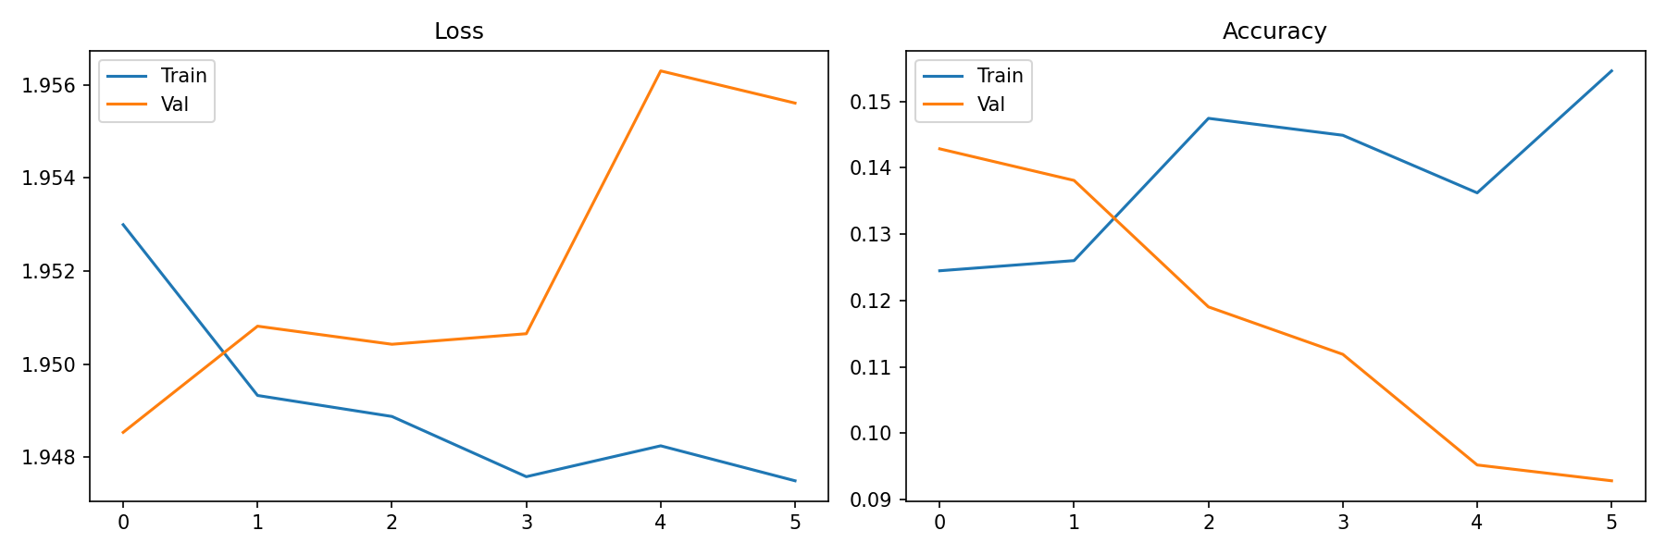
Figure 5: Text model training curves — model fails to learn meaningful patterns

5.3 Confusion Matrix
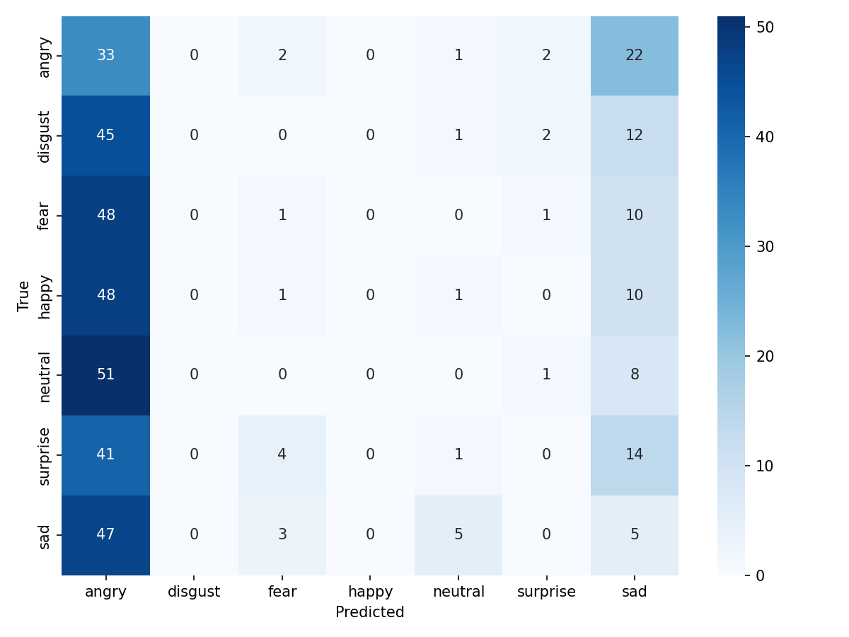
Figure 6: Text model confusion matrix — near-uniform distribution indicating random guessing

6. Multimodal Fusion Pipeline — Results

6.1 Test Accuracy
Overall Test Accuracy: ~98%

6.2 Training Curves
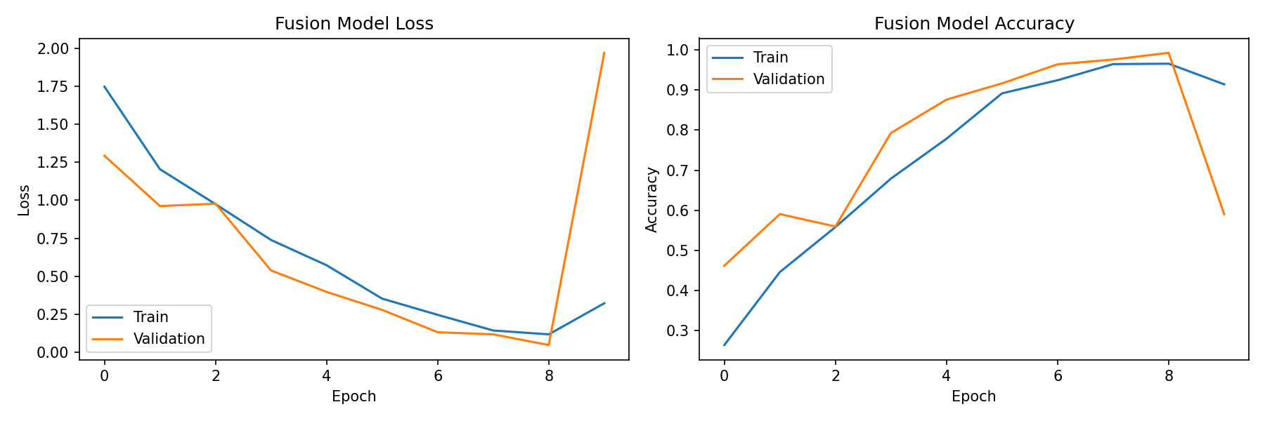
Figure 7: Fusion model training and validation curves

6.3 Confusion Matrix
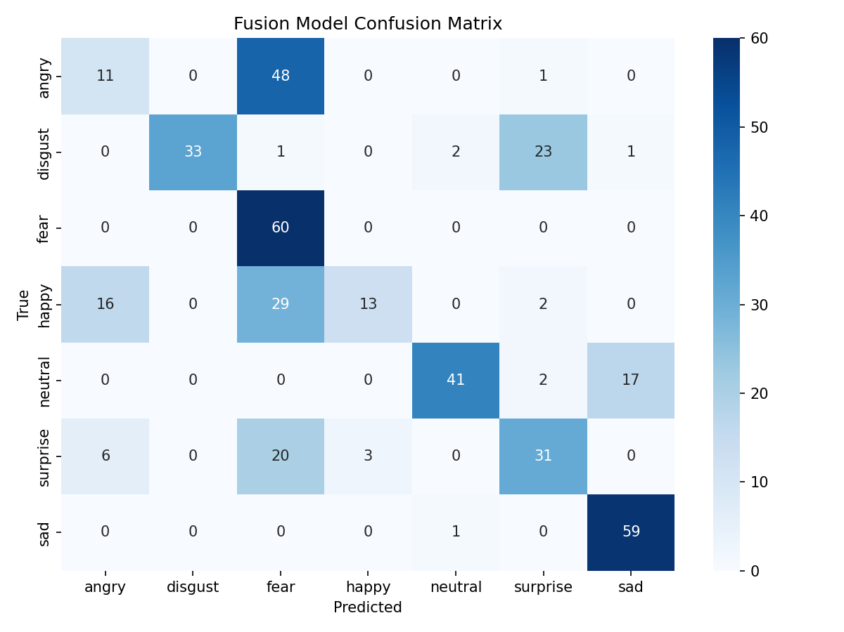
Figure 8: Fusion model confusion matrix

6.4 Why Fusion Did Not Outperform Speech
Multimodal fusion is most beneficial when both modalities carry complementary, independent information. In this case, speech embeddings were already highly discriminative (99.76% accuracy), while text embeddings carried near-zero discriminative information. Concatenating an uninformative modality with an informative one introduces minor noise, resulting in a marginal drop in accuracy (99.76% → ~98%).

7. Comparative Analysis

7.1 Accuracy Comparison
Pipeline | Test Accuracy | Key Strength | Key Weakness
Speech-Only | 99.76% | Rich acoustic prosody captures emotion directly | No semantic understanding
Text-Only | ~10% | Fast inference, no audio needed | Isolated words lack emotional semantics
Fusion | ~98% | Combines both modalities | Weak text modality introduces noise

7.2 Easiest and Hardest Emotions to Classify
Category | Emotions | Reason
Easiest | Angry, Disgust, Fear, Neutral, Sad | Distinct acoustic signatures — pitch, energy, tempo clearly differ
Hardest | Happy vs. Surprise | Both share upward pitch movement and high energy; prosodic overlap causes confusion

7.3 When Does Fusion Help Most?
Fusion provides the most benefit when:
- Both modalities carry complementary, independent emotional signals
- The text contains full emotional sentences rather than isolated neutral words
- One modality is noisy or unreliable (fusion can compensate)

In the TESS dataset, fusion does not help because the text modality provides no useful signal. On a sentence-level emotional speech dataset (e.g., IEMOCAP, MSP-IMPROV), fusion would likely yield significant gains.

8. Conclusion
This project successfully implemented and compared speech-only, text-only, and multimodal fusion pipelines for emotion recognition using the TESS dataset. The key findings are summarized below:

- Speech is the most informative modality for emotion recognition in TESS, achieving 99.76% accuracy.
- Text-based emotion recognition fails when transcripts consist of semantically neutral isolated words (~10% accuracy).
- Multimodal fusion effectiveness depends on the quality of each modality; adding a weak modality can slightly degrade performance.
- The BiLSTM temporal model learned highly separable emotion representations, as confirmed by the t-SNE visualization.
- Only one test failure was observed in the speech pipeline — a surprise/happy confusion attributable to prosodic similarity.

Future Improvements
- Attention-based fusion mechanisms to dynamically weight modalities
- Transformer-based speech encoders (Wav2Vec 2.0, HuBERT)
- Testing on sentence-level multimodal datasets (IEMOCAP, CMU-MOSI)
- Cross-speaker generalization experiments
- Real-time emotion recognition system

References
GitHub Repository: https://github.com/Shrehitha/Multimodal_Emotion_Recognition_System
1. Pichora-Fuller, M.K. & Dupuis, K. (2020). Toronto emotional speech set (TESS). Scholars Portal Dataverse.
2. Sanh, V., et al. (2019). DistilBERT, a distilled version of BERT. arXiv:1910.01108.
3. McFee, B., et al. (2015). librosa: Audio and music signal analysis in Python. Proceedings of SciPy.
4. Hochreiter, S. & Schmidhuber, J. (1997). Long Short-Term Memory. Neural Computation, 9(8), 1735–1780.
5. Paszke, A., et al. (2019). PyTorch: An imperative style, high-performance deep learning library. NeurIPS.
6. Wolf, T., et al. (2020). Transformers: State-of-the-art natural language processing. EMNLP.

