Attendance Data Analysis Project – Presentation

1. Data Loading & Cleaning (Python)
• Loaded data using pandas:
• Converted Date column to datetime using:
• Checked dataset structure
• Cleaned column names:

2. SQL Analysis Queries
The following insights were generated using SQL Server:
• Q1 – Region grouping based on the middle letter of school_dbn.
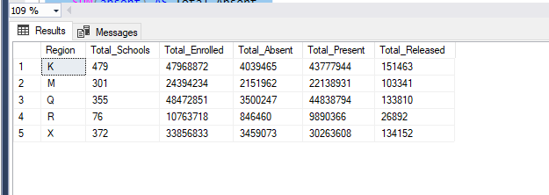
• Q2 – Top 10 schools with the highest student absence + yearly breakdown.
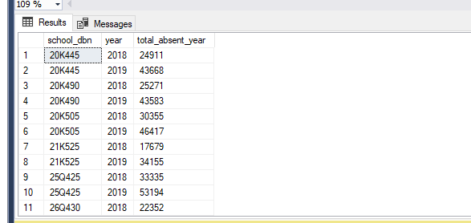

• Q3 – Top 10 schools with the highest student presence + yearly breakdown.
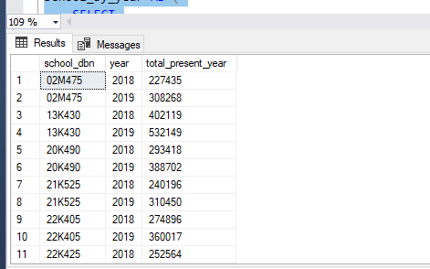
• Q4 – Top 10 schools with the highest released students.
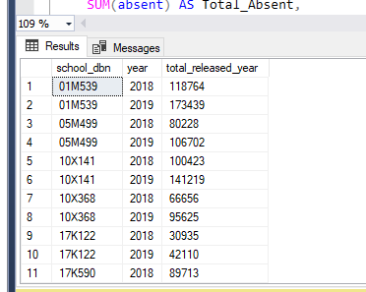
• Q5 – Total enrolled, present, absent, released (overall totals).
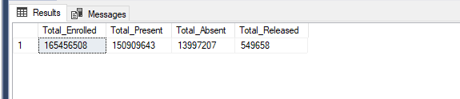
• Q6 – Overall attendance rate.
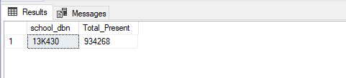
• Q7 – School with highest attendance (present).
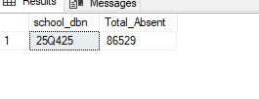
• Q8 – School with lowest attendance (highest absence).
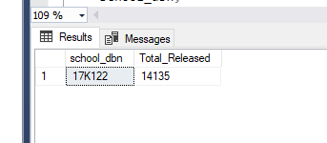
• Q9 – School with highest released count.
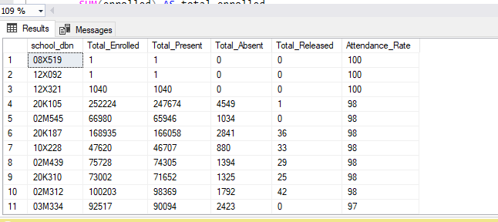

• Q10 – Attendance rate for each school.
• Q11 – Comparing each school to the overall average attendance rate.
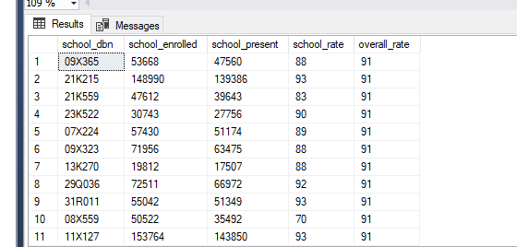

• Q12 – Schools with highest absent + highest released.
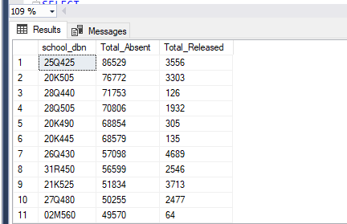
• Q13 – Day with the lowest attendance rate.
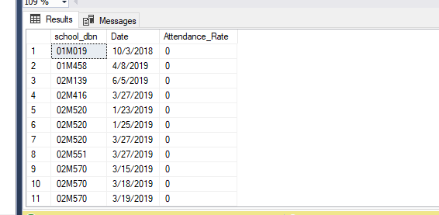

3. Power BI Dashboard
• Connected SQL Server data to Power BI.
• Built visualizations for:
- Attendance trends
- Top schools by absence/presence/release
- School comparison to overall average
- Daily attendance performance
• Created final dashboard summarizing all KPIs.
