2027 Water Quality – Marine & Estuaries
Sample Stream Collection
Sample Tournament

Part 1 – General Information

1. Name four abiotic factors which control an aquatic ecosystem.

2. Name three biotic factors which control an aquatic ecosystem.

3. Where is the largest portion of the earth’s water housed? What % is housed here?

4. How does water get from the atmosphere to the ground?

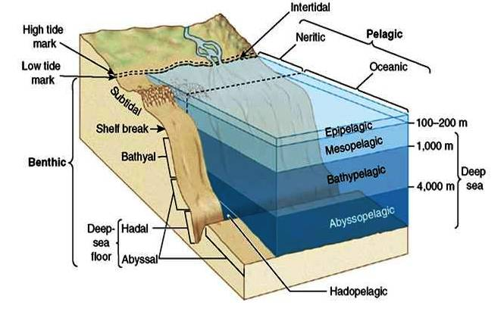

5. Define the following ocean biozones:
a. Benthic Zone
b. Pelagic Zone
c. Intertidal Zone

6. Define the following ocean light zones:
a. Euphotic (epipelagic) zone
b. Disphotic (mesopelagic) Zone
c. Aphotic (bathypelagic) Zone

7. What is the difference between nertic and oceanic zones?

2027 Water Quality – Marine & Estuaries
Sample Tournament

Part 1 – General Information

1. Name four abiotic factors which control an aquatic ecosystem.
Sunlight, nutrients, salinity, and temperature

2. Name three biotic factors which control an aquatic ecosystem.
Habitat, symbiosis, biodiversity

3. Where is the largest portion of the earth’s water housed? What % is housed here? Oceans – 97.5 %

4. How does water get from the atmosphere to the ground? Precipitation

5. Define the following ocean biozones:
a. Benthic Zone the bottom of the ocean
b. Pelagic Zone open water region of the seas
c. Intertidal Zone encompasses the region from the wave splash zone to the low tide mark

6. Define the following ocean light zones:
a. Euphotic (epipelagic) zone receives enough sunlight to support photosynthesis
b. Disphotic (mesopelagic) Zone only small amount of light penetrate
c. Aphotic (bathypelagic) Zone no light penetrates

7. What is the difference between nertic and oceanic zones?
Neritic: intertidal zones where land meets sea; area above the continental shelf
Oceanic: open sea
8. Name the defining abiotic factors for each of the following ecosystems:

a. Estuaries

b. Coral Reefs

c. Hydrothermal Vents

d. Intertidal Zones

9. Consider the following food chain:

Phytoplankton zooplankton krill baleen whale

a. Which organisms are the most abundant in aquatic ecosystems and why?

b. Who are the major primary consumers?

c. Who is the 3rd order carnivore?

d. If producers generate 50,000 J of energy, how much of that energy would be available to secondary consumers?

10. For each of the following statements concerning estuaries, indicate whether the statement is TRUE or FALSE.

- Estuaries are areas of great diversity, with complex and interrelated trophic patterns and they support a large number of top predators, including humans

- Most species live in only one of the many habitats associated with estuaries

- Coping mechanisms include moving out of unfavorable areas, shutting up shells, digging borrows and excretion of excess salts
- Organic accumulation is rare because most is dumped way out to sea onto the ocean floor

- Unlike the open ocean, where phytoplankton are the sole primary producers, estuarine systems usually contain several types of primary producers.

- Estuaries are nurseries of the sea because juvenile forms of many marine animals live and feed in estuaries before returning to the sea

- There are freshwater estuaries – many on the Great Lakes

8. Name the defining abiotic factors for each of the following ecosystems:

a. Estuaries variable salinity, winds, tides, mud

b. Coral Reefs water flow, sunlight, mild temperature, nutrients

c. Hydrothermal Vents high pressure, extreme at the vents otherwise cold, no sunlight, sulfur
d. Intertidal Zones moderate temperatures, sunlight, waves, tides

9. Consider the following food chain:

Phytoplankton zooplankton krill baleen whale

a. Which organisms are the most abundant in aquatic ecosystems and why? Plankton - phytoplankton and zooplankton because they are very small and the major producers and first order consumers

b. Who are the major primary consumers? zooplankton

c. Who is the 3rd order consumer? baleen whale

d. If producers generate 50,000 J of energy, how much of that energy would be available to secondary consumers? Primary consumers get 5,000 J and so secondary consumers get 500 J

10. For each of the following statements concerning estuaries, indicate whether the statement is TRUE or FALSE.

- Estuaries are areas of great diversity, with complex and interrelated trophic patterns and they support a large number of top predators, including humans
TRUE
- Most species live in only one of the many habitats associated with estuaries
FALSE
- Coping mechanisms include moving out of unfavorable areas, shutting up shells, digging borrows and excretion of excess salts
TRUE
- Organic accumulation is rare because most is dumped way out to sea onto the ocean floor
FALSE
- Unlike the open ocean, where phytoplankton are the sole primary producers, estuarine systems usually contain several types of primary producers.
TRUE
- Estuaries are nurseries of the sea because juvenile forms of many marine animals live and feed in estuaries before returning to the sea
TRUE
- There are freshwater estuaries – many on the Great Lakes
TRUE

11. Examine the following productivity table and answer the following questions.

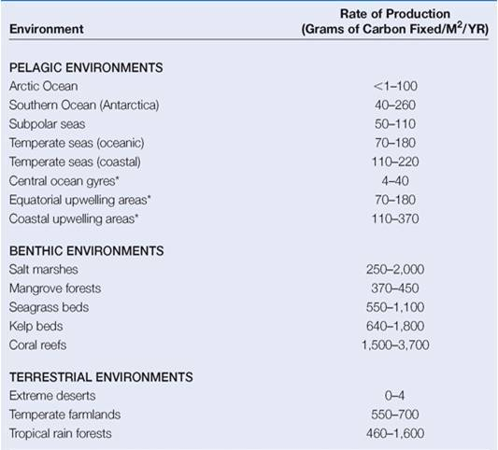

a. Which of these environments would be considered as Estuary Environments?

b. How do estuaries and Coral Reefs compare with Tropical Rain Forests in Productivity

c. Why do the Pelagic Environments have such a low productivity as compared to the benthic environments?

12. What are the major environment threats to oceans and estuaries?

11. Examine the following productivity table and answer the following questions.

a. Which of these environments would be considered as Estuary Environments?
Salt marshes, mangrove forests, Seagrass beds, Kelp beds

b. How do estuaries and Coral Reefs compare with Tropical Rain Forests in Productivity?
They are both high productivity like tropical rain forests

c. Why do the Pelagic Environments have such a low productivity as compared to the benthic environments? Their productivity is defined by the limits of light penetration the top 200 meters is where the majority of productivity occurs

12. What are the major environment threats to oceans and estuaries?
- Overfishing and Exploitation
- Climate Change
- Sea Temperature Rise
- Ocean Acidification
- Oil spills and their ecological disasters
- Ocean dead zones
- Bycatch – marine wildlife unintentionally caught as sea turtles, porpoises, albatross, crabs, starfish & fish
- Marine dumping of wastes – plastic and other wastes
- Dredging Wastes
- Invasive Species
Part 2 – Coral Reefs

1. Which of the following factors are needed for coral reef development.
Choose all of the factors that apply.

- A solid structure for the base with a hard substrate for attachment
- Warm and predictable water temperatures > 20°C (68°F) and oceanic salinities
- High Light Levels
- Clear waters with high water transparency
- Low nutrient waters - low in phosphate and nitrogen nutrients
- Good water circulation with moderate wave action to disperse wastes and bring oxygen and plankton to the reef
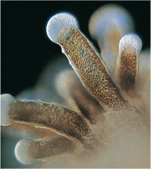
2. There is an important symbiotic relationship between coral and the dinoflagellate zooxanthellae that is beneficial to both. What type of symbiotic relationship is this and what does each supply to the relationship?

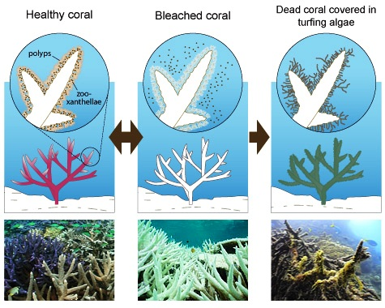
3. Coral bleaching occurs when the symbiotic relationship between algae (zooxanthellae) and their host coral breaks down under various environmental stresses. The host expels its zooxanthellae, exposing its white calcium carbonate skeleton, and the affected coral colony pales in color or becomes stark white. This is known as "bleaching." Warm water temperatures have been observed to be one of the major causes of mass coral bleaching worldwide. Ambient water temperatures as little as 1 to 2 °C above a coral's tolerance level, indicated by summer monthly mean temperatures, have caused coral bleaching. Corals that are partially to totally bleached for long periods often die. When coral senses the photosynthesis is occurring too fast, it normally expels some of the zooxanthellae algae and loses some of its color. This is not considered coral bleaching. When a coral becomes too stressed, it will expel too much of the zooxanthellae algae at one time and causes a loss of color.

Indicate whether the following are TRUE or FALSE.

A. The beautiful colors of the coral come from the zooxanthellae.

B. All loss of zooxanthellae is permanent and causes death to the coral

C. Water temperature elevation is the only stress that causes coral bleaching.
Part 2 – Coral Reefs

1. Which of the following factors are needed for coral reef development.
Choose all of the factors that apply.
- A solid structure for the base with a hard substrate for attachment
- Warm and predictable water temperatures > 20°C (68°F) and oceanic salinities
- High Light Levels
- Clear waters with high water transparency
- Low nutrient waters - low in phosphate and nitrogen nutrients
- Good water circulation with moderate wave action to disperse wastes and bring oxygen and plankton to the reef
A, B, C, D, E, F - ALL ARE FACTORS NEEDED
2. There is an important symbiotic relationship between coral and the dinoflagellate zooxanthellae that is beneficial to both. What type of symbiotic relationship is this and what does each supply to the relationship?
Coral Polyp provides a home for the zooxanthellae, it provides nitrates and phosphates, and it gives off CO₂ – 90% of the coral’s nutrients
Zooxanthellae carries out photosynthesis and make oxygen and food for the polyp through photosynthesis, gain nutrients from the corals nitrogen and phosphorus wastes, and provide for most of the colors for the coral in the reef making them look like underwater gardens

3. Coral bleaching occurs when the symbiotic relationship between algae (zooxanthellae) and their host coral breaks down under various environmental stresses. The host expels its zooxanthellae, exposing its white calcium carbonate skeleton, and the affected coral colony pales in color or becomes stark white. This is known as "bleaching." --- Warm water temperatures have been observed to be one of the major causes of mass coral bleaching worldwide. Ambient water temperatures as little as 1 to 2 °C above a coral's tolerance level, indicated by summer monthly mean temperatures, have caused coral bleaching. Corals that are partially to totally bleached for long periods often die. When coral senses the photosynthesis is occurring too fast, it normally expels some of the zooxanthellae algae and loses some of its color. This is not considered coral bleaching. When a coral becomes too stressed, it will expel too much of the zooxanthellae algae at one time and causes a loss of color.

Indicate whether the following are TRUE or FALSE.
A. The beautiful colors of the coral come from the zooxanthellae. TRUE
B. All loss of zooxanthellae is permanent and causes death to the coral. FALSE
C. Water temperature elevation is the only stress that causes coral bleaching. FALSE
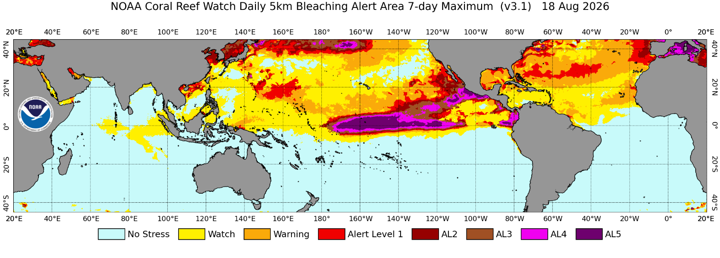

Table 1. Coral bleaching thermal stress levels based on the CRW 50 km Coral Bleaching Hot Spots and DHW (coral bleaching degree heating week) products.

Stress Level | Definition | Effect
No Stress | HotSpot ≤ 0 | No bleaching
Bleaching Watch | 0 < HotSpot < 1 | No bleaching
Bleaching Warning | 1 ≤ HotSpot and 0 < DHW < 4 | Risk of possible bleaching
Bleaching Alert Level 1 | 1 ≤ HotSpot and 4 ≤ DHW < 8 | Risk of reef-wide bleaching
Bleaching Alert Level 2 | 1 ≤ HotSpot and 8 ≤ DHW < 12 | Risk of reef-wide bleaching with mortality
Bleaching Alert Level 3 | 1 ≤ HotSpot and 12 ≤ DHW < 16 | Risk of multi-species mortality
Bleaching Alert Level 4 | 1 ≤ HotSpot and 16 ≤ DHW < 20 | Risk of severe, multi-species mortality (> 50% of corals)
Bleaching Alert Level 5 | 1 ≤ HotSpot and 20 ≤ DHW | Risk of near complete mortality (> 80% of corals)

5. When would you assume that the normal greatest heating weeks would occur?

6. What could the ocean surface water temperature to rise above normal levels?

7. What could cause the watch/warnings near South West Africa to the Caribbean and South America to progress towards an alert?

8. What other environmental stresses might cause coral bleaching?

Table 1. Coral bleaching thermal stress levels based on the CRW 50 km Coral Bleaching Hot Spots and DHW (coral bleaching degree heating week) products.

Stress Level | Definition | Effect
No Stress | HotSpot ≤ 0 | No bleaching
Bleaching Watch | 0 < HotSpot < 1 | No bleaching
Bleaching Warning | 1 ≤ HotSpot and 0 < DHW < 4 | Risk of possible bleaching
Bleaching Alert Level 1 | 1 ≤ HotSpot and 4 ≤ DHW < 8 | Risk of reef-wide bleaching
Bleaching Alert Level 2 | 1 ≤ HotSpot and 8 ≤ DHW < 12 | Risk of reef-wide bleaching with mortality
Bleaching Alert Level 3 | 1 ≤ HotSpot and 12 ≤ DHW < 16 | Risk of multi-species mortality
Bleaching Alert Level 4 | 1 ≤ HotSpot and 16 ≤ DHW < 20 | Risk of severe, multi-species mortality (> 50% of corals)
Bleaching Alert Level 5 | 1 ≤ HotSpot and 20 ≤ DHW | Risk of near complete mortality (> 80% of corals)

5. When would you assume that the normal greatest heating weeks would occur?
Generally during the local summertime (or warmest months of the year). The peak season is July-September for the northern Atlantic and Pacific Oceans, and January-March for the southern Atlantic and Pacific Near the equator, there are often two potential bleaching “seasons” during the boreal spring and fall, when the sun is directly overhead in the tropical regions

6. What could the ocean surface water temperature to rise above normal levels?
Global warming will warm surface temperatures of the oceans

7. What could cause the watch/warnings near South West Africa to the Caribbean and South America to progress towards an alert? Hot winds coming off of the Sahara Desert moving toward the Americas

8. What other environmental stresses might cause coral bleaching? The effects of El Nino and La Nina weather situations - freshwater inundation (low salinity) and poor water quality from sediment or pollutant run-off
9. Indicator Species are used by Coral Watch to monitor the health of coral reef around the world. Match the Organism to its Picture.

Organisms

Hard coral -
Butterfly fish -
Grouper -
Pencil urchin -
Moray eel -
Banded Coral Shrimp -
Crown of thorns starfish -
Parrotfish -

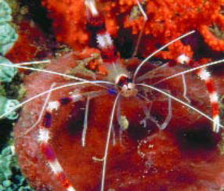
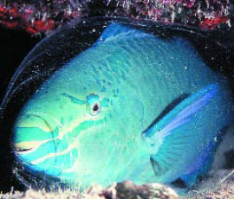
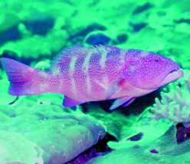
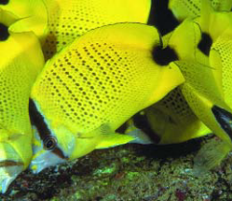

A. B C D
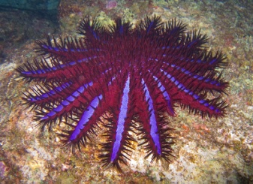
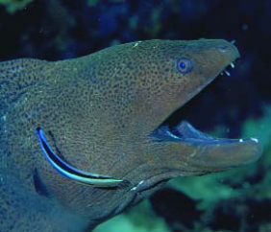
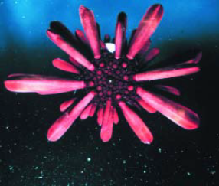
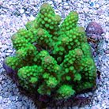

E F G H

10. One study of a cruise ship anchor dropped in a coral reef for one day found an area about half the size of a football field completely destroyed, and half again as much covered by rubble that died later. It was estimated that coral recovery would take fifty years. Why is this a problem and how might it be remedied?

9. Indicator Species are used by Coral Watch to monitor the health of coral reef around the world. Match the Organism to its picture.

Organisms

Hard coral - E
Butterfly fish - B
Grouper - A
Pencil urchin - F
Moray eel - G
Banded Coral Shrimp - D
Crown of thorns starfish - H
Parrotfish - C

A. B C D

E F G H

10. One study of a cruise ship anchor dropped in a coral reef for one day found an area about half the size of a football field completely destroyed, and half again as much covered by rubble that died later. It was estimated that coral recovery would take fifty years. Why is this a problem and how might it be remedied?

Anchors from cruise ships are very large and these ships come into port in the bays around tropical islands or at the ports along the continental shelf where coral reefs are present. Their waste dumped into the ocean can cause major pollution. Local governments must take responsibility for controlling where the ships are allowed to dock and how their waste is handled.

Part 3: Water Analysis

Almost all large estuaries are the sight of a major city.
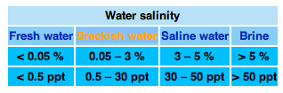

Dissolved Oxygen for Aquatic Species

Optimal Acceptable Poor Fatal
> 9 ppm 7-8 ppm 3.5—6 ppm < 3.5

1. Why would major cities spring up at large estuaries?

2. How does the salinity level change as you go from the river entrance to the open ocean?

3. Based upon the data given, what would be a normal change of salinity through an estuary?

4. How does the location of major cities along large estuaries pose a threat to pollution? What types of pollution could result?

5. These large rivers like the Mississippi River contain the draining sediments from several smaller rivers. How can this sediment affect the ocean environment where the sediment is dropped?

6. What is the optimum dissolved oxygen concentration to support aquatic species?

7. The sediment in large rivers affects turbidity of the water. What is turbidity and how does it affect organisms if it gets too high?

Part 3: Water Analysis

Almost all large estuaries are the sight of a major city.

Dissolved Oxygen for Aquatic Species

Optimal Acceptable Poor Fatal
> 9 ppm 7-8 ppm 3.5—6 ppm < 3.5

1. Why would major cities spring up at large estuaries?
Large rivers leading into oceans provide important transport routes

2. How does the salinity level change as you go from the river entrance to the open ocean?
The salinity increases as you go from the fresh water river toward the open ocean.

3. Based upon the data given, what would be a normal change of salinity through an estuary?
0.05 % in the freshwater river to 3% in the ocean
4. How does the location of major cities along large estuaries pose a threat to pollution? What types of pollution could result?
Point sources -localized inputs such as pipes, industrial plants, sewer systems, oil spills from tankers, and aquaculture ventures. Non-point sources do not have a clearly defined source, such as runoff of petroleum products from roadways + toxic substances as metals, oils, pesticides, careless dumping of waste along shorelines

5. These large rivers like the Mississippi River contain the draining sediments from several smaller rivers. How can this sediment affect the ocean environment where the sediment is dropped?
"Dead Zone" - The Mississippi River drains more than 40 percent of the continental United States, carrying excess nutrients into the Gulf of Mexico. The excess nutrients cause algal bloom. Along with the decay it consumes oxygen, kills shellfish and displaces fish in a 4,000 square mile bottom area off the coast of Louisiana and Texas

6. What is the optimum dissolved oxygen concentration to support aquatic species?
> 9
7. The sediment in large rivers affects turbidity of the water. What is turbidity and how does it affect organisms if it gets too high?
Turbidity refers to the cloudiness of water and if the water is too cloudy due to sediment, it can block the sun to inhibit photosynthesis, clog gills, and smother organisms.

Aragonite Saturation refers to the amount of calcium carbonate in the water.

Conditions for Coral Reef Growth:
Ω > 4.0: optimal
3.5 < Ω < 4.0: adequate
3.0 < Ω < 3.5: marginal
Ω < 3.0: poor
When Ω = 1, the solution is saturated, and when Ω >1, the solution is supersaturated, meaning that there is more calcium carbonate dissolved in the water than is possible under normal conditions

Ocean Acidification is affecting the Aragonite Saturation and the health of coral reefs. When carbon dioxide from the atmosphere is added to surface seawater, the acidity of the surface water increases. If the surface acidity increases, then there is relatively less carbonate ion in seawater, and thus the value of Ω decreases and so does the saturation state of seawater with respect to aragonite.
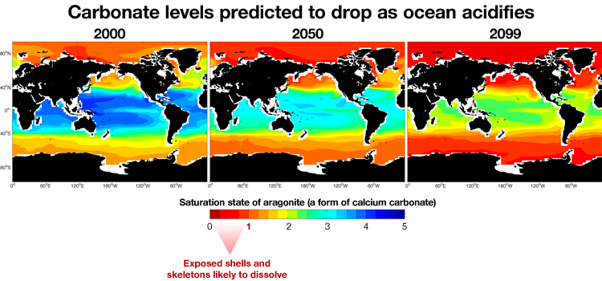
8. What is the optimum Aragonite saturation for coral growth?

9. How does ocean acidification occur?

10. What is the cause of increased ocean acidification?

11. How does ocean acidification affect Aragonite saturation?

12. How does ocean acidification affect the growth of coral reefs?

13. Where were conditions optimal for coral reefs in 2000?

14. Where will there be optimum conditions in 2050 unless the problem is corrected?

15. What can be done to correct this problem?
Aragonite Saturation refers to the amount of calcium carbonate in the water
Conditions for Coral Reef Growth:
Ω > 4.0: optimal
3.5 < Ω < 4.0: adequate
3.0 < Ω < 3.5: marginal
Ω < 3.0: poor
When Ω = 1, the solution is saturated, and when Ω >1, the solution is supersaturated, meaning that there is more calcium carbonate dissolved in the water than is possible under normal conditions

Ocean Acidification is affecting the Aragonite Saturation and the health of coral reefs. When carbon dioxide from the atmosphere is added to surface seawater, the acidity of the surface water increases. If the surface acidity increases, then there is relatively less carbonate ion in seawater, and thus the value of Ω decreases and so does the saturation state of seawater with respect to aragonite.
8. What is the optimum Aragonite saturation for coral growth? Ω > 4.0: optimal
9. How does ocean acidification occur?
When carbon dioxide is added to surface seawater from the atmosphere, the acidity of the surface seawater increases. – It is called the twin evil of global warming
10. What is the cause of increased ocean acidification? the absorption of anthropogenic carbon dioxide (CO2) released from the burning of fossil fuels, into surface seawaters
11. How does ocean acidification affect Aragonite saturation?
It decreases Aragonite saturation levels
12. How does ocean acidification affect the growth of coral reefs?
Decreased Argonite saturation values reduce the potential for coral reef development and affects all other calcifying organisms as mussels, oysters, crustaceans, and Coccolothophore phytoplankton
13. Where were conditions optimal for coral reefs in 2000?
Regions near the equator
14. Where will there be optimum conditions in 2050 unless the problem is corrected?
According to the predictions there are none - Conditions are likely to become very hostile for all calcifying species of organisms in the north Atlantic and Pacific over the next decade and in the Southern Ocean over the next few decades
15. What can be done to correct this problem? Possible solutions that have been suggested include reduce use of fossil fuels, produce carbon negative fuels, iron fertilization, increase alkanization

