Portfolio Modeling, Risk Management, Simulation & Reporting
Prepared for: Laura Gao Portfolio | Generated 2026-10-12 00:57 UTC | Seed 42 | 1,500 simulations | Model v1.0.0
All forward-looking figures are model estimates, simulation results, scenarios, or assumptions — never guarantees.

How to read this report
Read it as answers to these questions rather than front to back:
question | see
Can the 2033 obligation actually be funded? | Section 12 Model Comparison; Section 6 Risk Analysis
How bad can it get? | Section 9 Monte Carlo Results; Section 11 Historical Bootstrap Results
Is this actually diversified? | Section 7 Correlation Analysis; Section 8 Concentration Analysis
Which decisions dominate the outcome? | Section 19.5 Rule-Based Flags
How much do my assumptions matter? | Section 13 Sensitivity Analysis
What would a real crisis do to this mix? | Section 14 Crisis Stress Tests
What does any given number mean? | Appendix A Metric Definitions
Every metric named in this report is defined in Appendix A, generated from the same source file as the workbook Definitions sheet and the web UI Definitions tab.

1. Executive Summary
Where are we now? 7 holdings; equity 70%, bonds 18%, cash 12%. Historical CAGR 8.4%, volatility 12.4%, max drawdown -31.0%.
What is expected? Simulated median 2033 value: Monte Carlo $674,244, bootstrap $679,084, Markov $654,294 (from $450,000 invested 2027-2028). These are model estimates, not guarantees.
What could go wrong? 5th-percentile 2033 outcomes: MC $421,535, bootstrap $452,196. CVaR95 (bootstrap terminal): 7%.
Biggest concentration: correlated group Growth/Consumer-Tech (ADBE+DIS+DUOL) at 45% vs 30% cap; largest single holding VOO at 25%.
Biggest modeling uncertainty: MATERIAL disagreement between Monte Carlo and historical bootstrap — see Model Comparison.
What should change? See Recommended Actions (prioritized): trim correlated-group overweight, size the 2033 reserve from bootstrap (heavier-tail) results, adopt the glide path.
Reserve design: required reserve (PV of 10 x $50,000 payments 2033-2042 at 2.9%) = $441,127.
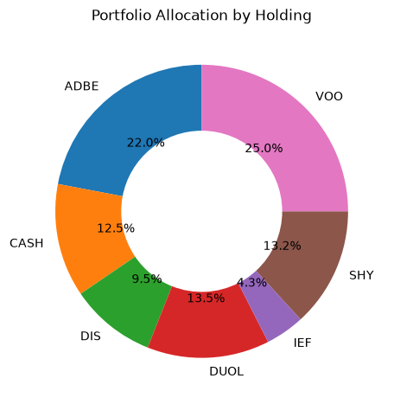

2. Portfolio Overview
7 holdings; total invested contributions $450,000 (2027-2028); weights supplied; equity 70%, bonds 18%, cash 12%.
ticker | asset_class | sector | weight | expected_return | volatility
ADBE | US Equity | Information Technology | 22.0% | 12.0% | 28.0%
CASH | Cash | Cash | 12.5% | 4.1% | 0.0%
DIS | US Equity | Communication Services | 9.5% | 8.0% | 30.0%
DUOL | US Equity | Information Technology | 13.5% | 14.0% | 40.0%
IEF | Treasury | Bonds | 4.3% | 4.5% | 7.0%
SHY | Treasury | Bonds | 13.2% | 4.2% | 2.0%
VOO | ETF | Broad Market (ETF) | 25.0% | 9.0% | 15.0%

3. Current Allocation
weight | n_holdings
35.5% | 2.000
9.5% | 1.000
25.0% | 1.000
17.5% | 2.000
12.5% | 1.000
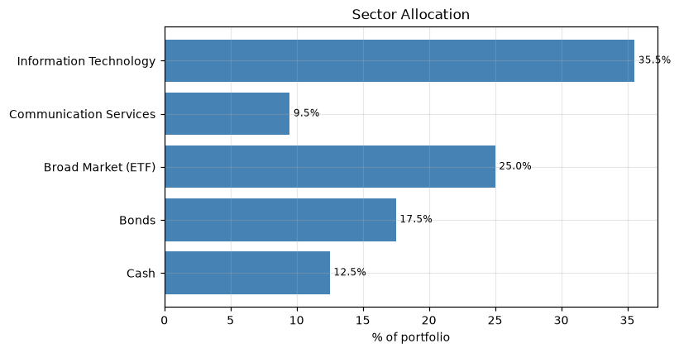

4. Investment Thesis
Theses below are taken from the input spreadsheet where supplied; missing theses are flagged as THESIS RISK.
ticker | thesis | portfolio_role | target_weight | current_weight | risk_rating
ADBE | Creative software; thematic tie to Laura's creative-economy background. | Core Growth | 0.220 | 0.220 | Moderate
CASH | Liquidity/flexibility buffer; held flat, not risk-scored. | Cash Equivalent | 0.125 | 0.125 | Moderate
DIS | Storytelling/media/IP; thematic tie to Laura's work as an author and illustrator. | Cyclical | 0.095 | 0.095 | Moderate
DUOL | Education/edtech; thematic tie to Laura's work as an educator. | Core Growth | 0.135 | 0.135 | Elevated (high volatility)
IEF | Intermediate-duration safety; matches your existing 10-Year Treasury pick. | Defensive / Income | 0.043 | 0.043 | Elevated (correlated cluster)
SHY | Short-duration complement; adds internal diversification within the Bonds bucket. | Defensive / Income | 0.132 | 0.132 | Elevated (correlated cluster)
VOO | Core broad-market holding; anchors the growth bucket with built-in diversification. | Core Growth / Diversifier | 0.250 | 0.250 | Moderate

5. Historical Performance
Portfolio history spans 26.8 years on current weights (rebalanced monthly, total-return basis). CAGR 8.43%, mean annual return 8.72%, volatility 12.45%, Sharpe 0.70, Sortino 1.21, max drawdown -31.02% (peak 2021-09-16 00:00:00, trough 2022-10-14 00:00:00, recovery 2023-11-09 00:00:00). Survivorship bias applies: only current holdings are represented.
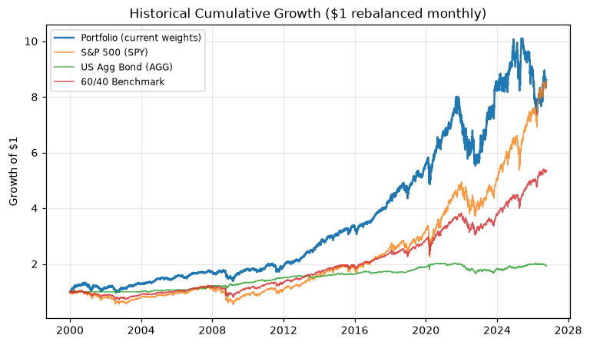
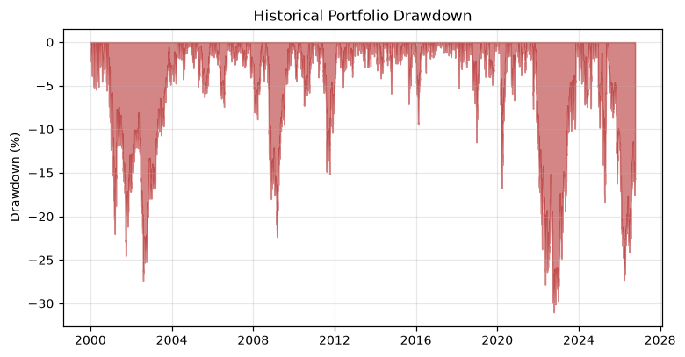

6. Risk Analysis
metric | value
95% historical_VaR | 1.3%
95% historical_CVaR | 2.0%
95% parametric_VaR | 13.6%
95% parametric_CVaR | 19.3%
99% historical_VaR | 2.4%
99% historical_CVaR | 3.3%
99% parametric_VaR | 22.9%
99% parametric_CVaR | 27.6%
Monte Carlo VaR 95% (terminal) | 6.3%
Monte Carlo CVaR 95% (terminal) | 15.5%
Bootstrap VaR 95% (terminal) | -0.5%
Bootstrap CVaR 95% (terminal) | 7.5%
Historical max drawdown | -31.0%
Sharpe (historical) | 70.0%
Sortino (historical) | 120.6%
Downside deviation (annual) | 7.2%
HHI raw | 17.3%
HHI normalized | 3.5%
Effective number of bets | 577.7%
MC max-drawdown median | -16.4%
MC max-drawdown 95th pct | -9.2%
MC P(>20% drawdown) | 27.7%
Bootstrap P(>20% drawdown) | 19.1%
MC success above real capital @ 2% inflation | 84.2%
Bootstrap success above real capital @ 2% inflation | 88.2%
MC success above real capital @ 3% inflation | 78.4%
Bootstrap success above real capital @ 3% inflation | 82.5%
MC success above real capital @ 4% inflation | 73.1%
Bootstrap success above real capital @ 4% inflation | 76.2%
MC success above real capital @ 5% inflation | 66.1%
Bootstrap success above real capital @ 5% inflation | 68.3%
MC prob terminal above 100% real capital floor | 84.2%
MC prob terminal above 90% real capital floor | 91.6%
MC prob terminal above 80% real capital floor | 96.5%
MC prob terminal above 70% real capital floor | 99.1%
VaR/CVaR are one-month horizon figures unless labeled terminal; historical, parametric, and Monte Carlo variants shown for comparison.

7. Correlation Analysis
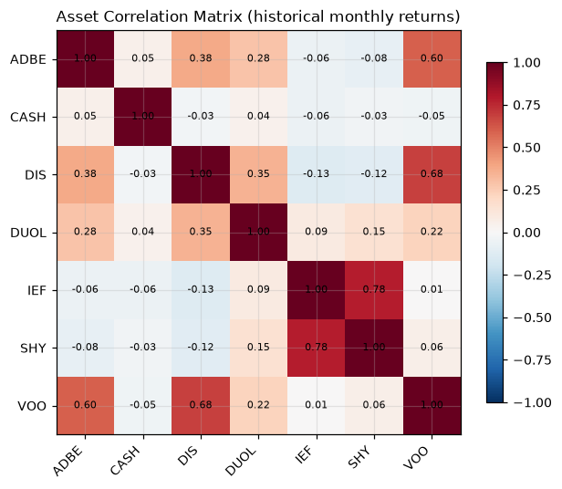
1 pair(s) exceed the 0.70 threshold: IEF-SHY (0.78). Nominal diversification across 7 tickers masks correlated exposures — number of securities is not the number of independent risk bets.

8. Concentration Analysis
Largest position VOO at 25.0%; top-3 60.5%; HHI 0.173 (effective bets 5.8 of 7 holdings). Correlation groups: Growth/Consumer-Tech: 45%.
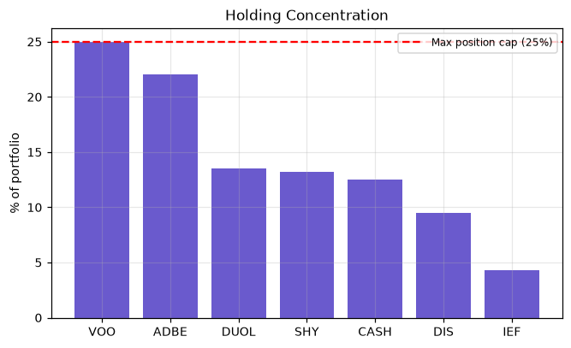

9. Monte Carlo Results
Monte Carlo (gaussian, 1,500 sims, seed 42, monthly steps, correlated multivariate returns, glide path + 5pp bands + 0.10% transaction cost). Median 2033 value $674,244; P(terminal > $450k) = 92.4%; P(all 10 reserve payments funded) = 84.3%; P(>20% drawdown) = 27.7%. Required reserve $441,127; median facility contribution $233,116.
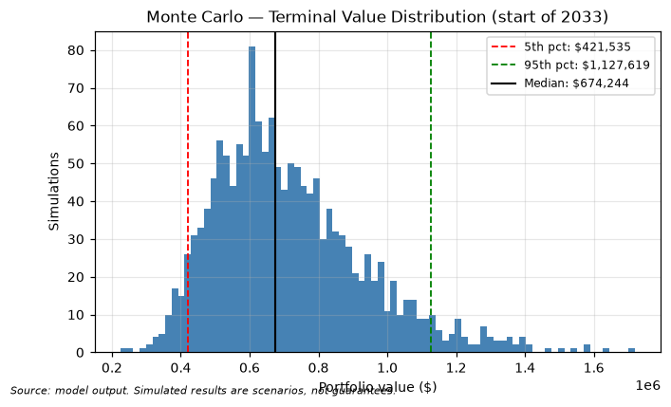
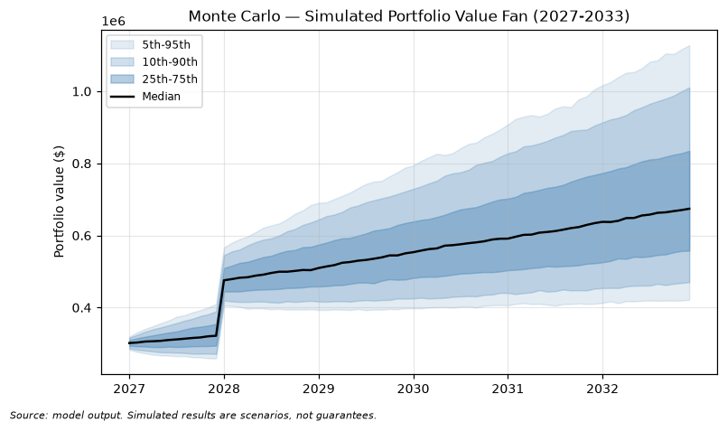

10. Markov Model Results
Markov regime model on annual portfolio returns (states: severe_bear, bear, neutral, bull, strong_bull). Current state: neutral. P(bear next year) 9.5%; P(bear at any point 2027-2032) 61.5%. Stationary distribution: severe_bear=0.04, bear=0.08, neutral=0.25, bull=0.44, strong_bull=0.19. Limitations: Markov memoryless assumption, state discretization, dependence on historical transition frequencies, non-stationarity, structural market change — not a deterministic forecast.
index | severe_bear | bear | neutral | bull | strong_bull
severe_bear | 0.0% | 0.0% | 0.0% | 0.0% | 100.0%
bear | 0.0% | 0.0% | 50.0% | 50.0% | 0.0%
neutral | 0.0% | 20.0% | 20.0% | 60.0% | 0.0%
bull | 9.1% | 0.0% | 36.4% | 27.3% | 27.3%
strong_bull | 0.0% | 16.7% | 0.0% | 66.7% | 16.7%

11. Historical Bootstrap Results
Historical bootstrap (block bootstrap, 20-trading-day blocks of real 2000-2025 joint daily returns, 1,500 sims). Median 2033 value $679,084; P(terminal > $450k) = 95.3%; P(all payments funded) = 18.0%; P(>20% drawdown) = 19.1%. This engine answers: what if the portfolio lived through actual historical market sequences?
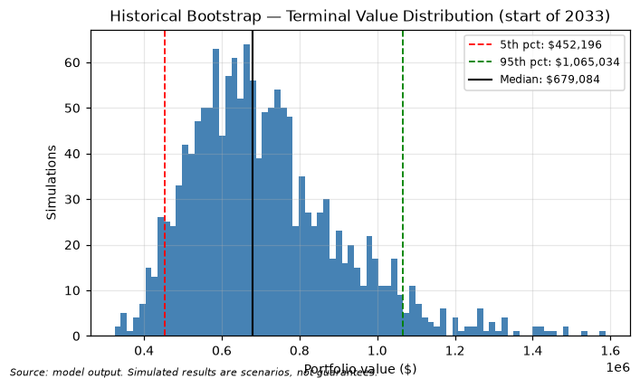
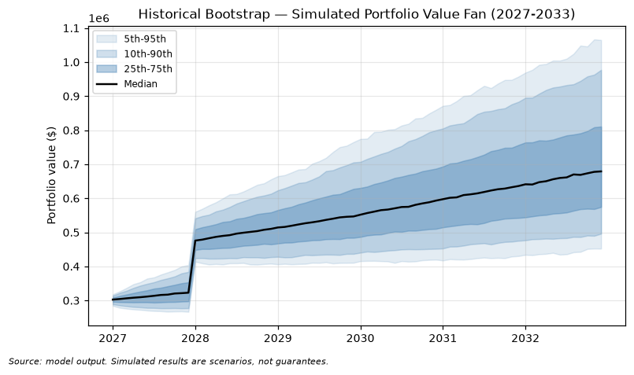

12. Model Comparison
metric | Monte Carlo | Markov | Historical Bootstrap
Median terminal value (2033) | 674,244 | 654,294 | 679,084
5th percentile | 421,535 | 419,604 | 452,196
25th percentile | 557,947 | 540,808 | 574,701
50th percentile | 674,244 | 654,294 | 679,084
75th percentile | 834,769 | 804,239 | 810,838
95th percentile | 1,127,619 | 1,091,573 | 1,065,034
Probability terminal > contributions | 0.924 | 0.914 | 0.953
Probability reserve fully funded | 0.843 | 0.924 | 0.180
Median max drawdown (growth) | -0.164 | n/a | -0.149
Probability >20% drawdown | 0.277 | n/a | 0.191
VaR 95% (terminal) | 0.063 | 0.068 | -0.005
CVaR 95% (terminal) | 0.155 | 0.160 | 0.075
VaR 99% (terminal) | 0.209 | 0.213 | 0.116
CVaR 99% (terminal) | 0.285 | 0.270 | 0.192
MATERIAL MODEL DISAGREEMENT between engines. The portfolio's apparent robustness depends on modeling assumptions; plan against the more conservative engine.

13. Sensitivity Analysis
Base case success 92.3%. Minimum return shift for >=90% success: -2%. Portfolio remains robust across the tested volatility range.
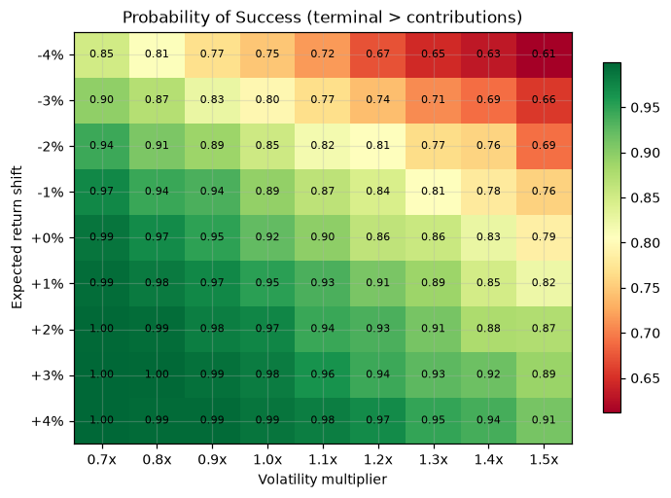
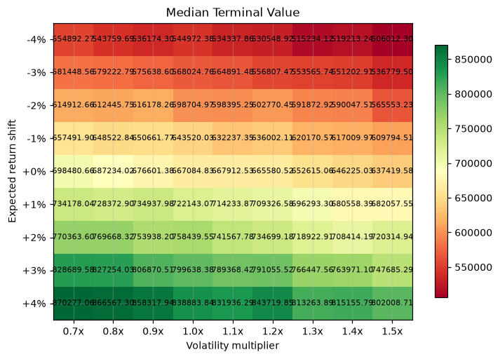

14. Crisis Stress Tests
crisis | window | portfolio_return | max_drawdown | trough_date | recovery_date | days_to_recovery | worst_day | worst_week | worst_month | worst_holding | worst_holding_return | best_holding | best_holding_return
2008 Global Financial Crisis | 2008-01-01 to 2009-03-31 | -12.9% | -22.3% | 2009-03-02 | 2009-10-19 | 231 | -0.032 | -0.068 | -0.087 | ADBE | -0.499 | IEF | 0.162
2020 COVID Crash | 2020-02-19 to 2020-04-30 | -4.9% | -16.8% | 2020-03-20 | 2020-06-05 | 77 | -0.067 | -0.076 | -0.063 | DIS | -0.223 | IEF | 0.075
2022 Rate-Hike Selloff | 2022-01-01 to 2022-12-31 | -20.8% | -24.1% | 2022-10-14 | 2023-06-12 | 241 | -0.042 | -0.074 | -0.100 | DIS | -0.439 | CASH | 0.042
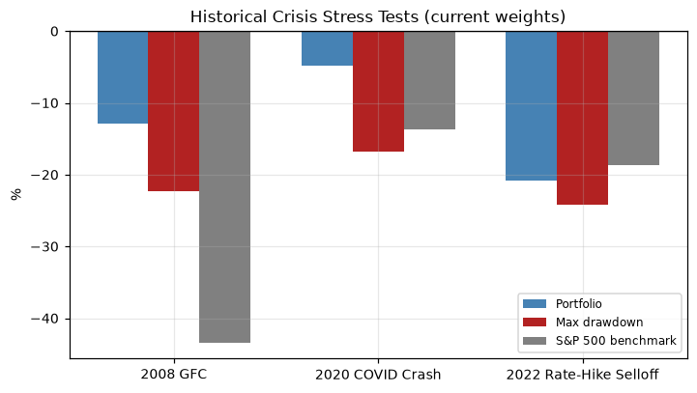

14.1 Hypothetical Forward Scenarios (assumptions, not forecasts)
scenario | portfolio_return | note
severe_equity_crash | -27.1% | Hypothetical assumption scenario, not a forecast.
stagflation | -15.8% | Hypothetical assumption scenario, not a forecast.
recession | -20.6% | Hypothetical assumption scenario, not a forecast.
inflation_shock | -12.0% | Hypothetical assumption scenario, not a forecast.

15. Sector Analysis
Information Technology: 35.5% of portfolio, 2 holding(s) (ADBE, DUOL); 12m return -33.2%, contribution -11.81%.
Communication Services: 9.5% of portfolio, 1 holding(s) (DIS); 12m return -2.7%, contribution -0.25%.
Broad Market (ETF): 25.0% of portfolio, 1 holding(s) (VOO); 12m return 15.4%, contribution 3.86%.
Bonds: 17.5% of portfolio, 2 holding(s) (IEF, SHY); 12m return 0.1%, contribution 0.01%.
Cash: 12.5% of portfolio, 1 holding(s) (CASH); 12m return 3.9%, contribution 0.49%.
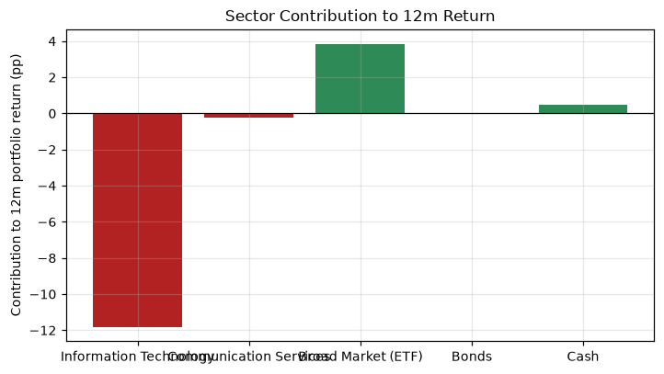

16. Rebalancing Framework
Bands: absolute 5%; transaction cost 0.10% of turnover assumed (not zero).
class | current_weight | target | lower_band | upper_band | trigger | suggested_trade | turnover
Equity | 70.0% | 70.0% | 65.0% | 75.0% | False | 0.0% | 0.000
Bonds | 17.5% | 17.5% | 12.5% | 22.5% | False | 0.0% | 0.000
Cash | 12.5% | 12.5% | 7.5% | 17.5% | False | 0.0% | 0.000

17. 2033 Glide Path
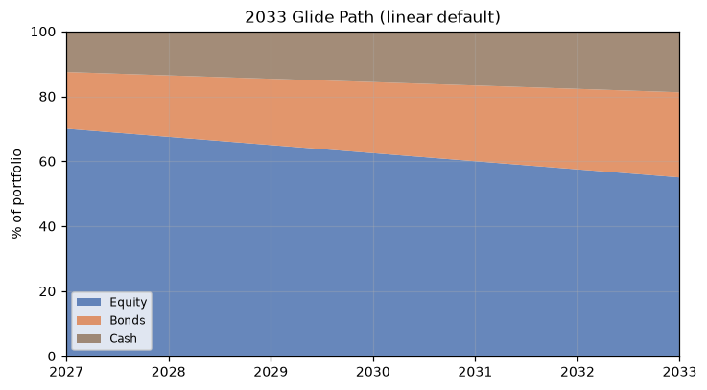
method | median_terminal | p5_terminal | prob_depletion | prob_payments_funded | median_max_dd | var_95 | cvar_95
none | 684,915 | 407,103 | 0.0% | 82.5% | -0.183 | 0.095 | 0.207
linear | 675,908 | 421,713 | 0.0% | 83.5% | -0.163 | 0.063 | 0.167
accelerating | 677,981 | 414,222 | 0.0% | 83.1% | -0.171 | 0.080 | 0.183
custom | 675,908 | 421,713 | 0.0% | 83.5% | -0.163 | 0.063 | 0.167
Greater downside protection may reduce upside participation — see impact table.

18. Position-Level Risk Discipline
These are portfolio risk-discipline rules, not short-term trading signals.
- Maximum position size: 25% (current max: 25.0% in VOO)
- Maximum sector/group exposure: correlated-group cap 30%
- Thesis-break condition: trim any holding whose stated thesis is invalidated (see Investment Theses sheet)
- Valuation/concentration trim: review any holding drifting >5pp beyond target band
- Drawdown review: portfolio-level review triggered at 20% simulated drawdown

18.1 Stop-Loss Backtests (historical, not advice)
Hard and trailing stops were backtested on adjusted price history with re-entry after 21 trading days. A stop is not selected merely because it produced the highest historical return.
ticker | mode | level | cagr | vol | sharpe | sortino | max_drawdown | total_return | exits | turnover | missed_upside | reentry_days | note
ADBE | none | nan | 10.6% | 0.421 | 0.452 | 0.597 | -79.9% | 13.886 | 0 | 0.000 | 0.0% | 0 | Historical backtest on adjusted prices; re-entry after 21 trading days. Not a recommendation to adopt any stop.
ADBE | hard | 0.100 | 4.4% | 0.381 | 0.304 | 0.395 | -84.3% | 2.163 | 13 | 26.000 | 198.7% | 21 | Historical backtest on adjusted prices; re-entry after 21 trading days. Not a recommendation to adopt any stop.
ADBE | hard | 0.150 | 7.6% | 0.406 | 0.384 | 0.499 | -74.3% | 6.039 | 5 | 10.000 | 91.4% | 21 | Historical backtest on adjusted prices; re-entry after 21 trading days. Not a recommendation to adopt any stop.
ADBE | hard | 0.200 | 9.1% | 0.412 | 0.418 | 0.545 | -85.1% | 9.141 | 3 | 6.000 | 48.4% | 21 | Historical backtest on adjusted prices; re-entry after 21 trading days. Not a recommendation to adopt any stop.
ADBE | hard | 0.250 | 9.9% | 0.414 | 0.436 | 0.585 | -81.5% | 11.588 | 2 | 4.000 | 26.4% | 21 | Historical backtest on adjusted prices; re-entry after 21 trading days. Not a recommendation to adopt any stop.
ADBE | trailing | 0.150 | 2.4% | 0.328 | 0.237 | 0.280 | -87.5% | 0.871 | 59 | 118.000 | 300.6% | 21 | Historical backtest on adjusted prices; re-entry after 21 trading days. Not a recommendation to adopt any stop.
ADBE | trailing | 0.200 | 9.1% | 0.363 | 0.422 | 0.519 | -84.0% | 9.130 | 37 | 73.000 | 99.3% | 21 | Historical backtest on adjusted prices; re-entry after 21 trading days. Not a recommendation to adopt any stop.
ADBE | trailing | 0.250 | 7.6% | 0.383 | 0.384 | 0.484 | -79.9% | 6.052 | 25 | 50.000 | 115.6% | 21 | Historical backtest on adjusted prices; re-entry after 21 trading days. Not a recommendation to adopt any stop.
DIS | none | nan | 6.1% | 0.305 | 0.345 | 0.484 | -67.9% | 3.821 | 0 | 0.000 | 0.0% | 0 | Historical backtest on adjusted prices; re-entry after 21 trading days. Not a recommendation to adopt any stop.
DIS | hard | 0.100 | 3.6% | 0.289 | 0.266 | 0.369 | -79.2% | 1.556 | 10 | 20.000 | 75.9% | 21 | Historical backtest on adjusted prices; re-entry after 21 trading days. Not a recommendation to adopt any stop.
DIS | hard | 0.150 | 6.9% | 0.298 | 0.373 | 0.532 | -60.7% | 4.978 | 2 | 4.000 | -16.2% | 21 | Historical backtest on adjusted prices; re-entry after 21 trading days. Not a recommendation to adopt any stop.
DIS | hard | 0.200 | 6.7% | 0.299 | 0.365 | 0.520 | -61.5% | 4.632 | 2 | 4.000 | -11.1% | 21 | Historical backtest on adjusted prices; re-entry after 21 trading days. Not a recommendation to adopt any stop.
DIS | hard | 0.250 | 5.7% | 0.301 | 0.334 | 0.467 | -70.0% | 3.383 | 2 | 4.000 | 12.1% | 21 | Historical backtest on adjusted prices; re-entry after 21 trading days. Not a recommendation to adopt any stop.
DIS | trailing | 0.150 | 3.8% | 0.256 | 0.275 | 0.368 | -77.0% | 1.741 | 40 | 80.000 | 92.5% | 21 | Historical backtest on adjusted prices; re-entry after 21 trading days. Not a recommendation to adopt any stop.
DIS | trailing | 0.200 | 6.9% | 0.271 | 0.383 | 0.528 | -60.4% | 5.000 | 24 | 48.000 | 4.0% | 21 | Historical backtest on adjusted prices; re-entry after 21 trading days. Not a recommendation to adopt any stop.
DIS | trailing | 0.250 | 7.7% | 0.279 | 0.405 | 0.578 | -52.8% | 6.293 | 15 | 30.000 | -21.4% | 21 | Historical backtest on adjusted prices; re-entry after 21 trading days. Not a recommendation to adopt any stop.
DUOL | none | nan | 2.2% | 0.659 | 0.359 | 0.535 | -83.3% | 0.117 | 0 | 0.000 | 0.0% | 0 | Historical backtest on adjusted prices; re-entry after 21 trading days. Not a recommendation to adopt any stop.
DUOL | hard | 0.100 | -10.5% | 0.572 | 0.092 | 0.123 | -83.3% | -0.438 | 9 | 18.000 | 95.2% | 21 | Historical backtest on adjusted prices; re-entry after 21 trading days. Not a recommendation to adopt any stop.
DUOL | hard | 0.150 | -5.0% | 0.599 | 0.213 | 0.298 | -83.3% | -0.234 | 5 | 10.000 | 56.3% | 21 | Historical backtest on adjusted prices; re-entry after 21 trading days. Not a recommendation to adopt any stop.
DUOL | hard | 0.200 | -4.6% | 0.622 | 0.236 | 0.329 | -83.3% | -0.215 | 4 | 8.000 | 46.6% | 21 | Historical backtest on adjusted prices; re-entry after 21 trading days. Not a recommendation to adopt any stop.
DUOL | hard | 0.250 | -10.4% | 0.619 | 0.133 | 0.187 | -83.6% | -0.433 | 4 | 8.000 | 79.9% | 21 | Historical backtest on adjusted prices; re-entry after 21 trading days. Not a recommendation to adopt any stop.
DUOL | trailing | 0.150 | -12.2% | 0.446 | -0.070 | -0.081 | -73.5% | -0.491 | 25 | 49.000 | 138.8% | 21 | Historical backtest on adjusted prices; re-entry after 21 trading days. Not a recommendation to adopt any stop.
DUOL | trailing | 0.200 | 4.3% | 0.533 | 0.343 | 0.442 | -75.8% | 0.245 | 16 | 32.000 | 27.8% | 21 | Historical backtest on adjusted prices; re-entry after 21 trading days. Not a recommendation to adopt any stop.
DUOL | trailing | 0.250 | -11.6% | 0.545 | 0.045 | 0.058 | -79.9% | -0.474 | 14 | 28.000 | 109.8% | 21 | Historical backtest on adjusted prices; re-entry after 21 trading days. Not a recommendation to adopt any stop.
IEF | none | nan | 3.4% | 0.068 | 0.524 | 0.801 | -23.9% | 1.235 | 0 | 0.000 | 0.0% | 0 | Historical backtest on adjusted prices; re-entry after 21 trading days. Not a recommendation to adopt any stop.
IEF | hard | 0.100 | 3.4% | 0.068 | 0.524 | 0.801 | -23.9% | 1.235 | 0 | 0.000 | 0.0% | 21 | Historical backtest on adjusted prices; re-entry after 21 trading days. Not a recommendation to adopt any stop.
IEF | hard | 0.150 | 3.4% | 0.068 | 0.524 | 0.801 | -23.9% | 1.235 | 0 | 0.000 | 0.0% | 21 | Historical backtest on adjusted prices; re-entry after 21 trading days. Not a recommendation to adopt any stop.
IEF | hard | 0.200 | 3.4% | 0.068 | 0.524 | 0.801 | -23.9% | 1.235 | 0 | 0.000 | 0.0% | 21 | Historical backtest on adjusted prices; re-entry after 21 trading days. Not a recommendation to adopt any stop.
IEF | hard | 0.250 | 3.4% | 0.068 | 0.524 | 0.801 | -23.9% | 1.235 | 0 | 0.000 | 0.0% | 21 | Historical backtest on adjusted prices; re-entry after 21 trading days. Not a recommendation to adopt any stop.
IEF | trailing | 0.150 | 3.4% | 0.068 | 0.522 | 0.796 | -24.4% | 1.221 | 1 | 2.000 | 0.7% | 21 | Historical backtest on adjusted prices; re-entry after 21 trading days. Not a recommendation to adopt any stop.

19. Key Risks
- Correlated Growth/Consumer-Tech group concentration (45% vs 30% cap).
- DUOL has short history (since 2021) — statistics low-confidence; Medium confidence estimates.
- Tail risk: bootstrap CVaR95 7% vs Gaussian MC 15% — real history has fatter tails than the parametric model.
- Reserve funding risk: P(all 10 payments funded) = 84.3% (MC) / 18.0% (bootstrap).
- Survivorship bias: historical analysis reflects only surviving current holdings.
- 1 high-correlation pairs (>0.70) reduce effective diversification.

19.5 Rule-Based Risk & Rebalancing Flags
Every flag below is produced by an explicit rule with a configured threshold and a calculated value. These are rule-based portfolio risk flags, not AI-generated recommendations.
id | severity | category | metric | current_value | threshold | rule | action
GRP-01 | HIGH | Concentration | Correlated group 'Growth/Consumer-Tech' total weight | 0.450 | 0.300 | Correlated-group exposure > configured cap (30.0%) | Trim the 'Growth/Consumer-Tech' group (ADBE, DIS, DUOL) toward 30.0%; these holdings move together and diversification is overstated.
MODEL-06 | HIGH | Model Risk | Monte Carlo vs historical bootstrap disagreement | 1.000 | 1.000 | Key metrics differ materially between Gaussian MC and real-history bootstrap (>10pp probability or >25% value) | Report ranges, not point estimates; make reserve/funding decisions using the conservative bootstrap engine.
RESV-05 | HIGH | Funding Risk | Probability all 10 reserve payments funded | 0.180 | 0.900 | min(MC, bootstrap) P(all reserve payments funded) < 90.0% | Increase the reserve discount buffer, extend the glide path, or reduce payment size; plan against the conservative engine.
CORR-03 | WARNING | Correlation | IEF-SHY correlation | 0.785 | 0.700 | |Pairwise monthly correlation| > configured threshold (0.70) | Treat IEF and SHY as one risk bet when sizing exposure; avoid adding correlated positions.
DD-04 | WARNING | Drawdown | Monte Carlo P(>20% growth-phase drawdown) | 0.277 | 0.250 | Simulated probability of a >20% drawdown > 25.0% review trigger | Portfolio-level review triggered: consider glide-path acceleration, band tightening, or a defensive sleeve.
SEC-02 | WARNING | Sector Concentration | Information Technology sector weight | 0.355 | 0.350 | Sector allocation > configured maximum sector weight (35.0%) | Review/rebalance Information Technology exposure toward the 35.0% cap.

19.6 What each high-severity flag is really about
GRP-01 (HIGH) — Correlated group 'Growth/Consumer-Tech' total weight
Metric: The size of the single bet that several correlated holdings actually represent.
How to read it here: This is the cap that tells the truth about diversification. A portfolio can pass every position and sector cap and still breach this one.
The trap: Correlation is estimated on shared history, so a cluster can be understated when a holding has a short record.
Do this: Trim the 'Growth/Consumer-Tech' group (ADBE, DIS, DUOL) toward 30.0%; these holdings move together and diversification is overstated.
Evidence: Group 'Growth/Consumer-Tech' (ADBE, DIS, DUOL) totals 45.0% vs a 30.0% cap.
MODEL-06 (HIGH) — Monte Carlo vs historical bootstrap disagreement
Metric: How much the answer depends on which model you believe.
How to read it here: A large spread is a finding, not noise: it means the assumption set, not the holdings, is driving the answer.
The trap: The engines answer different questions, so some spread is expected. Only a spread in a decision-relevant metric matters.
Do this: Report ranges, not point estimates; make reserve/funding decisions using the conservative bootstrap engine.
Evidence: reserve funded differs by 66.3%.
RESV-05 (HIGH) — Probability all 10 reserve payments funded
Metric: Whether the obligation is actually met on time, every time.
How to read it here: The most decision-relevant number in the report. The bootstrap version is the one to plan against.
The trap: It requires the reserve to be intact at each payment date; a simulation that ends solvent but was empty in 2037 still fails.
Do this: Increase the reserve discount buffer, extend the glide path, or reduce payment size; plan against the conservative engine.
Evidence: MC 84.3% / bootstrap 18.0% vs a 90.0% planning standard.

20. Recommended Actions

Immediate (Priority 1-2)
- Trim the Growth/Consumer-Tech correlated group from 45% toward the 30% cap (e.g., reduce DUOL/ADBE) — model identifies a cap breach; investor should weigh tax and conviction before acting.
- Size the 2033 reserve using the bootstrap (heavier-tail) distribution, not the Gaussian MC: bootstrap P(funded) = 18.0%.

Medium-Term (Priority 3)
- Add a defensive sleeve (Health Care / Consumer Staples / Utilities) or broad-market value exposure to reduce sector concentration in the equity bucket.
- Adopt 5pp rebalancing bands with 0.10% cost budget; simulated mean turnover $477,200 per path.

2033 Preparation (Priority 2-3)
- Follow the linear glide path 70% -> 55% equity by 2033; impact table shows modest upside trade-off for materially lower drawdown risk.
- Report the 2031 sponsor range as a percentile band (p5-p95), not a point estimate.

Watchlist (Priority 4)
- DUOL history length and data confidence; revisit estimates as history accumulates.
- Model disagreement between engines — rerun quarterly and widen reserve if disagreement grows.
- Correlation clusters during stress periods (correlations rise in crises).

21. Methodology
- Prices: dividend/split-adjusted daily closes (Yahoo Finance via yfinance), 2000-01-01 to latest available; total-return basis.
- Portfolio history: current weights held constant, rebalanced monthly (rebalanced-index convention).
- Monte Carlo: multivariate correlated monthly returns via Cholesky decomposition of covariance; gaussian/lognormal/student-t/historical-residual models selectable.
- Expected returns/volatilities: spreadsheet assumptions where supplied; otherwise historical estimates with shrinkage. Covariance = historical correlations x assumed volatilities.
- Markov: 5-state regime model on annual portfolio returns; transition matrix, stationary distribution, within-state bootstrap simulation.
- Historical bootstrap: block bootstrap (20-trading-day blocks) of real joint daily returns compounded to monthly; no synthetic distributions.
- Simulation timeline: $300k at 2027 start, $150k at 2028 start, glide path to 2033, reserve split at 2033, ten $50k payments 2033-2042.
- VaR/CVaR: historical, parametric (normal), and Monte Carlo variants at 95%/99%.
- Success definitions: terminal > contributions; all reserve payments funded; terminal above inflation-adjusted capital floor.

22. Assumptions
- Contributions: $300,000 at start of 2027 and $150,000 at start of 2028 (user-supplied schedule); total $450,000. No other contributions or withdrawals.
- Reserve: PV of ten $50,000 payments (2033-2042, start of year) discounted at 2.9%.
- Risk-free rate 4.1%; cash earns the risk-free rate.
- Inflation base 2.0% (scenarios 2-5% in sensitivity).
- Weights supplied; normalized to 100%.
- Transaction costs 0.10% of turnover (not zero).
- Taxes excluded: no tax-lot information supplied.
- Glide path: linear 70% -> 55% equity by 2033 (configurable).
- Random seed 42; 1,500 simulations per engine.

23. Data Limitations
- Survivorship bias: only current holdings are represented in history.
- Look-ahead caution: current weights applied to full history is a convention, not a tradable backtest.
- Low-confidence histories: none.
- Yahoo Finance data may contain gaps/survivorship issues; corporate actions handled via adjusted prices only.
- Markov model assumes memoryless regime transitions.
- No tax-lot data: rebalancing tax impact not estimated.
- Currency: all holdings assumed USD-denominated (no FX conversion applied).

Final Conclusions

What is working?
- Both engines show median 2033 value above invested contributions (MC $674,244, bootstrap $679,084).
- Bond + cash sleeve (~32.5%) provides a real buffer; glide path further de-risks into 2033.

What is fragile?
- Correlated tech/consumer-tech group concentration (61% in top 3 holdings).
- Bootstrap downside: p5 2033 value $452,196; reserve funding probability 18.0%.

What matters most?
- 1. Equity expected return (sensitivity grid dominates outcomes).
- 2. Volatility regime (fragility threshold in sensitivity analysis).
- 3. Reserve discount rate and payment schedule.
- 4. Correlated-group sizing (largest controllable risk).
- 5. Glide-path aggressiveness into 2033.

What should be changed?
- Trim correlated group to cap; size reserve from bootstrap percentiles; adopt glide path and bands.

What should be monitored?
- Band breaches, drawdown vs 20% review trigger, model disagreement magnitude, DUOL data confidence.

Monitoring Checklist
- [ ] Portfolio value & allocation drift vs targets
- [ ] Sector weights vs bands
- [ ] Correlation clusters (>0.70 pairs)
- [ ] VaR/CVaR monthly
- [ ] Max drawdown vs 20% review trigger
- [ ] Glide-path position vs 2033 target
- [ ] Rebalancing band breaches
- [ ] Simulation success probabilities (rerun quarterly)
- [ ] Thesis status per holding
- [ ] DUOL history length / data confidence

Appendix A. Metric Definitions
Generated from portfolio_model/src/metric_glossary.py — the same source as the workbook Definitions sheet and the web UI Definitions tab. The 'Trap' column is the way this metric is most often misread.
metric | what_it_is | how_to_read_it | trap
Weights source | Which input column was used: explicit portfolio weights, market value / total, or quantity x price. | If it says 'supplied weights', the analysis is about the allocation you wrote down. If it says 'derived from market value', it reflects your actual positions today. | Weights are renormalised to 100%. If your weights summed to 92%, everything is scaled up by 8.7% silently.
Expected return (annual) | Spreadsheet 'Expected Return' column when present and expected_returns.source = input; otherwise the historical mean compounded to a year, shrunk toward the cross-asset mean by expected_returns.shrinkage. | This is the single most influential number in the whole report. A 1pp change moves the median 2033 outcome by roughly the horizon length in years. | It is an assumption, not a forecast. The engines are not predicting; they are answering 'what follows from these assumptions'.
Volatility (annual) | Standard deviation of monthly returns x sqrt(12). | 20% annual volatility means roughly two-thirds of months land within +/-5.8% of the average month. It measures dispersion, not the chance of losing money. | Volatility from a short history (see confidence) is unreliable, and it treats upside and downside moves identically.
Risk-free rate | Config risk.risk_free_rate; also used as the return earned by the CASH holding every period. | Cash is never modelled as 0% return; it earns this rate. Raising it raises cash-heavy portfolios. | Sharpe here divides raw return by volatility (no risk-free subtraction), so it is a risk-adjusted *ratio*, not the textbook excess-return Sharpe.
Inflation assumption | Config risk.inflation_base, applied to convert nominal capital into 'real capital' for floor tests. | Real success is always lower than nominal success. The gap between the two is the cost of ignoring inflation. | Returns are nominal; only the success thresholds are inflation-adjusted. The model does not deflate the return series.
Historical CAGR | (final index value / first index value)^(1 / years) - 1, on the rebalanced current-weight index. | A smoothed average of what this allocation actually did. Compare it with the simulated median to see whether your assumptions are optimistic or conservative. | It is path-dependent and start-date dependent. It also assumes today's weights had been held the whole time (rebalanced index), which is a hypothetical, not your real account.
Mean annual return (historical) | (1 + average monthly return)^12 - 1. | Higher than CAGR whenever returns were volatile, because volatility drags compounding down. | Mean annual return minus CAGR is roughly the volatility drag: never quote the mean as if it were achievable growth.
Volatility (historical, annual) | Standard deviation of portfolio monthly returns x sqrt(12). | Roughly 1 in 6 months lands outside +/-1 annual-volatility/3.6 of the average month. | Portfolio volatility is not the weighted average of holding volatilities; correlation is what makes it lower.
Sharpe (historical) | Mean annual return / annual volatility. | Above ~0.6 for a stock/bond portfolio is respectable; below ~0.25 means the extra return is not paying for the volatility. | No risk-free subtraction here, and it is computed on history. Two portfolios with the same Sharpe can have completely different drawdown shapes.
Sortino (historical) | Mean annual return / downside deviation (std of negative months only, x sqrt(12)). | Sortino > Sharpe whenever upside is large. A big gap means the volatility is mostly good news. | With few negative months the downside deviation is noisy and Sortino looks flattering.
Downside deviation | Standard deviation of negative monthly returns x sqrt(12). | This is the number that maps to how the portfolio actually feels to hold. | Counts only months below zero, so it ignores how *often* you lose.
Max drawdown (historical) | Minimum of (value / running peak - 1) on the rebalanced index. | The realistic test of whether you could have held. -35% is survivable for a long horizon; -60% usually is not. | One event defines it. It says nothing about how long the recovery took (see the recovery table) and nothing about drawdowns that started after the trough.
Drawdown peak / trough / recovery dates | Date of the running peak before the worst trough, the trough date, and the first date the index exceeded the peak again. | Depth plus time-underwater is the real pain. A -30% drawdown recovered in 6 months is a different risk from one that took 4 years. | A blank recovery means the index had not recovered by the end of the data - not that it never will.
Days to recover (drawdown events) | Calendar days from each trough (deeper than -5%) back to zero drawdown. | Long recoveries are the argument for the glide path into 2033. | Events shallower than -5% are not listed, so the table understates small-but-frequent pain.
Correlation (pairwise, monthly) | Pearson correlation of monthly returns between two holdings over the full history. | +0.9 means they are effectively the same position split in two. Below +0.4 they genuinely diversify. Negative correlation is a hedge. | Correlation is estimated on history and rises toward 1.0 exactly when you need it not to.
Correlation cluster | Single-linkage grouping of holdings joined by correlation above the threshold. | A cluster of four names at 20% each is a 80% single-bet portfolio wearing four labels. | Single-linkage can chain A-B and B-C into one cluster even when A-C correlation is modest.
HHI (concentration index) | Sum of squared weights. Normalised version: (HHI - 1/n) / (1 - 1/n). | Raw HHI 0.25 means the concentration of an equal-weighted 4-holding portfolio. Normalised HHI 0 = perfectly spread, 1 = all in one name. | HHI sees position size only. Two 25% positions in perfectly correlated names look the same as two independent names.
Effective number of independent bets | 1 / HHI, where HHI is the sum of squared weights over all holdings with weight > 0. | 7 holdings with effective_n 3.4 is a three-bet portfolio. This is the most honest diversification number in the report. | It measures weight concentration, not correlation-adjusted independence, so it is an upper bound on real diversification.
Top 3 / 5 / 10 weight | Sum of the largest three, five and ten weights. | Top 3 above 60% means three decisions dominate the outcome, whatever the rest of the sheet says. | With fewer than 3 holdings the top-3 figure is simply 100%.
Invested capital / contributions | Sum of cashflows.contributions amounts (default 2027: $300,000, 2028: $150,000). | Every 'success' number is measured against this figure, so changing it changes all probabilities. | Contributions are invested at the current glide-path target weights at that month, not at today's holdings weights.
Required reserve (present value) | Payment x [1 - (1+r)^-n] / r x (1+r) for n = last_year - first_year + 1 payments at rate = reserve_discount_rate (annuity-due). | This is the hard obligation the 2033 split must cover. Everything above it is the facility contribution. | It is a present value, not cash you must hold. A reserve exactly equal to it only works if the reserve keeps earning that rate.
2033 split | At the start of the glide-end year: reserve = min(value, required_reserve); facility = value - required_reserve. | A negative facility means the portfolio cannot cover the reserve at 2033 - the core failure mode of the plan. | The split is a modelling convention (one clean cut), not a legal or tax event.
Facility contribution | Terminal value at 2033 minus required reserve, per simulation. | Its 5th percentile is the number to plan against; its median is the number to hope for. | Negative values are real outcomes, not errors - they are the shortfall cases.
Glide path targets | Year-by-year equity/bond/cash targets from glide_path.method between start_equity and end_equity. | The equity share each year is what the simulation rebalances toward; it is the model's main risk control. | Glide path changes risk, not expected return much. Its value shows up in drawdown and reserve-funding probabilities, not in the median.
Rebalancing band | Absolute: target +/- band percentage points. Relative: target x (1 +/- relative_band). | Tight bands mean more trades and more transaction cost; loose bands mean the glide path is advisory only. | Bands are tested on asset *class* weights at month end, not on individual holdings.
Turnover / rebalances (mean) | Sum over time of absolute weight changes per simulation; mean across simulations. | High turnover with tiny benefit means the band is too tight. | Turnover is not a cost. The cost is turnover x transaction_cost, already netted out of values.
Terminal value (2033) | Portfolio value at the end of the growth phase (month before the glide-end year), per simulation. | Read the distribution, not the average: p5 is the planning case, p50 the expected case, p95 the lucky case. | It is measured *before* the 2033-2042 payments are made, so it is not the money you end with.
Median terminal value | 50th percentile of simulated 2033 values. | The headline number. Compare it across engines - if Monte Carlo and bootstrap disagree by more than 25%, the distribution shape is doing the work. | Median is not mean. With fat tails the mean is higher than the median, and the median is the safer one to quote.
Terminal percentiles (p5 ... p95) | Percentiles of the simulated 2033 value distribution. | p5 is the case you must survive; p95 is the case you must not plan for. | Percentiles from 10,000 simulations are stable to roughly +/-0.5pp in probability terms, not to the dollar.
Success: terminal > contributions | Share of simulations where 2033 value > total contributions (nominal). | 92% sounds safe, but it is a nominal test against a 2027-28 figure. | Growing money in nominal terms while losing purchasing power still counts as success here.
Success above real capital | Share of simulations where 2033 value > contributions x (1 + inflation)^(years to 2033). | This is the honest success number. The gap to the nominal version is the inflation tax. | It uses one inflation assumption; the scenario rows show the sensitivity.
Capital-floor probabilities | Share of simulations where terminal value >= floor x inflation-adjusted contributions, for floors 100%, 90%, 80%, 70%. | A ladder, not a verdict: 95% chance of keeping 80% of real capital is a very different claim from 95% chance of keeping all of it. | Floors are relative to contributions, not to the reserve obligation.
Probability all reserve payments funded | Share of simulations where the reserve balance never goes below zero at any of the 10 payment dates. | The most decision-relevant number in the report. The bootstrap version is the one to plan against. | It requires the reserve to be intact at each payment date; a simulation that ends solvent but was empty in 2037 still fails.
Probability the facility gets nothing | Share of simulations where 2033 value < required reserve. | High values mean the reserve is eating the whole portfolio by 2033. | Markov reports it as 1 - P(facility negative) in the comparison table; check the label before comparing rows.
Probability of capital depletion | Share of simulations where the 2033 value is essentially zero. | Usually near zero for a diversified stock/bond/cash mix. If it is not, the return assumptions or the model choice are extreme. | Zero here means the model's distribution produced a catastrophic path; real total loss also comes from forced selling, which is not modelled.
Max drawdown (growth phase) | Deepest peak-to-trough fall in each simulated path before the 2033 split; reported as a median and as probabilities of exceeding 10/20/30/40%. | Median max drawdown is the typical experience; P(>20%) is the trigger for a portfolio review. | Measured on the growth phase only. Reserve-phase drawdowns are deliberately excluded because that money is already earmarked.
Expected CAGR (Monte Carlo) | (median terminal / total contributions)^(1 / years to 2033) - 1. | The bridge between the simulation and an intuitive rate. Compare it with historical CAGR to see how aggressive the assumptions are. | It uses contributions as the base, so a mid-period contribution drags it below the portfolio's own return.
2031 sponsor checkpoint | Percentiles of portfolio value at the start of 2031, and of value minus required reserve. | The projected-facility p5 at 2031 is the earliest honest signal that the reserve is at risk. | It is a snapshot, not a promise; two more years of market risk remain after it.
Monte Carlo engine | Monthly returns drawn from a parametric distribution (gaussian | lognormal | student_t | historical_residual) with the estimated mean vector and covariance, then run through the shared path engine. | Smooth, symmetric (unless Student-t), and only as good as the mean/covariance you fed it. | Gaussian Monte Carlo systematically understates crash frequency. Never use it alone for a reserve obligation.
Student-t simulation | Same covariance, with each month scaled by sqrt(dof / chi-square(dof)); dof = simulation.student_t_dof. | Lower p5, higher CVaR, lower reserve-funding probability than gaussian - and closer to how markets actually behave. | Fat tails also raise the variance of the estimate; you need more simulations for stable percentiles.
Historical bootstrap engine | Each simulation concatenates contiguous blocks of real historical joint daily returns (block bootstrap, block_size_days) covering the horizon, compounded to months, then run through the same path engine. | The reality check. It carries real crashes and real correlation behaviour, so it is usually the more conservative engine. | It cannot invent a crisis that never happened in the sample, and it inherits the sample's survivorship.
Block size (bootstrap) | Length of each contiguous historical window drawn (config bootstrap.block_size_days). | 20 trading days keeps a month of momentum together; 1 day (iid) shuffles good and bad days apart and understates runs of bad news. | Larger blocks reduce the number of distinct combinations, so very large blocks make results lumpier.
Markov regime engine | Historical calendar-year portfolio returns are bucketed into 5 states by the configured thresholds; a 5x5 transition matrix is estimated from year-to-year moves; simulations draw state sequences and then a real return from the matching state. | It answers 'how likely is a bad stretch' better than it answers 'what is the terminal value'. | Estimated from roughly 25 annual observations. Each transition probability has a wide confidence interval, and unobserved states are assumed to persist.
Regime states and thresholds | severe_bear < -20%, bear -20% to -5%, neutral -5% to +5%, bull +5% to +20%, strong_bull > +20% of annual portfolio return (config markov.thresholds). | A portfolio-level -5% year is already 'bear' because the thresholds apply to the whole portfolio, not to the S&P. | Thresholds are absolute, so a conservative bond-heavy portfolio may never leave 'neutral'.
Transition matrix P | P[i][j] = share of historical years in state i that were followed by a year in state j. | A high diagonal means regimes persist - bad years come in runs. | Rows built from one or two observations are not probabilities, they are anecdotes; the engine marks unobserved rows as persistent.
Stationary distribution | Long-run share of years in each state implied by P (left eigenvector at 1). | If the stationary bear share is 25%, expect roughly one year in four to be a bear year over a long horizon. | It assumes the process is stable forever, which no market is.
Expected regime duration | 1 / (1 - P[state][state]). | A 2.5-year expected bear duration means a bad stretch is likely to span more than one planning year. | Mean duration says nothing about the worst case; runs can be far longer.
P(bear at any point 2027-2032) | Share of Markov simulations where at least one growth-phase year lands in bear or severe_bear. | Usually high. It is a near-certainty statement, which is why it should not be used as an alarm by itself. | 'At least one bear year' is a low bar; 60% here does not mean 60% chance of failure.
P(bull by 2032) | Share of Markov simulations whose final growth-phase year is bull or strong_bull. | Arriving in a bull year is favourable for the split, but it says nothing about the path taken to get there. | A bull final year is compatible with a -35% drawdown in 2029.
VaR (value at risk) | Historical: -quantile(returns, 1 - confidence). Parametric: -(mean + z x std). Monte Carlo: -quantile of simulated terminal return vs contributions. | VaR 95% = 4% means 19 months in 20 lose less than 4%; it says nothing about how bad the 20th month is. | Sign convention: VaR is reported as a positive loss. A 'VaR 95% = 0.04' means a 4% loss, not a 4% gain; a NEGATIVE VaR means the 5th-percentile outcome is itself a gain. Historical, parametric and Monte Carlo VaR are computed on different horizons and bases - never compare them directly.
CVaR / expected shortfall | Negative of the mean of returns at or beyond the VaR quantile. | CVaR is the number that should size a reserve. If CVaR95 is 30%, the worst 5% of outcomes lose a third on average. | Terminal CVaR is measured on the 2033 outcome relative to contributions over six years, not on a month. It is a horizon loss, not a monthly one. A NEGATIVE CVaR is not an error: it means that even the worst 5% of simulated outcomes are, on average, still gains - the tail is not loss-making under these assumptions.
Horizon warning (VaR rows) | Risk-sheet VaR/CVaR rows are one-month horizon; comparison-table VaR/CVaR rows are 2033 terminal horizon. | A 4% monthly VaR and a 30% terminal VaR are consistent, not contradictory. | This is the single most common misreading in the workbook.
Sensitivity grid | For each (return shift, volatility multiplier) pair, re-run the simulation and record median terminal, p5, success probability, reserve-funding probability, median drawdown, VaR/CVaR. | Find the base cell (shift 0, multiplier 1.0), then walk outward. A plan whose success collapses one row away is fragile. | Return shifts are applied to every asset equally; it is a systematic shock, not a single-name change.
Minimum return shift for 90% success | Smallest return shift in the grid where success probability is still at or above 90%. | -2% means the plan survives 2pp lower returns everywhere. A value near 0 means no margin at all. | It is found at the grid's coarse 1pp steps.
Fragile volatility threshold | At the base return assumption, the smallest volatility multiplier >= 1.0 where success falls below 75%. | 1.1 means a 10% increase in volatility breaks the plan; 1.5 means it is robust to a 50% volatility regime shift. | Volatility is scaled, not returns: it widens the distribution without changing the average.
Sharpe proxy (sensitivity grid) | Mean / standard deviation of the simulated annualised terminal outcomes in that grid cell. | Use it to rank cells against each other; do not compare it with the historical Sharpe on the dashboard. | It is computed on terminal outcomes over the whole horizon, so it is not annual return over annual volatility.
Historical crisis replay | Apply the actual daily returns of your holdings during a configured window (2008, 2020, 2022) to current weights and report portfolio return, worst holding, sector contributions and benchmark comparison. | The most persuasive evidence in the report because it uses no assumptions at all - only what happened. | It is a static snapshot: no rebalancing, no glide path, no contributions during the window. Holdings that did not exist then are excluded.
Hypothetical scenario shocks | Apply configured asset-class/sector shocks (severe equity crash, stagflation, recession, inflation shock) to current weights. | Use it to test whether the defensive sleeve actually defends. A stagflation scenario that loses 25% means it does not. | Shocks are applied once, instantaneously, to today's weights. There is no recovery and no management response.
Stop-loss backtest | For each holding: hold, exit at the close that breaches a hard (vs entry) or trailing (vs running peak) stop, re-enter after 21 trading days; compare CAGR, volatility, Sharpe, Sortino, max drawdown, exits, turnover and missed upside against buy-and-hold. | A stop that cuts max drawdown a lot while giving up little CAGR is worth considering. One that cuts CAGR materially is a drag. | Historical backtest on adjusted prices with a fixed 21-day re-entry. It is not advice, and it ignores taxes, slippage and the behavioural value of a stop.
Missed upside (stop backtest) | Sum of buy-and-hold returns minus sum of stopped-path returns over the same period. | Positive means the stop cost you return; negative means the stop helped. | It is a cumulative arithmetic difference, not an annualised figure.
Suggested allocation (max-Sharpe diagnostic) | SLSQP optimisation of expected return / volatility subject to weights summing to 1, per-position cap, cash floor and correlated-group caps. | Read the *differences* column, not the levels: it shows which positions the assumptions want bigger or smaller. | Optimisers amplify estimation error: a suggested weight is only as good as the expected-return input, and small input changes can move weights a lot.
Rule flag | Deterministic comparison of a calculated value against a configured threshold. Each flag carries id, severity, metric, current value, threshold, rule text, action and evidence. | Severity ladder: CRITICAL > HIGH > WARNING > MONITOR > INFO. HIGH means the number breaches a planning standard; MONITOR means watch it; INFO is context. | A flag is a threshold breach, not a forecast. No AI or judgement is involved, and no flag fires without a configured rule.
Severity ladder | CRITICAL, HIGH, WARNING, MONITOR, INFO (rules/rule_engine.py SEVERITY_ORDER). | HIGH = a configured planning standard is breached (position cap, reserve funding, tail loss, model disagreement). WARNING = a band or limit is out of tolerance. MONITOR = a data or governance weakness. INFO = context. | Severity is about the rule, not about the size of the loss.
Estimate confidence (High / Medium / Low) | High if >=10 years of monthly history, Medium if >=2, Low otherwise. | A Low-confidence holding contributes numbers that look precise but are not. Its simulation weight is built on a guess. | History length is not the same as stability: 25 years of a regime that has since ended is still misleading.
Data provenance (source / as-of) | Per ticker: cache hit, network download, or committed bundled snapshot, with rows, inception date and data-as-of date. | Two runs with different provenance can differ. 'bundled snapshot' means the analysis used the committed offline dataset, not live prices. | Offline reproducibility and live freshness are different goals; the report states which one it used.
Return basis (adjusted close) | All prices are dividend- and split-adjusted closes, i.e. total-return series. | For bond ETFs and dividend payers this materially raises measured return versus raw price. | Comparing these results to a price-index chart will make the model look too optimistic.
Survivorship bias | Historical series only contain securities that still exist. | Every historical return figure here is mildly flattering. | It cannot be corrected by the model; it can only be acknowledged.
P&L basis | Dollar P&L is computed only when cost basis is supplied; otherwise return-based attribution is used. | Without cost basis there are no dollar gains and losses in the report, only percentage returns. | The model never invents a cost basis. Missing data is reported as missing.
Taxes | Excluded unless tax-lot information is supplied. | Rebalancing suggestions ignore tax cost, so a 'trim the winner' recommendation is more expensive in reality than in the model. | Transaction cost is modelled (0.1% of turnover); tax is not modelled at all.
Scorecard / overall score | Category scores (0-10) for funding, concentration, diversification, data quality and process, combined into an overall score. | Use it to find which category to open first. It is deliberately not the conclusion of the report. | It is a weighted judgement encoded in code; changing weights changes the score, not the portfolio.
Position weight cap | risk.max_position_weight in the config, compared against each holding's weight. | A breach says one company, not one sector, can move the whole plan. The severity follows how far past the cap it sits. | Passing the cap test says nothing about correlated groups: several legal positions can be one economic bet.
Sector weight cap | risk.max_sector_weight in the config, compared against each sector total. | Sector caps catch concentration that position caps miss, because it aggregates several compliant holdings. | Sector labels come from a lookup table; an unmapped ticker lands in a catch-all sector and can hide real concentration.
Correlated group cap | risk.max_correlated_group_weight in the config, compared against the total weight of holdings whose correlation exceeds risk.correlation_threshold. | This is the cap that tells the truth about diversification. A portfolio can pass every position and sector cap and still breach this one. | Correlation is estimated on shared history, so a cluster can be understated when a holding has a short record.
Cash floor | risk.min_cash_weight in the config, compared against the cash-like weight. | Below the floor, the first payment or the first drawdown has to be funded by selling something at whatever price is available. | Cash-like means excluded from simulation, so its return is zero in every scenario - it buys safety, not yield.
Engine disagreement spread | Relative difference between the Monte Carlo and historical bootstrap values of the same metric. | A large spread is a finding, not noise: it means the assumption set, not the holdings, is driving the answer. | The engines answer different questions, so some spread is expected. Only a spread in a decision-relevant metric matters.
Thesis coverage | Number of holdings with no stated investment thesis in the input. | A missing thesis is not a risk estimate, it is a governance gap: it means nobody wrote down why the position should exist. | The model cannot judge whether a thesis is good, only whether one is recorded.

Appendix B. Worked Examples From This Portfolio
Each headline metric below is recomputed from this run's own results. Nothing here is generated commentary: the numbers are the numbers the engines produced.
Weights source
Calculation: 7 holdings: ADBE 22.0%, CASH 12.5%, DIS 9.5%, DUOL 13.5%, IEF 4.3%, SHY 13.2%, VOO 25.0% = supplied
What it means for this portfolio: These weights are what every simulation starts from. Total invested contributions are $450,000, and the plan's obligation is $441,127.
The trap: Weights are renormalised to 100%. If your weights summed to 92%, everything is scaled up by 8.7% silently.
What to do: If the source is not what you intended, fix the spreadsheet column rather than the model.
HHI (concentration index)
Calculation: 0.220² + 0.125² + 0.095² + 0.135² + 0.043² + 0.132² + 0.250² = 0.1731 = 0.1731
What it means for this portfolio: With 7 holdings, a perfectly even portfolio would give 0.1429. Yours is 0.1731, so the concentration is real rather than nominal.
The trap: HHI sees position size only. Two 25% positions in perfectly correlated names look the same as two independent names.
What to do: Use it to argue concentration quantitatively instead of saying 'it feels concentrated'.
Effective number of independent bets
Calculation: 1 / 0.0353 = 5.78 = 5.78
What it means for this portfolio: You hold 7 positions but they behave like 5.78 independent bets. That is the number the funding probabilities are really built on.
The trap: It measures weight concentration, not correlation-adjusted independence, so it is an upper bound on real diversification.
What to do: The rule engine flags it when effective_n falls below 60% of the holding count.
Top 3 / 5 / 10 weight
Calculation: largest VOO 25.0%; top 3 = 60.5% of the portfolio = 60.5%
What it means for this portfolio: Three positions carry 60.5% of the plan. If any one of them halves, the whole terminal value moves by roughly a third of that weight.
The trap: With fewer than 3 holdings the top-3 figure is simply 100%.
What to do: Compare against max_position_weight and max_sector_weight.
Correlation cluster
Calculation: IEF, SHY move together (mean correlation 0.78) and carry 17.5% together = 17.5%
What it means for this portfolio: Those 2 holdings are one bet. Treat their combined weight as a single exposure when you compare it to the 30.0% group cap.
The trap: Single-linkage can chain A-B and B-C into one cluster even when A-C correlation is modest.
What to do: Apply the correlated-group cap to the cluster, not to each member.
Required reserve (present value)
Calculation: $50,000/(1+0.029)^0 + $50,000/(1+0.029)^1 + $50,000/(1+0.029)^2 + $50,000/(1+0.029)^3 + $50,000/(1+0.029)^4 + $50,000/(1+0.029)^5 + $50,000/(1+0.029)^6 + $50,000/(1+0.029)^7 + $50,000/(1+0.029)^8 + $50,000/(1+0.029)^9 … = $441,127 = $441,127
What it means for this portfolio: 10 payments of $50,000 from 2033 to 2042, discounted at 2.9%, must be standing still in 2033. Everything above that is facility surplus.
The trap: It is a present value, not cash you must hold. A reserve exactly equal to it only works if the reserve keeps earning that rate.
What to do: If the discount rate is wrong, the obligation is wrong: 2.9% here, so test 2% and 4% before committing.
Terminal percentiles (p5 ... p95)
Calculation: 1,500 simulated outcomes of the 2033 value: p5=$421,535, p25=$557,947, p50=$674,244, p75=$834,769, p95=$1,127,619 = $674,244
What it means for this portfolio: The median is $674,244, but half the runs land below it. Against contributions of $450,000, the 5th percentile is $421,535 - that is the number the reserve decision should be sized from.
The trap: Percentiles from 10,000 simulations are stable to roughly +/-0.5pp in probability terms, not to the dollar.
What to do: Fund obligations from p5-p10, plan spending from p50.
Success: terminal > contributions
Calculation: 1386 of 1,500 Monte Carlo paths end above $450,000 = 92.4%
What it means for this portfolio: Nominal success looks comfortable at 92.4%. Compare it with the bootstrap figure of 95.3%, which only uses sequences that actually happened.
The trap: Growing money in nominal terms while losing purchasing power still counts as success here.
What to do: Always read it next to prob_terminal_gt_real_start.
Probability all reserve payments funded
Calculation: Monte Carlo: 1265 of 1,500 paths fund all 10 payments; bootstrap: 270 of 1,500 = 84.3% / 18.0%
What it means for this portfolio: This is the decision metric, and the two engines disagree: 84.3% against 18.0%. Plan against the lower one.
The trap: It requires the reserve to be intact at each payment date; a simulation that ends solvent but was empty in 2037 still fails.
What to do: Below the 90% rule threshold the engine raises a HIGH funding flag: extend the glide path, raise the buffer, or shrink payments.
CVaR / expected shortfall
Calculation: average of the worst 5% of bootstrap outcomes = 7.5% of invested capital = 7.5%
What it means for this portfolio: In the bad tail the average outcome is a loss of 7.5%
The trap: Terminal CVaR is measured on the 2033 outcome relative to contributions over six years, not on a month. It is a horizon loss, not a monthly one. A NEGATIVE CVaR is not an error: it means that even the worst 5% of simulated outcomes are, on average, still gains - the tail is not loss-making under these assumptions.
What to do: The rule engine raises a HIGH tail flag above 30% terminal CVaR95.
Max drawdown (growth phase)
Calculation: across the simulations the median worst peak-to-trough is -16.4% and the worst 5% of paths reach -28.6% = -28.6%
What it means for this portfolio: In the unlucky 5% of paths the portfolio falls 28.6% from its peak before the glide end, against a configured review trigger of 20%.
The trap: Measured on the growth phase only. Reserve-phase drawdowns are deliberately excluded because that money is already earmarked.
What to do: Above the 25% review trigger the engine raises a drawdown flag.
Glide path targets
Calculation: 2027: equity 70.0% → 2033: equity 55.0% = 55.0%
What it means for this portfolio: Equity moves from 70.0% to 55.0% across the plan - this schedule de-risks only if the end target is below the start weight. The simulations follow it mechanically, so changing the 2033 equity target changes every funding probability.
The trap: Glide path changes risk, not expected return much. Its value shows up in drawdown and reserve-funding probabilities, not in the median.
What to do: Compare the glide variants table: it re-runs the simulation with no glide path, linear, accelerating and custom.
Rebalancing band
Calculation: 0 of 3 classes sit outside the ±5.0% band = 0
What it means for this portfolio: With a 5.0% band and 0.1% transaction cost, 0 classes are currently outside the band.
The trap: Bands are tested on asset *class* weights at month end, not on individual holdings.
What to do: Check mean_turnover and mean_rebalances to see what the band actually costs.
Engine disagreement spread
Calculation: reserve funding: Monte Carlo 84.3% vs bootstrap 18.0% = a 66.3% spread = 66.3%
What it means for this portfolio: The engines disagree more than any single holding's weight. That is a statement about the assumptions, not about the portfolio.
The trap: The engines answer different questions, so some spread is expected. Only a spread in a decision-relevant metric matters.
What to do: Report ranges rather than point estimates, and decide on the more conservative engine.
P(bear at any point 2027-2032)
Calculation: the regime model puts 61.5% probability on at least one bear year between 2027 and 2032 = 61.5%
What it means for this portfolio: This is not a loss estimate; it is the chance that the plan has to absorb a bad year somewhere in the glide, which is what makes the drawdown numbers worth reading.
The trap: 'At least one bear year' is a low bar; 60% here does not mean 60% chance of failure.
What to do: Pair it with expected duration and terminal percentiles, not with the headline.
Data provenance (source / as-of)
Calculation: prices resolved from: cache (8); earliest as-of 2026-10-09 = cache
What it means for this portfolio: Two runs of the same portfolio disagree most often because of data vintage, not mathematics. This is the vintage this run used.
The trap: Offline reproducibility and live freshness are different goals; the report states which one it used.
What to do: Refresh with `python scripts/build_offline_dataset.py` when you need current prices, or run with --offline for a reproducible result.
GRP-01 — Correlated group 'Growth/Consumer-Tech' total weight
Calculation: measured 0.4500 against threshold 0.3000 = HIGH
What it means for this portfolio: Group 'Growth/Consumer-Tech' (ADBE, DIS, DUOL) totals 45.0% vs a 30.0% cap.
The trap: Correlation is estimated on shared history, so a cluster can be understated when a holding has a short record.
What to do: Trim the 'Growth/Consumer-Tech' group (ADBE, DIS, DUOL) toward 30.0%; these holdings move together and diversification is overstated.
MODEL-06 — Monte Carlo vs historical bootstrap disagreement
Calculation: measured 1.0000 against threshold 1.0000 = HIGH
What it means for this portfolio: reserve funded differs by 66.3%.
The trap: The engines answer different questions, so some spread is expected. Only a spread in a decision-relevant metric matters.
What to do: Report ranges, not point estimates; make reserve/funding decisions using the conservative bootstrap engine.
RESV-05 — Probability all 10 reserve payments funded
Calculation: measured 0.1800 against threshold 0.9000 = HIGH
What it means for this portfolio: MC 84.3% / bootstrap 18.0% vs a 90.0% planning standard.
The trap: It requires the reserve to be intact at each payment date; a simulation that ends solvent but was empty in 2037 still fails.
What to do: Increase the reserve discount buffer, extend the glide path, or reduce payment size; plan against the conservative engine.

Appendix C. Position-by-Position Guide
What each holding contributes, how much of the plan it carries, and the specific thing to watch about it. Every value is this run's own measurement.
ticker | weight | role | expected_return | volatility | contribution_12m | confidence | history | what_to_watch
ADBE | 0.220 | Core exposure at 22% of the plan with 28% annual volatility. | 12.0% | 28.0% | -6.3% | High | 6733 rows from 2000-01-03 to 2026-10-09 (cache) | Within 20% of the position cap (22.0% vs 25.0%); any drift puts it in breach.
CASH | 0.125 | Buffer: excluded from the simulations, so it earns nothing in any scenario and is there only to fund the first payments without selling. | 4.1% | 0.0% | 0.5% | High | not a market series (cash-like or excluded) | 12.5% of the plan in Cash, inside every cap and not part of a correlated cluster.
DIS | 0.095 | Core exposure at 9% of the plan with 30% annual volatility. | 8.0% | 30.0% | -0.3% | High | 6733 rows from 2000-01-03 to 2026-10-09 (cache) | 9.5% of the plan in US Equity, inside every cap and not part of a correlated cluster.
DUOL | 0.135 | High-volatility engine: 40% annual volatility drives most of the spread in the terminal distribution. | 14.0% | 40.0% | -6.0% | Medium | 1307 rows from 2021-07-28 to 2026-10-09 (cache) | 13.5% of the plan in US Equity, inside every cap and not part of a correlated cluster.
IEF | 0.043 | Stabiliser: low volatility, so its job is to shorten drawdowns rather than add return. | 4.5% | 7.0% | -0.2% | High | 6089 rows from 2002-07-30 to 2026-10-09 (cache) | Part of one bet with IEF, SHY: mean correlation 0.78, combined weight 17.5%, which is within the 30.0% group cap.
SHY | 0.132 | Stabiliser: low volatility, so its job is to shorten drawdowns rather than add return. | 4.2% | 2.0% | 0.2% | High | 6089 rows from 2002-07-30 to 2026-10-09 (cache) | Part of one bet with IEF, SHY: mean correlation 0.78, combined weight 17.5%, which is within the 30.0% group cap.
VOO | 0.250 | Core exposure at 25% of the plan with 15% annual volatility. | 9.0% | 15.0% | 3.9% | High | 4046 rows from 2010-09-09 to 2026-10-09 (cache) | Within 20% of the position cap (25.0% vs 25.0%); any drift puts it in breach.

