***POC – Dashboard Dynatrace***

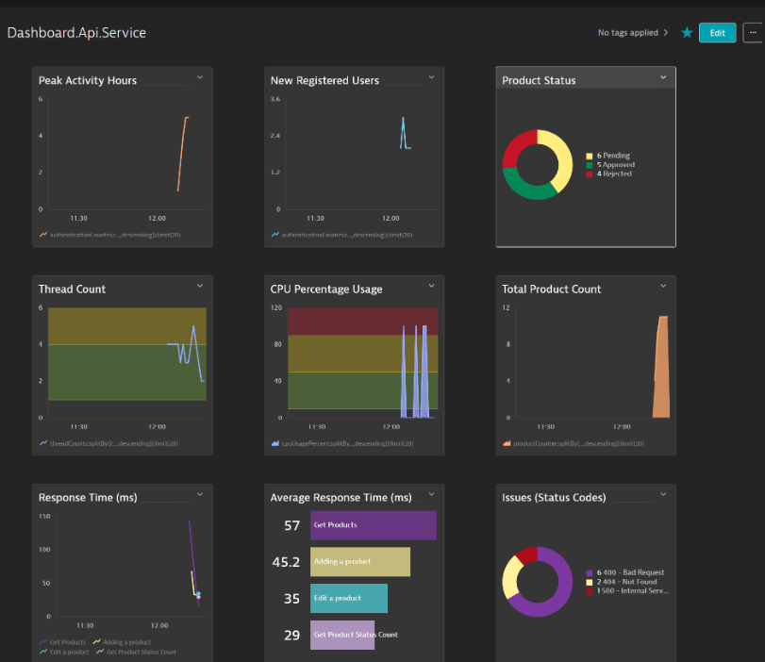

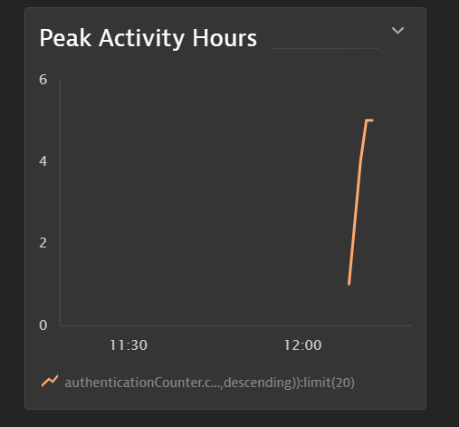

Peak Activity Hours – Time Interval at which we get the maximum peak usage of our application by registered users

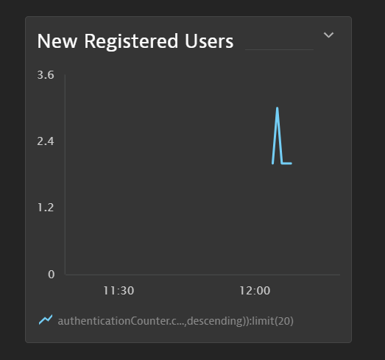

New Registered Users – New Users registering in our application in a particular time frame

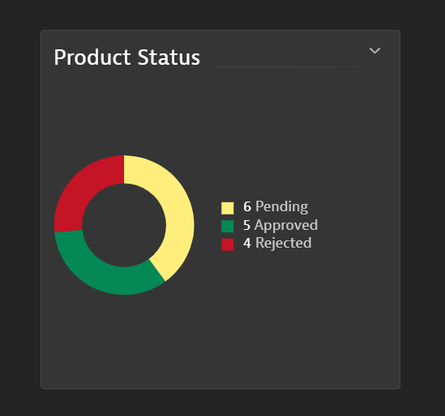

Product Status – Displaying the products with Status Distribution

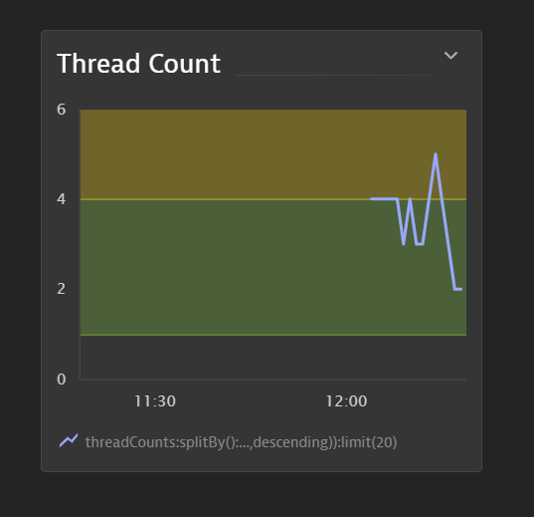  
  
Thread Count – Number of Threads used by our application, the safe threads that can be used by our application is 4, if it uses more than 4 then it’s a warning and if it uses more than 10 then this would be dangerous for our application

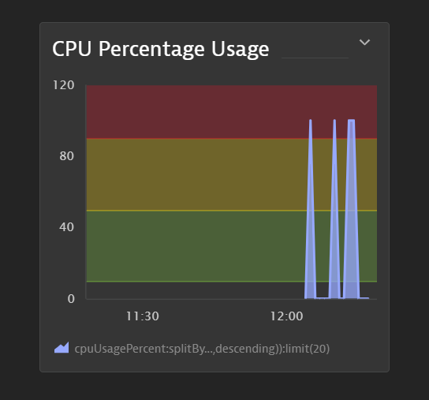

CPU Percentage Usage – It refers to the **portion of our processor’s total capacity** being used at a given moment, expressed as a **percentage**.

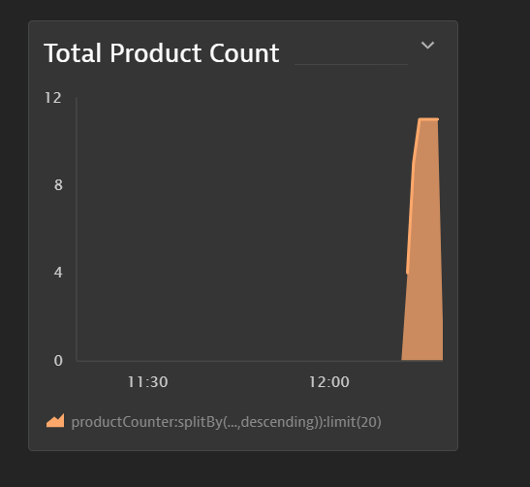

Total Product Count – The number of products added to our system irrespective of their status

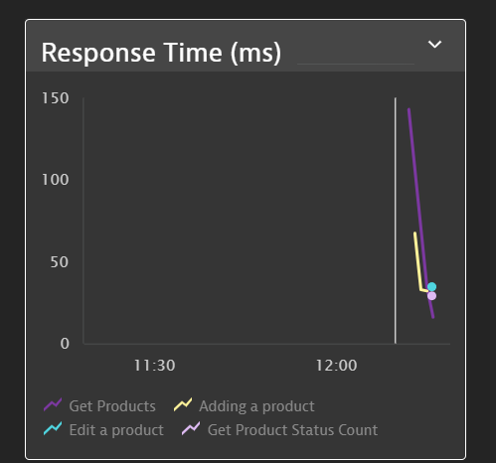  
Response Time – Displaying the time taken per request whenever they are called.

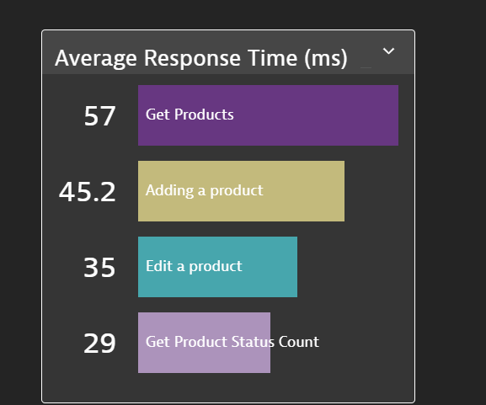

Average Time Request – Average Response for each request.

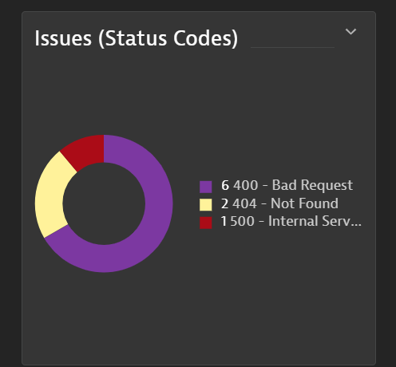

Issues – Number of issues that our applications give while using it.