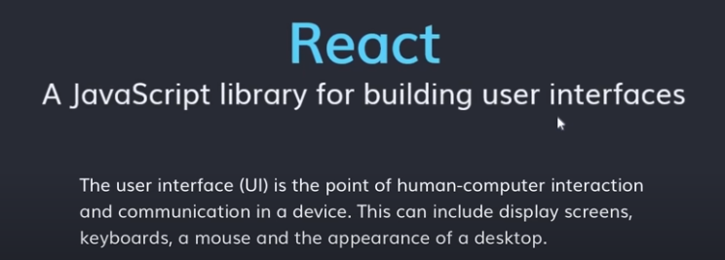

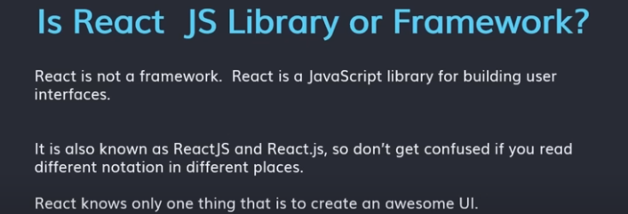

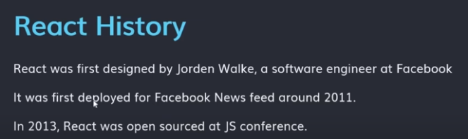

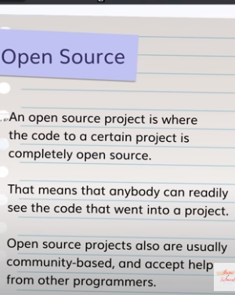

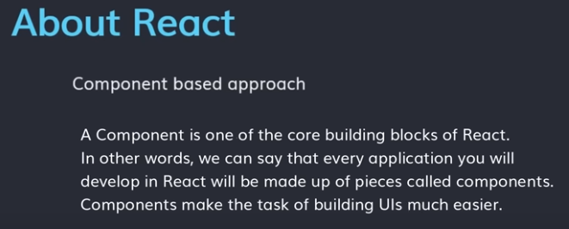

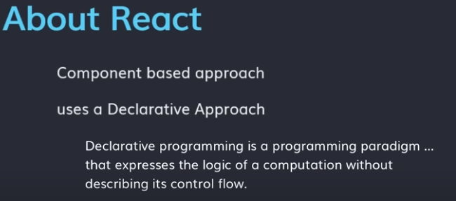

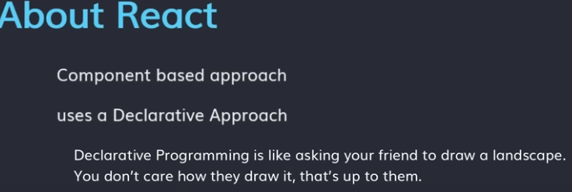

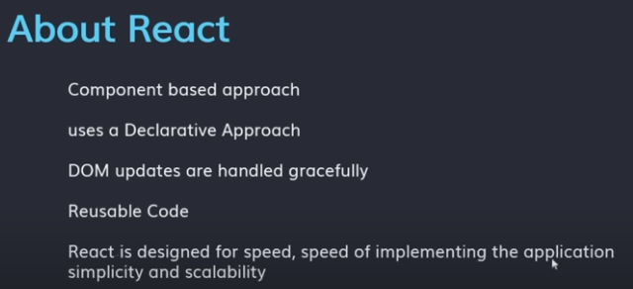

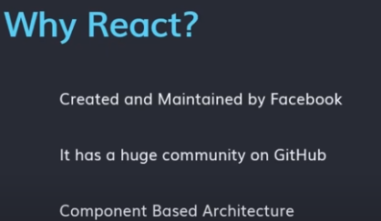

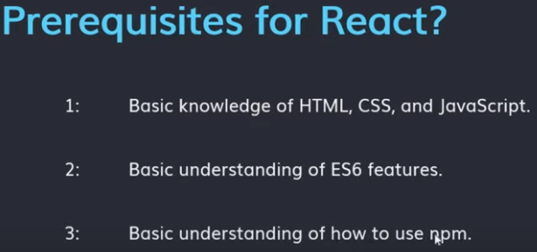

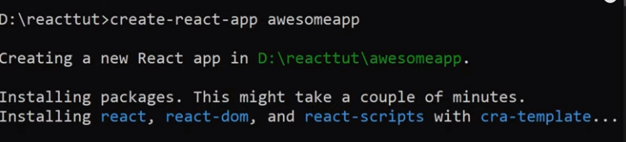

package .json humara metadata store karta hai.aur uss par kitne dependenices hai iss file ki madad se hum apne project kokisi se bhi share kar sakte hai toh yeh json file bht important hai react ke liye

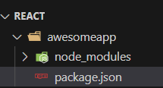

react ke liye hum eek server chaiye jiska nam npm hai

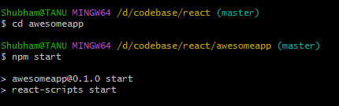

npm start karne par hume localhost3000 open karke deta hai

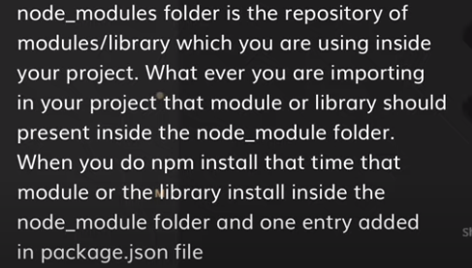

now start react code:

so for react hume do module hmesha import karane chaiye then render function (render means dikhao)



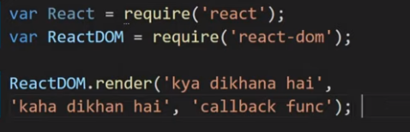

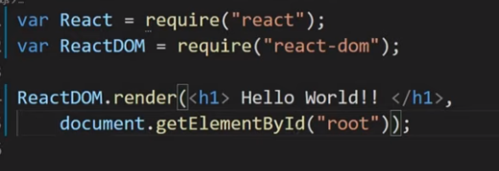

with the help of babel we write the code in simple format

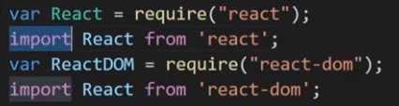

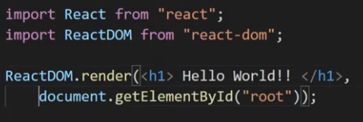

introduction on JSX: jsx full form is javascript extension or java script XML

<h1> HELLO WORLD </h1>

this is not a html in react it is a JSX. agarhume jsx ko import karna ho toh hume react module ko import karna hi hota hai. hum react dom module ko isliye import karte hai kyuki hume render method ki jarurat hai.

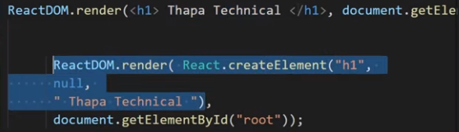

jsx humare code ko complie karke ek line ke code me convert karta hai

render ke anadar multiple jsx ko enter karna ha otoh hum use wrap karte hai div ke andar.

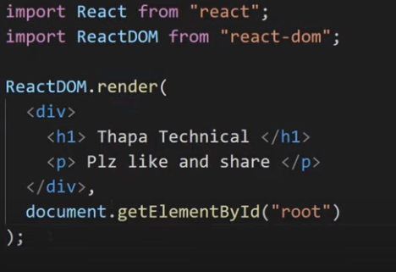

agar div nahi lagana ho toh hum as a array bhi pass kar sakte hai.

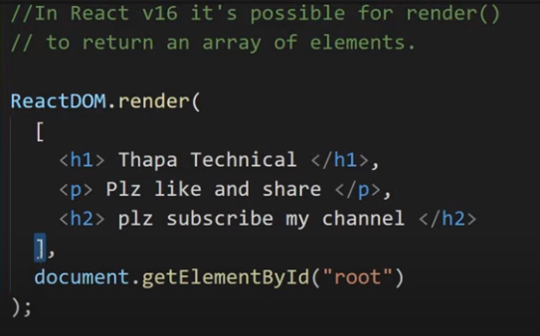

React Fragment: isko bhi hum use kar sakte hai div and array ki jagah because react fragment se extra div remove ho jata hai aur hmare code ki speed aur fast ho jati hai and its consume less memory.

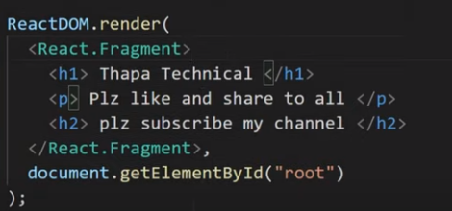

aga hum react fragment nahi likh pa rahe toh simply hum <> </> yeh hi likh kar chor sakte hai

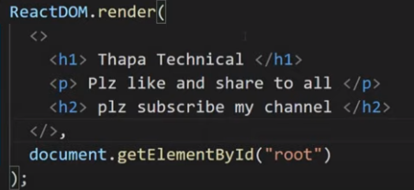

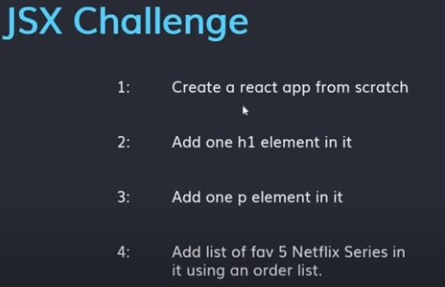

JSX Expression in React:

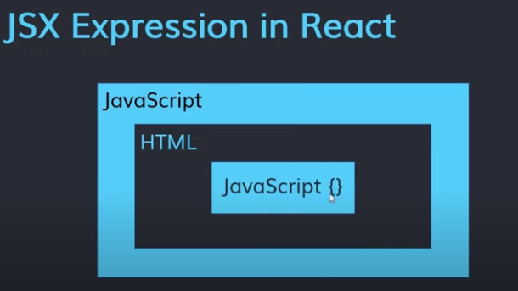

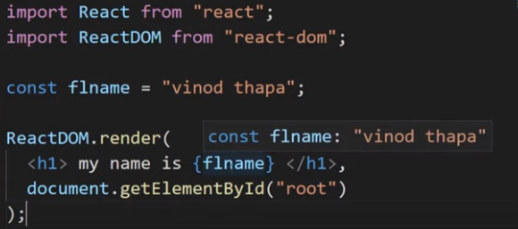

Template literals:

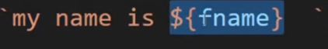

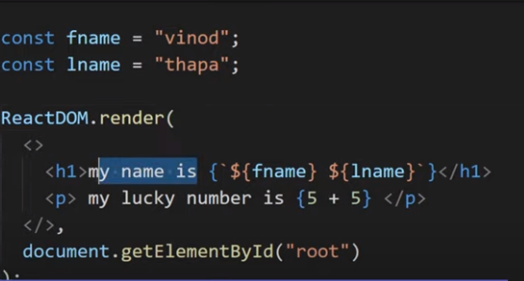

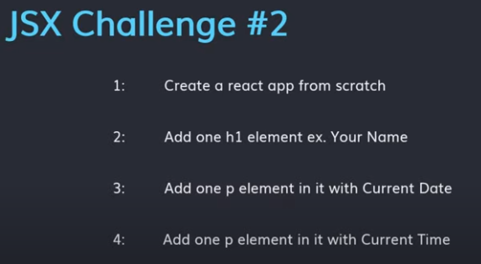

JSX Attribute: this highlighted one is called attribute.

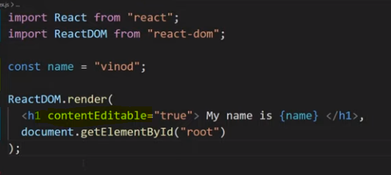

using underscore we move to next page.

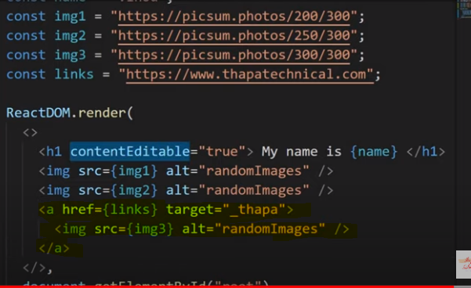

IMPORT CSS STYLING IN REACT: for importing we use below

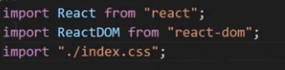

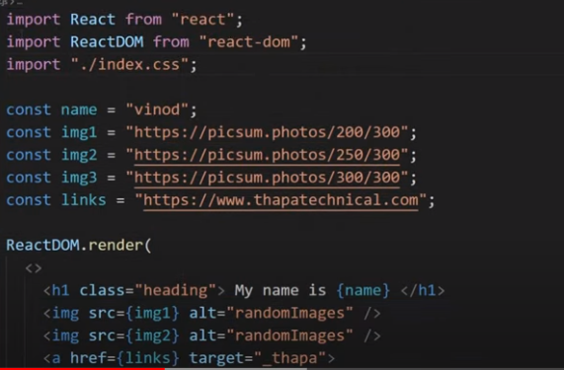

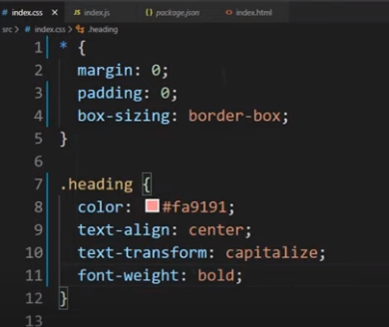

in react we don’t use class because react ke pass class already reserve hai toh hum class ki jagah className kar sakte hai .

GOOGLE FONT:

first we need to seacrch in browser google font and then copy the google font link and paste it into index.html(head) part and then css font copy and paste it into index.css file.

