KHWOPA SECONDARY SCHOOL
DEPARTMENT OF COMPUTER SCIENCE
Dekocha-6, Bhaktapur

A PROJECT REPORT ON
“SPACE INVADER”

A report submitted for the partial fulfillment of the requirement for the degree of
NEB on Computer Science

Submitted by:
Aman Manandhar (503)
Rajwol Shrestha (579)
Sushan Shrestha (598)
Raju Thakur (529)
Submitted to:
Computer Science Department
Khwopa Secondary School
Dekocha-6, Bhaktapur

UNDER THE GUIDANCE OF
Er. Pujan Changubhari
Date of submission:2080/12 /01

DEPARTMENT OF COMPUTER SCIENCE
KHWOPA SECONDARY SCHOOL
DEKOCHA-6, BHAKTAPUR

CERTIFICATE
This is to certify that the project entitled “Space Invader” submitted by Mr. Aman Manandhar, Mr. Rajwol Shrestha, Mr. Sushan Shrestha and Mr. Raju Thakur in partial fulfillment of the requirements for the internal marks of Computer Science in NEB (Nepal Education Board) Class 12 (XII), is a real work to the best of my knowledge and may be placed before the Examination Board for their consideration.

Panel of Examiners:

Name
External Examiner
…………………..
Project Supervisors
Er. Bikash Kumar Chawal

Signature

Date

ACKNOWLEDGEMENT
First and foremost, we would like to thank the Department of Computer Science of Khwopa Secondary School for providing us the opportunity to do this project entitled “Space Invader”. We are also thankful to all who have helped us directly or indirectly with the completion of this project.
We would like to thank our computer teacher Er. Pujan Changubhari for his guidance while developing the project and for organizing the project schedules. Also, we would like to acknowledge his efforts that encouraged us to take on this challenging project. We would also like to offer our gratitude towards our friends who helped us throughout our project development phase by providing several references regarding different links for the code and making of the project report.

ABSTRACT

This project is constructed using HTML,CSS and Java Script . This project focus on use of different types of HTML tags , JS functions and formatting styles using CSS .This is a simple game where we have to control the alien shooting spaceship using left and right arrow and fire bullet upon aliens using spacebar key.. The score upon shotting of alien is displayed on the top right corner of the screen.
This project mainly focus on how we and implement different types html tags , java script functions and css for realistic application in game development.
The code utilizes event listeners to capture keyboard inputs for controlling the spaceship and firing bullets. It also incorporates collision detection mechanisms to determine interactions between bullets and aliens, resulting in score updates and alien elimination. The game includes a restart button to reset the game state after a game over scenario.

Overall, the provided Space Invaders game code serves as a foundation for a classic and engaging gaming experience, demonstrating fundamental principles of HTML5 Canvas and JavaScript game development.

TABLE OF CONTENTS
Contents
ACKNOWLEDGEMENT 2
ABSTRACT 3
INTRODUCTION 5
1.1BACKGROUND 5
1.2OBJECTIVES 5
1.3APPLICATIONS 5
1.4 SCOPE AND LIMITATIONS 6
METHODOLOGY 7
BLOCK DIAGRAM REPRESENTING THE CODE EXECUTION PROCESS 8
TOOLS AND PLATFORM 9
DISCUSSION AND CONCLUSION 10
I. DISCUSSION 10
II. CONCLUSION 10
(I)APPENDIX-1 11
(I)Appendix-2 12
(III)APPENDIX-3 13
REFERENCES 22

INTRODUCTION

1.1BACKGROUND
The game development project at hand is an immersive and engaging web-based adaptation of the iconic arcade game, "Space Invaders." This classic title, originally released in the late 1970s, has been reimagined and brought to life using a combination of HTML, CSS, and JavaScript technologies.

The primary objective of this project is to provide users with a modern and interactive gaming experience reminiscent of the retro Space Invaders era. The game leverages the capabilities of web development to create a visually appealing and dynamic environment, allowing players to navigate a spaceship, shoot bullets, and confront waves of descending alien invaders.

The HTML structure defines the game board through a canvas element, and CSS is employed for styling to enhance the visual presentation. The JavaScript component is pivotal in orchestrating the game's logic, including the movement of game elements, collision detection, scoring, and user interaction.

1.2OBJECTIVES
- To be familiar with the use of java script in realistic manner.
- To entertain people using a simple game
- To be able to design a simple application by the use of JavaScript codes

1.3APPLICATIONS
- To entertain people with game within a short time

1.4 SCOPE AND LIMITATIONS
The first and foremost things are our country is lacking on the development of internet and skilled programmers. So the scope of our project is to make everyone an eligible programmer and able to design software, applications in our own country.
The limitations are people don’t have computers in their home to practice programming and familiar with it. The game that I have designed is only fruitful for Laptop and PC not in mobile phones.

METHODOLOGY

The main technique used for development of this game is waterfall model of software development. The waterfall model is a breakdown of development activities into linear sequential phases, meaning they are passed down onto each other, where each phase depends on the deliverables of the previous one and corresponds to a specialization of tasks. The approach is typical for certain areas of engineering design. In software development, it tends to be among the less iterative and flexible approaches, as progress flows in largely one direction ("downwards" like a waterfall) through the phases of conception, initiation, analysis, design, construction, testing, deployment and maintenance. The waterfall model is the earliest SDLC approach that was used in software development.

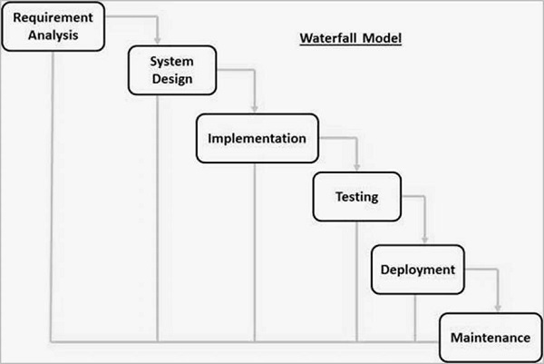

BLOCK DIAGRAM REPRESENTING THE CODE EXECUTION PROCESS

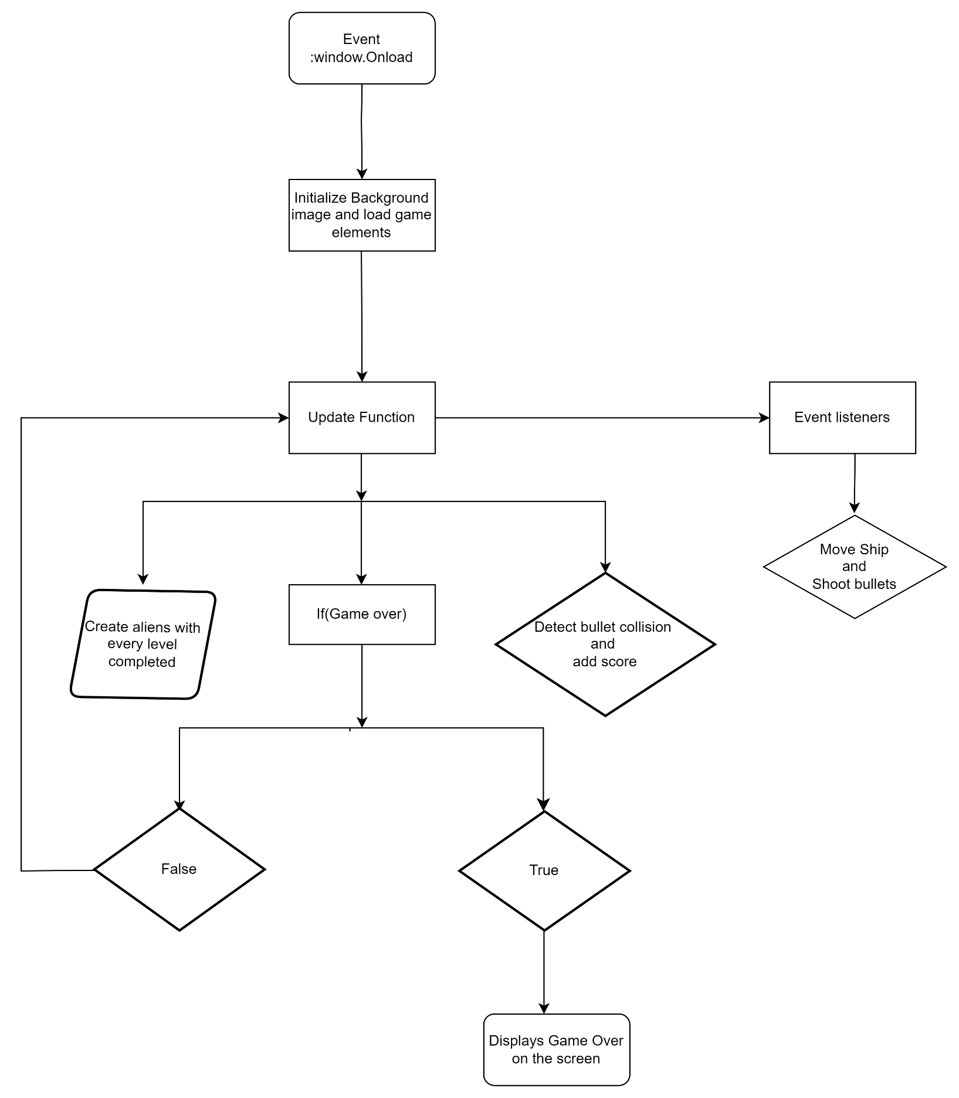

TOOLS AND PLATFORM
We have used Visual Studio Code (VS Code ) for coding the overall game which is the widely used platform for editing HTML and Java Scripts files. This Space Invaders game is developed using HTML, CSS, and JavaScript, making it a web-based game. The different types of extensions available on vs code makes the coding easier and smooth running of output.
The overall project is done in MS Word which is the most powerful text documenting application.

DISCUSSION AND CONCLUSION

I. DISCUSSION
By doing this project we are able to make a web based space invader game. Through this project we were able to learn to utilize functions in java script and different html elements to create a practical application. The game incorporates fundamental concepts such as canvas rendering, user input handling, collision detection, and game logic.

II. CONCLUSION
The game features a player-controlled spaceship that can move horizontally, shoot bullets, and engage with a dynamic alien fleet. The alien movement pattern, bullet interactions, and scoring system add depth to the gameplay. The visuals are simple yet effective, utilizing images for the spaceship and aliens, enhancing the overall gaming experience.
The game provides a responsive design, ensuring compatibility with different devices and screen sizes. Additionally, it includes a restart button for players to reset the game and try again, promoting engagement and replayability. Overall, this Space Invaders game project serves as an educational and entertaining resource for those looking to understand the basics of game development using web technologies.
APPENDIX

(I)APPENDIX-1

- This is the main screen that appears at the first after compiling and running program

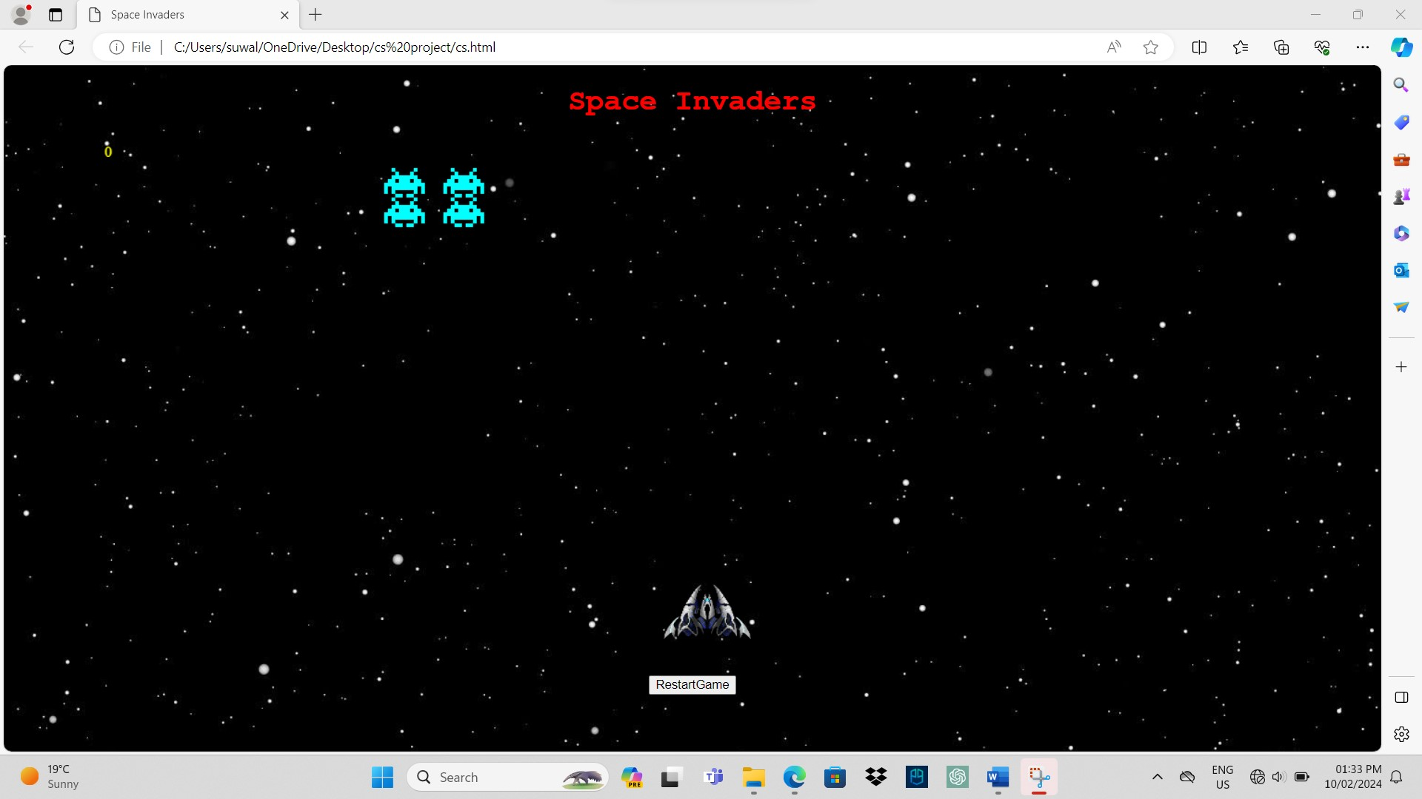

(I)Appendix-2
- This is the screen which appears when game is over

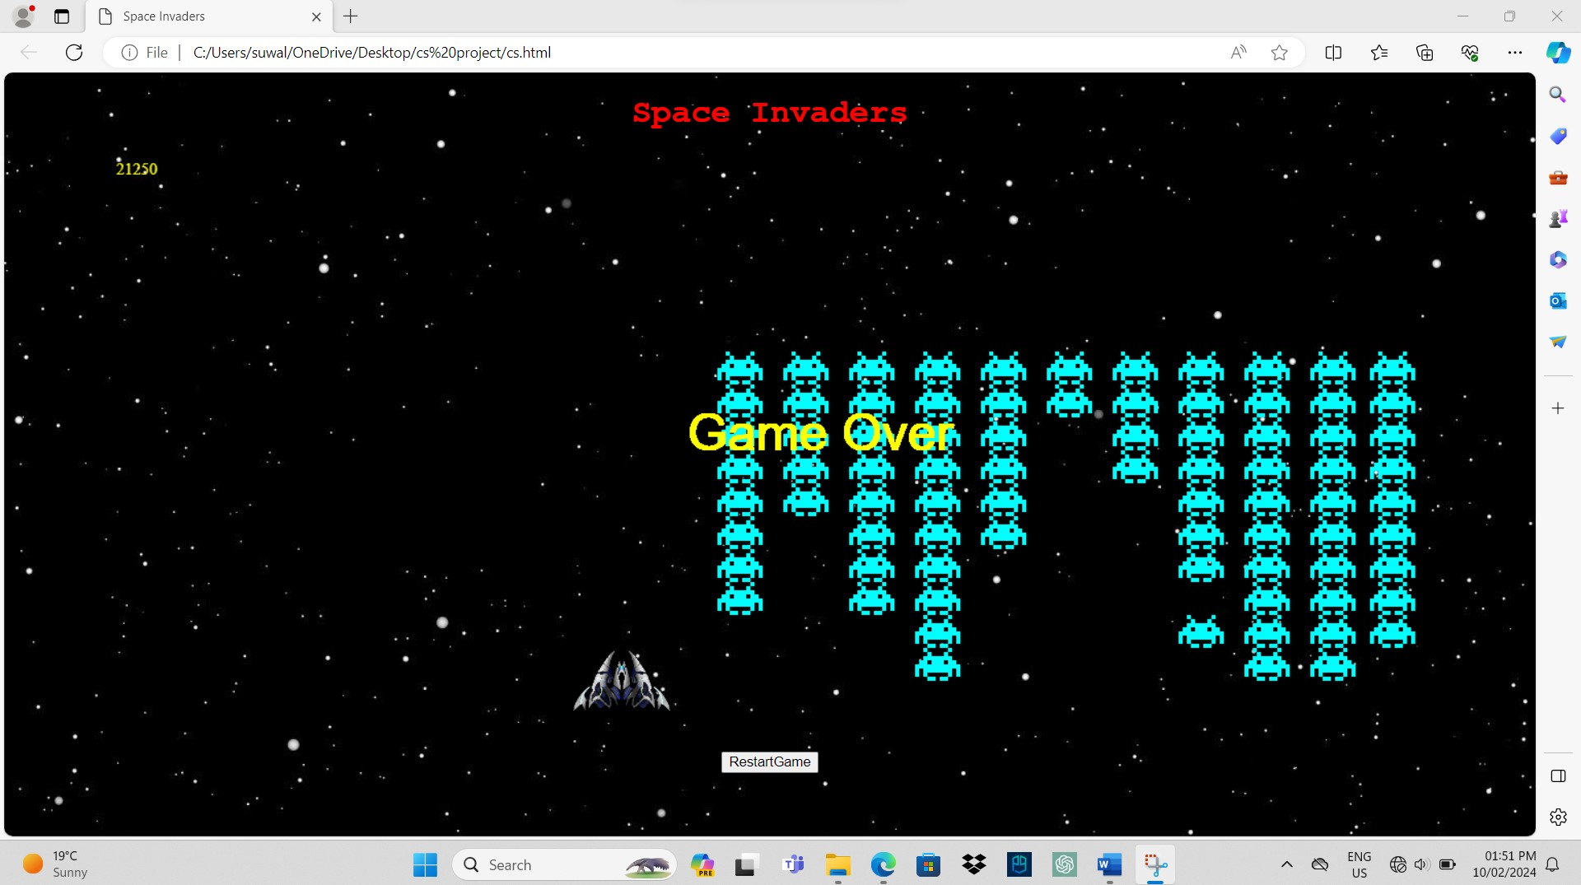

(III)APPENDIX-3
- Game Code
<!DOCTYPE html>
<html>
<head>
<meta charset="UTF-8">
<meta name="viewport" content="width=device-width,initial-scale=1.0">
<title>Space Invaders</title>
<style>
body{
background-image: url(./space.png);
font-family: 'Courier New', Courier, monospace;
text-align: center;
}
</style>
</head>
<body>
<h1 style="color: red; text-decoration: wavy;">Space Invaders</h1>
<canvas id="board"></canvas>
<div><input type="button" onclick="restartGame()" value="RestartGame"></div>

<script type="text/javascript">
//board element
let tilesize=32;
let rows=18;
let columns=40;

let board;
let boardWidth=tilesize*columns;//32*40
let boardHeight=tilesize*rows;//32*18
let context;

//ship
let shipWidth=tilesize*3;
let shipHeight=tilesize*2;
let shipX=tilesize*columns/2 - tilesize;/*it fix the x coordinate i.e horizontal alignment of the ship to the center of the board (384)*/
let shipY=tilesize*rows -tilesize*3;/*it fix the y coordinate i.e vertical alignment of the ship to the center near the bottom of the game board, leaving some space at the bottom(448)*/

let ship={
x:shipX,
y:shipY,
width :shipWidth,
height :shipHeight
}
let shipImg;
let shipVelocityX=tilesize; //ship moveing speed along x -axis
//aliens
let alienArray=[];
let alienWidth=tilesize*2;/*these are the codes to define alien variables with alien count initial counting of the alien rows and size of the alien*/
let alienHeight=tilesize;
let alienX=tilesize;
let alienY=tilesize;
let alienImg;

let alienRows=2;//initialize the number of alinens in rows default by 2
let alienColumns =2;
let alienCount=0;//it defines number of aliens to be knocked out
let alienVelocityX=1;//sets the alien moving speed

//bullets
let bulletArray=[];
let bulletVelocityY=-10;//specifies bullet speed

//score
let score=0;
let gameover=false;

//explosionImg
let explosionImg = new Image();
explosionImg.src = "./explosion.png";

//shootsound
let shootSound;

window.onload=function(){
board=document.getElementById("board");//calls on board id to load the board info
board.width=boardWidth;
board.height=boardHeight
context = board.getContext("2d"); //used for drawing on the board

//drawing ship onloading the html page
shipImg=new Image();
shipImg.src = "./spaceship.png";
shipImg.onload=function(){
context.drawImage(shipImg,ship.x,ship.y,ship.width,ship.height);//draws ship image on the canvas with provided info
}
//loading the alien on loading the page
alienImg =new Image();
alienImg.src = "./alien-cyan.png";
createAliens();

requestAnimationFrame(update);
document.addEventListener("keydown",moveShip);/*it is used to receive the event or keys being pressed and calls the moveship function for the action*/
document.addEventListener("keyup",shoot);
document.getElementById('restartButton').addEventListener('click', restartGame);
}
//functions used
function update(){
requestAnimationFrame(update);
/* if(gameover){
return;
}*/
if (gameover) {
context.fillStyle = "yellow";
context.font = "50px Arial";
context.fillText("Game Over", boardWidth / 2 - 80, boardHeight / 2);
return;
}
context.clearRect(0,0,board.width,board.height);//clears the canvas when the ship moves left or right
//ship
context.drawImage(shipImg,ship.x,ship.y,ship.width,ship.height);
//alien
for(let i=0;i<alienArray.length;i++){
let alien=alienArray[i];
if(alien.alive){
alien.x+=alienVelocityX;//increases alien velocity with 1 of INITIAL VELOCITY
//code to execute if alien touches the borders
if(alien.x+alien.width>=board.width || alien.x<=0)
{
alienVelocityX*=-1;//this line of code helps reverse the direction of velocity
alien.x+=alienVelocityX*2;//it increases the velocity of alien by 2 when it changes row or reverse direction
//move all alien down by one row
for(let j=0;j<alienArray.length;j++){
alienArray[j].y += alienHeight;
}
}
context.drawImage(alienImg,alien.x,alien.y,alien.width,alien.height);
if(alien.y>=ship.y){
gameover=true;//here gameover is true if ship and alien y coordinate is same
}
}
}
//bullets
for(let i=0;i < bulletArray.length;i++){
let bullet=bulletArray[i];
bullet.y+=bulletVelocityY;
context.fillStyle="red";
context.fillRect(bullet.x,bullet.y,bullet.width,bullet.height);

//bullet collidion check
for(let j=0;j<alienArray.length;j++){
let alien=alienArray[j];
if(!bullet.used && alien.alive && detectCollision(bullet,alien))//it checks and decrease alien count by 1 if alien is not alive and bullet is used
{
explode(alien); // Trigger explosion effect
bullet.used=true;
alien.alive=false;
alienCount--;
score+=50;//increase score by 50 of the initial if the alien count decrease by 1
}
}
}
//clear bullets
while(bulletArray.length>0 && (bulletArray[0].used || bulletArray[0].y<0)){
bulletArray.shift();//removes the bullets after passing canvas
}
//next level
if(alienCount==0){
//increasing the number of aliens in comumns and rows by 1
alienColumns=Math.min(alienColumns+1,columns/2-2);//for increasing alien column i.e(26/2-2=11)at most no.of aliens columns
alienRows=Math.min(alienRows+1,rows-4);//for increasing rows i.e max (16-4=12)rows is possible
alienArray=[];
bulletArray=[];
createAliens();
}
//score
context.fillStyle="yellow";
context.font="16px aerial";
context.fillText(score,5,20);//it is for x and y coordinate of score to be depicted in canvas

}
function moveShip(e){
if (gameover) {
context.fillStyle = "yellow";
context.font = "50px Arial";
context.fillText("Game Over", boardWidth / 2 - 80, boardHeight / 2);
return;
}
if(e.code == "ArrowLeft" && ship.x-shipVelocityX>=0 )//here we used && operator to prvent the ship move beyond the canvas
{
ship.x -=shipVelocityX;//move the ship on the left with one tile decreasing
}
else if(e.code=="ArrowRight" && ship.x+shipVelocityX+shipWidth<=board.width)//we used the && operator in order to prevent ship go beyond canvas on right side
{
ship.x+=shipVelocityX;//moves ship right with one tile increasing

}
}
function createAliens(){
for (let c=0;c<alienColumns;c++ ){
for (let r=0;r<alienRows;r++)
{
let alien ={
img:alienImg,
x:alienX+c*alienWidth,
y:alienY+r*alienHeight,
width:alienWidth,
height:alienHeight,
alive:true

}
alienArray.push(alien);
}
}
alienCount=alienArray.length;
}
function explode(alien) {
context.drawImage(explosionImg, alien.x, alien.y, alien.width, alien.height);
setTimeout(function() {
alien.alive = false; // Mark the alien as dead after explosion animation
}, 100); // Adjust the timing of explosion
}

function shoot(e){
if (gameover) {
context.fillStyle = "yellow";
context.font = "50px Arial";
context.fillText("Game Over", boardWidth / 2 - 80, boardHeight / 2);
return;
}
if(e.code=="Space"){
//shoot
let bullet={
x: ship.x+shipWidth*15/32,
y: ship.y,
width:tilesize/8,
height:tilesize/2,
used:false
}
bulletArray.push(bullet);

}
}
function detectCollision(a,b){
return a.x < b.x + b.width && //a's top left corner doesn't reach b's top right corner
a.x + a.width > b.x && //a's top right corner passes b's top left corner
a.y < b.y + b.height && //a's top left corner doesn't reach b's bottom left corner
a.y + a.height > b.y; //a's bottom left corner passes b's top left corner
}
function restartGame() {
gameover = false;
score = 0;
ship.x = shipX;
ship.y = shipY;
shipVelocityX = tilesize;
bulletArray = [];
alienRows = 2;
alienColumns = 2;
alienArray = [];
createAliens();
shoot();
update();

}
</script>
</body>
</html>

REFERENCES

- https://github.com/ImKennyYip/space-invaders/commit/950b428dd28ecdffbe3277ac74345633d5bc1c16
- https://www.geeksforgeeks.org/

