**PROJECT 1**

**Input file:**

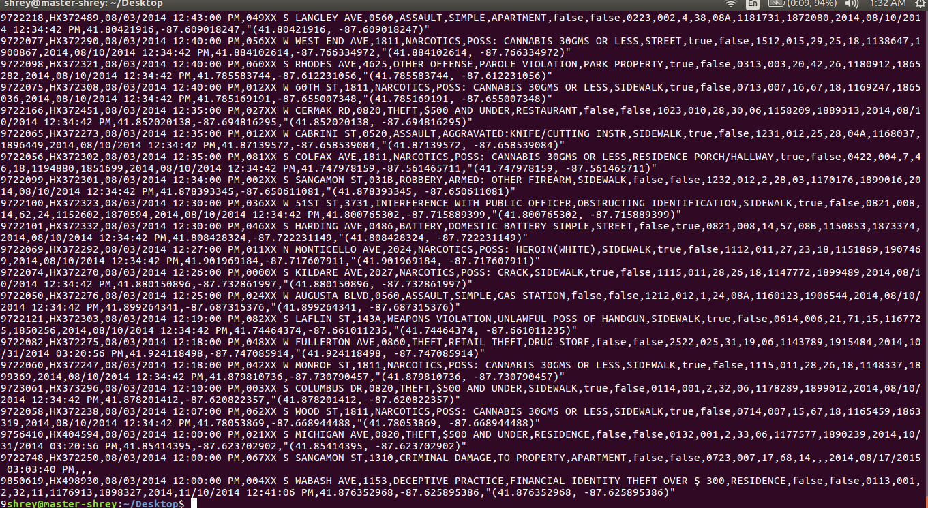

**Using Map Reduce :**

**The driver and the reducer are same for all the parts . Driver -**

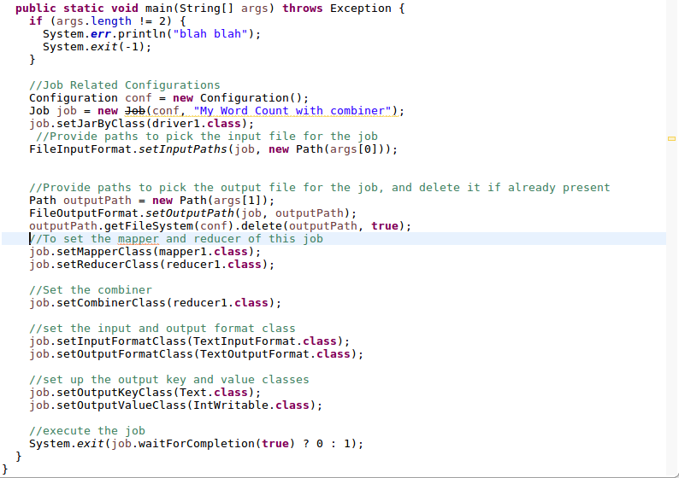

**Reducer:**

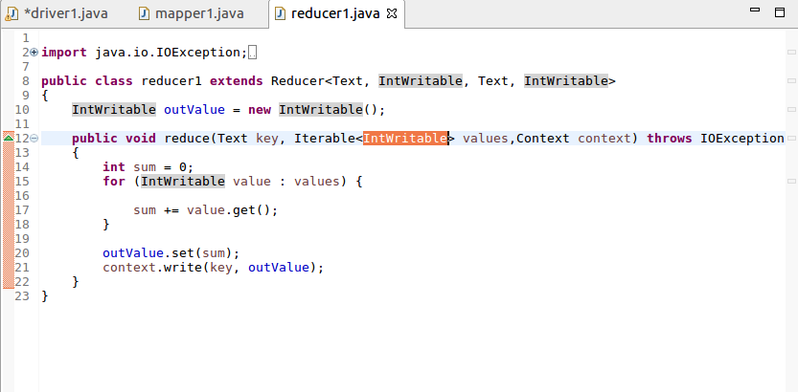

**1.Write a mapreduceand pig program to calculate the number of cases investigated under each FBI code.**

**Mapper :**

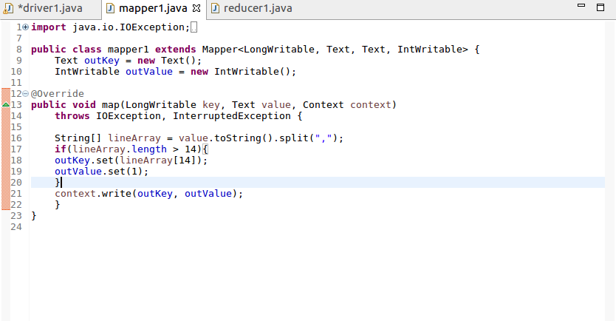

**Output :**

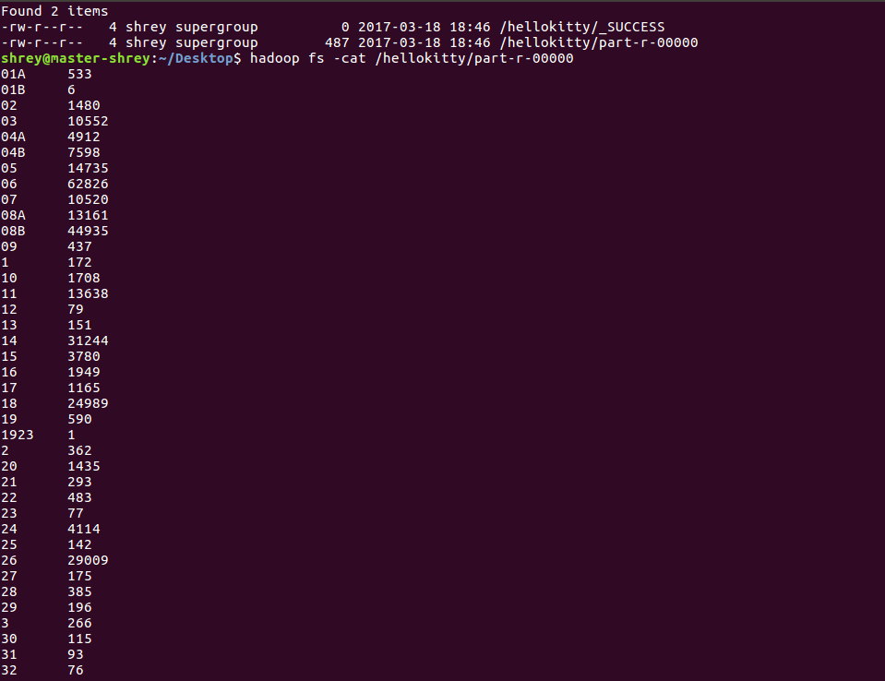

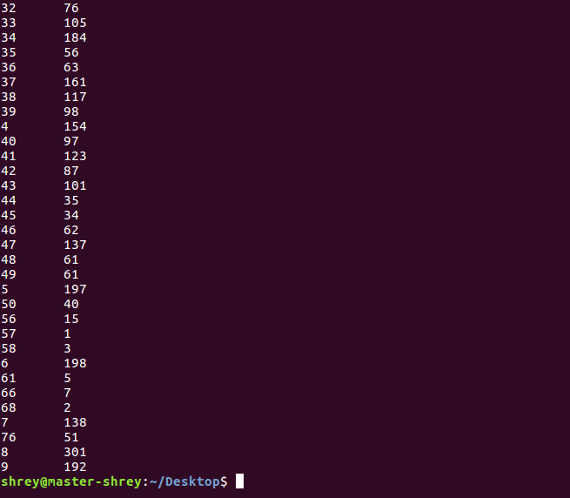

**2.Write a mapreduce and pig program to calculate the number of cases investigated under FBI code 32.**

**Mapper :**

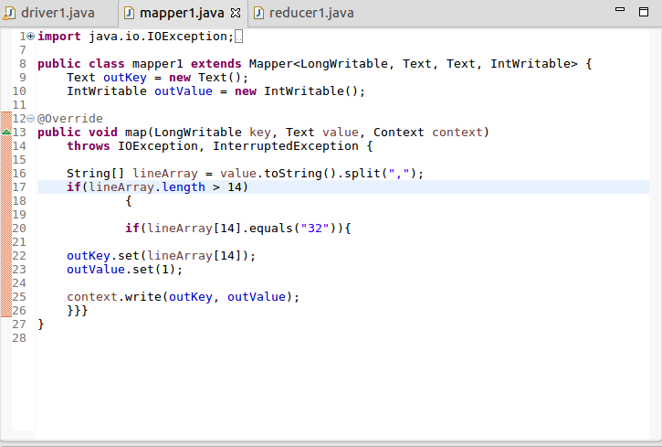

**Output :**

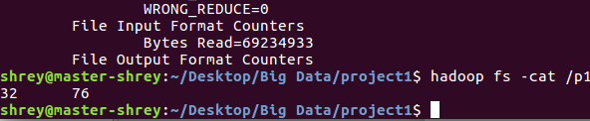

**3.Write a mapreduce and pig program to calculate the number of arrests in theft district wise.**

**Mapper :**

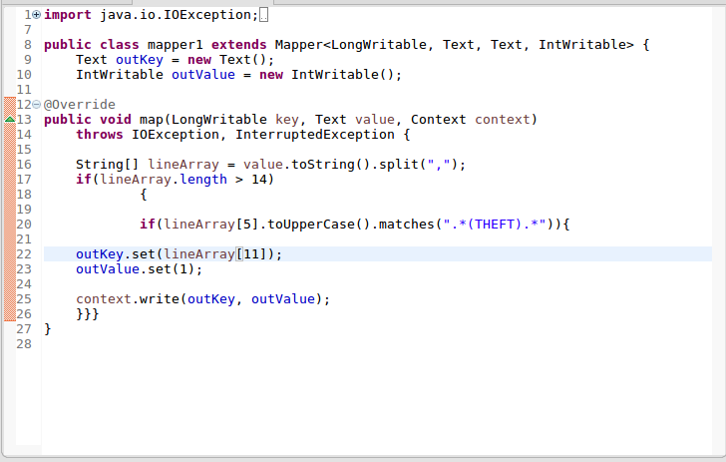

**Output :**

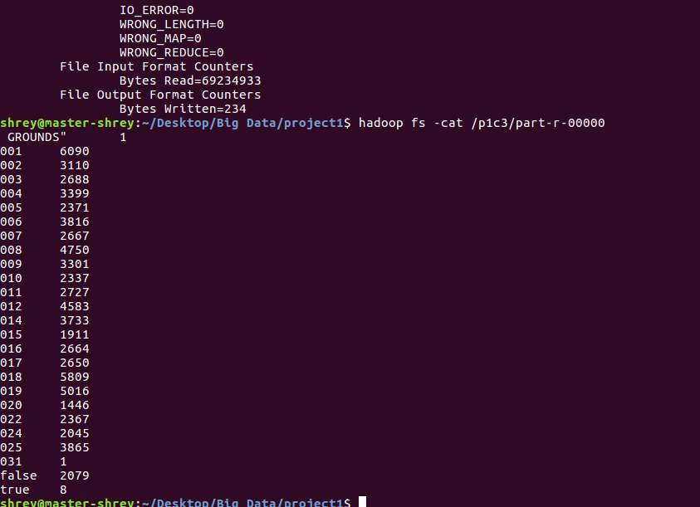

**4.Write a mapreduce and pig program to calculate the number of arrests done between October 2014 and October 2015.**

**Mapper :**

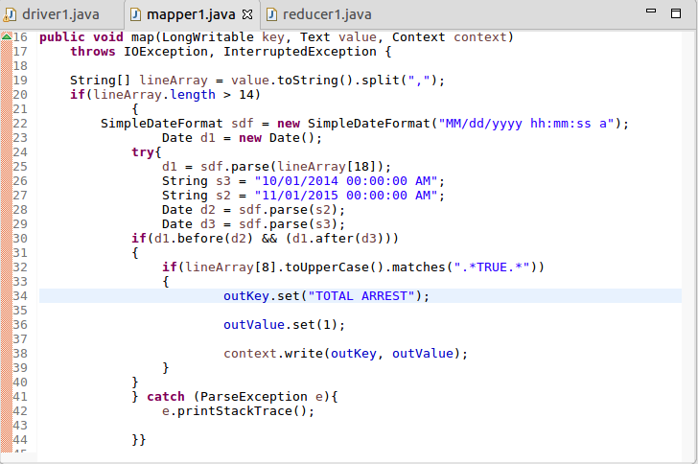

**Output :**

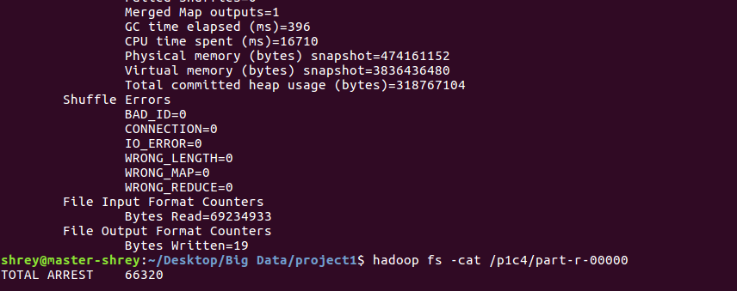

**Solving by Pig -**

**First load the file :**



**Part 1 -**

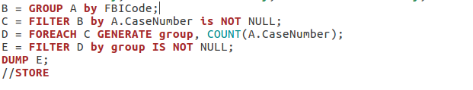

**Output :**

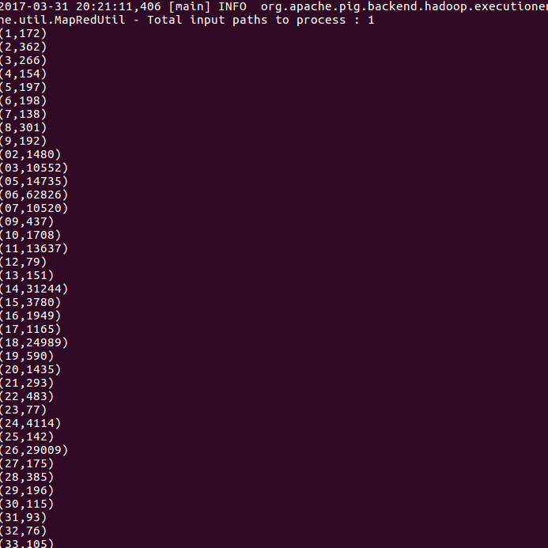



**Part 2 :**

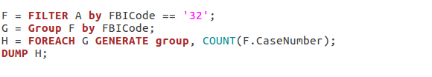**Output :**

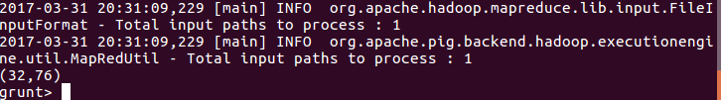

**Part 3 -**

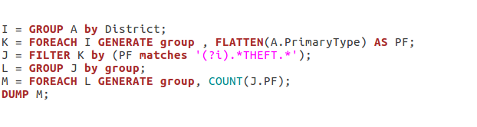

**Output -**

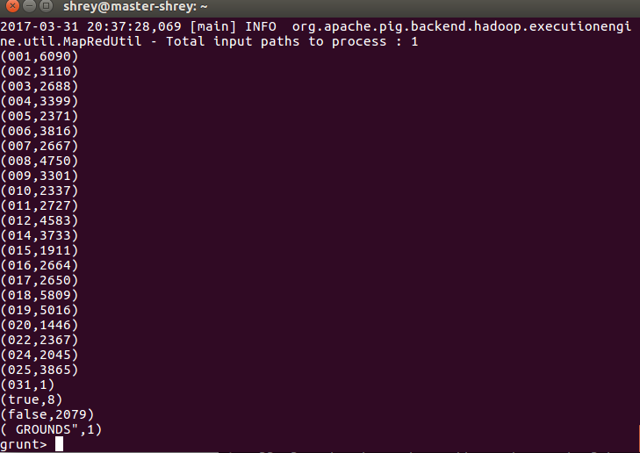

**Part 4 -**

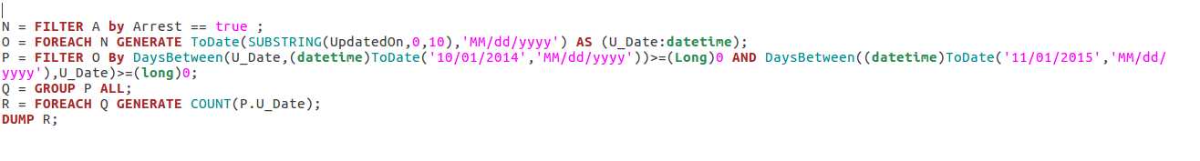

**Output :**

