**Project Part 2**

PIG

1. Write a pig script to find no of complaints which got timely response

INPUT

LOAD THE DATA







OUTPUT



2. Write a pig script to find no of complaints where consumer forum forwarded the complaint same day they received to respective company







OUTPUT



3. Write a pig script to find list of companies topping in complaint chart (companies with maximum number of complaints)



OUTPUT

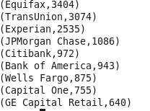

4. Write a pig script to find no of complaints filed with product type has "Debt collection" for the year 2015



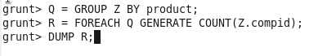

OUTPUT



MAP REDUCE

1. Write a mapreduce program to remove commas present inside the double quotes.



