**PROBLEM STATEMENT:**

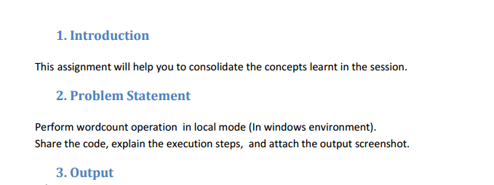

**INPUT DATASET:**

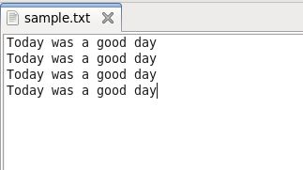

**PROGRAM:**

**DRIVER CLASS :**

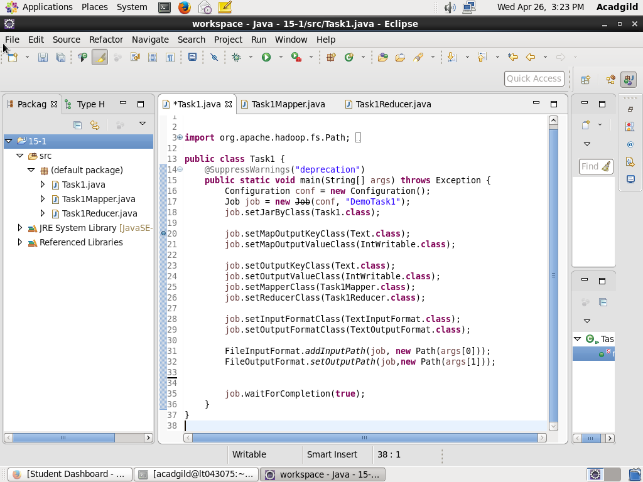

**MAPPER CLASS :**

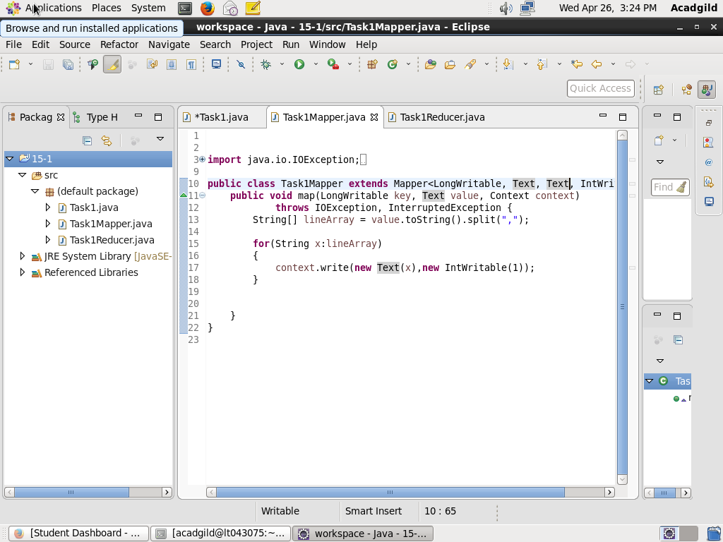

**REDUCER CLASS :**

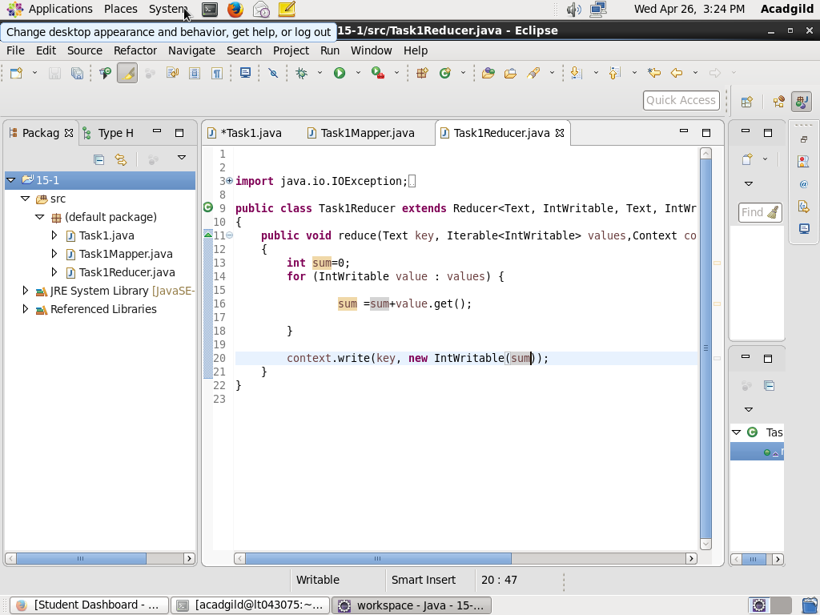

**OUTPUT:**

**ECLIPSE CONSOLE >**

