**ASSIGNMENT 19.2**

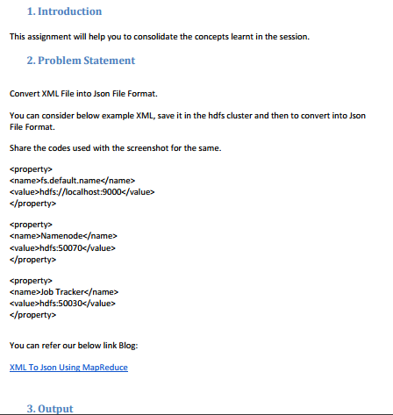

**PROGRAM:**

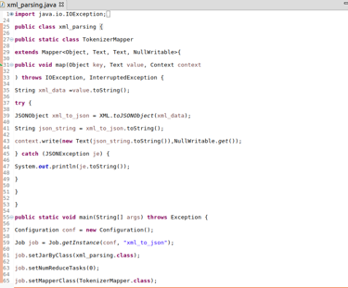

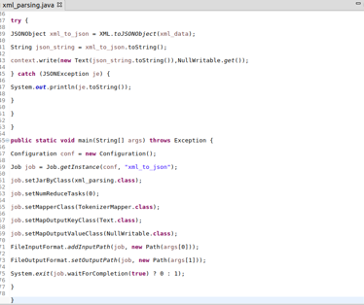

**EXECUTING COMMAND:**

**$ Hadoop jar 19-2.jar /example.xml /19-2**

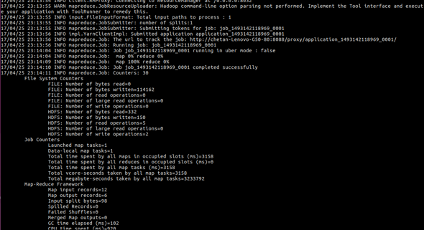

**OUTPUT:**

**$ Hadoop fs –ls /19-2/**



**$ Hadoop fs –cat /19-2/part-m-00000**

