**Assignment 25.1**

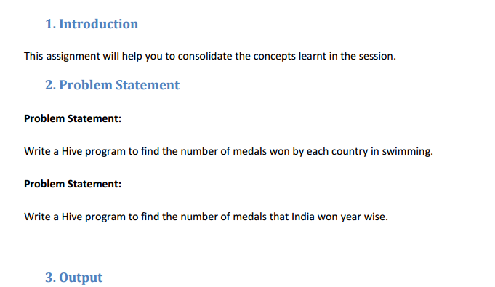

* **First we will create table Olympic_data using create command with name,age,country,year,closing_date,sport,gold_medal,silver_medal ,bronze medal and total as columns.**

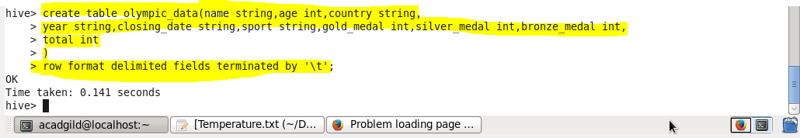

* **We can check our table if created or not using show tables.**

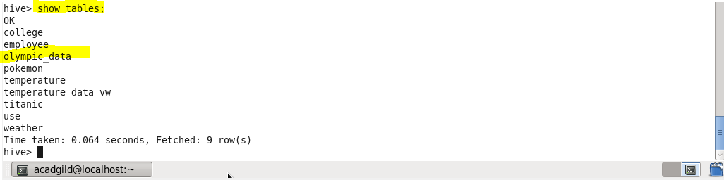

* **now we will load our dataset Olympic_data.csv using LOAD command**

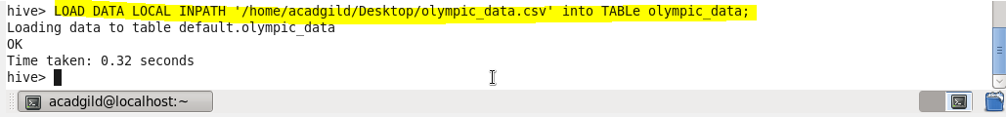

**1.Write a Hive program to find the number of medals won by each country in swimming.**

**- Since we want the number of medals won by each country in swimming so we will group by country and filtered by swimming using where condition**

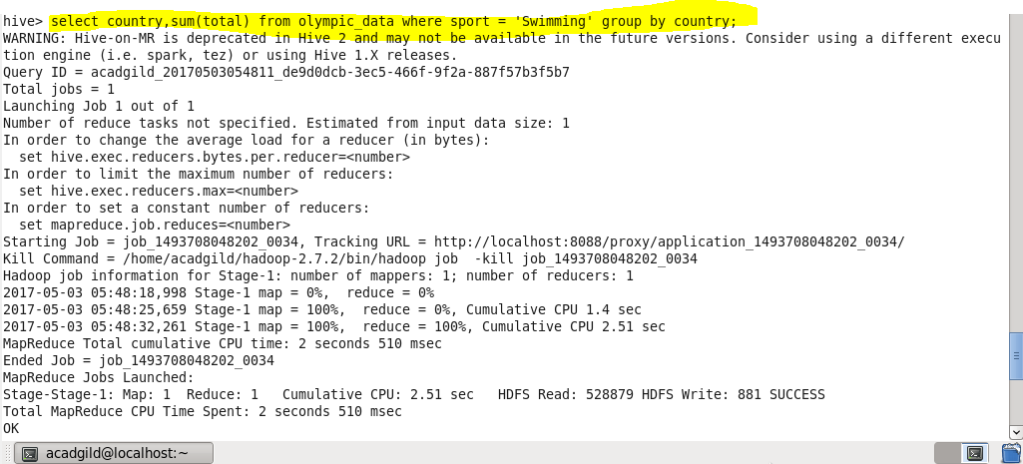

**Output**

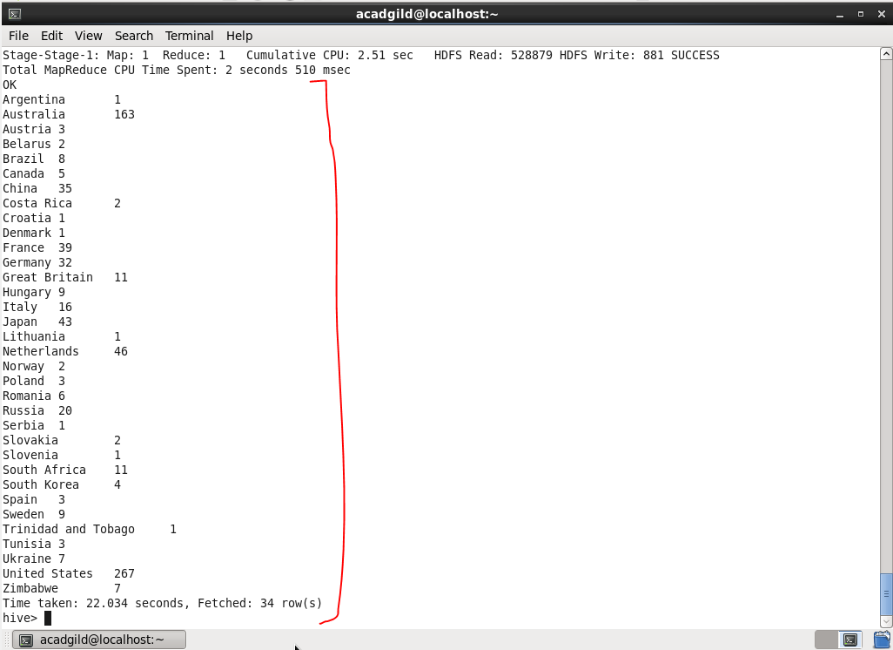

**Q2. Write a Hive program to find the number of medals that India won year wise**

* **Since we want medal won by India year wise , so we will group our result by year and filter by country equal to india using where condition.**

**OUTPUT -**

