**ASSIGNMENT 25.2**

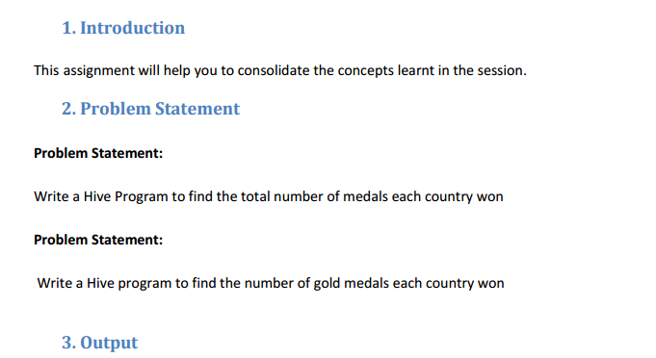

* **First we will create table Olympic_data using create command with name,age,country,year,closing_date,sport,gold_medal,silver_medal ,bronze medal and total as columns.**

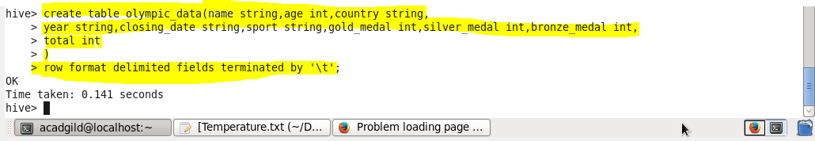

* **We can check our table if created or not using show tables.**

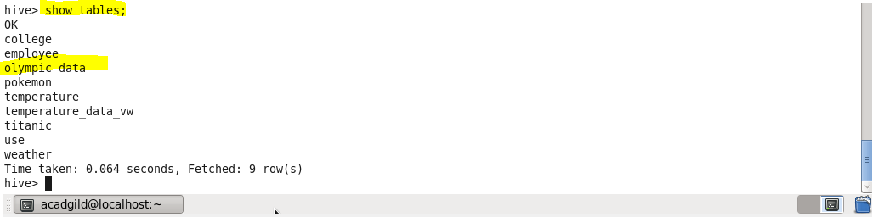

* **now we will load our dataset Olympic_data.csv using LOAD command**

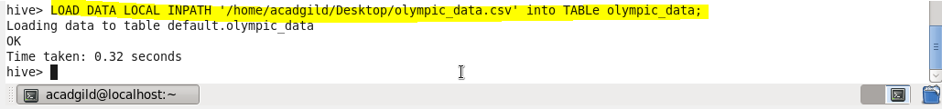

* **Write a Hive Program to find the total number of medals each country won**
* **Since we want to find the total medals won by each country , so we will select the country name and will use sum function so to find the sum of total medals then will group the result by country .**
* 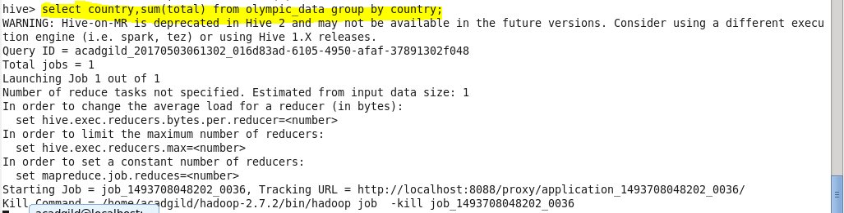
* **Output**

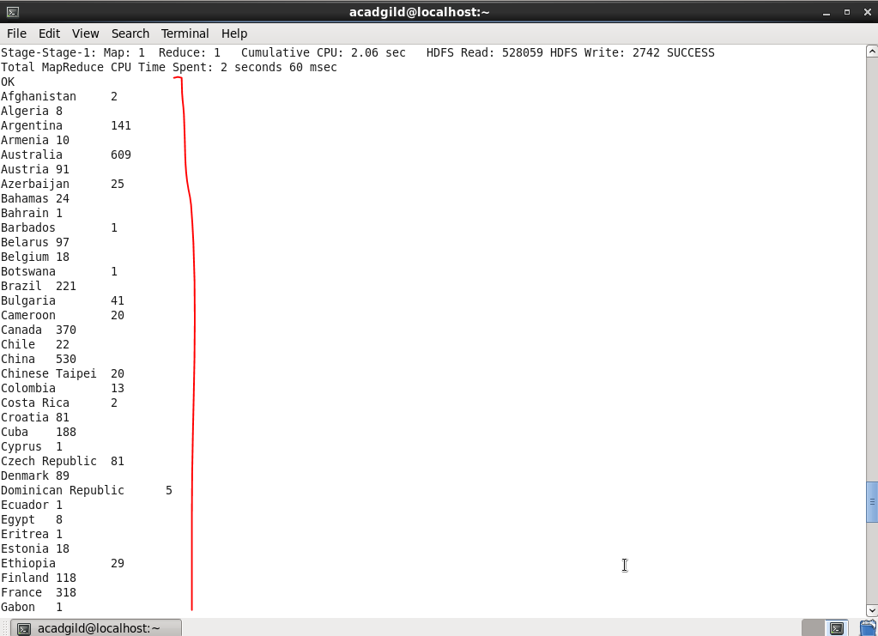

* 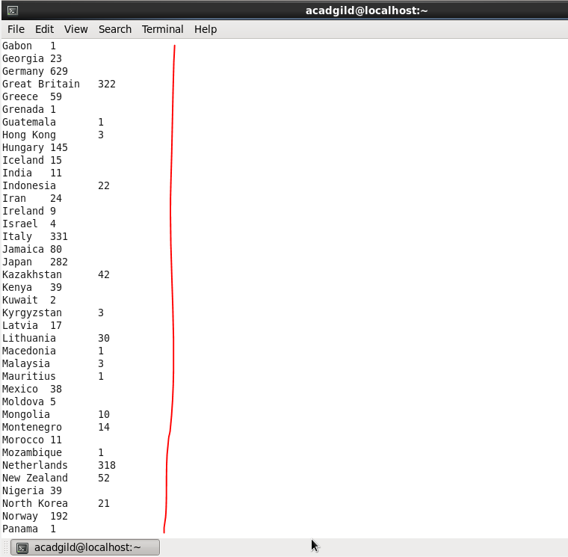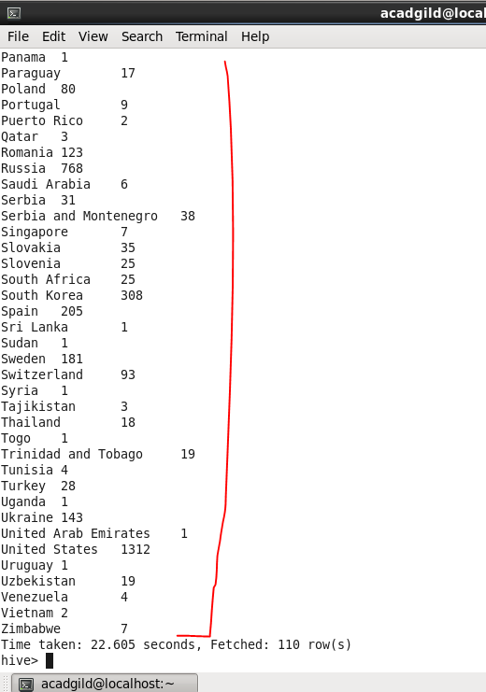
* **Write a Hive program to find the number of gold medals each country won**
* **Since we want to find the gold medals won by country , so we will select the country name and will use sum function so to find the sum of gold medals then will group the result by country**

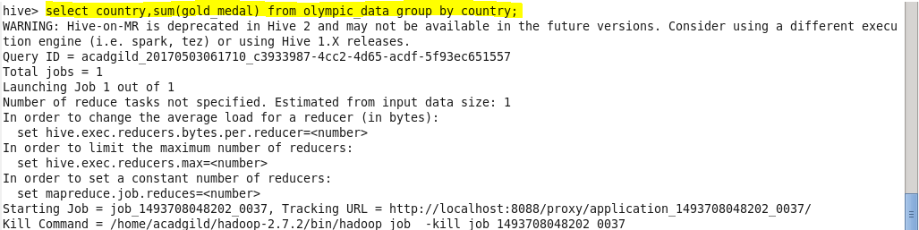

**Output -**

