**Assignment 26.4**

**View in Hive**

* **A view may be used to hide the complexity by dividing the query into smaller, more manageable pieces**
* Hive view is similar to view in other RDBMS. Suppose we have a very long query that consists of multiple join , It will be large and time consuming to read and it will also result in a complex execution and will be difficult to understand the query flow and execution
* View can also be used if we want hide some information to common user
* Since it is a virtual table whenever a view is created only the query gets saved and whenever the view is used again in any other query it just reruns the query and no memory is allocated
* **First for Hive View, we will create a table inside Hive and load the respective data.**
* **Commands for doing so are:**

**Creating and loading data in table cart :**

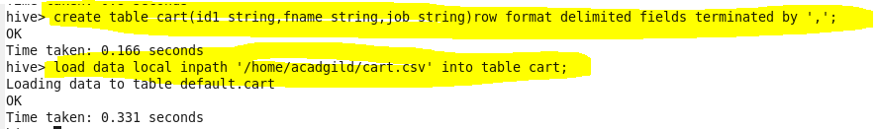

**Creating and loading data in table people:**

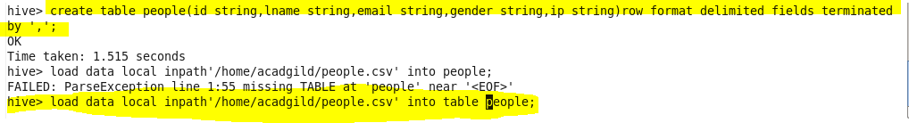

**Let us consider the below join statement**

**FROM (SELECT * FROM people JOIN cart**

**ON (cart.id1=people.id) WHERE last_name=’Henderson’) a**

**SELECT a.first_name WHERE a.id=’40-8340379′;**

* The above query is a nested query where we are joining people and cart and giving a alias name as “a”.Then we are selecting firstname where id is 40-8340379

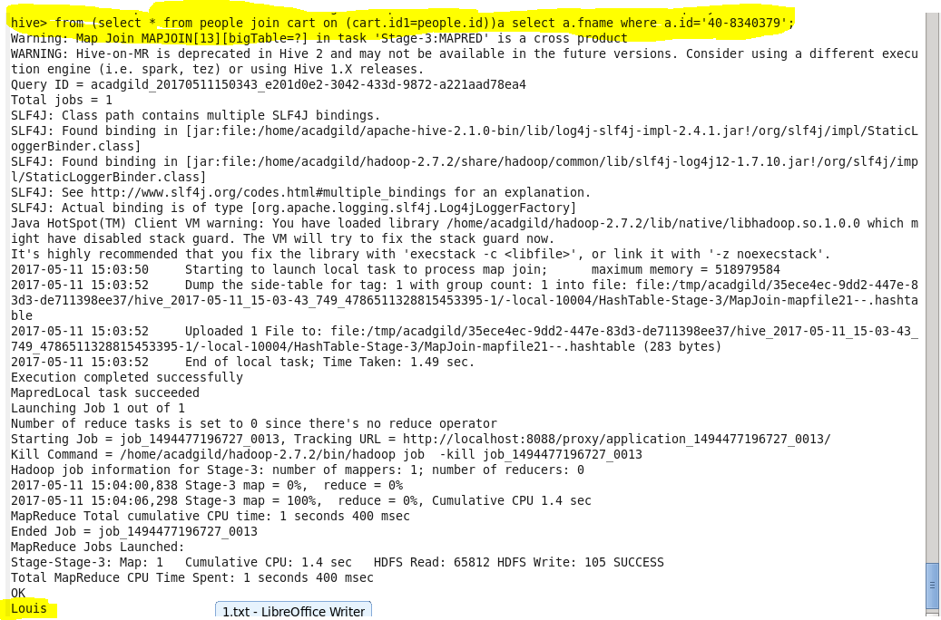

**Instead of using this complicated query we are creating view where we are joining this table as shown**

**Creating view**

C:\Users\612971\AppData\Local\Microsoft\Windows\Temporary Internet Files\Content.Word\26 4 join.png

**Now we are accessing data from this view and selecting the first_name where id=40-8340379**

**Output**

