**Assignment 28.1**

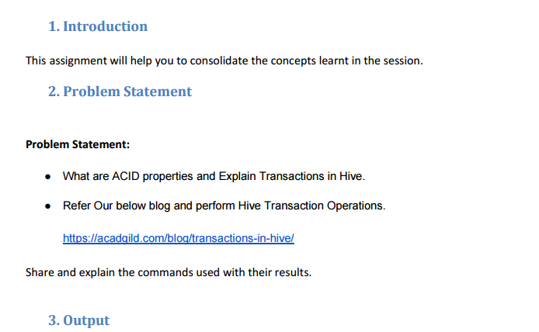

* **What are ACID properties**
* ACID stands for Atomicity, Consistency, Isolation, and Durability.
* ACID properties are important properties of any Transaction in database.A transaction is said to be done in a proper manner only if it obeys the following properties.

**Atomicity:**

Atomicity means, a transaction should complete successfully or else it should fail completely i.e. it should not be left partially.

**Consistency:**

Consistency ensures that any transaction will bring the database from one valid state to another state.

**Isolation:**

Isolation states that every transaction should be independent of each other i.e. one transaction should not affect another.

**Durability:**

Durability states that if a transaction is completed, it should be preserved in the database even if the machine state is lost or a system failure might occur.

These ACID properties are essential for a transaction and every transaction should ensure that these properties are met.

* **TRANSACTIONS IN HIVE:**

Transactions are provided at the row-level in Hive 0.14. The different row-level transactions available in Hive 0.14 are as follows:

1. Insert
2. Delete
3. Update

There are numerous limitations with the present transactions available in Hive 0.14. ORC is the file format supported by Hive transaction. It is now essential to have ORC file format for performing transactions in Hive. The table needs to be bucketed in order to support transactions.

The below properties needs to be set appropriately in ***hive shell***, order-wise to work with transactions in Hive:

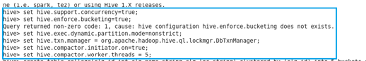

**Hive Transaction Operations**

## Creating a Table That Supports Hive Transactions

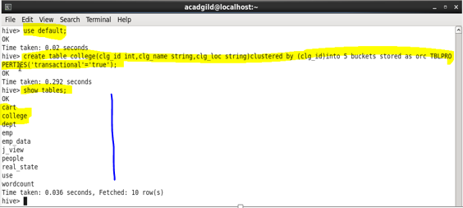

## Inserting Data into a Hive Table

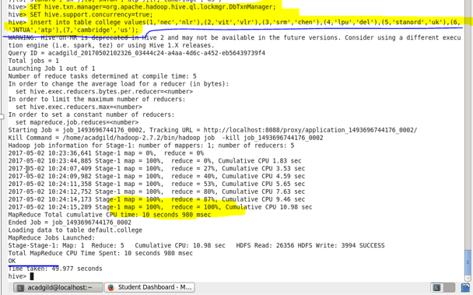

**Output**

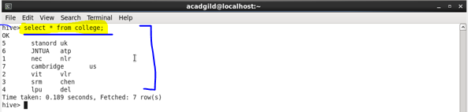

## Updating the Data in Hive Table

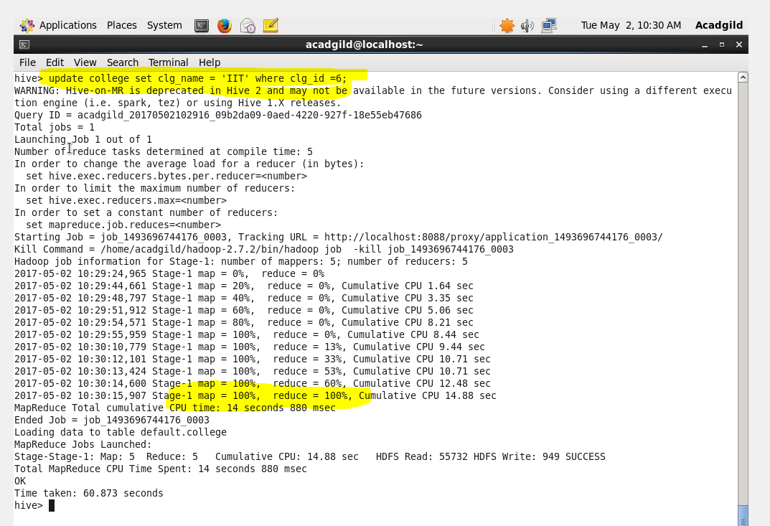

**Output**

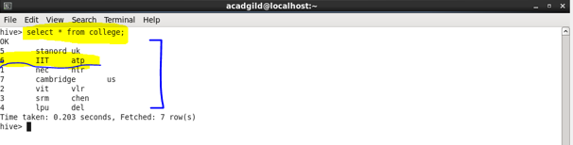

## Deleting a Row from Hive Table

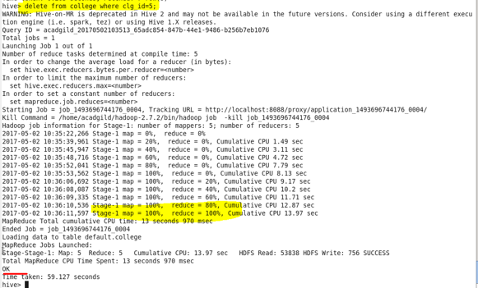

**Output**

