**Assignment 35.1**

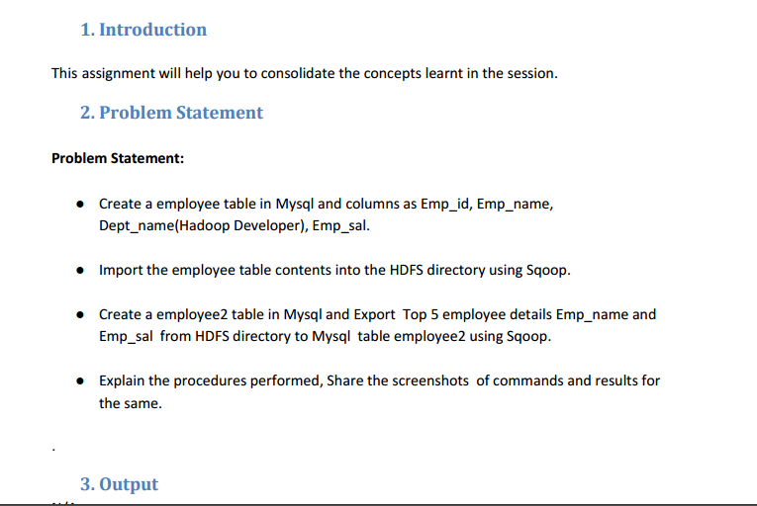

* Using show databases we can check the databases available and we can use one of them using use command.

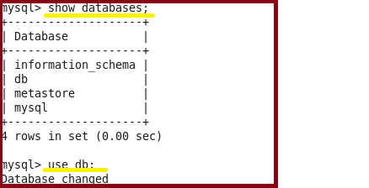

* **Creating a table named Employee and inserting the values using insert command.**

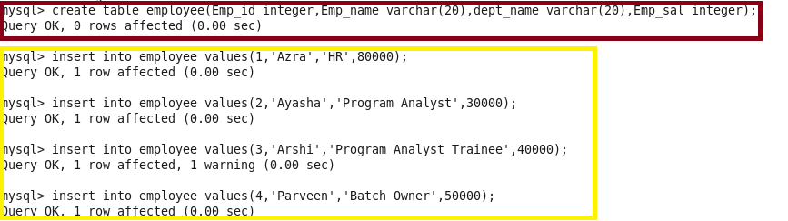

* Performing basic select operation to display the contents of the table

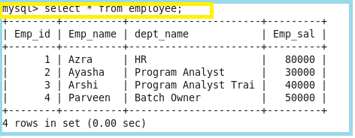

* **Importing the data from mysql to hdfs using the below command**

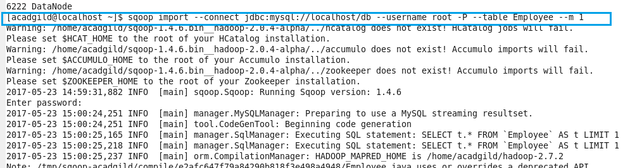

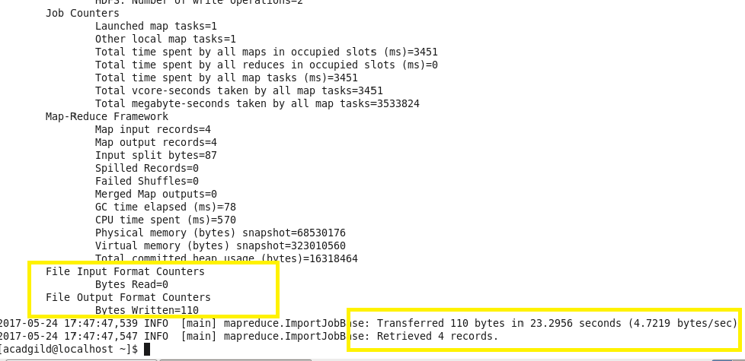

Here we can see that the data is imported successfully to hdfs.

**Checking whether the files are imported and displaying the contents of the Employee:**

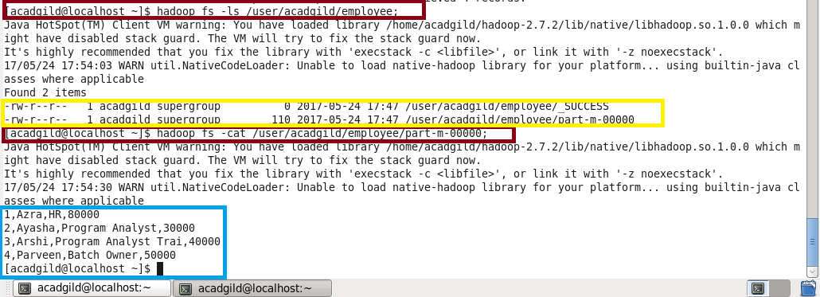

**Again creating the new table as Employee1 and no data is inserting into it so as to export it from hdfs to mysql:**

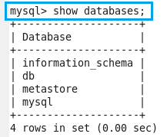

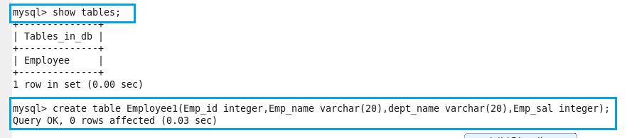

Here we can see that there is no data present in the table Employee1

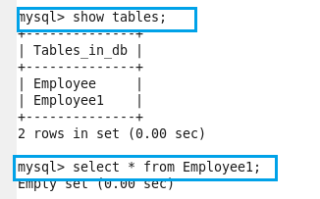

**Exporting the table from hdfs to mysql:**

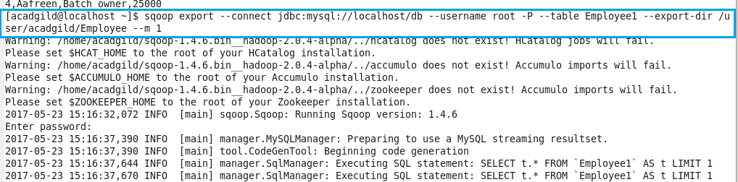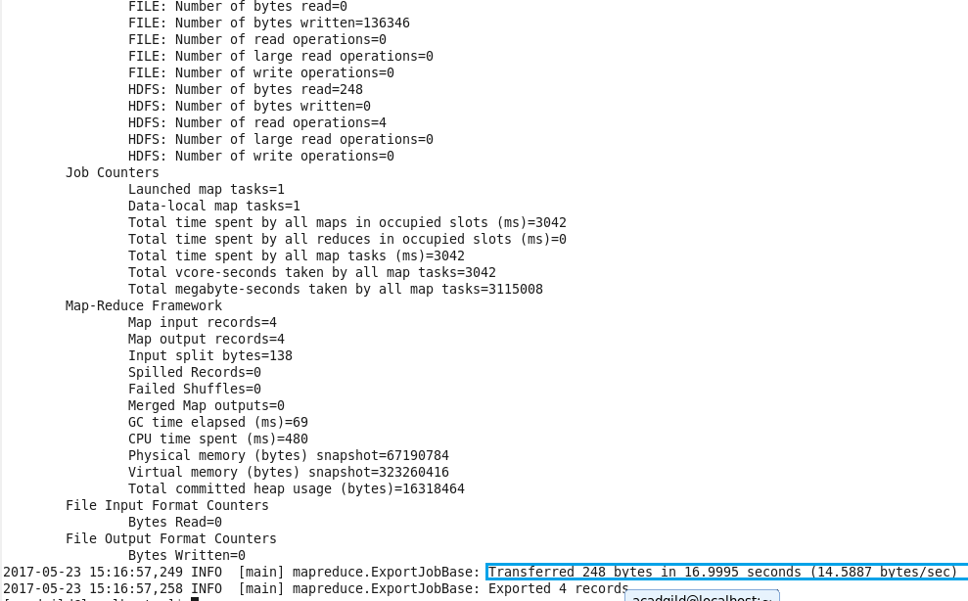

Here we can see that the data is successfully exported.

Now, showing the exported table

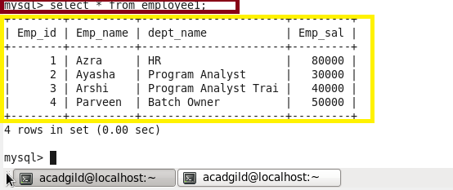

**So we are successfully done with import and export operations.**