**ASSIGNMENT 35.3**

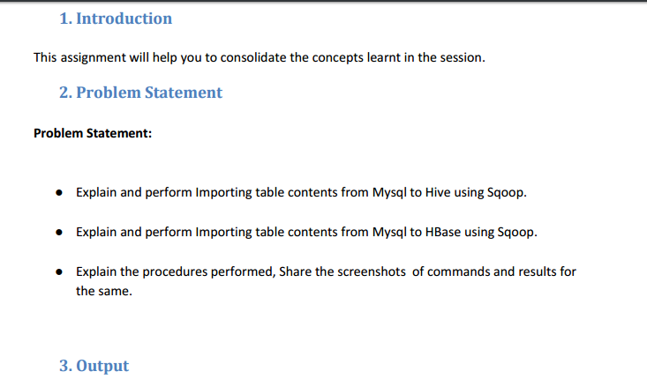

* **Explain and perform Importing table contents from Mysql to Hive using Sqoop.**

Using employee table we created earlier with data as :

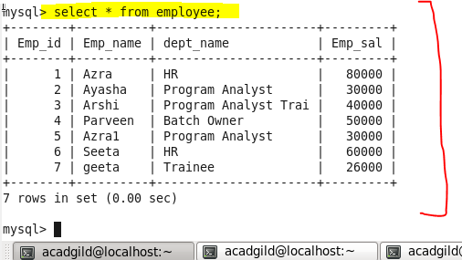

**PERFORMING IMPORT USING SQOOP(we have to transform the data from mysql to hive )**

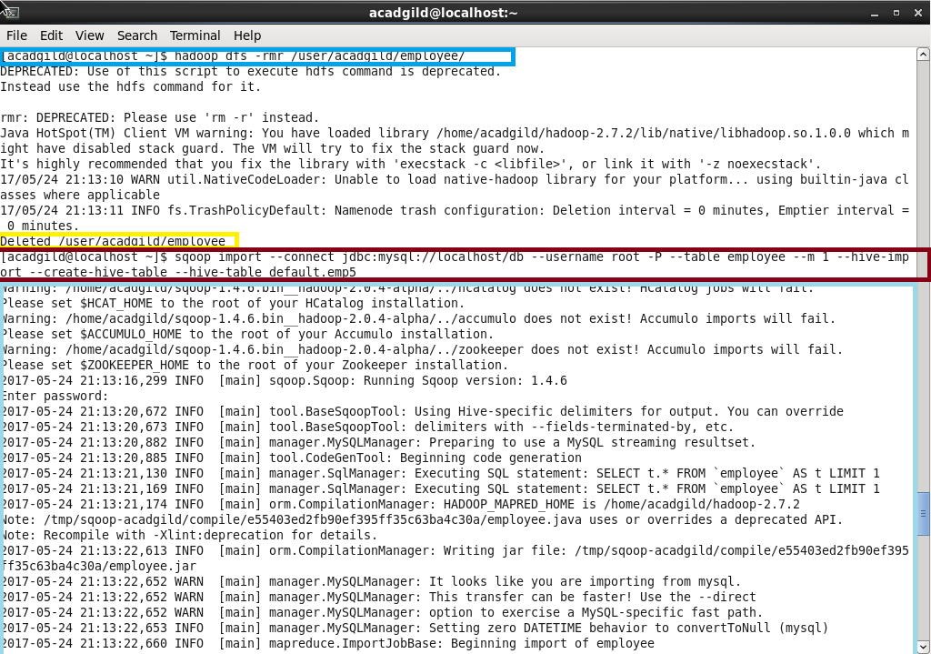

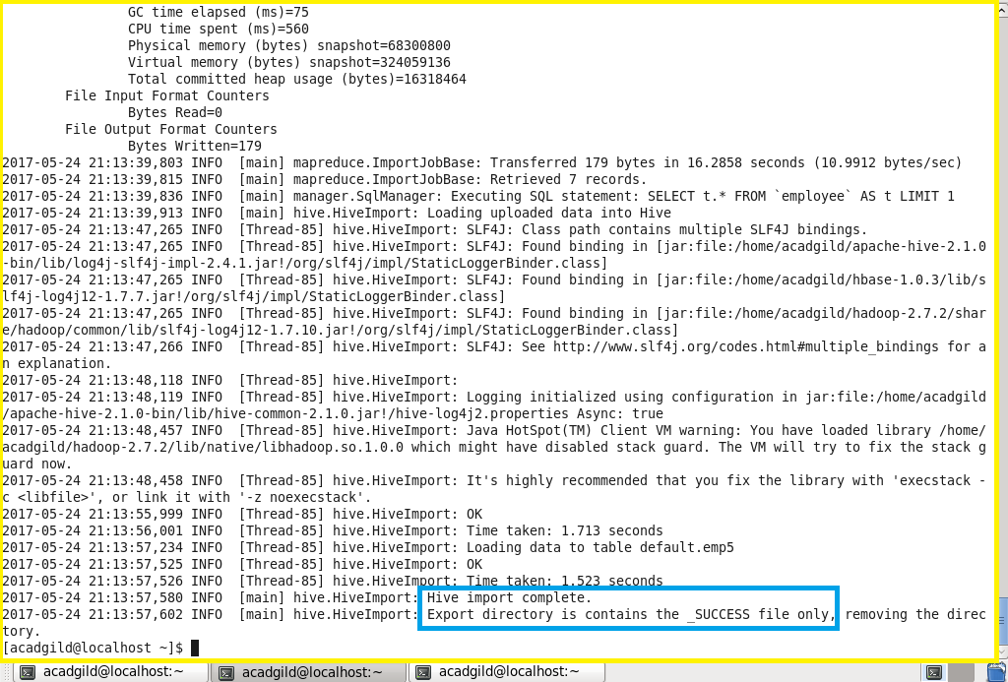Note : Before running the import command we should close the hive shell, otherwise we’ll get an error

**So a table with name emp5 will be created and the data from employee table in mysql will be imported into that , we can see down**

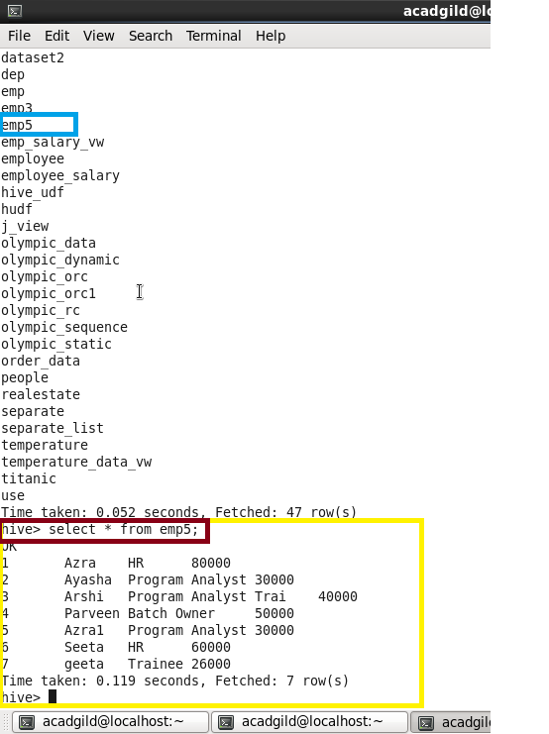

**Same data as in employee table in mysql**

* **Explain and perform Importing table contents from Mysql to HBase using Sqoop.**

Open hbase and **create a table “hivesql” with “Detail” as column family in HBASE**

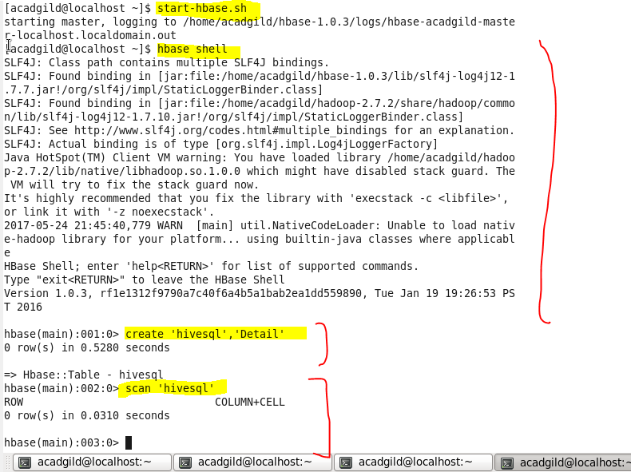

* **performing import from mysql to hbase**

using the same table employee we created earlier

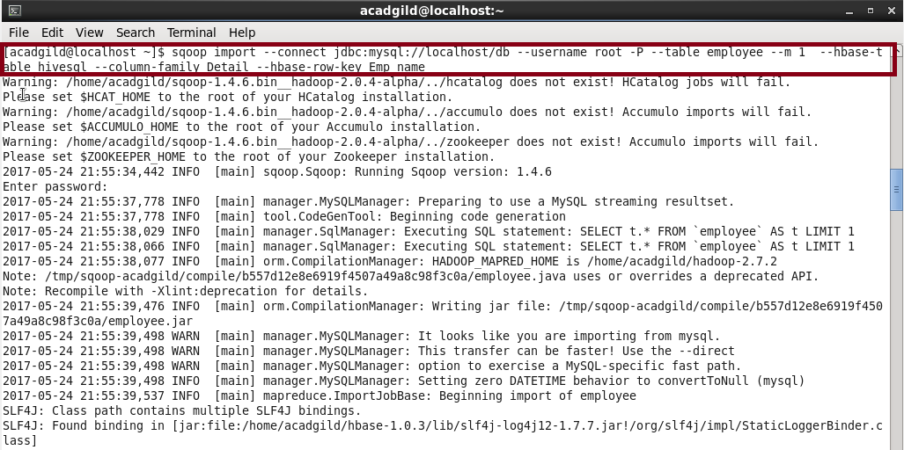

**successfully transferred data from mysql to hbase**

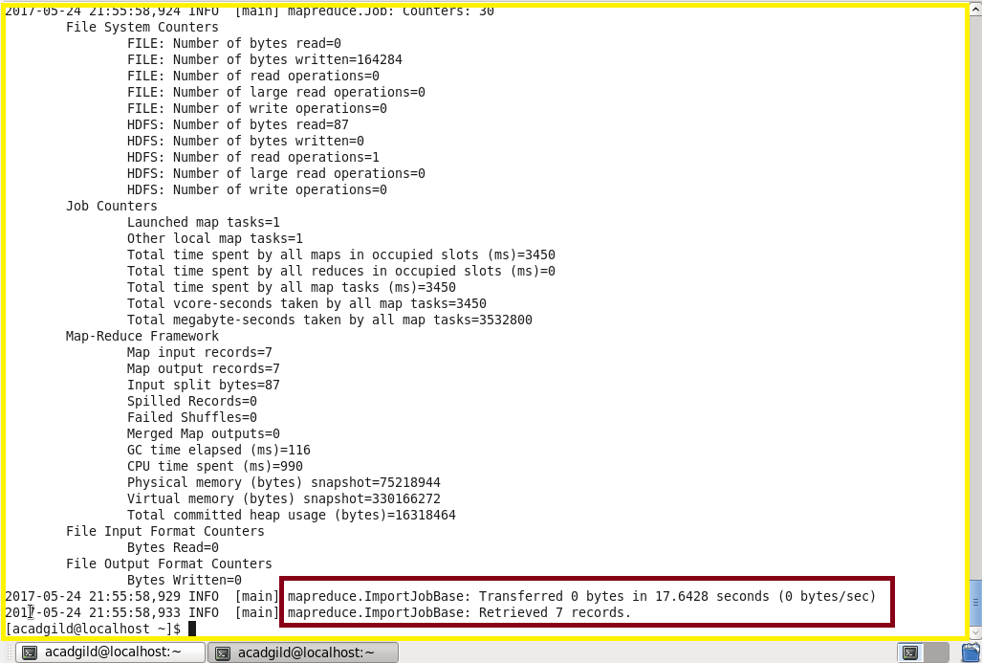

**Output**

* **scan ‘hivesql’ gives the full details about the table(transferred data)**

**We can see that the table is imported into HBase using sqoop with Emp_name as rowkey**

