**Assignment 8.5**

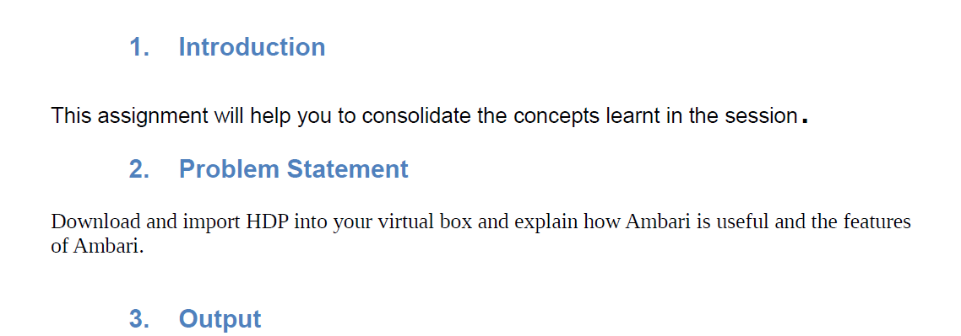

* First we will download HDP and then we will import that
* Then we will start ambari using **suso ambari-server start** command



* After running above command we will get following result that shows we are ready to use ambari

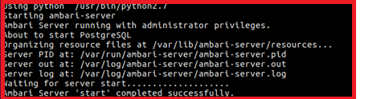

* To check if ambari is running or not we can check the status using following command



Running above command we will get :



This shows our ambari server is running

**Ambari login page :**

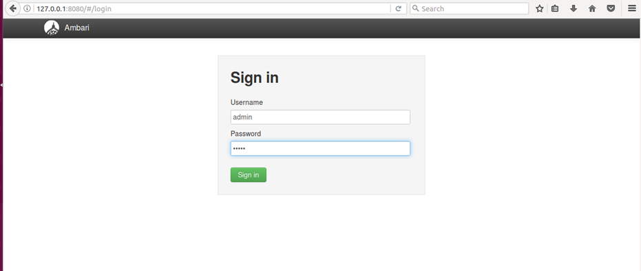

**Ambari web-Interface :**

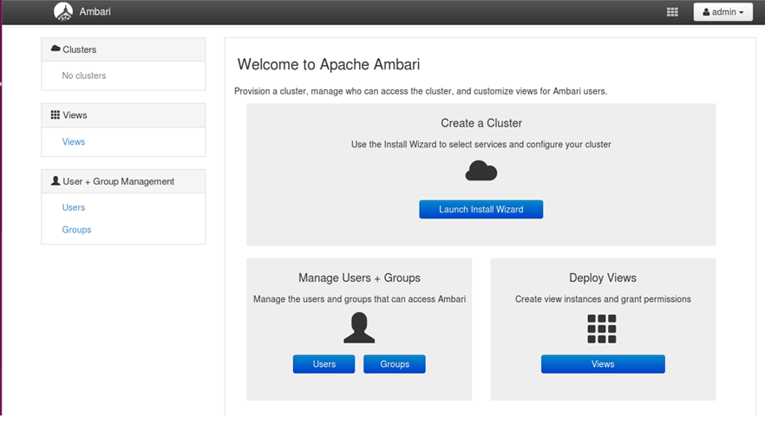

**Benefits of ambari and its features :**

* A completely open source management platform for provisioning, managing, monitoring and securing Apache Hadoop clusters. Apache Ambari takes the guesswork out of operating Hadoop.
* Apache Ambari, as part of the Hortonworks Data Platform, allows enterprises to plan, install and securely configure HDP making it easier to provide ongoing cluster maintenance and management, no matter the size of the cluster.

**What Ambari Does :**

Ambari makes Hadoop management simpler by providing a consistent, secure platform for operational control. Ambari provides an intuitive Web UI as well as a robust REST API, which is particularly useful for automating cluster operations.

With Ambari , Hadoop operators get the following core benefits:

* **Simplified Installation, Configuration and Management.** Easily and efficiently create, manage and monitor clusters at scale. Takes the guesswork out of configuration with [Smart Configs](https://cwiki.apache.org/confluence/display/AMBARI/Enhanced+Configs) and Cluster Recommendations.  Enables repeatable, automated cluster creation with [Ambari Blueprints](https://cwiki.apache.org/confluence/display/AMBARI/Blueprints).
* **Centralized Security Setup.** Reduce the complexity to administer and configure cluster security across the entire platform. Helps automate the setup and configuration of advanced cluster security capabilities such as Kerberos and [Apache Ranger](https://hortonworks.com/apache/ranger/).
* **Full Visibility into Cluster Health.** Ensure your cluster is healthy and available with a holistic approach to monitoring. Configures predefined alerts — based on operational best practices — for cluster monitoring. Captures and visualizes critical operational metrics — using [Grafana](http://grafana.org/) — for analysis and troubleshooting. Integrated with [Hortonworks SmartSense](https://hortonworks.com/products/subscriptions/smartsense/) for proactive issue prevention and resolution
* **Highly Extensible and Customizable.** Fit Hadoop seamlessly into your enterprise environment. Highly extensible with [Ambari Stacks](https://cwiki.apache.org/confluence/pages/viewpage.action?pageId=38571133) for bringing custom services under management, and with [Ambari Views](https://cwiki.apache.org/confluence/display/AMBARI/Views) for customizing the Ambari Web UI.